Use-Case Model

Version <1.0>

Revision History

|  |  |  |  |
| --- | --- | --- | --- |
| **Date** | **Version** | **Description** | **Author** |
| 23/Mar/17 | <x.x> | <details> | <name> |
|  |  |  |  |
|  |  |  |  |
|  |  |  |  |

Table of Contents

1. Use-Cases Identification 4

1.1 Register a new user 4

1.2 Log in as a user 4

1.3 Add a message to a conversation 5

2. UML Use-Case Diagrams 5

# Use-Cases Identification

## Register a new user

**Use case: Register a new user**

**Level: user-goal**

**Primary actor: Administrator user**

**Main success scenario:**

* **The administrator logs in**
* **The administrator goes to the new user page**
* **The administrator is prompted to input the following data:**
  + **Full name**
  + **Username**
  + **Password**
  + **Chose a role**
* **The administrator enters the requested data**
* **The system validates the data**
* **The new account is created**

**Extensions:**

* **Username already used – display an error message, return to first step**
* **Invalid username – display an error message, return to first step**

## Log in as a user

**Use case: Log in as a user**

**Level: sub-function**

**Primary actor: user**

**Main success scenario:**

* **The user is prompted to input their username and password**
* **The user enters the requested data**
* **The system checks if the credentials match with the ones stored in the database**
* **The system sends a token to the user’s client**
* **The user’s client receives the token and uses it for making further requests**

**Extensions:**

* **The credentials supplied by the user are invalid – display an error message, return to first step**

## Add a message to a conversation

**Use case: Add a text message to a conversation**

**Level: user-goal**

**Primary actor: user**

**Main success scenario:**

* **The user logs in**
* **The user selects a conversation they belong to**
* **The user types in the message and presses the send button**
* **The message is inserted by the system into that conversation’s history**
* **The message is displayed for all the users associated with that conversation**

**Extensions:**

* **The log in step fails – this case is treated in the log in sub-function described above**
* **The user has no conversation they belong to – only the ‘Create a new conversation’ option is shown. The other steps are not available yet**
* **The user’s client fails to send the message to the server – an error message is displayed**

# UML Use-Case Diagrams

Here, ‘user’ refers to any user that created an account for this application. The log-in operation is not mentioned as a use-case because it is considered a step in the use-cases that are mentioned.

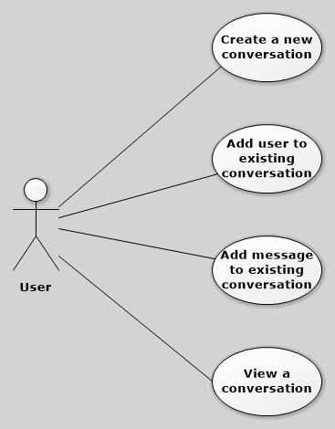

Another user is the administrator, who has the right to perform CRUD operations on users.

