# Students: Cristian-Nicolae Birla

# Carla-Alexandra Olaru

# Instructor:Claudiu Groza

Date: June 2018

Facial recognition camera

Detect the features of someones face

**1. Repository**

The project history, schematics, diagrams and codebase are contained under the following git repository:

**<https://github.com/CristiBirla/MSProject>**

**2. User requirements**

1. The system must provide relevant information about a person that is in front of the camera.

2. The system should be open for extensions, eg. adding a LCD display.

3. The system should run in an environment that provides a 24/24 access.

4. The information will be sent as an email to a specific address.

5. The system must provide the in formation with a maximum latency of 10 seconds.

6. The system might provide access to all the pictures taken by the camera.

7. The system may provide a module for data interpretation.

**3. System overview**

The overview of the system is presented in Figure 1. 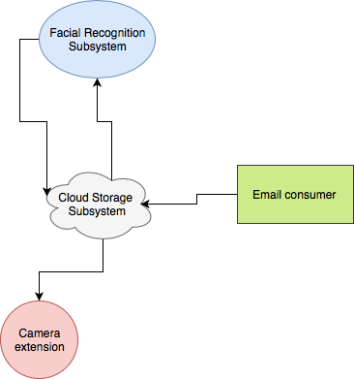

Figure1:System overview diagram

Facial Recognition Subsystem represents the functionality of the camera. It’s role is to gather information from it’s extension and process it. Additionally it offers the possibility to interpret stored information.

Cloud Storage Subsystem stores the data pushed by the camera and the Facial Recognition Subsystem.

Camera extension provides an interface for taking pictures.

Email consumer provides a UI for the stored data.