**Mobile Devices Homework**

**Team:**

**Nistor Cristi Eduard**

**Serban Alin**

**Group 1231 E**

1. **Introduction**

The purpose of this project is to create an application for mobile devices, using Android programming language. The application allows the user to register an account and login into it with a username and a password. Every user together with all information about him will be stored in a database. For this purpose we have used SQLite Database. In the application the user can enter in his profile. There he can see his profile and the current weather activity.

We chose Android platform because it is one of the most popular and used mobile platform. The application was created using Android Studio.

1. **Specifications**
2. The application will display a login interface, with 2 buttons, one for login and the other one for signing up.
3. The authenticated user can see a home screen. There he can see a welcome message and an image.
4. In the home screen, the authenticated user has the possibility to change his password.
5. The authenticated user can enter his profile from the home screen.
6. The authenticated user can modify his profile, having the data stored in the database.
7. **Prerequisites**
8. We developed the application for the minimum required SDK of 4.0 (IceCream Sandwich), with a minimum SDK of 4.0.
9. The application should compile with Android 4.4 KitKat Wear version.
10. **Implementation**

The application is implemented in the main project com.example.loginexample, which has the following java classes:

1. SignUPActivity – it makes the connection between the application and the SQLite database.
2. HomeActivity – it provides methods for the registration of a user.
3. LoginDataBaseAdapter and DataBaseHelper are classes that creates and manages the database.
4. Weather – it is a class which displays the current weather using yahoo api.
5. **User flow**

In this part we are going to test the application, from the user’s point of view.

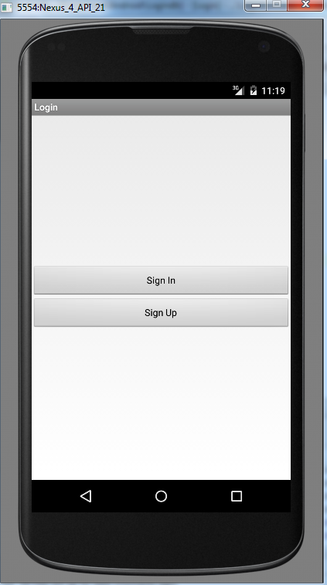

When launching the application, the user is presented with a login screen, where, obviously, he can login with an existing account via the “Sign In” button, or he can choose to create a new account pressing the “Sign up” button.

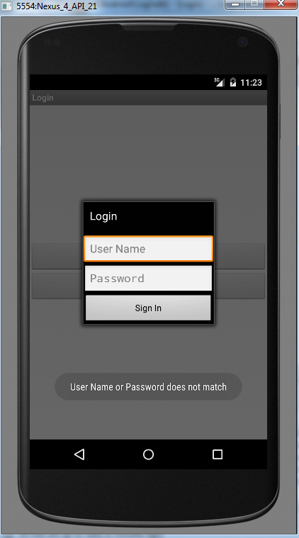

If the user does not write anything in one of the fields for “username” or “password”, or if he writes incorrect information, than the corresponding “Username or password does not match” will appear.

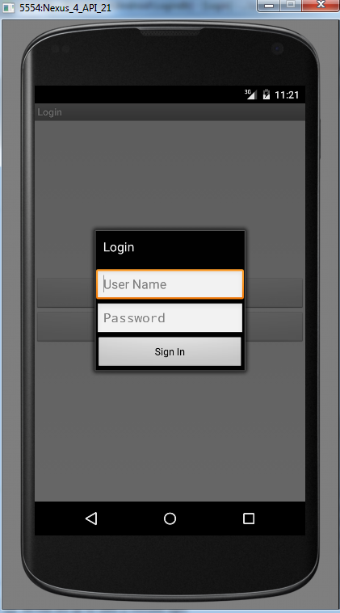

Upon pressing the “Sing up” Button, the application will switch to the Register Screen where the user has to insert a desired username and a password. By pressing the “Create Account” button in here, the message “Account successfully created” will be displayed.

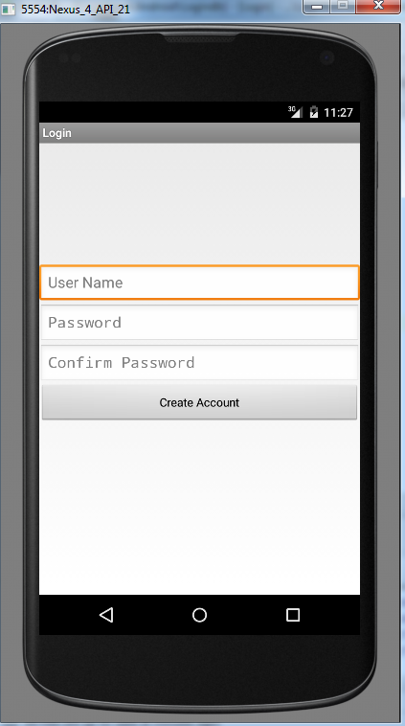

In his profile, the user has the option to modify his password, by pressing “Change Password” button, which advances him into another screen. There he can see three fields that usually appear when anyone changes the password for any account: old password, new password.

1. **Improvements**

Even though we have created a working version of the application, there could be some things that need to be improved.

1. **References**
2. Android Developer Guide

<http://developer.android.com/index.html>

1. Android Coding

<http://stackoverflow.com>