Roskilde Daycare Project

KEA Copenhagen School of Design and Technology

Lygten 37 - 2200 København N

Computer Science, 2nd Semester 2020

Group 8 : Remi Foss, Aleksandar Miroslavov Minchev, Maja Rebeka Miskéri, Dagmara Przygocka, Cristian-Valentin Purcea

Table of contenct

Project Overview 3

# Project Overview

Introduction

In this project our team created administrative IT-system to for Roskilde Daycare. The main purpose of the system is to aid in maintaining daycare’s administrative tasks in a simple manner.

System description:

Available features:

* add, remove, display, child
* add, remove, display teacher
* add, display parent
* add, delete, display schedule
* add activity to the schedule
* add, display activities
* add, delete, display group,
* add child to the group,
* add, delete, display waiting list
* add, delete, display invoice
* add, delete, display appointment

Data storage:

Information in the system are stored in database.

Description:

In order to create the system we used Java programming language to create functionalities and MySQL to deliver necessary information from database.

In the system there ae two types of user:

-Administrator

There is only one Administrator account which has access to all functionality of the system.

-Teacher

There is several accounts of Teacher user and more can be created by the administrator. Teacher account has access to functionalities like:

* add, delete, display waiting list,
* add, delete, display appointments,
* add, delete, display groups,
* display schedule,
* display phone list

# Description Of Development

# Diagrams

In our program we tried to make our information flow as clear as we could. We designed class menu to display available features to user and send information about needed information to controller. Next controller class sends information to service class in which we extract information from database and display what needed to the user.

# Snippets Of Code

We have decided to present snippets of code :

* Log in as administrator
* Create teacher
* Delete child
* Display list of parents

These methods represent general idea how our program works. In order to see the rest of the methods we encourage you to look at our source code attached to the report.

Log in as administrator

Create teacher method

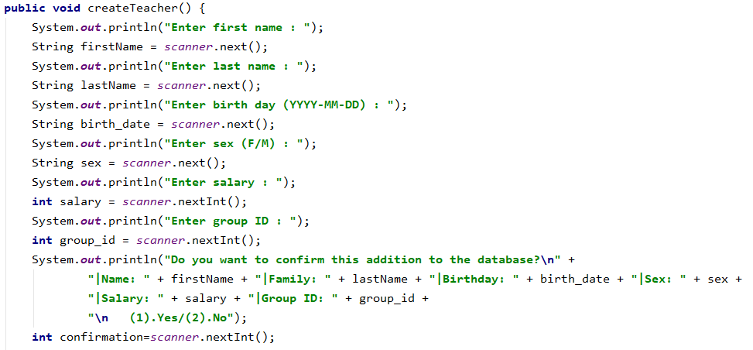

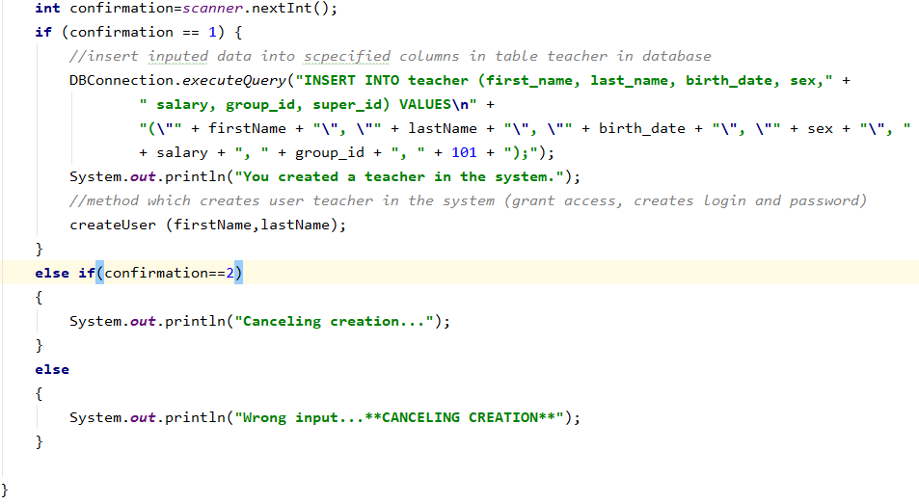

Delete child

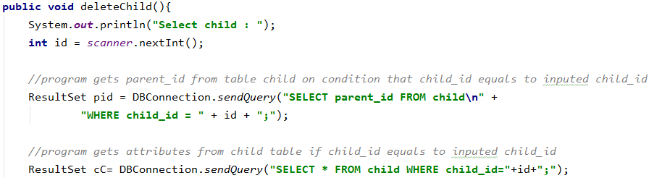

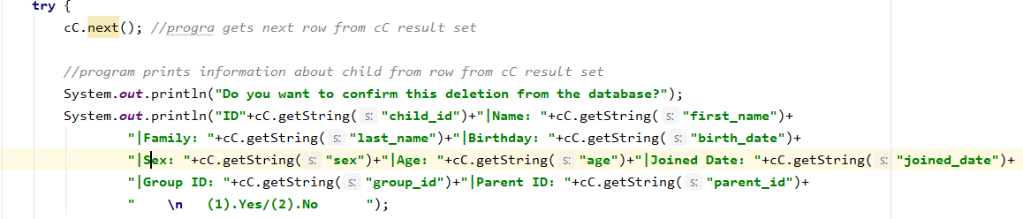

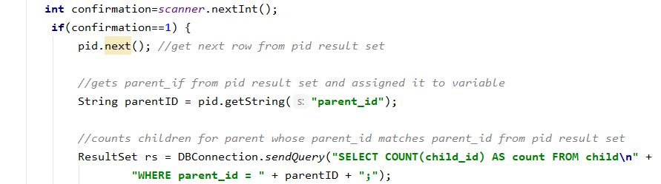

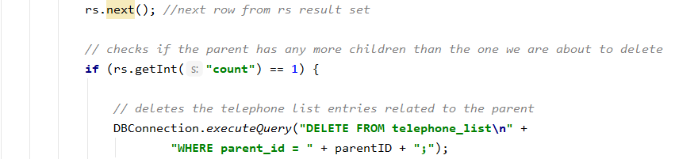

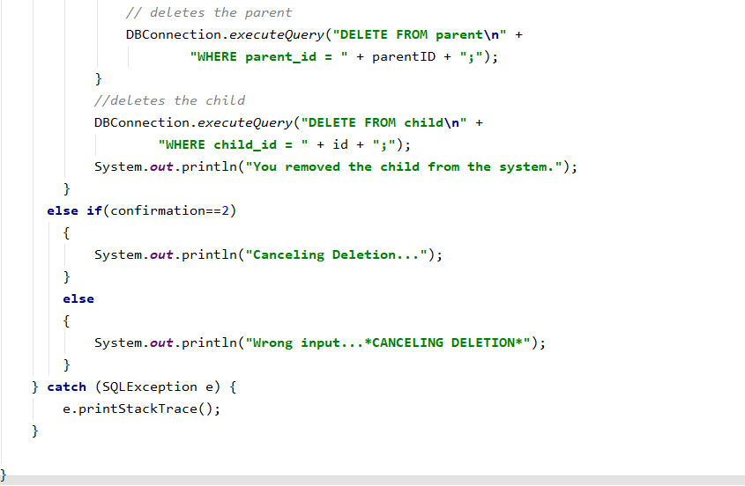

Display list of parents

