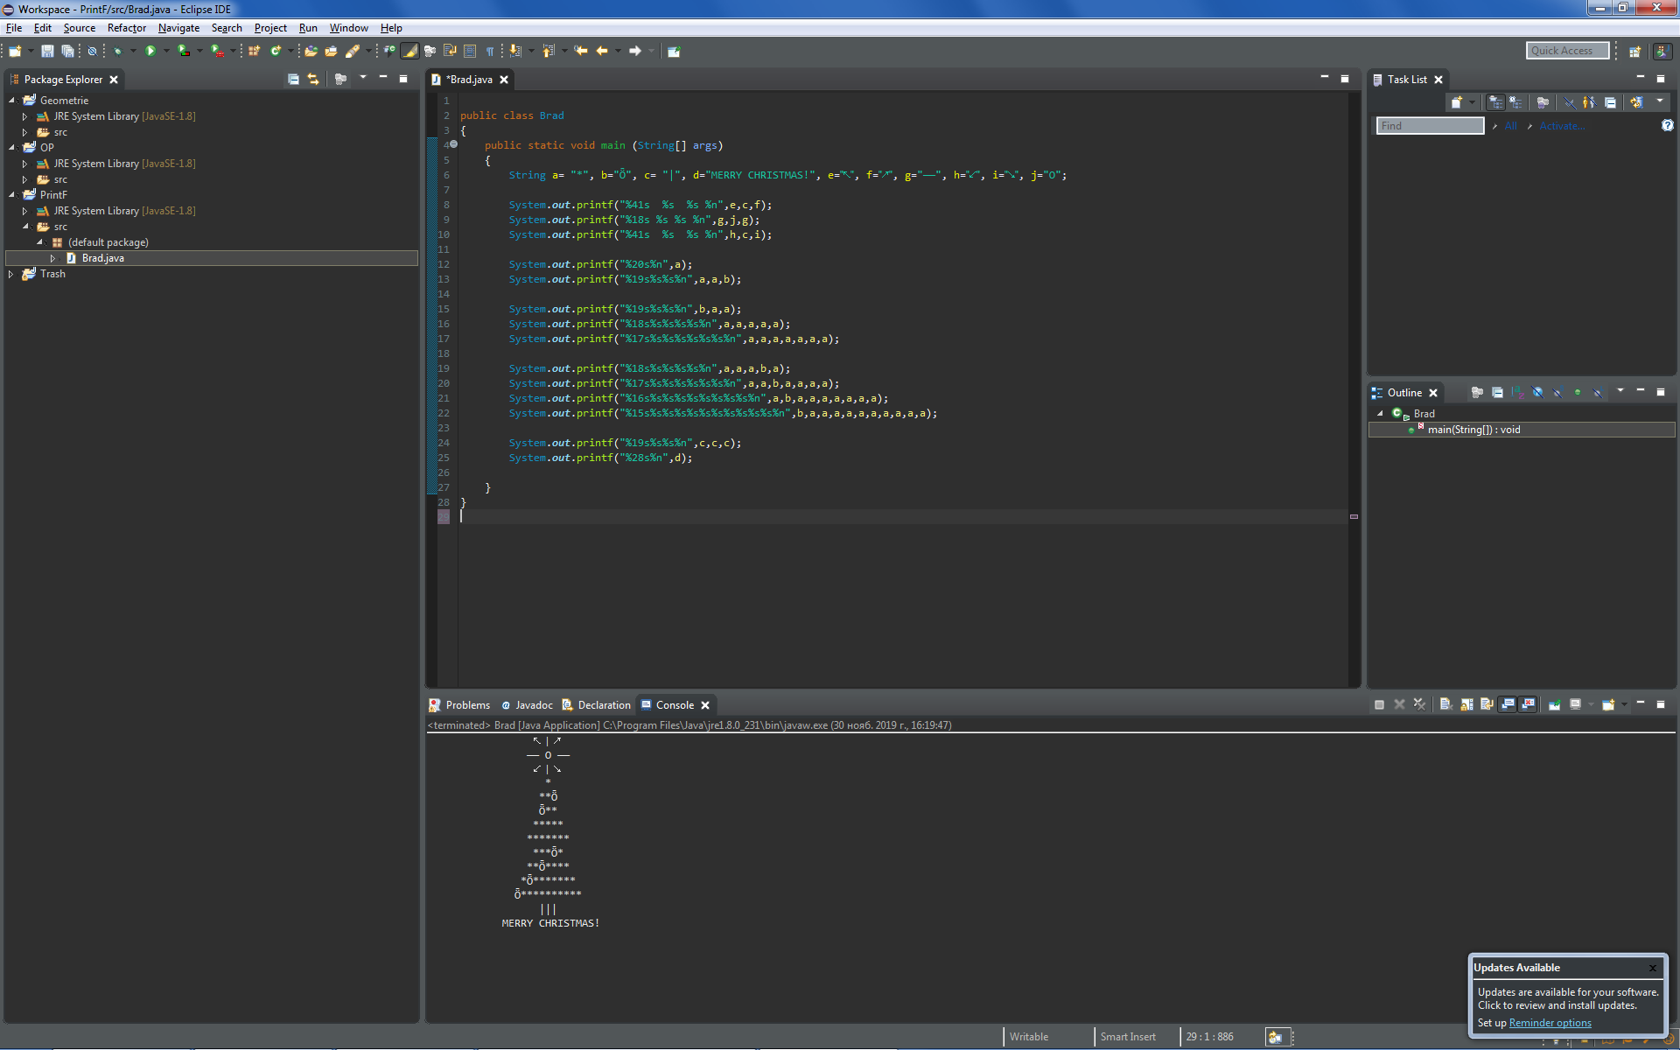

public class Brad

{

public static void main (String[] args)

{

String a= "*", b="Ȫ", c= "|", d="MERRY CHRISTMAS!", e="↖", f="↗", g="——", h="↙", i="↘", j="O";

System.***out***.printf("%41s %s %s %n",e,c,f);

System.***out***.printf("%18s %s %s %n",g,j,g);

System.***out***.printf("%41s %s %s %n",h,c,i);

System.***out***.printf("%20s%n",a);

System.***out***.printf("%19s%s%s%n",a,a,b);

System.***out***.printf("%19s%s%s%n",b,a,a);

System.***out***.printf("%18s%s%s%s%s%n",a,a,a,a,a);

System.***out***.printf("%17s%s%s%s%s%s%s%n",a,a,a,a,a,a,a);

System.***out***.printf("%18s%s%s%s%s%n",a,a,a,b,a);

System.***out***.printf("%17s%s%s%s%s%s%s%n",a,a,b,a,a,a,a);

System.***out***.printf("%16s%s%s%s%s%s%s%s%s%n",a,b,a,a,a,a,a,a,a);

System.***out***.printf("%15s%s%s%s%s%s%s%s%s%s%s%n",b,a,a,a,a,a,a,a,a,a,a);

System.***out***.printf("%19s%s%s%n",c,c,c);

System.***out***.printf("%28s%n",d);

}

}