db.getCollection('customers').find({"_id" : {"$gt": 1}})

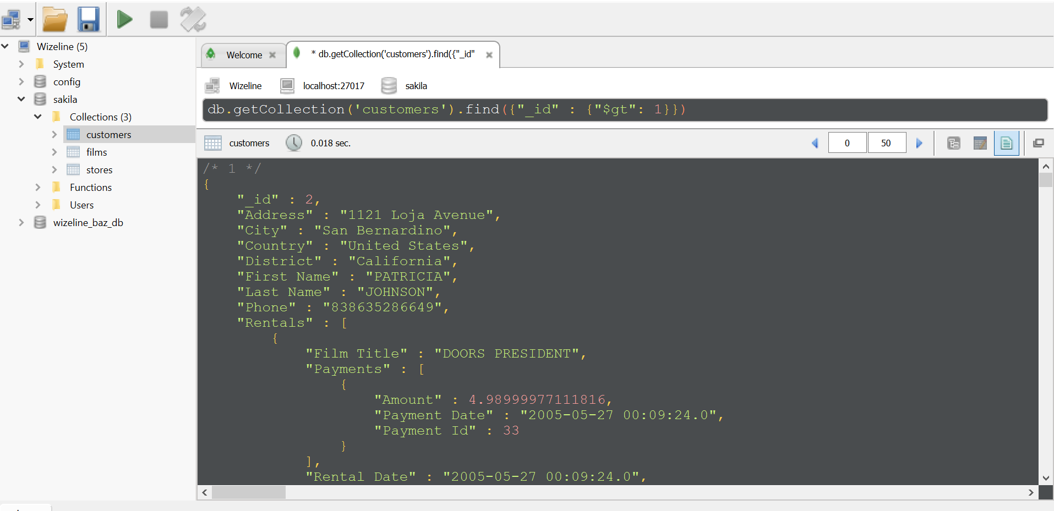

db.getCollection('films').insertOne({“”:””})

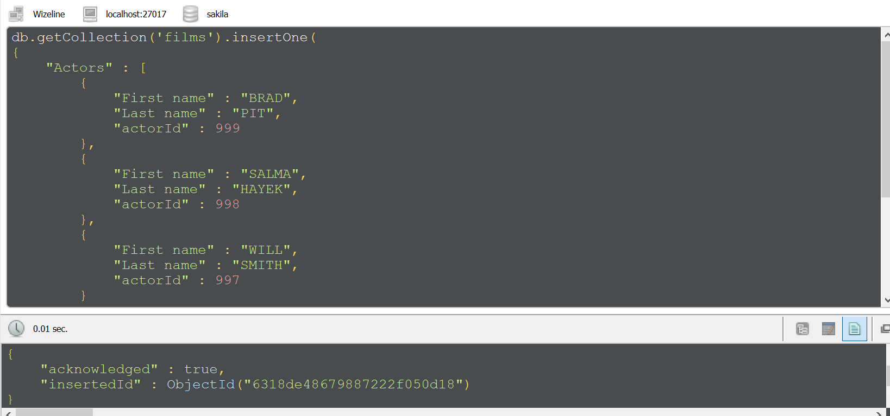

UpdateOne  
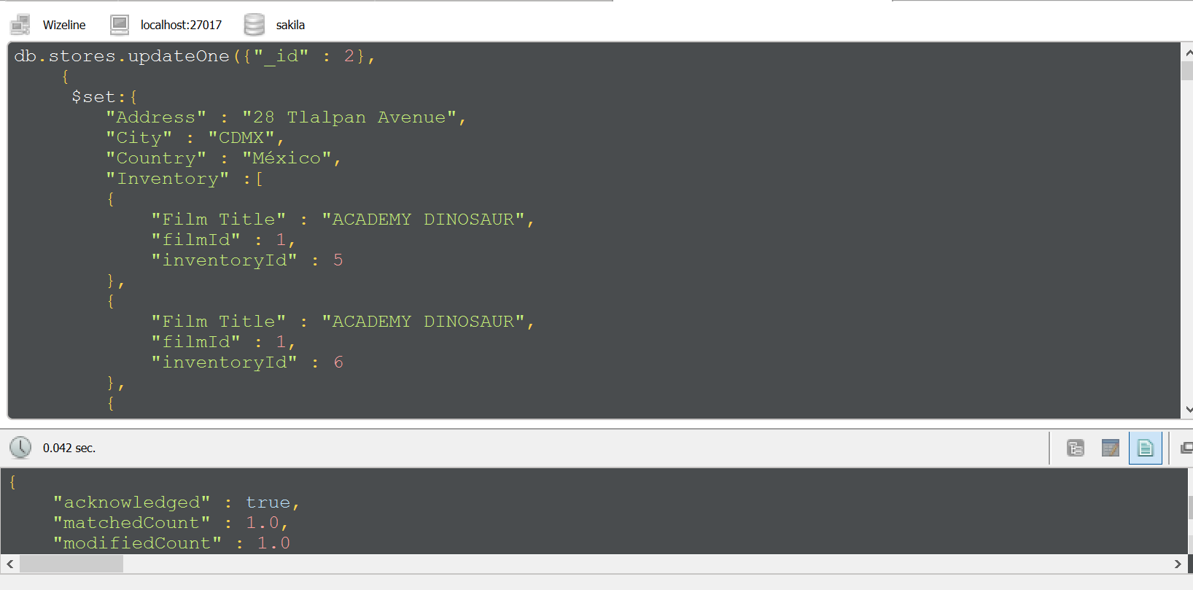

Delete

