

General description about them.

How do you think they are? How would you like them to be?

What do they live in your story?



MAX POWER

# Distinguishing Characteristics

* Mannerisms (self-conscious use of distinct style)
* Habits (done frequently/hard to give up)
* Flaws
* Health (illness? disorder? condition?)
* Qualities
* Pet peeves
* Speech and/or accent

# Emotional Characteristics

* Strengths
* Weaknesses
* Accomplishments
* Myers-Briggs Personality

# General

Age

Role in Story

Occupation

Nationality

Marital Status

Family

# Physical Description

Height

Weight

Eye color

Hair color

Skin color

Features

Dress style

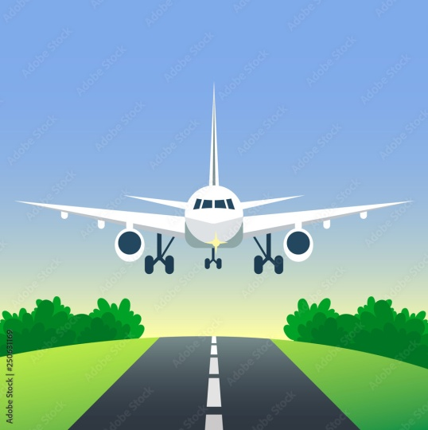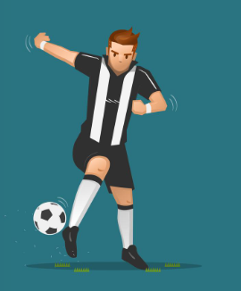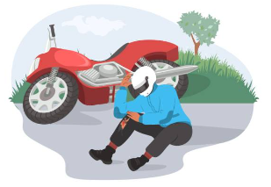

# Character Sketch

* What do other people see of them?
* What is important to them?
* What was their childhood like?
* Who are they close to?
* What are they hiding?
* Who or what do they love most?
* Who or what do they hate most?

# Character in the story

* What do they need to achieve in relation to your plot?
* What changes in their personality and circumstances will be effected by the end of the novel?

# Social Networks

* Would they have social networks?
* What would they post?