Laboratorio 2.1
int PULSADOR = 2;
int LED = 3;

void setup() {
pinMode(PULSADOR, INPUT_PULLUP);
pinMode(LED, OUTPUT);

}

void loop() {
if (digitalRead(PULSADOR) == LOW) {
digitalWrite(LED, HIGH);
} else {
digitalWrite(LED, LOW);
}
}
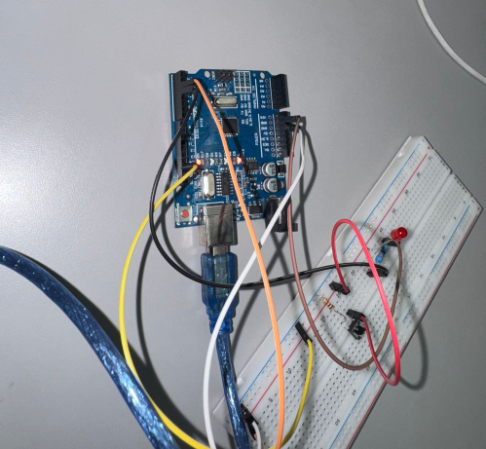
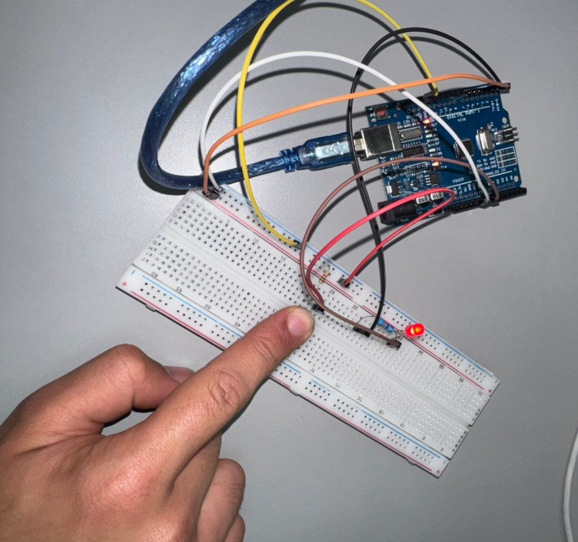

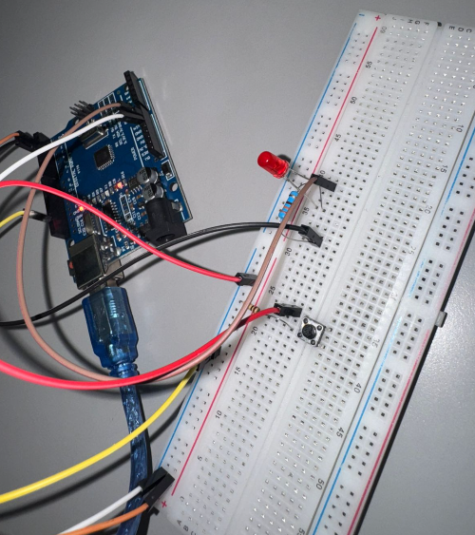
Tinkercard: https://www.tinkercad.com/things/8HepV9MOOW0-pulsador-y-led?sharecode=7o7_BwnzshltmrGqLp8i1NgjI5IwNu-2rtUD5Z6i17g

