Quantium Chips Category Customer Analytics: Data Cleaning, Segmentation, and Commercial Recommendations

This project analyzes supermarket transaction and customer data to understand who buys Chips and how their purchasing behavior differs across customer segments. The objective is to identify the key drivers of chip sales—such as customer lifestage, premium status, purchase volume, and price sensitivity—and translate these insights into practical recommendations for the next six-month category strategy. The workflow includes data quality checks and cleaning, merging transaction and customer datasets, building core sales and behavior metrics, and performing a deep dive into target segments using pack size and brand preferences to support actionable commercial decisions

Strategic Focus and Analytical Approach for Customer Segmentation

The objective of this analysis is to support a data-driven strategic recommendation for the upcoming Chips category review by understanding current purchasing trends and customer behaviour. The focus principal is on identifying which customer segments contribute most to chip sales and what factors drive their spending, including purchase frequency, volume, price sensitivity, pack size and brand preference
Key metrics were defined to describe customer purchasing behaviour, including total sales, number of customers, number of transactions, average spend per customer, average packs purchased, and average price per pack.
The insights generated at this stage are intended to inform clear, actionable recommendations that Julia, the Category Manager, can apply in the next six months of category planning.

Step 1 Data preparation & Customer Analysis
Based in the core objective analyze supermarket transaction and customer data to understand who purchases chips and what drives their spending behavior, is to generate data-driven insights that support strategic category decision, with a focus on customer segmentation and purchasing patterns

- To do this Quantium expected use R such tool in the data preparation because is harder in excel based in the huge dataset this step approach
- Performed data quality checks and cleaning on transaction and customer datasets
- Removed inconsistency
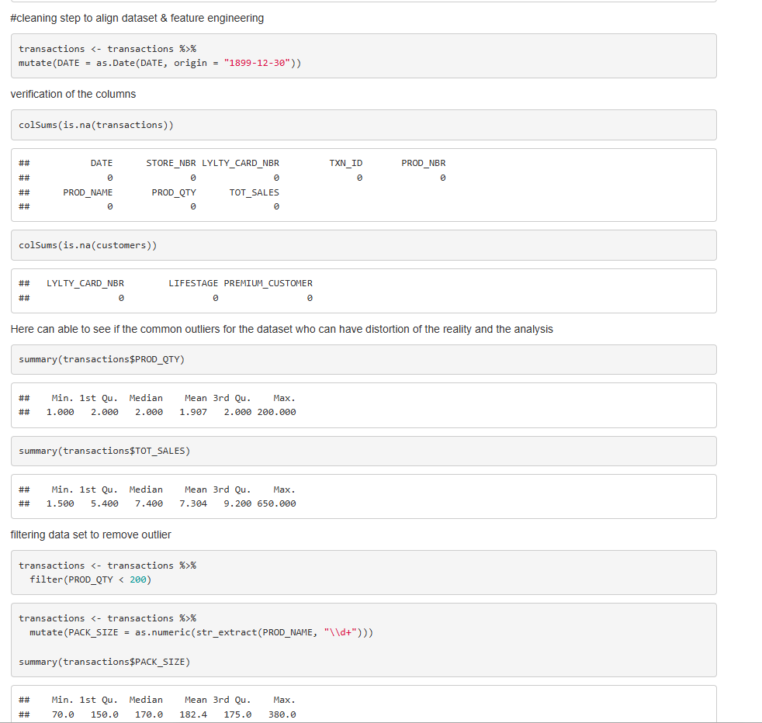
- Merged transaction and customer data JOINs to enable segment analysis level
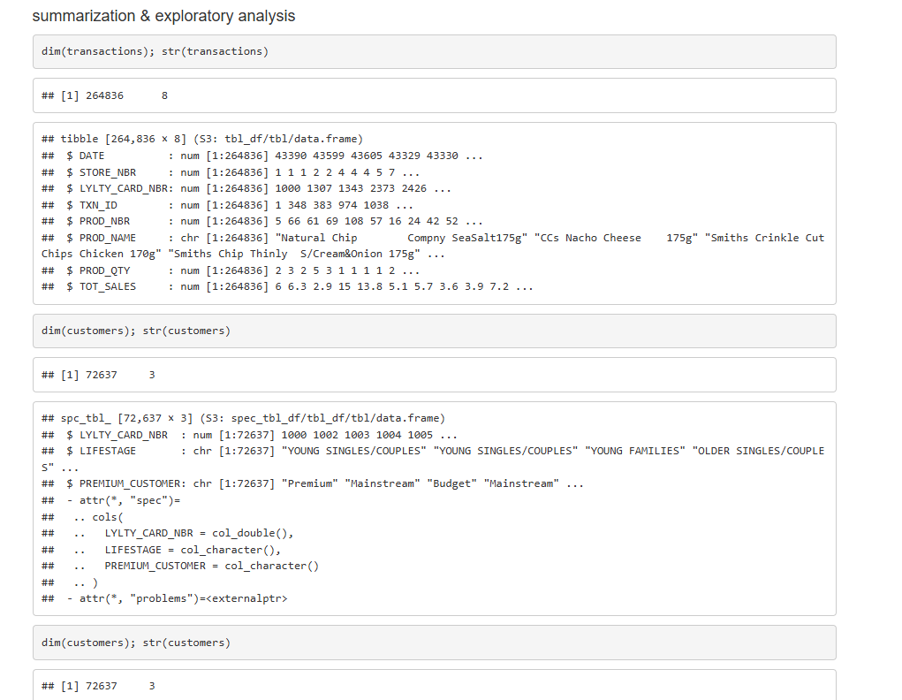

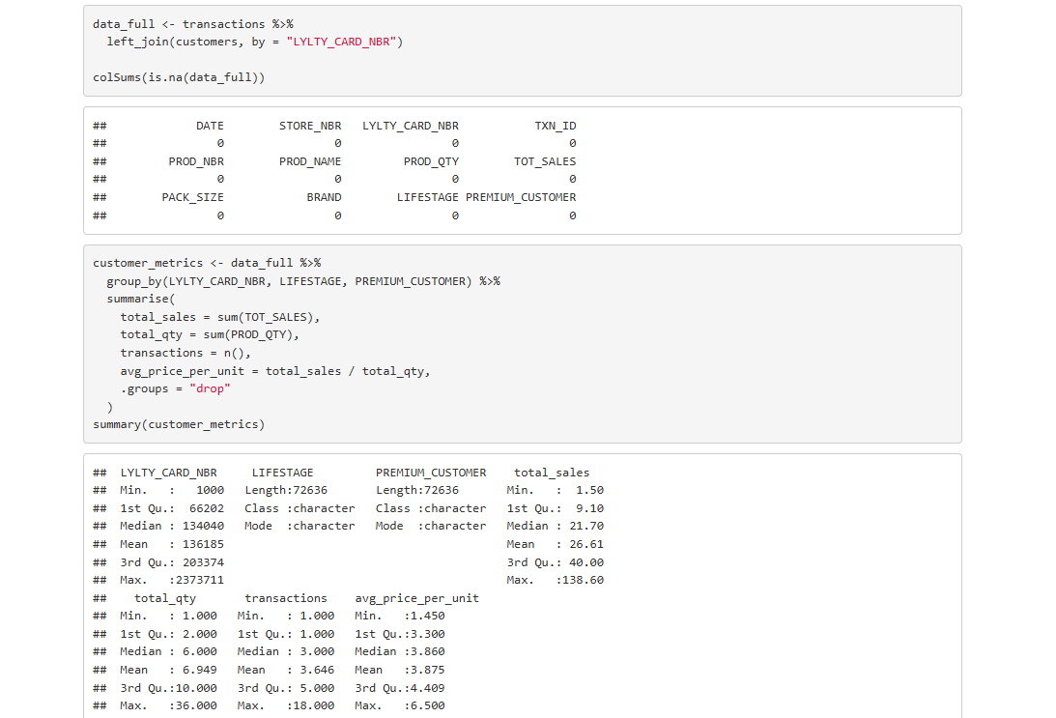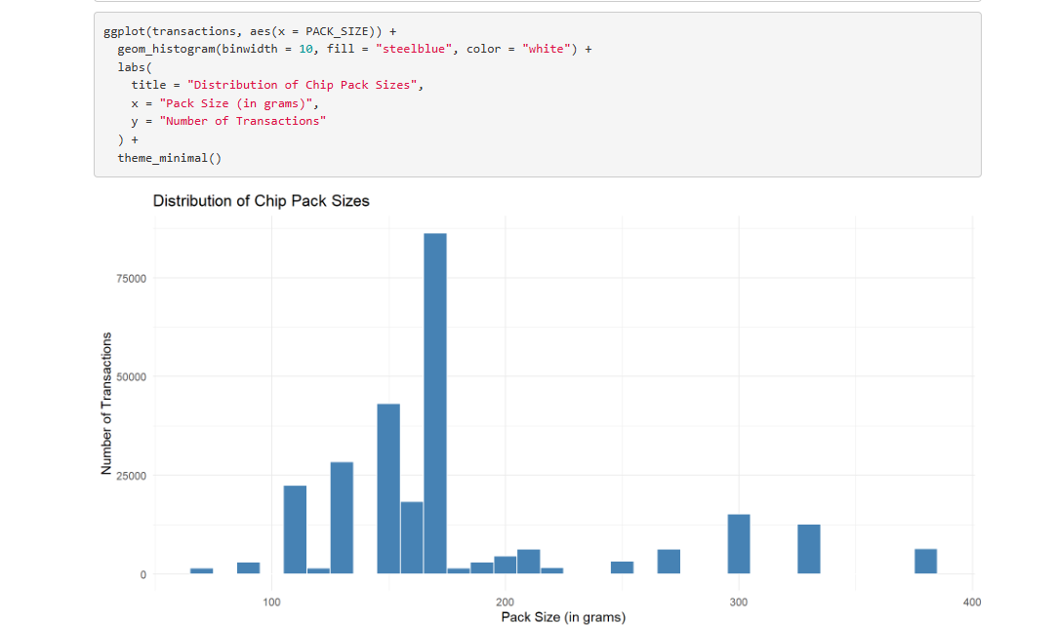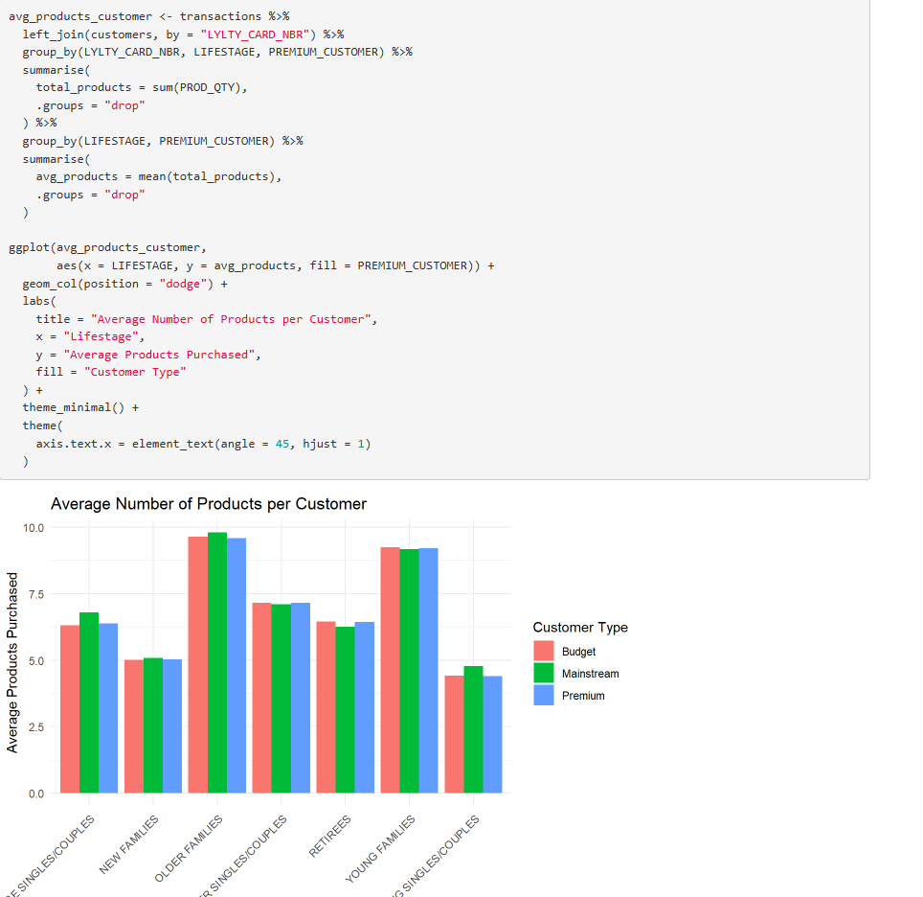

This analyze demonstrate how customer segmentation can be used to identify revenue drivers and optimize product range, pricing and promotional focus, the insight supports practical decision-making for short-term category planning and highlight the value

Step 2 Experimentation and uplift testing

Objective

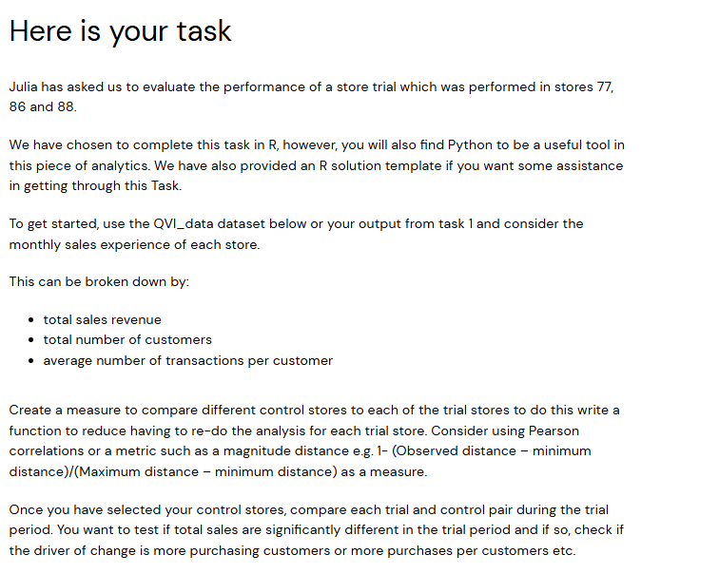

Julia sends email needed evaluate the impact of a strategic intervention by comparing customer purchasing behavior between trial stores and control stores. The company (Quantium) needs to validate that business initiatives generate measurable value before scaling them across the network.

Analytical Approach
Store Matching (Trial vs Control)
Control stores were selected by identifying stores with similar pre-trial performance to the trial stores. Key metrics used for matching included:
- Total sales
- Number of customers
- Transaction volume

Metrics Evaluated
The following metrics were tracked before and after the trial period:
- Total sales
- Number of customers
- Number of transactions
- Average sales per customer

Following the next link is upload al technique and code in R to approach the objective

Summarize:
- Cleaned and prepared transaction and customer data from the Task1 (step 1)
- Aggregated key performance indicator at store and monthly level
- Selected control stores with similar pretrial performance
- Compared trial and control store performance before and during the trial period

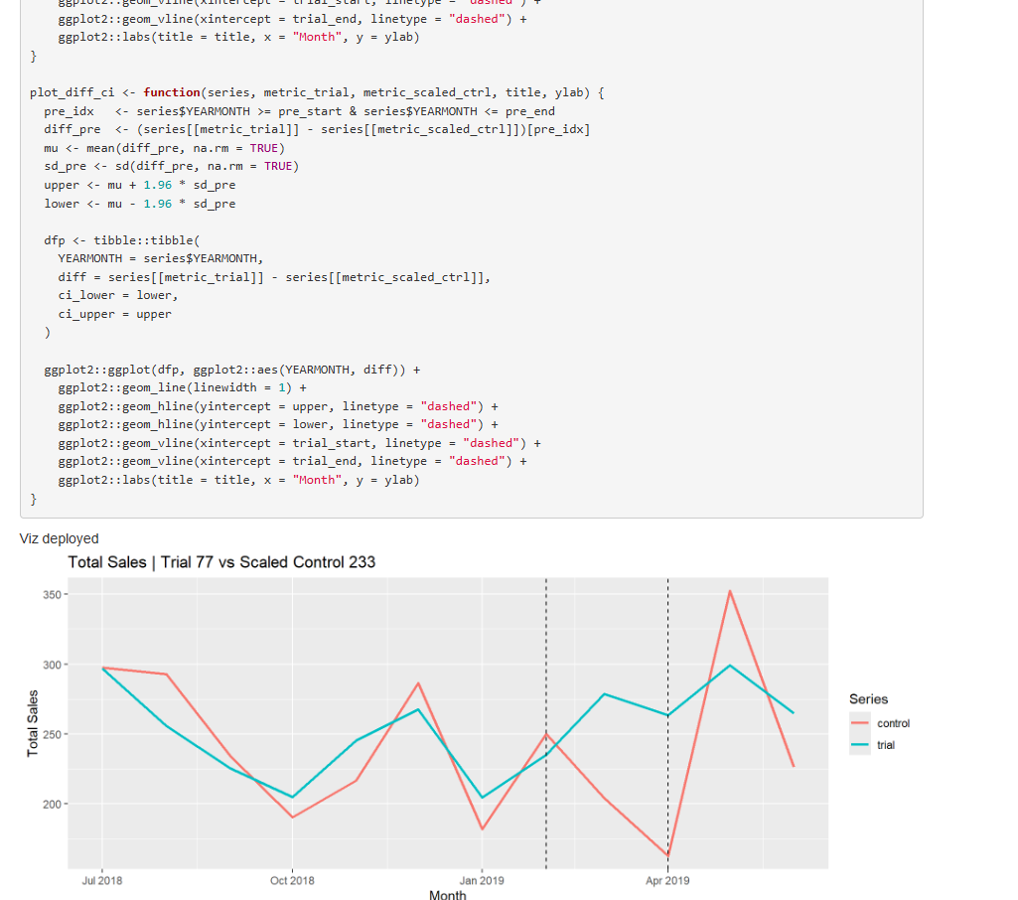
Viz to support insights

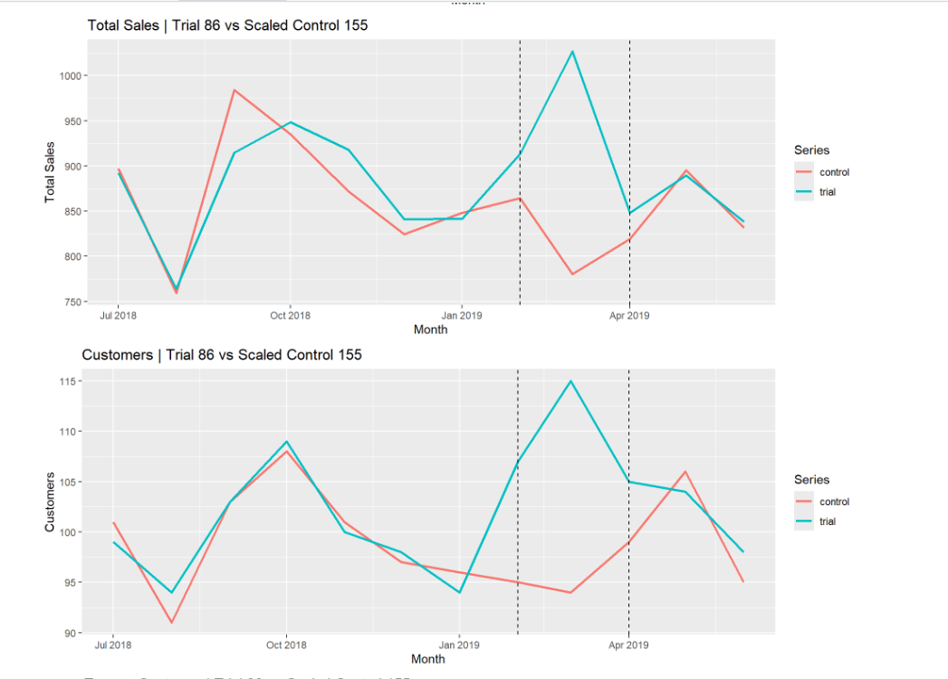

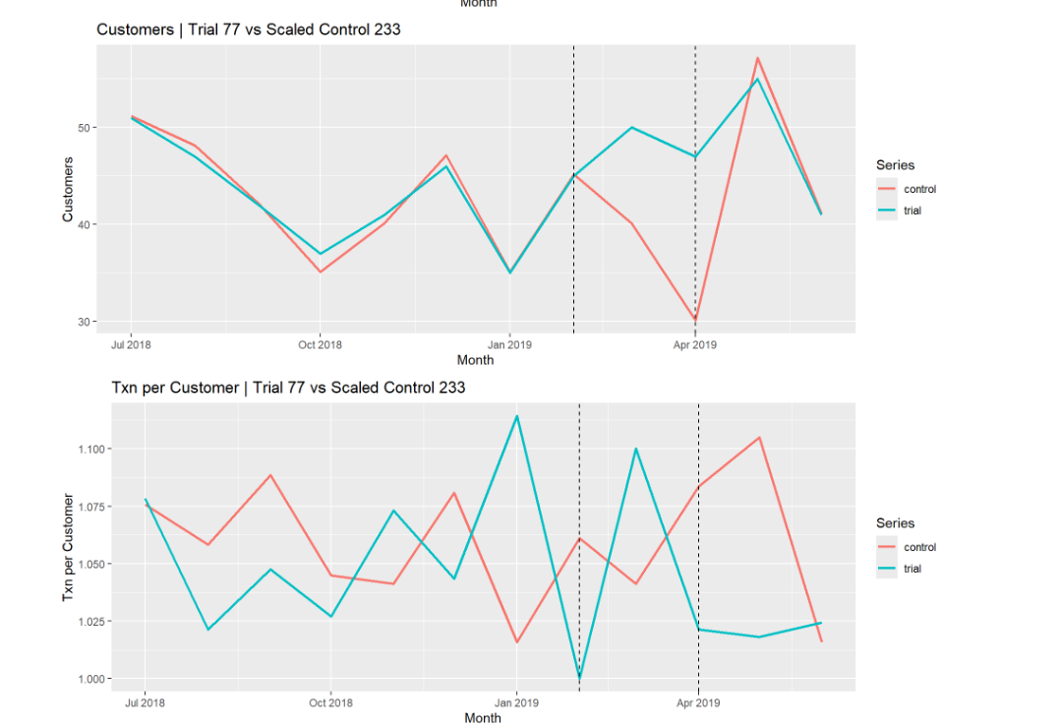

Here able to explain the trial delivered a positive and measurable impact, driven by increased customer participation rather than temporary changes in customer behavior. Because the uplit showed in Trial Stores 77 and 86 what show a clear uplift in total sales during the trial period compared to their scaled control stores and before the trial sales trends between trial and control stores were closely aligned, indicating a strong baseline match also the transaction per sutomer remained relatively stable across both trial and control store showing a increase in number of customers and stable purchase frequency.
These results support the conclusion that the trial strategy was effective

Step 3 Presentation to data-driven decision
The next step was to translate the analytical findings into a clear, business-focused presentation using google slides, The insights were structured the impact of the trial on sales and customer.
This presentation is to stakeholders who not have a technical background to enable quickly understand the results, assess the effectiveness of the trial and make an informed data-driven decision.

Presentation of Insights

