Student: Berengea Cristian

**CUPRINS**

1. Specificatie proiect
2. Componente necesare + Schema electrica
3. Implementare + DOC
4. Cum se utilizeaza?

**1.**  Specificatie proiect

Am construit o masinuta care sa poata fi controata prin bluetooth de pe telefon. Masinuta se opreste atutomat daca intalneste un obstacol in fata. De asemenea masinuta are stopuri, faruri, claxon si semnalizari. ”Farurile” masini se aprind automat atunci cand luminozitatea este scazuta, ”Stopurile” se sting cand masina este in miscare. In aplicatia de pe telefon este afisata distanta de la masinuta pana la obstacolul pe care il are in fata.

**2.** Componente necesare + Schema electrica

Componente necesare :

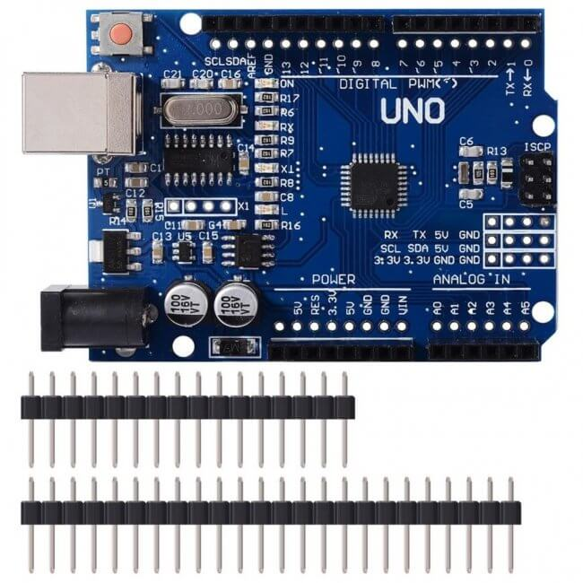 Placă de dezvoltare compatibilă UNO R3 CH340

# https://cleste.ro/media/catalog/product/cache/1/image/650x/6b9ffbf72458f4fd2d3cb995d92e8889/C/L/CL440_4.jpg

Placă expansiune 4 relee 5v

## https://cleste.ro/media/catalog/product/cache/1/image/650x/6b9ffbf72458f4fd2d3cb995d92e8889/i/m/img2_1_31.jpg

[Modul Bluetooth Serial HC06](https://cleste.ro/modul-bluetooth-serial-hc06.html)

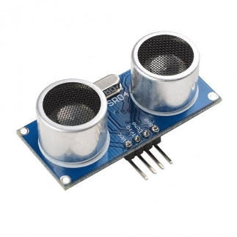

## [Senzor ultrasonic HC-SR04](https://cleste.ro/senzor-ultrasonic-hc-sr04.html)

* 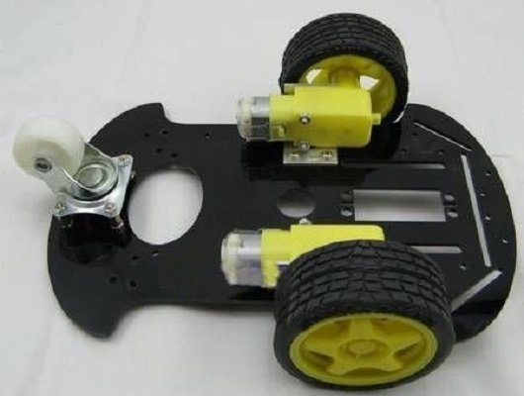1x Șasiu platformă mobilă
* 2x motor de 3,6 V DC
* 2x anvelope din cauciuc
* 2x suport motor cu stenturi metalice L
* 1x roată omnidirecțională
* 4x Cilindru de cupru (inclusiv șuruburi și piulițe)

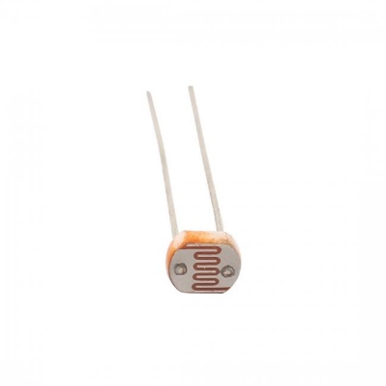

## [Fotorezistor 5528 LDR](https://cleste.ro/fotorezistor-5528-ldr.html)



## [Suport pentru senzor proximitate](https://cleste.ro/suport-pentru-senzor-proximitate.html)

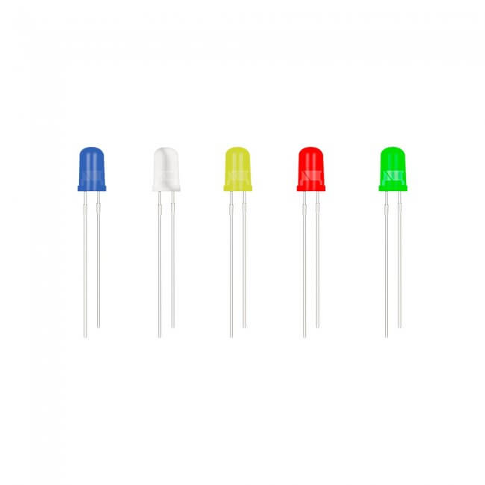

## [LED de 5 mm](https://cleste.ro/led-de-5-mm.html)

* 2 x alb
* 2x albasrtu
* 4x galben

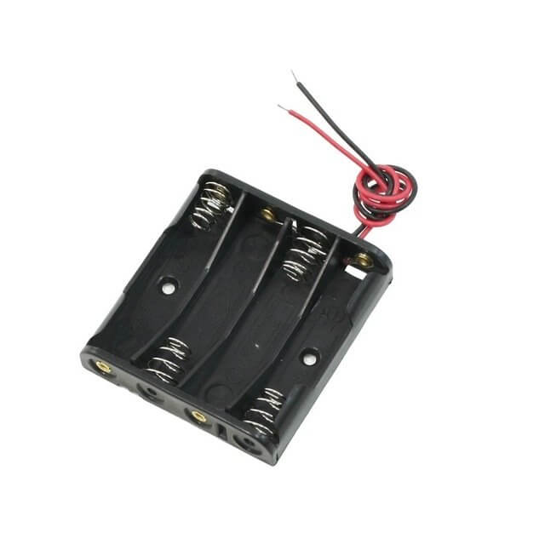

Compartiment pentru baterii

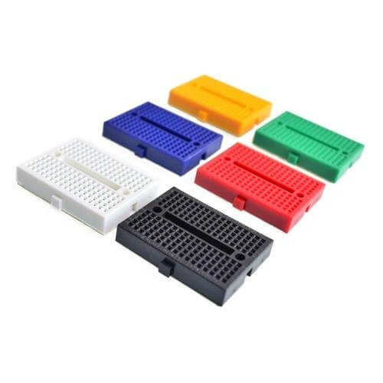

## [Breadboard Mini 170 puncte](https://cleste.ro/breadboard-mini-170-puncte.html) x2

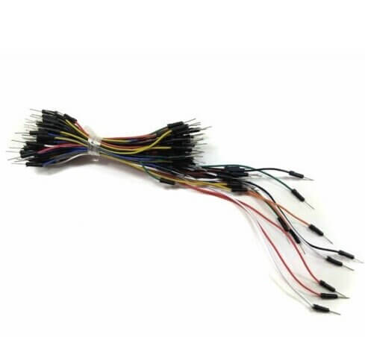

# Fire Dupont

* mama-mama
* mama-tata

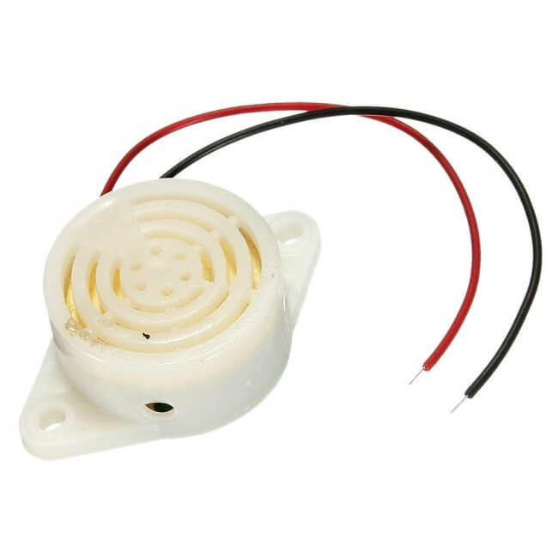

# Buzzer 3-24V

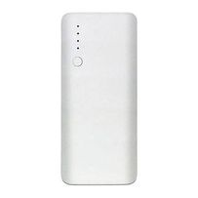

Power bank 5600 mAh

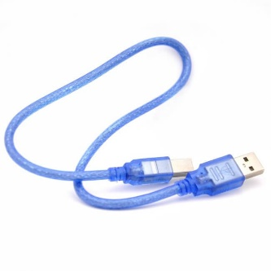

# Cablu USB A-B 0.3m

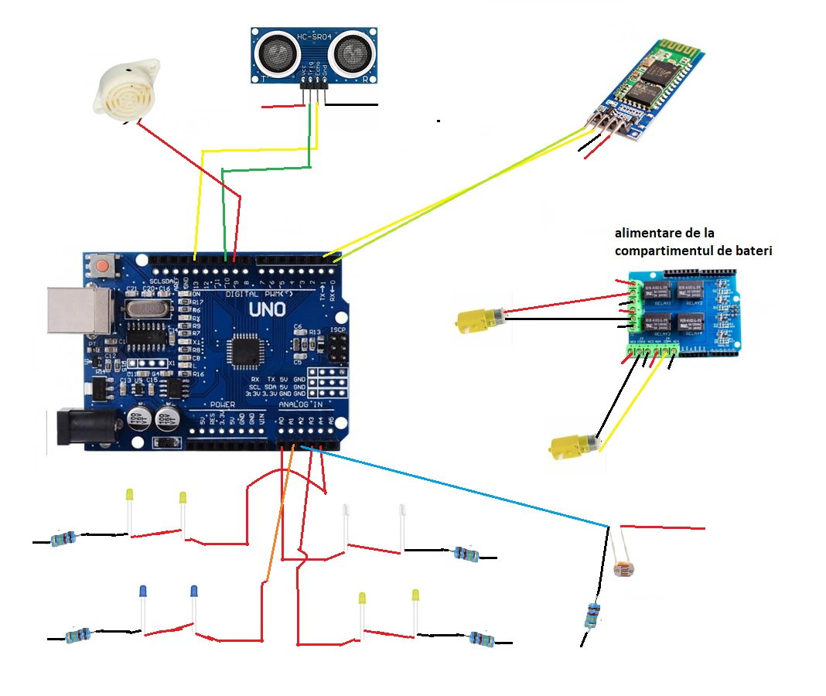

Ledurile albastre sunt stopurile.

Am folosit o placuta de expansiune cu 4 relee, folosesc 2 relee pentru fiecare motoras pentru a putea schimba sensul de rotatie al motorasului.

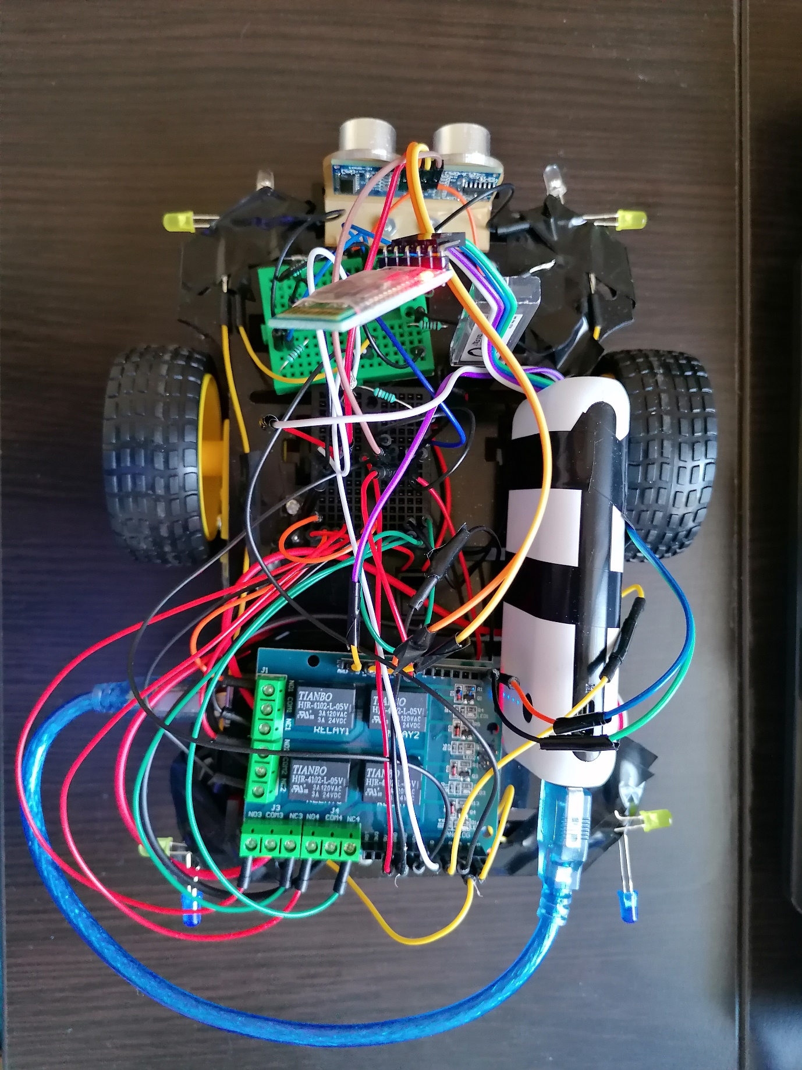

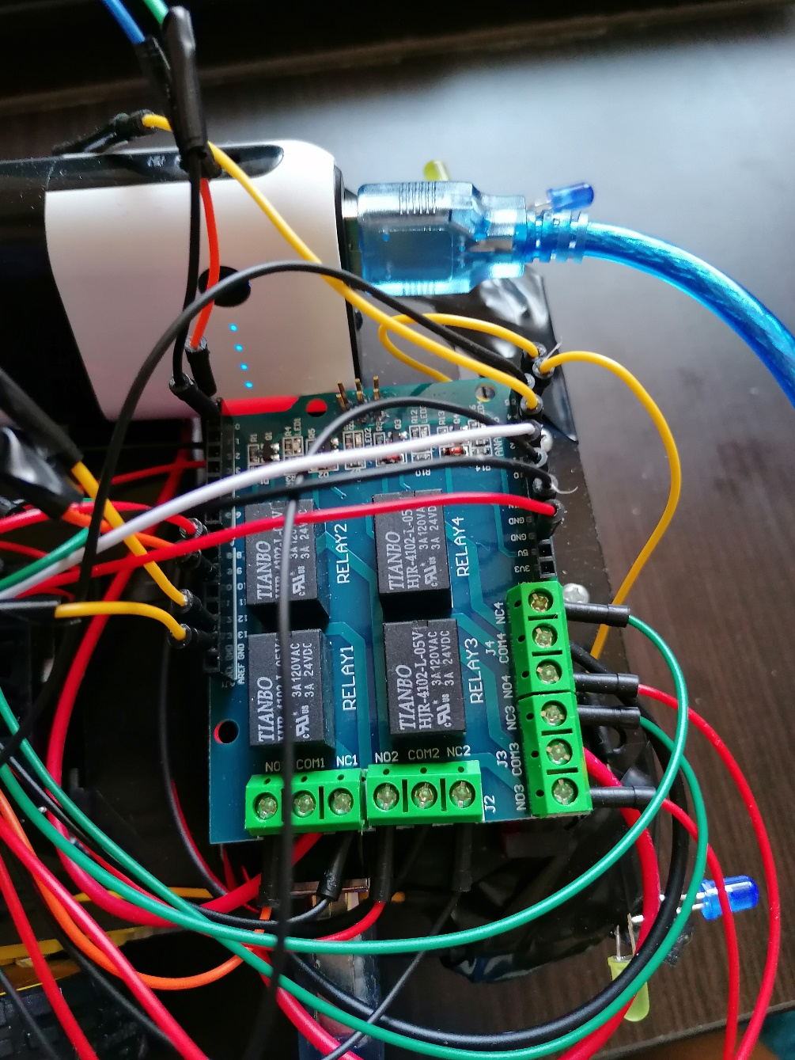

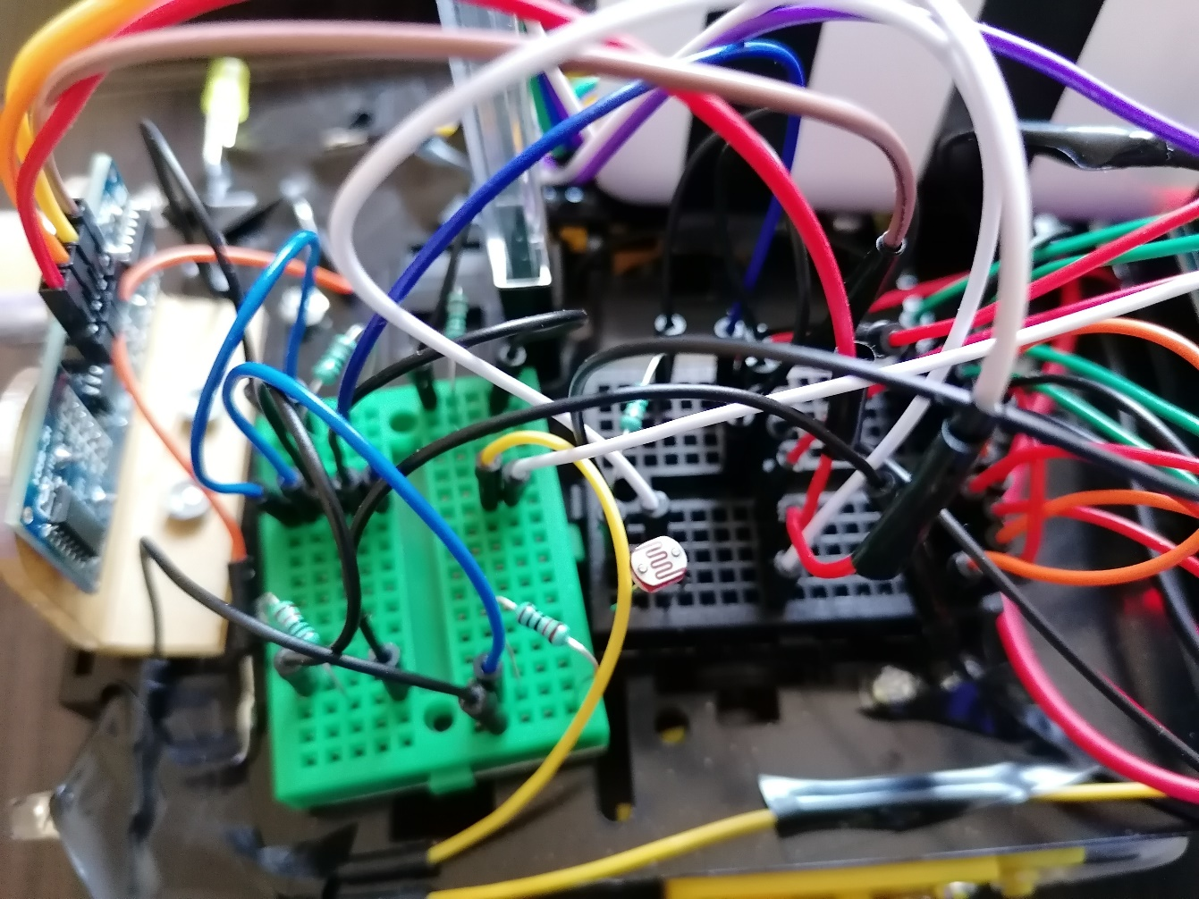

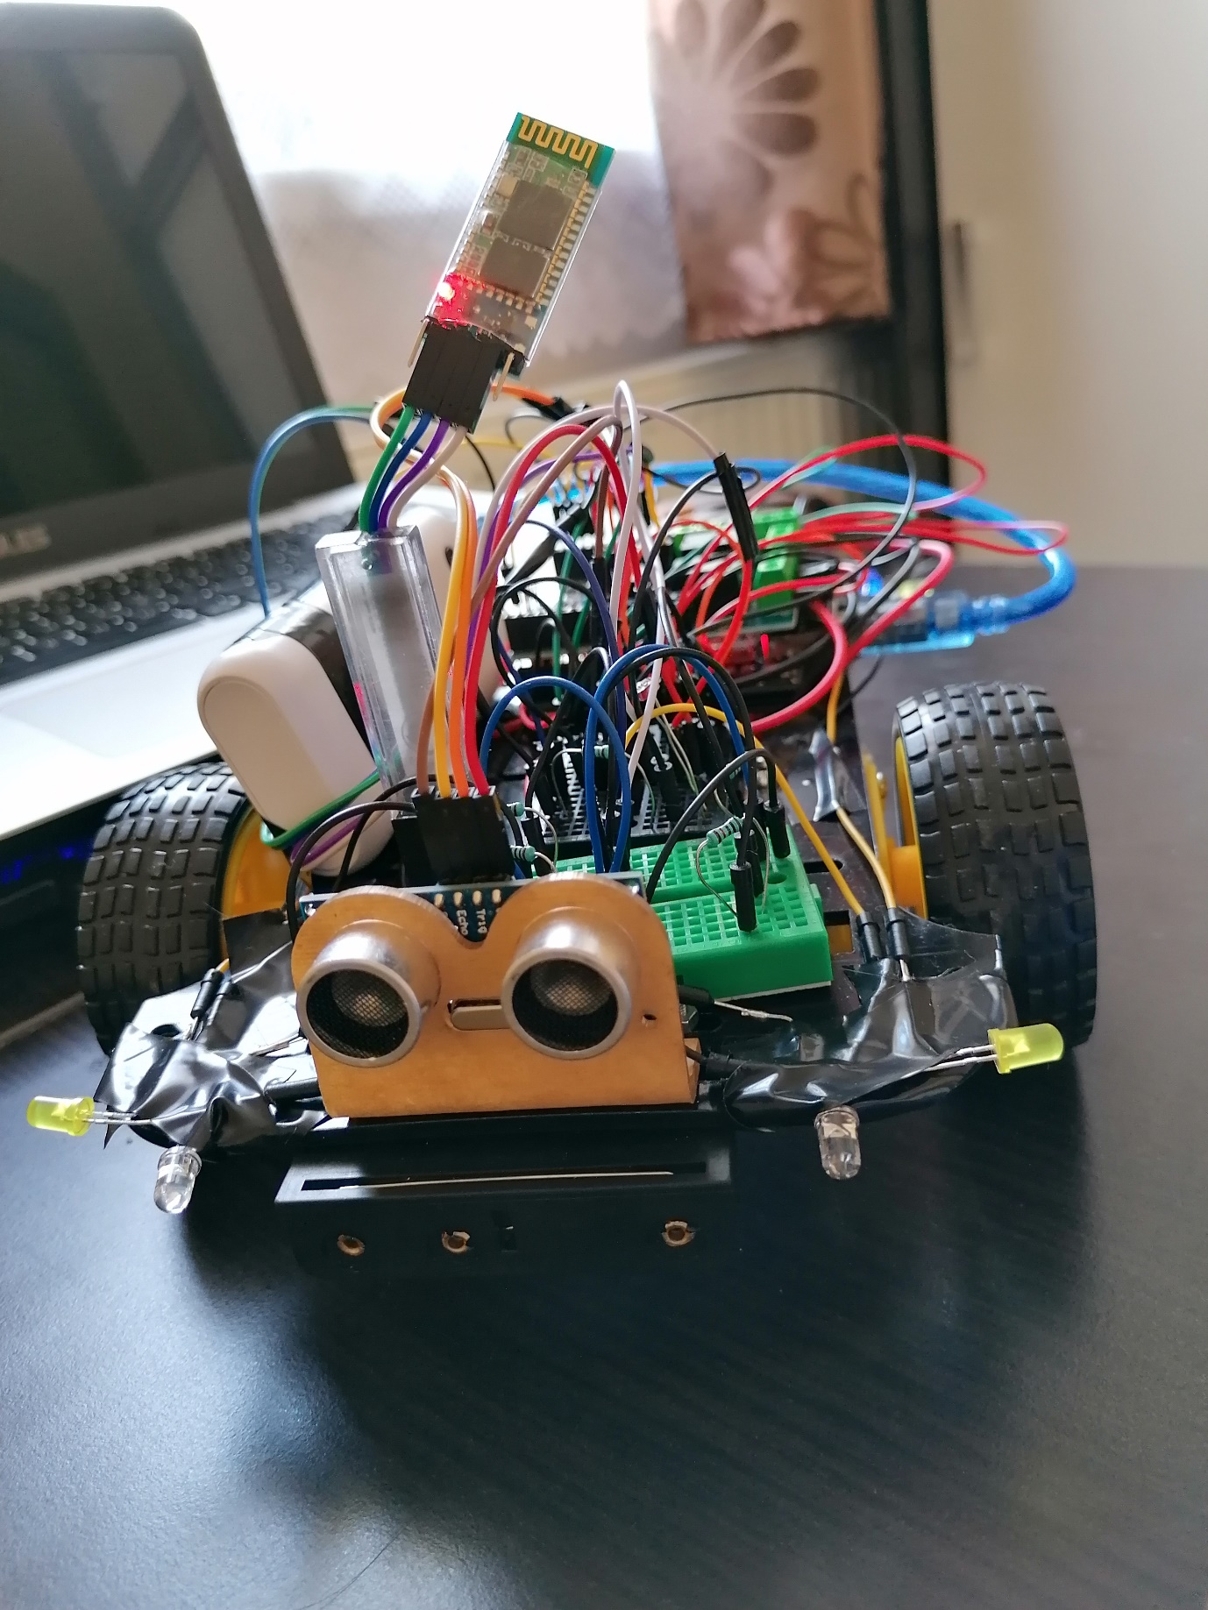

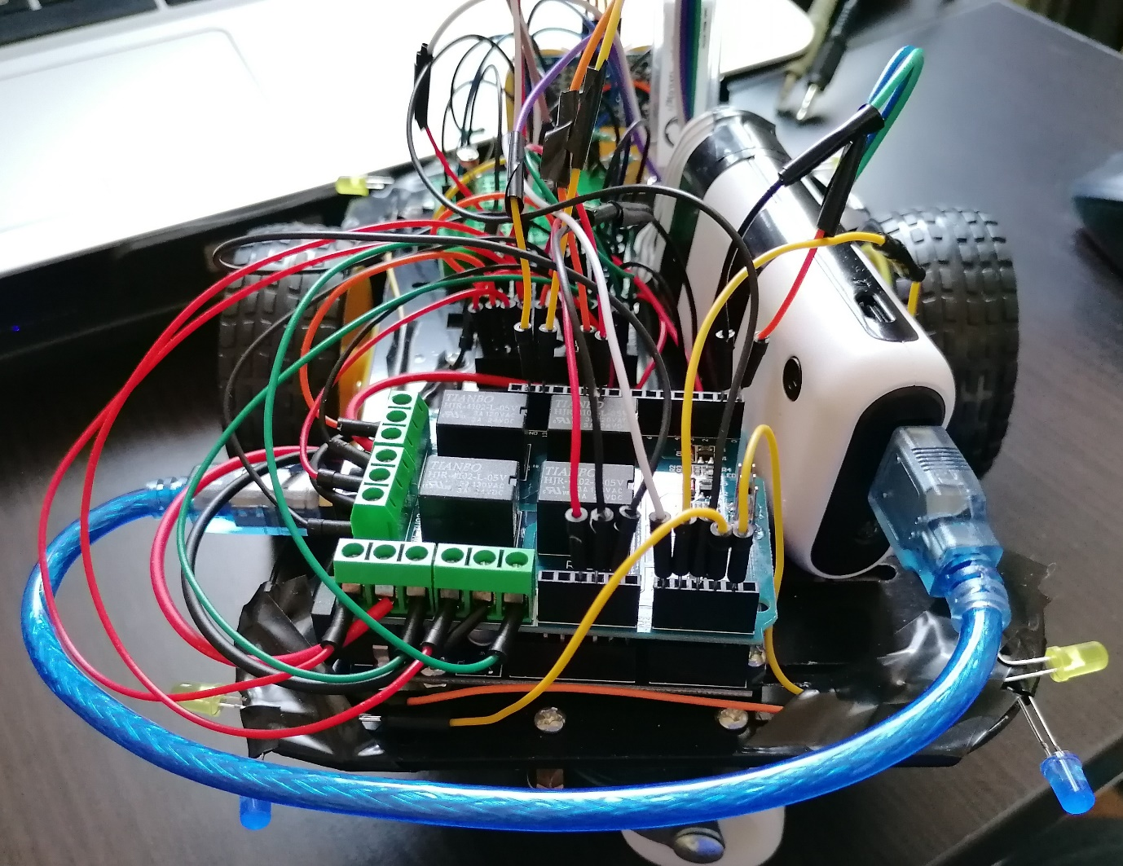

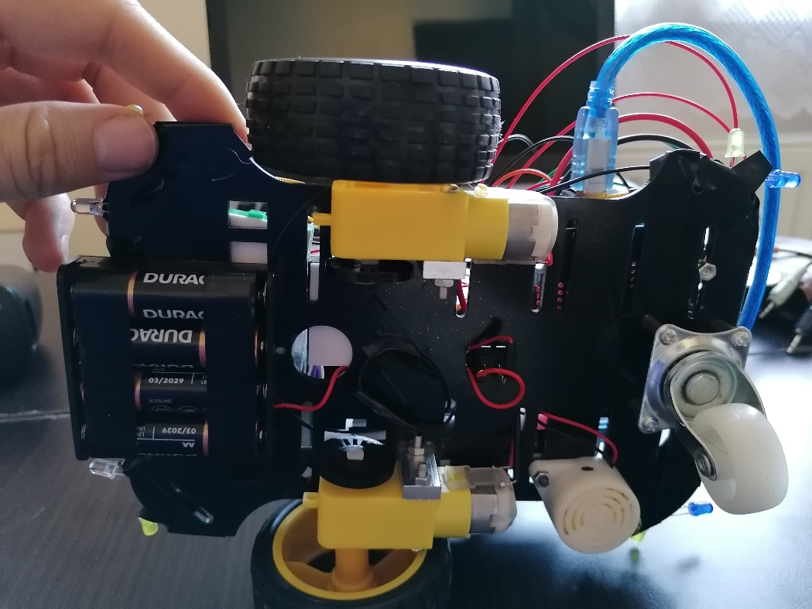

**3.** Implementare + DOC

#define relay1 7

#define relay2 6

#define relay3 5

#define relay4 4

#define trigPin 10

#define echoPin 13

#define buzzer 9

#define lights A0

#define tailLights A1

#define signalingRight A4

#define signalingLeft A3

bool tailLights_state = 1;

int signalingRight_state = -1;

int signalingLeft_state = -1;

float duration;

float cm = 2000;

char command;

int photocellReading;

int x;

void setup() {

Serial.begin(9600);

pinMode(relay1, OUTPUT);

pinMode(relay2, OUTPUT);

pinMode(relay3, OUTPUT);

pinMode(relay4, OUTPUT);

pinMode(trigPin,OUTPUT);

pinMode(echoPin,INPUT);

pinMode(buzzer, OUTPUT);

pinMode(lights, OUTPUT);

pinMode(tailLights, OUTPUT);

pinMode(buzzer,OUTPUT);

pinMode(signalingLeft,OUTPUT);

pinMode(signalingRight,OUTPUT);

}

void loop() {

if(Serial.available() > 0){

command = Serial.read();

switch(command){

case 'W':

forward();

tailLights_state = 0;

break;

case 'S':

back();

tailLights_state = 0;

break;

case 'A':

left();

tailLights_state = 0;

break;

case 'D':

right();

tailLights_state = 0;

break;

case 'B':

sstop();

tailLights_state = 1;

break;

case 'X':

signalingRight_state = signalingRight_state * -1;

break;

case 'Z':

signalingLeft_state = signalingLeft_state * -1;

break;

}

if(command == 'H') tone(buzzer,450);

if(command == 'J') noTone(buzzer);

}

ultrasonic();

if(command == 'W')

{

if(cm <= 15)

{

sstop();

tailLights_state = 1;

}

}

if(tailLights_state == 1) analogWrite(tailLights, 255);

else analogWrite(tailLights, 0);

photocellReading = analogRead(A2);

//Serial.print("Analog reading = ");

//Serial.println(photocellReading);

if(photocellReading <500) analogWrite(lights, 255);

else analogWrite(lights, 0);

if(signalingRight_state == 1) analogWrite(signalingRight,x);

else analogWrite(signalingRight,0);

if(signalingLeft_state == 1) analogWrite(signalingLeft,x);

else analogWrite(signalingLeft,0);

x+=5;

if(x==255) x=0;

}

void ultrasonic()

{

digitalWrite(trigPin, LOW);

delayMicroseconds(2);

digitalWrite(trigPin, HIGH);

delayMicroseconds(5);

digitalWrite(trigPin, LOW);

duration = pulseIn(echoPin, HIGH);

cm = microsecondsToCentimeters(duration);

if(cm<=200)

{

Serial.println(cm);

Serial.print(" ");

}else

{

Serial.println("Out of range ");

}

}

float microsecondsToCentimeters(float microseconds) {

// The speed of sound is 340 m/s or 29 microseconds per centimeter.

// The ping travels out and back, so to find the distance of the object we

// take half of the distance travelled.

return microseconds / 29 / 2;

}

void forward()

{

digitalWrite(relay1,LOW);

digitalWrite(relay4,LOW);

digitalWrite(relay2,HIGH);

digitalWrite(relay3,HIGH);

}

void back()

{

digitalWrite(relay1,HIGH);

digitalWrite(relay4,HIGH);

digitalWrite(relay2,LOW);

digitalWrite(relay3,LOW);

}

void left()

{

digitalWrite(relay1,LOW);

digitalWrite(relay4,HIGH);

digitalWrite(relay2,HIGH);

digitalWrite(relay3,LOW);

}

void right()

{

digitalWrite(relay1,HIGH);

digitalWrite(relay4,LOW);

digitalWrite(relay2,LOW);

digitalWrite(relay3,HIGH);

}

void sstop()

{

digitalWrite(relay1,LOW);

digitalWrite(relay3,LOW);

digitalWrite(relay2,LOW);

digitalWrite(relay4,LOW);

}

**4.** Cum se utilizeaza?

Descarcati si instalati aplicaia pe telefon :

<https://drive.google.com/file/d/1siK6I11DBMqHCFTQZcFHowHQOZj5MbFT/view?usp=sharing>

1. Activati bluetooth de pe telefon.
2. Conectati-va la modulul bluetooth al masinutei. Alegeti din lista de dispozitive bluetooth HC-06 si introduceti parola 1234.
3. Deschideti aplicatia si apoi apasati pe iconita cu pictograma 

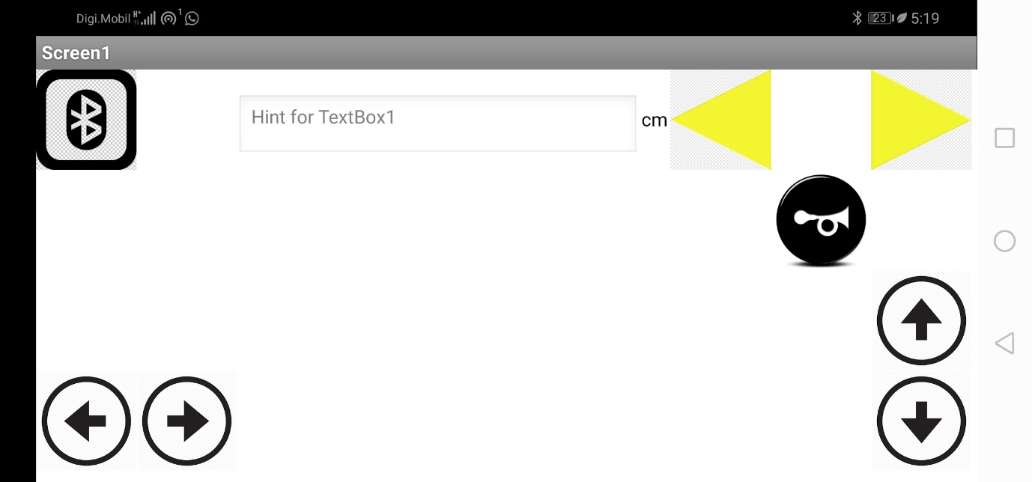

2.Alegeti din lista adresa bluetooth corespunzatoare masinutei (bluetoothul trebuie sa fie activat):

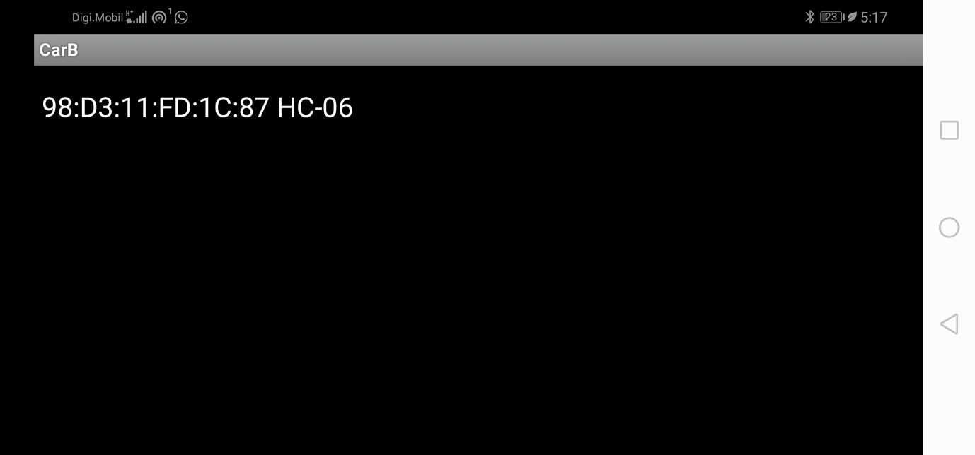

3.Daca ledul rosu de pe modulul bluetooth nu mai palpaie, aplicatia s-a conectat cu succes.

4.Acum puteti sa controlati masinuta, stanga, dreapta, inainte, inapoi, de asemenea puteti sa claxonati si sa semnalizati.

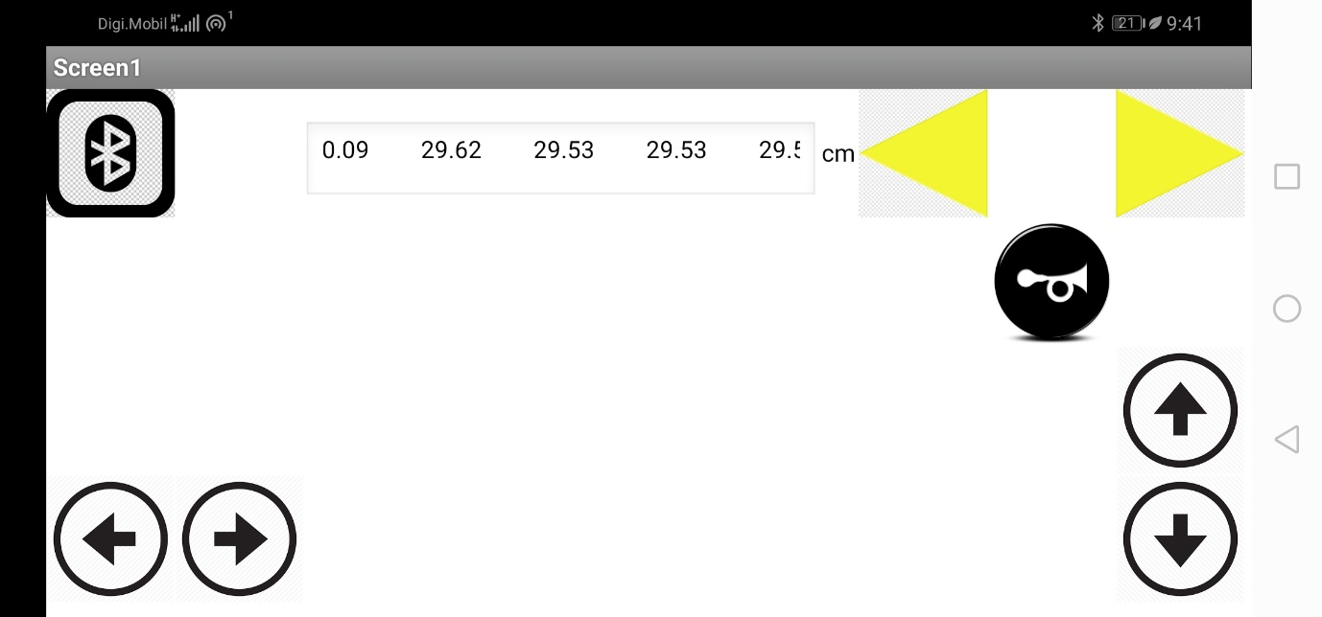

Puteti sa observati distanta citita de senzorul cu ultrasunete.