

# MINISTERUL EDUCAȚIEI, CULTURII ȘI CERCETĂRII AL REPUBLICII MOLDOVA

**Universitatea Tehnică a Moldovei**

# Facultatea Calculatoare, Informatică şi Microelectronică Departamentul Inginerie Software și Automatică

**Cristian Brinza FAF-212**

Report

*Laboratory work n.2*

***of Computer Graphics***

Checked by:

**Olga Grosu,** *university assistant*

DISA, FCIM, UTM

# Chișinău – 2022

1. **The purpose of the laboratory work (formulated by the student according to the problem to be solved);**

Learning and exercising the GC concepts, understanding and using them to create laboratories work which represents and simulates the use in the field.

# The condition / conditions of the problems:

Do some research by analysing the examples from “Learning processing” Daniel Shiffman: <http://learningprocessing.com/examples/>

Make a sketch with moving 2d primitives function.

Use: - Conditional and loop function

- Make you own function and calling it in draw()

# The program code, having relevant comments in it:

float r, b, g, a, diam, x, y; int ss = 0;

void setup() { size(480, 270);

background(255);

}

void draw() { // Draw stuff

// Use values to draw an ellipse

// If the mouse is on the window is equivalent to

// "if mouseX is greater than 0"

if (mouseX > 20 && mouseY > 20 && mouseX < width - 20 && mouseY < height - 20 && ss == 0) {

for (int t = 0; t <= 5; t++) {

// Each time through draw(), new random

// numbers are picked for a new ellipse. r = random(255);

g = random(255); b = random(255); a = random(255); diam = random(90);

//make sure there's no circles smaller than the next set diameter while (diam <= 20) {

diam++;

}

x = random(width); y = random(height);

noStroke(); fill(r, g, b, a);

ellipse(x, y, diam, diam); ss = 1;

}

} else if (mouseX < 20 || mouseY < 20 || mouseX > width - 20 || mouseY > height - 20 ) {

fill(255); stroke(255);

rect(0, 0, width, height); ss = 0;

}

}

1. 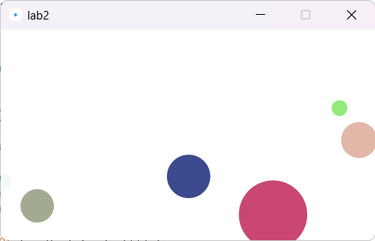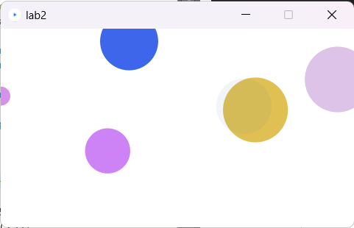**Screen printing of program execution;**

# The student's conclusions regarding the content of the laboratory work with personal reflections on what was achieved; difficulties encountered and how he/she got over them (if he/she got over them). Where did he find the answer? (specify the links to sources that help you to get the answer).

The laboratory work had a big impact in the quality of my development as a future Software Engineer in Computer Graphics. I enjoyed the process, developed my creativity and codding skills, understood better the IDE and the code functionality.

Biography: <http://learningprocessing.com/examples/>

<https://codebeautify.org/javaviewer>

<https://else.fcim.utm.md/course/view.php?id=573>