**Homework 5** Due 18:00, November 12, 2021

$$.$$

Cristian Brinza FAF 212

# Problem 5.1

Let *R* be a relation on a nonempty set *X*. Is this relation reflexive, transitive, symmetric, antisymmetric, equivalence relation, partial order, total order? If relation is an equivalence relation, identify the equivalence classes.

1. *X* = {1*,* 2*, ...,* 9}, *R* = {(*a, b*) | *a* + *b* is even number },
$$Reflexive, Symetric$$

2. *X* = R2, *R* = “symmetric with respect to x-axis”,
$$Symetric$$

3. *X* = R2*, R* = “is at the same distance from origin”,
$$Reflexive, Symetric$$

4. *X* = {all human beings}*, R* = “to be brother/sister”,
$$Reflexive, Transitive$$

5. *X* = {all human beings}*, R* = “to be descendant of” (child-parent),
$$Asymetric, Transitive$$

6. *X* = {all human beings }*, R* = “live in the same city”.
$$Reflexive, Symetric, Transitive$$

7. *X* = {*a, b, c, d*}, *R* = {(*a, a*)*,* (*b, b*)*,* (*c, c*)*,* (*d, d*)*,* (*c, a*)*,* (*a, d*)*,* (*c, d*)*,* (*b, c*)*,* (*b, d*)*,* (*b, a*)} .

$$Reflexive, Asymetric$$

# Problem 5.2

Let *R* be a relation on a nonempty set *X*.

1. If *R* is antisymmetric, does *R−*1 have to be also antisymmetric?
$$\left(x,y\right)Λ\left(y,x\right)ϵ R→x=y$$

$$\left(y,x\right)Λ\left(x,y\right)ϵ R^{-1}→x=y, so R^{-1} is also antisymetric$$

2. Show that *R* is symmetric iff *R* = *R−*1.
3. Show that *R* is transitive iff *R* ◦ *R* ⊆ *R*.

$$Lets assume that R is transitive→we need to prove thst R ◦ R ⊆ R-let \left(y,x\right) ϵ R◦R, → ∃zϵA:\left(x,z\right)ϵR, so \left(z,y\right)ϵR, therefore \left(y,x\right)ϵ R, lets assume that R ◦ R ⊆ R→\left(x,z\right)ϵR ◦ R, then \left(z,y\right)ϵR ◦ R, so since R ◦ R ⊆ R→ \left(y,x\right)ϵ R→R is transitive$$

# Problem 5.3

Let *A* be a nonempty set.

1. Describe a single relation on *A* that is both an equivalence relation on *A* and a partial order on *A*.
$$R⊆A^{2}, where a\sim b iff a=b→$$

$Symmetric:a=b→b=a$

$Antisymmetric:a=b and b=b→a=b$

$Reflexive: a=a$

$Transitive: a=b and b=c→a=c$

3. Is this relation a total order?

$$NO it is not a total order$$

# Problem 5.4

Let *A* = 1*,* 2*, ...,* 8 and define on *A* the relation # by *x*#*y* if and only if *x* is a multiple of *y*. What is its matrix form?

{ }

Draw its digraph. Draw its Hasse diagram.

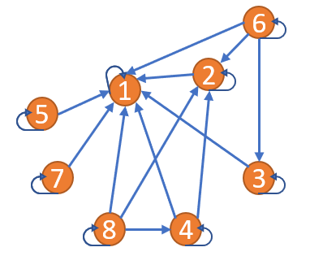 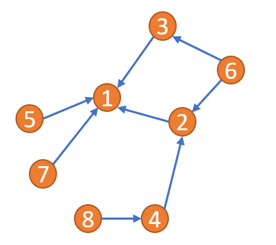

Show that # is a partial order on *A*. Is it a total order?

$$In order to be a partial order, it shoud be : relexife-all→slef-loops, antisymetric-if a⋮b and$$

$$b⋮a then a=b, and transitive-for any sequence of consecutive arrows,$$

$$there is a simple arrow from the first to the least node$$

Is it a total order?

$$It is not a total order, because there are incomparabe elements.$$

# Problem 5.5

The following DAG describes the prerequisites among tasks {*A,. . . , H*}.

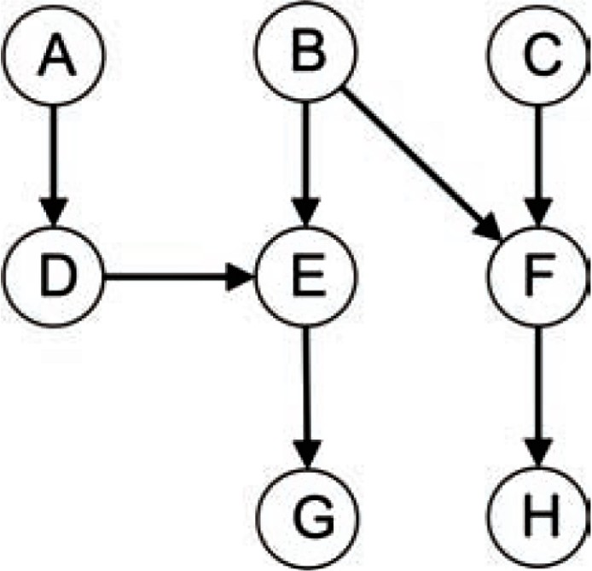

1. What are the two maximum size antichains?
$$size:3 :\left\{A,B, C\right\}, size 2 :\{E,F\}$$

2. If each task takes unit time to complete, what is the minimum parallel time to complete all the tasks?
$$4 units, bacause the biggest chain is A→D→E→G$$

3. What is the minimum parallel time if no more than two tasks can be completed in parallel?

$$4 units of time :( 1-A and B , 2-D and C, 3-E and F, 4-G and H)$$

# Problem 5.6

A set *S* = 1*,* 2*,* 3*, . . . ,* 10 of 10 tasks can be ordered by writing *x y* to mean that either *x* = *y* or *x* must be done before *y*, for all *x* and *y* in *S*. Thus, 1 6, 1 10, 2 8, 4 3, 5 4, 6 5, 7 3, 8 3, 9 5, 10

≤ ≤ ≤ ≤ ≤ ≤ ≤ ≤ ≤ ≤

{ } ≤

1. 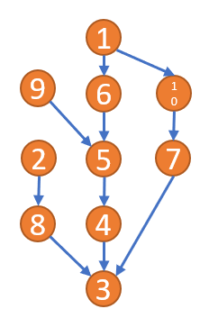Draw the Hasse diagram for this relation.
2. Find the minimal elements, maximal elements, longest chain, and antichain;
$$Min -2 ;9 ; 1 Max – 3 longest chain -1→6→5→4→3 antichain-2→9→1 or 8→6→10$$

3. Find a topological sort.
$$sort :1 , 6 , 9 , 5 , 4 , 10 , 7 , 2 , 8 , 3$$

4. In how many steps can you execute all tasks in parallel? (any task is executed in 1 unit of time)

$$5 steps$$

# Problem 5.7

Construct a schedule for logging on to a computer (A) and both checking email and modifying a text file. Checking email includes opening the mailer (B) and both replying to a new message (C) and creating a new message to another person (D), and sending it (E). Modifying the text file involves opening a text editor (F), loading a file (G), editing the first paragraph of the file (H), inserting a separate file at the end of the file (I), and saving the modified file (J). The user is allowed to move back and forth between the mailer and the text editor for separate tasks.

1. Draw the Hasse diagram.

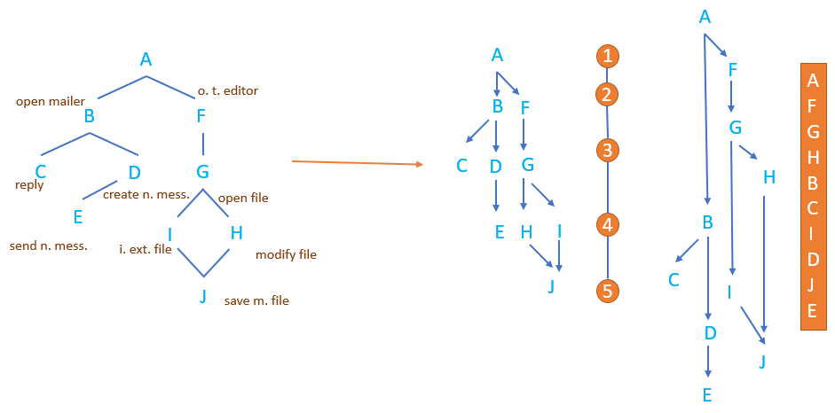

1. Find the minimal elements, maximal elements, longest chain, and antichain;

$$Min -A Max – C,E,I longest chain -\left\{A,F,G,H,I,J\right\} longest antichain-\{C,D,G\}$$

Find a topological sort.

$$A, B, D, F, G, H,B,E,F,I,J,C$$

# Problem 5.8

Consider the set of rectangles *A* given below and define on *A* the relation *R* given by:

For any rectangles *t, s* ∈ *A, t R s* if *t* is more distant than *s* from the viewer*.*

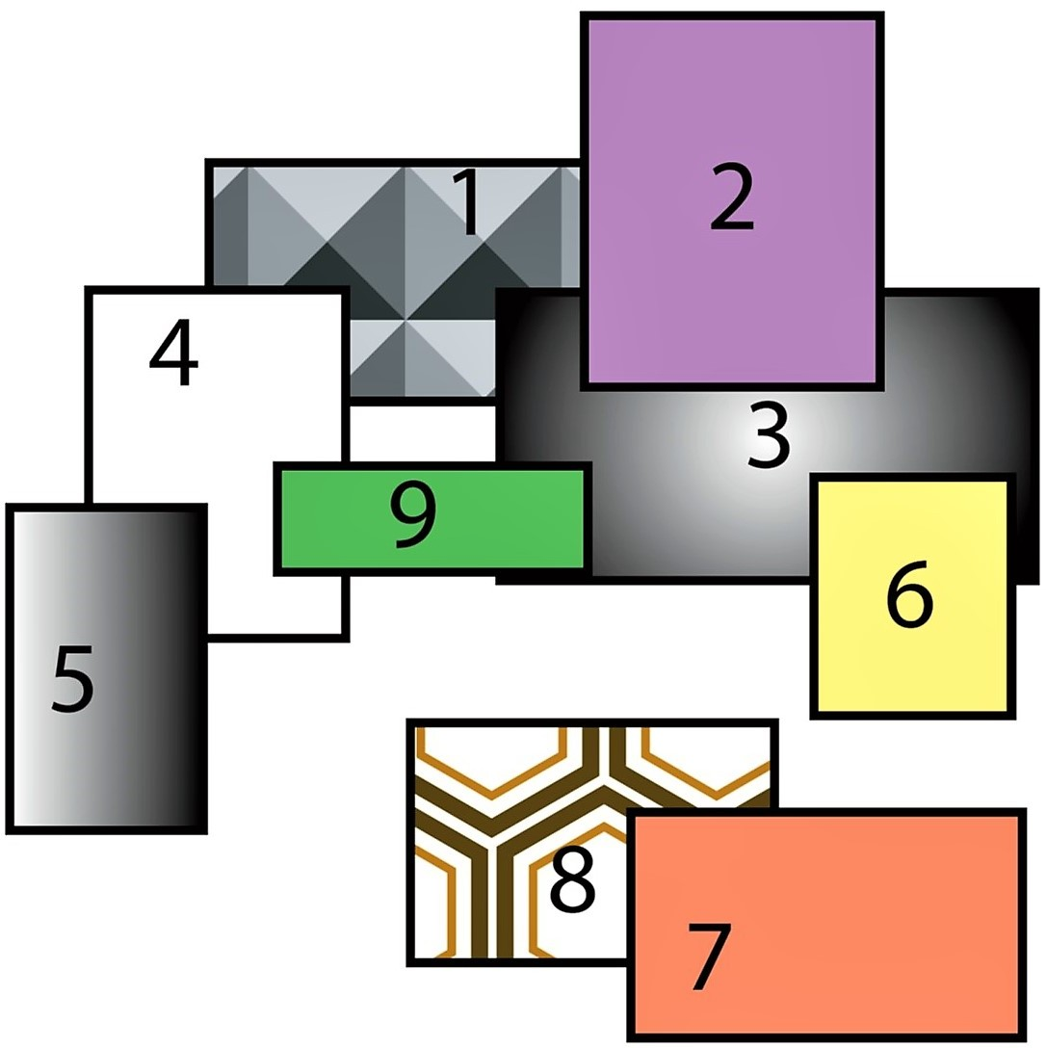

Thus, for example 1 *R* 2 and 3 *R* 2.

$$There are some of the relations that we find from the figure: 1R2, 1R4, 1R3, 4R5, 3R2, 3R9, 3R6..$$

1. Is this a partial order?
$$It is not partial order, bacause does not have reflective property, an object ca not be nore distant than itself$$

2. Is this a total order?
$$It is not a total order because, even if we assume that all elements are comarable, it is not a partial order$$

3. Draw the Hasse diagram.

# 

1. Find the minimal elements, maximal elements, longest chain, and antichain.
$$Min -1 ;8 Max – 4; 9;2; 6; 7 longest chain -size 3 :\left\{2, 3, 2\right\}, etc longest antichain-size5 :\{5, 9, 2, 6, 7\}$$

2. Find a topological sort.