# Ministry of Education of Republic of Moldova Technical University of Moldova

Report

## on Computer Programming

Laboratory Work Nr. 6



Performed by b.**Brinza Cristian FAF-212**

Verified by lect.univ  **Gaidău M.**

# Chișinău 2021

*Topic:* Pointers in C/C++ languages, Pointer operators & and *, Declaring pointers

**Purpose of the laboratory work:** Accumulation of practical skills for developing and programming computational processes and program testing skills.

### Condition of the problem:

**(Codeforces. Problem 31A,** https://codeforces.com/problemset/problem/27/A**)**

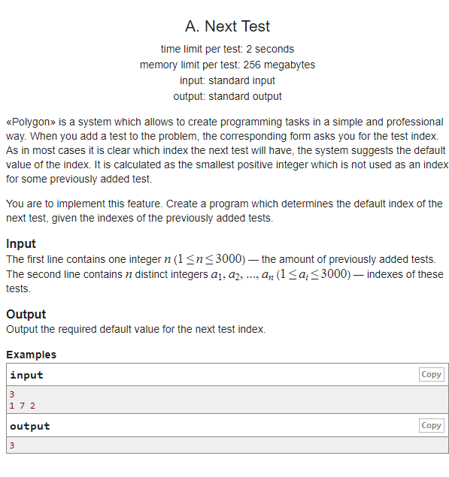

### Work processing:

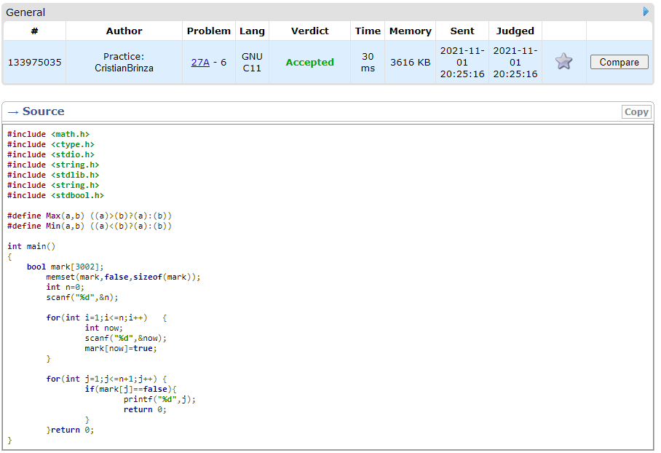

General knowlede used:

* #include<stdio.h> : stdio. h is a header file which has the necessary information to include the input/output related functions in our program. Example printf, scanf etc. If we want to use printf or scanf function in our program, we should include the stdio.Explanation:
* #include <math.h> - is a header file in the standard library of the C programming language designed for basic mathematical operations. Most of the functions involve the use of floating point numbers.
* #include <ctype.h> - header file contains inbuilt functions to handle Strings in C/C++, the ctype. h/<cctype> contains inbuilt functions to handle characters in C/C++ respectively. Characters are of two types: ... Control Characters: The characters that are initiated to perform a specific operation
* #include <string.h>- The string. h header defines one variable type, one macro, and various functions for manipulating arrays of characters.
* #include <stdbool.h> - the header <stdbool. h> is included, the Boolean type is also accessible as bool . Standard logical operators &&, ||, ! can be used with the Boolean type in any combination. A program may undefine and perhaps then redefine the macros bool , true and false .

1. We define the “max” and “min” function with the name functionality, for future program use. We declare an Boolean array with size of 3002 elements - **bool** mark[3002]; , a memeset with attributes - **bool** mark[3002]; , abd a temporary varial;ble from condition - **int** n=0; , next step we read from console this variable, and with 2 for loops we 1) **for**(**int** i=1;i<=n;i++) - read from conslole the elemnts of the array - , scanf(**"%d"**,&now); mark[now]=**true**; , by atribuite the “true” value to the corresponding positon read from console, 2) **for**(**int** j=1;j<=n+1;j++) – in witch with if function we check the rest of the elemts of the array -**if**(mark[j]==**false**), and print them printf(**"%d"**,j);.

*Tests:*

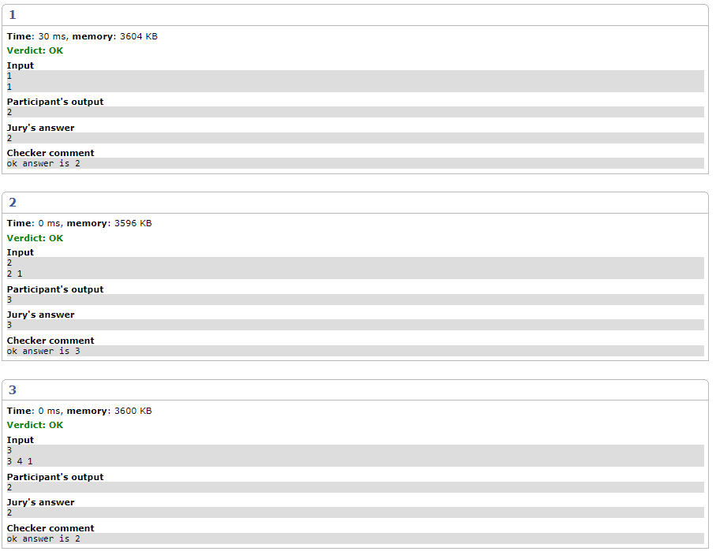

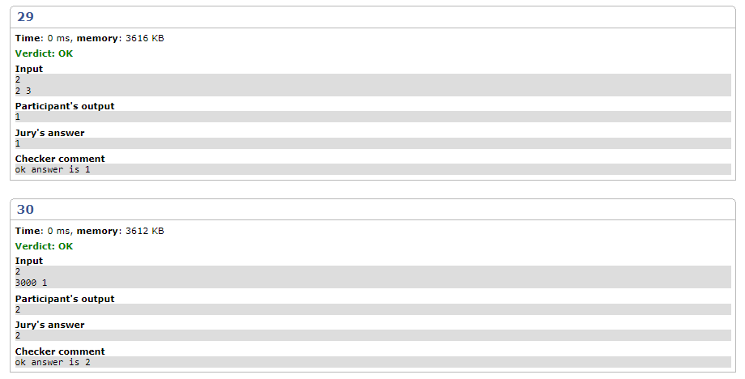

*Conclusion:*

It’s very interesting to see what you are creating by writing code. It’s like art based on code. Skills were developed to compile, run and test a simple program in the C++ programming language.

As a result of the elaboration of the given paper, the basis was applied for the practical application of the theoretical knowledge.

The structures/concepts/algorithms used in this problem, after writing, compiling the program severaltimes and sending to Codeforces server.

Thus one can judge about the wide possibilities offered by the Java language regarding data manipulation. In this practical work I realized the knowledge accumulated during the theoretical and practical classes, I consolidated the material and in some places I learned new things. It allowed the assessment of knowledge in writing style both for the grade and personally. It allowed us to correct mistakes and possible future misunderstandings. Under the guidance of the teacher, we conducted the first individual study on this subject, this facilitating the adaptation to the knowledge of the use of theoretical material.

The verification of the results confirms that the elaborated program works correctly.

Linear algorithms can be used to calculate mathematical expressions.

Where drawn conclusions about comments, characters, strings, names (identifiers) in C/C++. As in the end I can say that the study had a positive impact on my personal education.

## Bibliography:

1. https://en.cppreference.com/w/cpp/container/vector;
2. https://[www.geeksforgeeks.org/c-plus-plus/;](http://www.geeksforgeeks.org/c-plus-plus/%3B)
3. https://en.cppreference.com/w/cpp/language/goto;
4. https://[www.geeksforgeeks.org/vector-in-cpp-stl/;](http://www.geeksforgeeks.org/vector-in-cpp-stl/%3B)
5. https://[www.geeksforgeeks.org/loops-in-c-and-cpp/;](http://www.geeksforgeeks.org/loops-in-c-and-cpp/%3B)
6. https://[www.geeksforgeeks.org/selection-sort/;](http://www.geeksforgeeks.org/selection-sort/%3B)
7. https://[www.geeksforgeeks.org/decision-making-c-c-else-nested-else/.](http://www.geeksforgeeks.org/decision-making-c-c-else-nested-else/)