# Ministry of Education of Republic of Moldova Technical University of Moldova

Report

## on Computer Programming

Laboratory Work Nr. 8



Performed by b.**Brinza Cristian FAF-212**

Verified by lect.univ  **Gaidău M.**

# Chișinău 2021

*Topic:* Pointers in C/C++ languages, Pointer operators & and *, Declaring pointers

**Purpose of the laboratory work:** Accumulation of practical skills for developing and programming computational processes and program testing skills.

### Condition of the problem:

**(Codeforces. Problem** [**627 (Div. 3)**](627%20(Div.%203))**C,** https://codeforces.com/contest/1324/problem/CC**)**

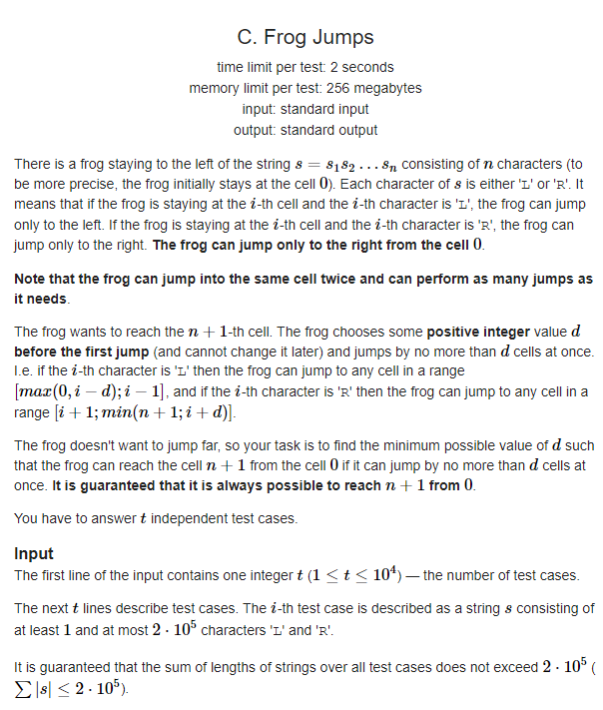

### 

### Work processing:

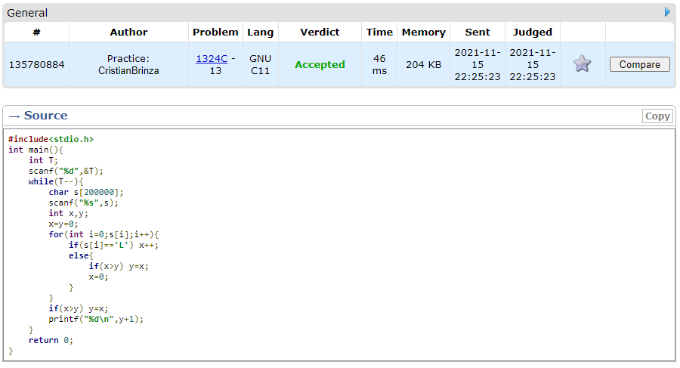

General knowlede used:

* **#include** **<iostream> -**iostream is the **header file** which contains all the functions of program like cout, cin etc. and #include tells the preprocessor to include these header file in the program.

1. We define a long type variable we defina a variable „T” and read it from console, with a loof while we write the amut od interes of number „t”, we check with a fro loop and a checker if, if x>y and give that value to y, searching for the max value. Annd print if so after the loop end.

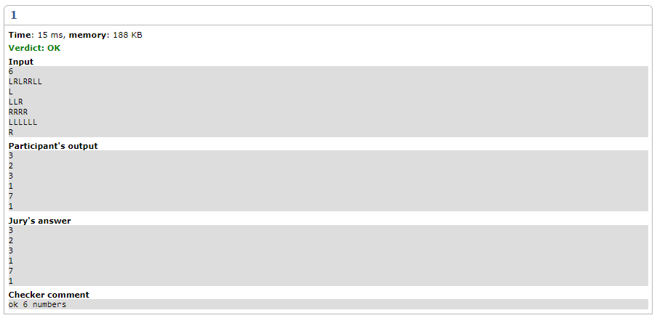

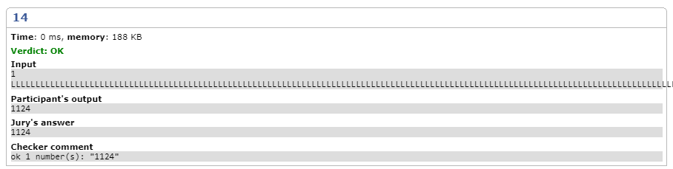

*Conclusion:*

It’s very interesting to see what you are creating by writing code. It’s like art based on code. Skills were developed to compile, run and test a simple program in the C++ programming language.

As a result of the elaboration of the given paper, the basis was applied for the practical application of the theoretical knowledge.

The structures/concepts/algorithms used in this problem, after writing, compiling the program severaltimes and sending to Codeforces server.

Thus one can judge about the wide possibilities offered by the C language regarding data manipulation. In this practical work I realized the knowledge accumulated during the theoretical and practical classes, I consolidated the material and in some places I learned new things. It allowed the assessment of knowledge in writing style both for the grade and personally. It allowed us to correct mistakes and possible future misunderstandings. Under the guidance of the teacher, we conducted the first individual study on this subject, this facilitating the adaptation to the knowledge of the use of theoretical material.

The verification of the results confirms that the elaborated program works correctly.

Linear algorithms can be used to calculate mathematical expressions.

Where drawn conclusions about comments, characters, strings, names (identifiers) in C/C++. As in the end I can say that the study had a positive impact on my personal education.

## Bibliography:

1. https://en.cppreference.com/w/cpp/container/vector;
2. https://[www.geeksforgeeks.org/c-plus-plus/;](http://www.geeksforgeeks.org/c-plus-plus/%3B)
3. https://en.cppreference.com/w/cpp/language/goto;
4. https://[www.geeksforgeeks.org/vector-in-cpp-stl/;](http://www.geeksforgeeks.org/vector-in-cpp-stl/%3B)
5. https://[www.geeksforgeeks.org/loops-in-c-and-cpp/;](http://www.geeksforgeeks.org/loops-in-c-and-cpp/%3B)
6. https://[www.geeksforgeeks.org/selection-sort/;](http://www.geeksforgeeks.org/selection-sort/%3B)
7. https://[www.geeksforgeeks.org/decision-making-c-c-else-nested-else/.](http://www.geeksforgeeks.org/decision-making-c-c-else-nested-else/)