Ministerul Educaţiei, Culturii și Cercetării al Republicii Moldova

Universitatea Tehnică a Moldovei

Departamentul Ingineria Software și Automatică

**RAPORT**

Lucrare de laborator Nr.2

Disciplina: Analiza si modelarea sistemelor informationale

Tema: Use-case diagram

A efectuat: st. Cristian Brinza gr. FAF-212,

A verificat : lect.univ.   
 Sava Nina  
Melnic Radu

Chișinău 2020

**Tema:** Analiza sistemului în baza metodologiei APOO şi elaborarea modelelor prin diagramele cazurilor de utilizare.

**Scopul**: studierea noțiunilor de actor, caz de utilizare, nota, pachet și relațiile între entități UML.  
 **Sarcina:** de realizat 4 diagrame use-case pentru sistemul informațional ales.

**Considerații teoretice**

**System** - whatever you are developing. It’s represented as a rectangle with its name at the top.

**Actor** - someone or something that uses our system to achieve a goal. A primary actor initiates the system, while a secondary actor is “reactionary”.

**Use case** - An action that accomplishes a task within the system. It’s represented with an oval.

**Relationship** - an interaction between elements of the system. It’s represented with a line.

There are different types of relationships:

* **Association** between actor and use case
* **Generalization** of an actor is an inheritance-like relationship, where the child actor inherits its parent’s use cases, but may have (usually does have) its specific ones
* **Extend** as its name suggests extends the base use case and adds additional functionality to the system. It is dependent on the base case. It is optional. It must be meaningful on its own.
* **Include** shows that the behavior of the included use case is part of the base case. The base case is incomplete without the included use case. The included use case is mandatory and never optional.

The main advantages of creating a software that runs the activity in the technical company are:

- Create the prototype of the company's activity

- It helps to increase sales progress

- It helps to notice the weak points

For this laboratory work I chose the modeling of a laptop.

**Implementare, rezultate practice:**

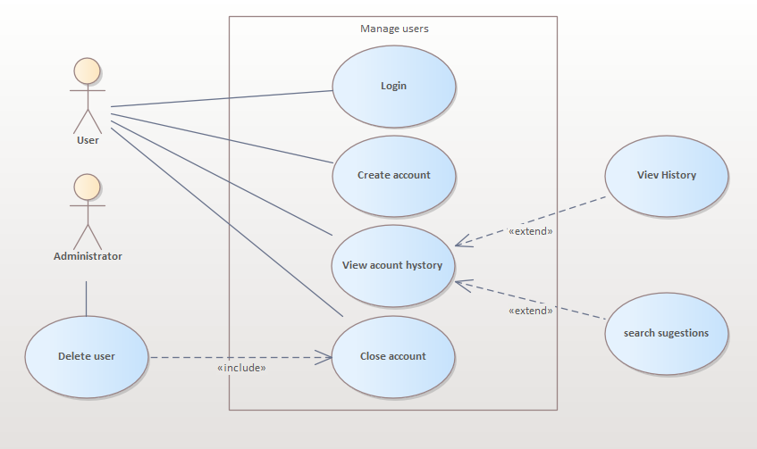

***Figura 1.*** *Use case diagram* on how users are managed

User can create an account, login into it, view and use his search history to find used information, and create new personalized suggestions, by using history view, also users can close theys accounts, the admin can manage users accounts too, they can delete users by closing accounts, but can not interact with others accessibilities.

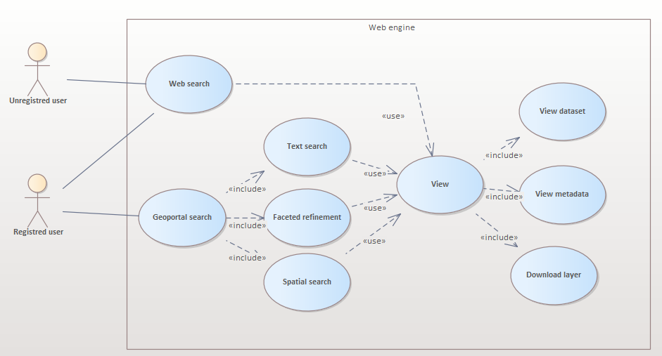

***Figura 2.*** *Use case diagram* on how web-engine works

Web search engine can be accessed by both un-regisred and registered user, unregistered users can access only key-futures of the engine, as registered ones can get the same views but with more accurate and easier searches, as theirs account will geoport their preferences and needs, the vied include structured information users access in the view/

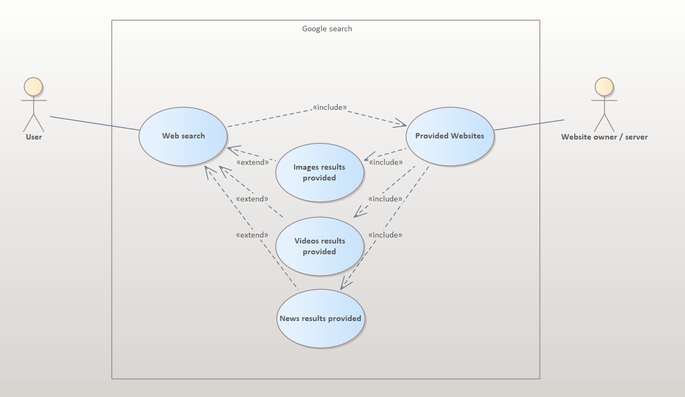

***Figura 3.*** *Use case diagram* on Google search use

On Google after a search is executed the results are structurized in categories, as seen: the websites themselves, the photos, the videos, the news

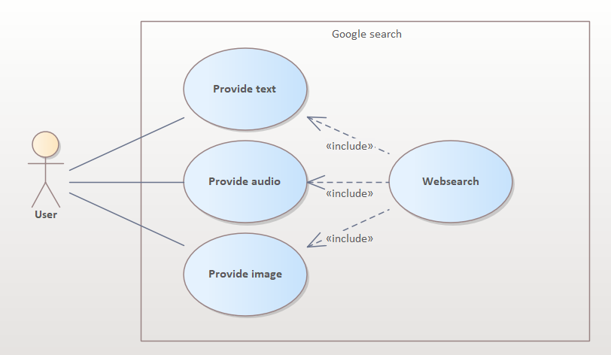

***Figura 4.*** *Use case diagram* on Google search types

Google search can be realized throw audio, text or image provided text, to be used as input for the search

**Concluzii:**

In this laboratory work I studied the use case diagram concept and the basic entities of this type of diagram. I built diagrams using the actor, use case, boundary and package entities. Also, I defined relationships between these entities. In order to define the 4 use case diagrams, I had to do a general research of the chosen field. The experience obtained after this laboratory is very important, being an introduction to the definition of diagrams used in system modeling

**Bibliografie**

1. **Melnic R., Sava N.** Indrumar metodic “Analiza si modelarea sistemelor informationale”.
2. **Моделирование бизнес процессов|CASE средства|Rational Rose**, [Электронный ресурс].-Режим доступа: <http://www.kpms.ru/Automatization/Rational_Rose.htm>