Universitatea Tehnică a Moldovei

Departamentul Ingineria Software și Automatică

REPORT

Laboratory Work Nr.3

Discipline: Analiza si Modelarea Sistemelor

Topic: Analysis of Modeling Results from Use Case Diagrams and Development into Sequence Diagrams

A efectuat: st. Cristisn Brinza gr. FAF212

A verificat : asistent univ. Sava Nina

lect.univ. Melnic Radu

Chișinău 2022

**Laboratory Goal**: Studying the notion of object, focus control, synchronous and asynchronous relationship, types of stereotypes

**Laboratory Task:** Realization of 3-4 sequence diagrams for the recruitment platform system

**Theoretical considerations:**

The basic entities of the sequence diagram are:

* *actor* (initializing actions),
* *object* (represents an instance of a class),
* *fragment* (represents a condition),
* *message* (represents the information that is transmitted between Actor-Object and Object-Object),
* *return label* (used to make checks),
* *boundary* (represents the system interface),
* *control* (represents the system),
* *entity* (represents the data base).

In the sequence diagram there are 3 main types of relationships:

* *synchronous* (waits for answer)*,*
* *asynchronous* (doesn’t wait for answer) and
* *return* (represents a response for the synchronous relation)*.*

**Implementation, practical results:**

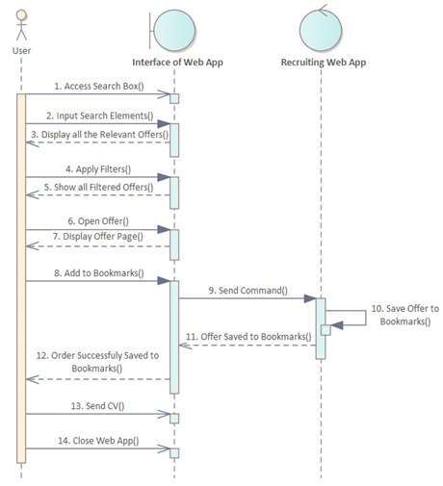

***Figura 1.*** *Search Offers* Action

The first action is that user accesses the search box.

Then the user inputs search elements, and the interface displays all the relevant offers.

Then the user applies the filters, and the interface displays the filtered results. Next action is that user opens an offer, and the interface displays it.

Then the user accesses “Add to Bookmarks” box, and the interface sends this command to the system, then the system saves this offer to bookmarks and returns a “Offer Saved to Bookmarks” message, and the interface returns a “Order Sucessfully Saved” message box.

Then the user sends the CV and closes the Web App.

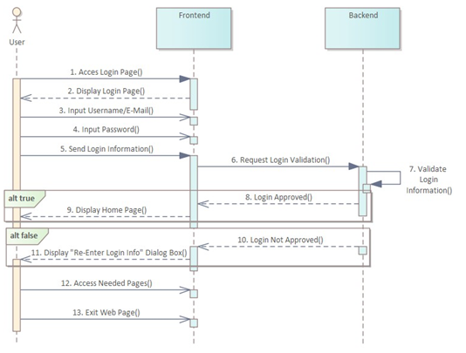

***Figura 2.*** *Login* Action

The first action is accessing the login page, and the Web App Interface returns this page displayed. Then the user inputs his username or e-mail, and then inputs the password.

Then the login information is sent by user to the frontend. After that the frontend makes a request for login validation, and the backend validates it. In case of true response, backend part approves login validation and the frontend displays the Home Page of the Web Recruiting Platform.

In case of a false response, backend doesn’t approve the login, and frontend displays a “Re-enter Password” message box. After that user accesses the needed pages and then exits the site.

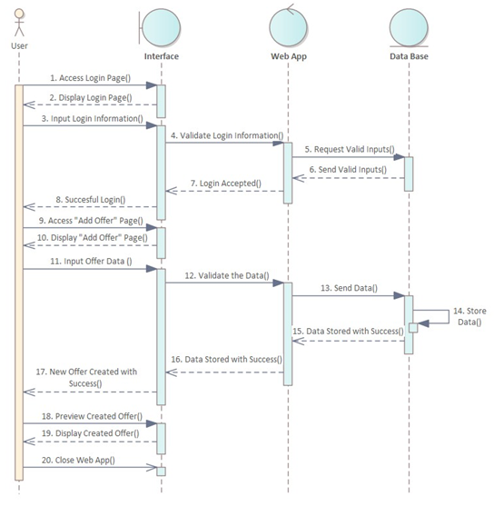

***Figura 3.*** *Add Offer* Action

The first action is that user accesses the login page, and the interface displays it as a return to that action.

Then the interface requests a login validation from the system.

Then the system requests all the valid logins from the data base, ad data base returns them.

Then the system accepts the login, and the interface displays a “Succesful Login” message. Next action is that user accesses the “Add Offer” page, and the interface displays it as a return.

Then the user inputs all the needed data, the interface validates the data, then the system sends this data to the data base. The data base stores the data and sends a message to the system, then the same message is sent from system to the interface, and interface displays a “New Offer Stored with Success” message box.

Next action is that the user presses “Preview Created Offer” button, and the interface displays the new offer. Last action is that user closes the Web App.

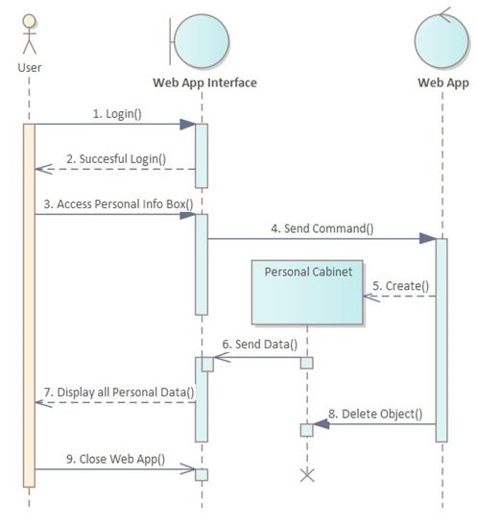

***Figura 4.*** *Access Personal Info* Action

The first action is that user logins, and the interface displays a “Successful Login” message box. Then the user presses “Access Personal Info” button.

The interface sends the command to the system, and the system creates a new object: Personal Cabinet. Personal Data object sends data to the interface, and the interface displays on the screen all the personal information.

Then the new object is deleted and then the user closes the site.

**Conclusions:**

In this laboratory work I studied the sequence diagram main concepts and the basic entities and types of relations specific to this type of diagram. I built the diagrams using the actor, object, fragment, message, return, boundary, entity and control UML entities. Also, I defined 3 types of relationships between these entities.

The experience obtained after this laboratory is very important, the new knowledge will be used also outside this course, especially during the technological practice, were we are already asked to make Use Case and Sequence diagrams.

**Bibliography:**

1. **Melnic R., Sava N.** Indrumar metodic “Analiza si modelarea sistemelor informationale”.
2. **Lucid Software** How to Make a UML Sequence Diagram, link: <https://www.youtube.com/watch?v=pCK6prSq8aw>