**TECHNICAL UNIVERSITY OF MOLDOVA**

**FACULTY OF COMPUTERS, INFORMATICS AND MICROELECTRONICS**

**DEPARTMENT OF SOFTWARE ENGINEERING AND AUTOMATICS**

**Laboratory work no. 2**

**Topic: "Studying the phenomenon of resonance in the oscillating circuit" at Circuits and electronic devices**

**Cristian Brinza**

st. gr. FAF-212

**N.Magariu**

lect. univ

**Chisinau 2024**

**The purpose of the Work:** Studying the phenomenon of voltage resonance and of the resonance of the currents in the LC oscillating circuit, the determination resonant frequency and quality factor of the circuit.

**General theoretical notions**

The oscillating circuit is an electrical circuit consisting of capacitor C and inductance L. Depending on the connection method L and C, series and parallel oscillating circuits are distinguished (fig 2.1a, b). A resonance is observed in the oscillating circuit at a certain frequency, at which the total resistance of the series circuit or the conductivity of the parallel circuit is zero.

**Description of the laboratory model:**

Electric circuits for the research of the oscillating circuit in series are shown in Fig. 2.5:

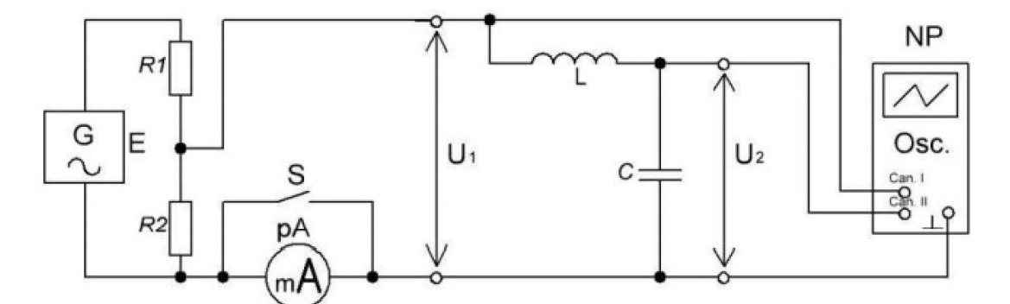

Fig, 2.5. Electric circuit for researching circuit characteristics

oscillating LC in series

**Tables:**

|  |  |  |  |  |  |  |
| --- | --- | --- | --- | --- | --- | --- |
| **L** | **C** | **r** | **f0** | | **ρ** | **Q** |
|  |  |
| **mH** | **nF** | **Ω** | **Hz** | | **Ω** | **-** |
| **4.07** | **33** | **1.2** | **13733** | **13893** | **351.18** | **292.65** |

**Table 2.1**

**Calculations:**

Uc =5 V XL(practic)=665.322 XC(practic)=672.043 Zk(practic)=1337.365

Q(practic) = 0.4946

I=7.44 mA  
UL=4.95 V

XL (theoretical)= 351.18 Q (theoretical)=50 XC (theoretical)=351.18

F=f0/Q=274.66 Vrms=2.5

|  |  |  |  |  |  |  |  |  |  |
| --- | --- | --- | --- | --- | --- | --- | --- | --- | --- |
| **f, Hz** | **12900** | **13000** | **13100** | **13483** | **f0** | **14273** | **14500** | **14600** | **14700** |
| **13733** |
| **U2, (U2m), V** | 0.93 | 1.01 | 1.1 | 1.765 | 2.5 | 1.7675 | 1.3 | 1.16 | 1.04 |
| **Ku=U2/U1=U2m/U1m** | 9.3 | 10.1 | 11 | 17.675 | 25 | 17.675 | 13 | 11.6 | 10.4 |
| **K= Ku/Kumax** | 0.372 | 0.404 | 0.404 | 0.707 | 1 | 0.707 | 0.52 | 0.464 | 0.416 |

**Calculations:**

Ku = 2.5/0.1= 25K = Ku/kumax = 17.675/25 = 0.707 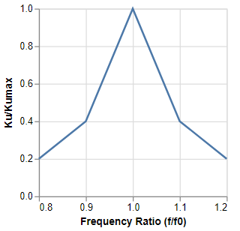  
Here is the line-chart diagram illustrating a generic representation of the Coefficient of Amplification Frequency (CAF) as a function of the frequency ratio (f/f₀) and normalized transfer coefficient (Kᵤ/Kᵤₘₐₓ):

**Conclusion:**

Following the completion of the laboratory work, the objectives were successfully achieved. The theoretical material provided in the assignment was thoroughly studied and assimilated, leading to new insights regarding the phenomenon of resonance within oscillatory circuits.

The investigation focused on the resonance of voltages and currents in LC oscillatory circuits, both in series and parallel connections. The resonant frequency and the quality factor of these circuits were determined, which facilitated a deeper understanding of the fundamental principles governing electrical circuits.

Based on the obtained data, it is evident that the most pronounced and clear signal is achieved when setting the frequency to the resonant value, as perfectly illustrated in the Coefficient of Amplification Frequency (CAF) graph. Additionally, due to the resistance incorporated in the circuit, a decrease in signal power was observed.

Data interpretation is more straightforward when presented graphically, thereby underscoring the importance of displaying all results in such a format to ensure the correct comprehension of the information.

F=f0/Q=274.66 Vrms=2.5

D  
escription of the laboratory modelPentru aceasta, am masurat valorile curenților și tensiunilor corespunzătoare in pozițiile 1 și 2

ale comutatorului SA