**TECHNICAL UNIVERSITY OF MOLDOVA**

**FACULTY OF COMPUTERS, INFORMATICS AND MICROELECTRONICS**

**DEPARTMENT OF SOFTWARE ENGINEERING AND AUTOMATICS**

**Laboratory work no. 5**

**Topic: "** **Study of bipolar transistors" at Circuits and electronic devices**

**Cristian Brinza**

st. gr. FAF-212

**N.Magariu**

lect. univ

**Chisinau 2024**

**The purpose of the Work:** Study of bipolar transistors. Raising the other static characteristics of the bipolar transistor in connection with the common base BC and with the common emitter EC and determining the parameters of the small signals h.

**General theoretical notions**

The bipolar transistor is a semiconductor device with two electron-hole (n-p) junctions, formed by a sequence of three p-n-p or n-p-n regions and has electrical signal amplification properties. The section and graphic notation of the bipolar transistor is shown in figure 5.1.

The middle area of the transistor is called the base (B) and has the following characteristics: it is very narrow (on the order of micrometers or even tenths of micrometers) and has much less impurities than the lateral ones. An extreme area with the greatest amount of impurities is called the emitter (E), the other extreme area is called the collector (C). An ohmic contact is made on each of these regions, on which the terminal conductors are welded.

The two junctions of the transistor are called: the emitter junction (JE) and, respectively, the collector junction (JC).

To follow the physical processes in the bipolar transistor we will consider the case of the p-n-p transistor; in the case of the n-p-n structure, the operation is similar, but the roles of holes and electrons are reversed, as well as the directions of voltages and currents. In normal operation, the junction of the emitter is directly polarized, and that of the collector - inversely, as shown in figure 5.2.

**Description of the laboratory model:**

Electric circuits for the research of the oscillating circuit in series are shown in Fig. 2.5:

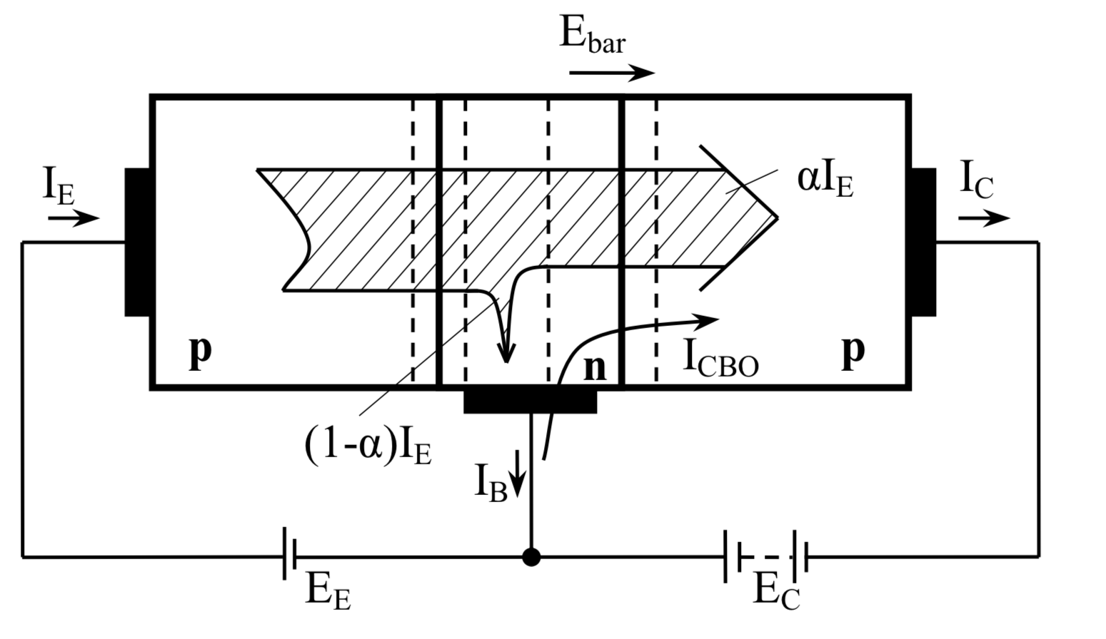

Fig, 5.2. The p-n-p bipolar transistor at normal polarization and the basic components of the currents

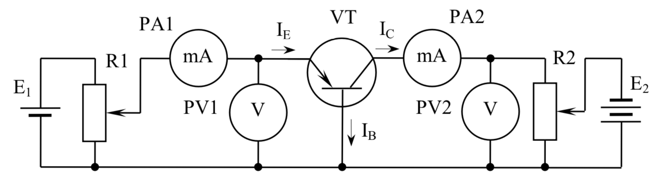 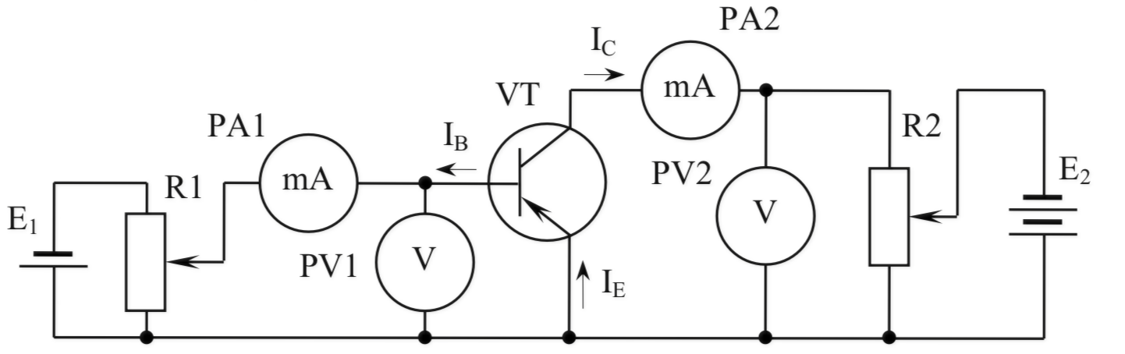

**Tables:**

|  |  |  |  |  |  |  |  |  |  |  |  |  |
| --- | --- | --- | --- | --- | --- | --- | --- | --- | --- | --- | --- | --- |
| ***UBE, mV*** | | **20** | **40** | **60** | **80** | **100** | **120** | **140** | **160** | **200** | **250** | **300** |
| **IB,mA** | **UCE = 0V** | 0.0022 | 0.0086 | 0.02 | 0.05 | 0.098 | 0.22 | 0.5 | 0.86 | 3.08 | 9.13 | 18.79 |
| **UCE = -5V** | 0.0055 | 0.0126 | 0.0261 | 0.05 | 0.09 | 0.24 | 0.55 | 0.95 | 3.76 | 12.26 | 27.5 |

**Table 5.1**

**Graph 5.1 -** **Caracteristica de intrare pentru BC**

|  |  |  |  |  |  |  |  |  |  |
| --- | --- | --- | --- | --- | --- | --- | --- | --- | --- |
| ***UCB, V*** | | **0** | **2** | **4** | **6** | **8** | **10** | **12** | **14** |
| **IC,mA** | **IE = 5mA** | 7.91 | 8.06 | 8.12 | 8.17 | 8.23 | 8.28 | 8.34 | 8.43 |
| **IE = 10mA** | 15 | 15.83 | 15.92 | 15.98 | 16.04 | 16.08 | 16.12 | 16.14 |

**Table 5.2**

**Graph 5.2 -** **Caracteristica de ieșire pentru BC**

|  |  |  |  |  |  |  |  |  |  |  |  |  |
| --- | --- | --- | --- | --- | --- | --- | --- | --- | --- | --- | --- | --- |
| ***UBE, V*** | | **20** | **40** | **60** | **80** | **100** | **120** | **140** | **160** | **200** | **240** | **280** |
| **IB,mA** | **UCE = 0V** | 0.0014 | 0.0048 | 0.0112 | 0.0249 | 0.04 | 0.08 | 0.14 | 0.26 | 0.6 | 1.18 | 2 |
| **UCE = -5V** | -0.0012 | -0.0009 | - 0.0002 | 0.0005 | 0.0024 | 0.006 | 0.013 | 0.0234 | 0.067 | 0.16 | 0.35 |

**Table 5.3**

**Graph 5.3**

|  |  |  |  |  |  |  |  |  |  |  |  |  |
| --- | --- | --- | --- | --- | --- | --- | --- | --- | --- | --- | --- | --- |
| ***UCB, V*** | | **0** | **0.5** | **1** | **1.5** | **2** | **3** | **4** | **6** | **8** | **10** | **12** |
| **IC,mA** | **IB = 100μA** | -0.13 | 7.22 | 7.35 | 7.54 | 7.7 | 8 | 8.23 | 9.3 | 9.781 | 0.221 | 0.6 |
| **IE = 200μA** | -1.2 | 73.2 | 73.8 | 76.5 | 78 | 83.5 | 88 | 96 | 102.8 | 110.7 | 116 |

**Table 5.4**

**Graph 5.4**

**Conclusion:**

Following the completion of the laboratory work, our objectives were thoroughly achieved, demonstrating a deep understanding of the operating principles and static characteristics of bipolar transistors. Through a structured sequence of inspections, assembly, and measurements, we delved into the behavior of these transistors in various configurations, notably observing their diode-like behavior in the common base setup.

The methodical gathering and analysis of data allowed us to calculate the static characteristics of the transistor, leading to insights that align closely with theoretical predictions. This process not only reinforced the theoretical knowledge provided in the coursework but also highlighted the importance of graphical data representation in understanding complex electronics concepts.

Data interpretation is more straightforward when presented graphically, thereby underscoring the importance of displaying all results in such a format to ensure the correct comprehension of the information.

Work facilitated a comprehensive exploration of bipolar transistors, blending theoretical knowledge with practical experimentation. The findings not only confirmed the expected behaviors of these semiconductor devices but also enriched our practical skills and theoretical understanding in electronics.

F=f0/Q=274.66 Vrms=2.5

D  
escription of the laboratory modelPentru aceasta, am masurat valorile curenților și tensiunilor corespunzătoare in pozițiile 1 și 2

ale comutatorului SA