**TECHNICAL UNIVERSITY OF MOLDOVA**

**FACULTY OF COMPUTERS, INFORMATICS AND MICROELECTRONICS**

**DEPARTMENT OF SOFTWARE ENGINEERING AND AUTOMATICS**

**Laboratory work no. 6**

**Topic: "Study of amplifier stages with transistors" at Circuits and electronic devices**

**Cristian Brinza**

st. gr. FAF-212

**N.Magariu**

lect. univ

**Chisinau 2024**

**The purpose of the Work:** Study the operation of broadband voltage amplifier stages, in RC coupling, equipped with bipolar transistors in EC, BC and CC connection without feedback and in EC connection with negative current feedback. To raise the amplitude and frequency characteristics for all the montages and cases studied.

**General theoretical notions**

An electronic circuit is called an electronic amplifier that transforms the low-power signal, applied at the input, into an output signal with much higher power, voltage or current, having the same form of time variation as the excitation signal.

The amplifier device is usually equipped with an amplifier element, input and output circuits, passive elements and a power supply. Transistors in electronic circuits are considered active devices, in the sense that they can control the power absorbed from the power sources in response to the action of the excitation signal (input), providing the payload with a power greater than that charged by the signal source.

By passive elements we mean coils, capacitors and positive resistance resistors that cannot provide power amplification, even the first two can store energy, returning only part of it due to internal losses. It should be mentioned that the transistors, in the amplification process, dissipate part of the power absorbed from the power sources, in general, from direct current sources.

**Description of the laboratory model:**

Electric circuits for fig 6:

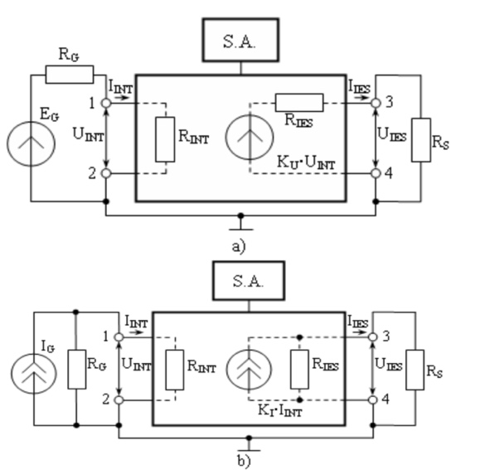

Fig. 6.1. General diagrams of amplifiers: a) with input voltage source;

b) input current flowpolarization and the basic components of the currents

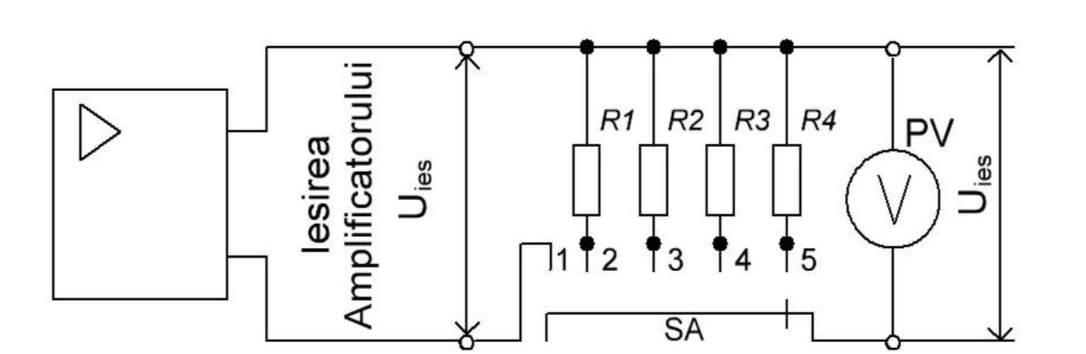

Fig. 6.4. The circuit for determining the output resistance of the amplifier

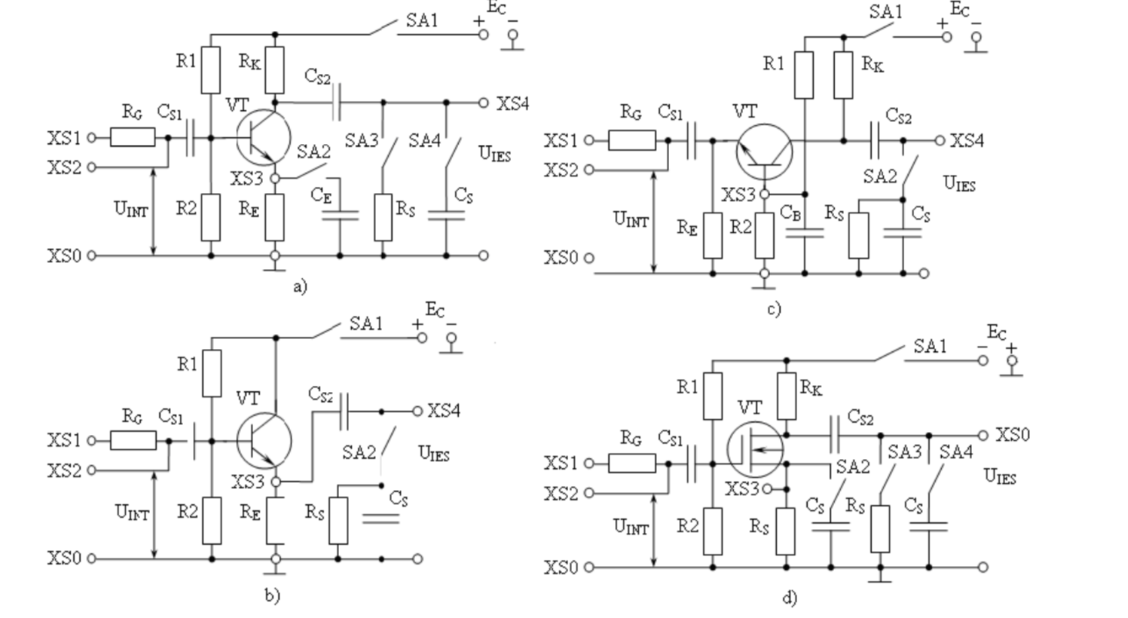

Fig. 6.5. The main electrical schemes of the amplifier stages: a) EC scheme; c) BC scheme;

b) CC scheme; d) scheme with unipolar transistor (SC)

**Tables + Calculations:**

Datele experimentale pentru ridicarea caracteristicii de transfer a amplificatorului EC fara reactie:

|  |  |  |
| --- | --- | --- |
|  |  |  |

|  |  |  |  |  |  |  |  |  |  |  |
| --- | --- | --- | --- | --- | --- | --- | --- | --- | --- | --- |
| **Uint** | 0 | 2 | 5 | 10 | 20 | 30 | 40 | 50 | 75 | 100 |
| **Uies** | 20.5 | 56.5 | 143.3 | 283.5 | 549 | 758.3 | 987.5 | 1159.4 | 1487 | 1661 |

**Table 6.1**

**Graph 6.1**

Datele experimentale pentru ridicarea caracteristicii de transfer a amplificatorului EC cu reactie negative:

|  |  |  |
| --- | --- | --- |
|  |  |  |

|  |  |  |  |  |  |  |  |  |  |  |  |  |  |
| --- | --- | --- | --- | --- | --- | --- | --- | --- | --- | --- | --- | --- | --- |
| **Uint** | 0 | 10 | 50 | 100 | 250 | 500 | 800 | 1000 | 1300 | 1500 | 1800 | 2000 | 2500 |
| **Uies** | 3.5 | 42 | 209.8 | 416 | 937.8 | 1409.3 | 1607.8 | 1603 | 1583 | 1569 | 1548.8 | 1536 | 1507 |

**Table 6.2**

**Graph 6.2**

|  |  |  |  |  |  |  |  |  |  |  |  |
| --- | --- | --- | --- | --- | --- | --- | --- | --- | --- | --- | --- |
| ***U*int., mV** | | **0** | **2** | **5** | **10** | **20** | **30** | **40** | **50** | **75** | **100** |
| *U*ieș., mV | ***BC*** | 6.69 | 17.93 | 45.3 | 90 | 177.5 | 261 | 338 | 408 | 554 | 663 |
| ***EC*** | 0.73 | 2 | 5 | 9.8 | 19.6 | 29.5 | 39.3 | 49.1 | 73.6 | 98.2 |

**Table 6.3**

**Graph 6.3**

|  |  |  |
| --- | --- | --- |
|  |  |  |

|  |  |  |  |  |  |  |  |  |  |  |  |  |  |  |  |  |  |
| --- | --- | --- | --- | --- | --- | --- | --- | --- | --- | --- | --- | --- | --- | --- | --- | --- | --- |
| **Frecvenţa**  ***f*, Hz** | | **10** | **60** | **100** | **200** | **400** | **800** | **103** | **5∙103** | **104** | **5∙104** | **105** | **2∙105** | **5∙105** | **106** | **2∙106** | **5∙106** |
| ***E.C*. fără reacţie** | ***U*ieș,mV** | 6.55 | 5.31 | 8.08 | 13.7 | 25.2 | 42.4 | 46.2 | 43.3 | 42 | 43.2 | 42.5 | 41 | 29 | 16 | 7.4 | 2.53 |
| ***K*u** | 0.65 | 0.53 | 0.80 | 1.37 | 2.52 | 4.24 | 4.62 | 4.33 | 4.2 | 4.32 | 4.25 | 4.1 | 2.9 | 1.6 | 0.74 | 0.25 |
| ***E.C*. eacţie negativă** | ***U*ieș,mV** | 6.09 | 90 | 130 | 200 | 270 | 304 | 308 | 320 | 321 | 315 | 297 | 246 | 125 | 59 | 18 | 3.4 |
| ***K*u** | 0.6 | 9 | 13 | 20 | 27 | 30.4 | 30.8 | 32 | 32.1 | 31.5 | 29.7 | 24.6 | 12.5 | 5.3 | 1.8 | 0.34 |
| ***BC*** | ***U*ieș,mV** | 163 | 208 | 207 | 209 | 209 | 209 | 206 | 206 | 207 | 206 | 200 | 190 | 125 | 64 | 27 | 14 |
| ***K*u** | 16.3 | 20.8 | 20.7 | 20.9 | 20.9 | 20.9 | 20.6 | 20.6 | 20.7 | 20.6 | 20 | 19 | 12.5 | 6.4 | 2.7 | 1.4 |
| ***CC*** | ***U*ieș,mV** | 1.88 | 4.4 | 4.6 | 7.54 | 5.09 | 5.54 | 4.95 | 5 | 8.3 | 9 | 8.65 | 8.56 | 8.2 | 7.92 | 7.2 | 5.8 |
| ***K*u** | 0.18 | 0.44 | 0.46 | 0.75 | 0.5 | 0.5 | 0.49 | 0.5 | 0.8 | 0.9 | 0.86 | 0.85 | 0.82 | 0.79 | 0.72 | 0.58 |
| lg*f* | | 1 | 6 | 10 | 20 | 40 | 80 | 100 | 500 | 1000 | 50000 | 100000 | 200000 | 500000 | 1000000 | 2000000 | 5000000 |

**Table 6.4**

**]\Conclusion:**

Following the completion of the laboratory work, our objectives were thoroughly achieved, demonstrating a deep understanding of the operating principles and static characteristics of amplifier stages with transistors. Through a structured sequence of inspections, assembly, and measurements, we delved into the behavior of these transistors in various configurations, notably observing their diode-like behavior in the common base setup.

Upon concluding our laboratory investigations, we achieved a comprehensive understanding of the operation of broadband voltage amplifiers utilizing bipolar transistors in various configurations, including emitter-coupled (EC), base-coupled (BC), and collector-coupled (CC) arrangements without feedback, as well as the emitter-coupled (EC) setup with negative current feedback. These amplifiers serve a pivotal role in electronics, transforming low-power input signals into significantly more powerful output signals while preserving their temporal waveform.

Our experiments meticulously charted the transfer characteristics – which delineate the relationship between output and input voltages at a fixed frequency – and the frequency characteristics, detailing how the gain factor's magnitude varies with frequency. Through careful measurement and analysis, as depicted in Figures 1 and 2, we successfully mapped out these critical amplifier properties.

This investigative process not only solidified our theoretical knowledge but also underscored the importance of graphical representation in comprehending the nuanced behaviors of amplifiers. By visually presenting the data, we facilitated a more intuitive understanding of these complex electronic components, bridging the gap between theory and practice. The work undertaken has deepened our understanding of electronic amplification, marrying practical experimentation with theoretical insights and highlighting the essential role of visual data in the analysis and interpretation of electronic phenomena.

F=f0/Q=274.66 Vrms=2.5

D  
escription of the laboratory modelPentru aceasta, am masurat valorile curenților și tensiunilor corespunzătoare in pozițiile 1 și 2

ale comutatorului SA