## Ministerul Educaţiei și Cercetării al Republicii Moldova Universitatea Tehnică a Moldovei

**Facultatea Calculatoare, Informatică și Microelectronică**

Criptography and Security Laboratory Work 5:

Public Keys Cryptography

# Elaborated:

st. gr. FAF-212 Cristian Brinza

# Verified:

asist. univ. Mitu Catalin

# Chişinău - 2023

### Objective

Study and implement the following public keys algorithms: RSA, ElGamal and Diffe-Helman. Implement the algorithms using Wolfram Matematica. Study the material posted on ELSE.

### Theoretical Notes

RSA is a widely used public-key encryption algorithm that utilizes a pair of keys (public and private) for secure communication and digital signatures. Its security is based on the computational difficulty of factoring large numbers. ElGamal is another public-key encryption algorithm and digital signature scheme. It relies on the Diffie-Hellman key exchange for secure key generation and is based on the discrete logarithm problem for its security. Diffie-Hellman is a public-key key exchange protocol that enables two parties to establish a shared secret key over an untrusted channel. Its security relies on the difficulty of calculating discrete logarithms in a finite field, and it forms the basis for many cryptographic protocols.

**Task 1**

Using the wolframalpha.com platform or the Wolfram Mathematica app, generate the keys and perform the encryption and decryption of the message **m = Last Name First Name** the RSA algorithm. The value of n must be at least 2048 bits.

### Implementation

In order to implement this algorithm we need to pass through these steps:

1. **Generate Prime Numbers (p and q):** Two large prime numbers, p and q, are generated. These primes are very large (between 21023 and 21024 −1), ensuring a high level of security.
2. **Compute the Modulus (n):** The modulus n is calculated by multiplying p and q. The value of n is used as part of the public and private keys and its length (in bits) determines the key size, which in our case is at least 2048 bits.
3. **Calculate Euler's Totient Function (ϕ)**: Euler's totient function ϕ(n) is computed as (p−1)(q−1). This value is used in the calculation of the private key.
4. **Choose Public Exponent (e):** A public exponent e is chosen. It is a prime number selected randomly between 216 and ϕ(n). The value of e must be coprime to ϕ(n), ensuring e and ϕ(n) have no common factors other than 1.
5. **Compute Private Exponent (d):** The private exponent d is calculated as the modular multiplicative inverse of *e mod ϕ(n)*. This means d is the number such that *e*×*d modulo ϕ(n)* equals 1.
6. **Encryption:** The message "Cristian Brinza" is converted into a numerical format (using character codes). Each character of the message is then encrypted using the formula *encryptedMessage =*

𝑚𝑒𝑠𝑠𝑎𝑔𝑒e *mod n.*

1. **Decryption:** The encrypted message is decrypted using the formula *decryptedMessage =*

𝑒𝑛𝑐𝑟𝑦𝑝𝑡𝑒𝑑𝑀𝑒𝑠𝑠𝑎𝑔𝑒d *mod n*. The decrypted numerical values are converted back to characters, reconstructing the original message.

## Task 2

Using the wolframalpha.com platform or the Wolfram Mathematica application, generate the keys and perform the encryption and decryption of the message **m = Last Name First Name** by applying the ElGamal algorithm (p and the generator are given below).

**p**=323170060713110073001535134778251633624880571334890751745884341392698068341362100027 920563626401646854585563579353308169288290230805734726252735547424612457410262025279165

729728627063003252634282131457669314142236542209411113486299916574782680342305530863490

506355577122191878903327295696961297438562417412362372251973464026918557977679768230146

253979330580152268587307611975324364674758554607150438968449403661304976978128542959586

595975670512838521327844685229255045682728791137200989318739591433741758378260002780349

731985520606075332341226032546840881200311059074842810039949669561196969562486290323380

72839127039

### g=2 Implementation

In order to implement this algorithm we need to pass through these steps:

1. Define Parameters: A large prime number p and a base g (usually a small integer like 2) are defined. These are public parameters in the ElGamal system.
2. Generate Private and Public Keys: A private key x is randomly chosen such that 1 ≤ x ≤ p−2. The public key y is computed as *y =* 𝑔x *mod p.*
3. Prepare the Message: The message "Cristian Brinza" is converted from its hexadecimal representation to a decimal format. Each character of the message is represented in hexadecimal and then converted to its decimal equivalent.
4. Encryption Function: The encrypt function takes a message, the prime p, the base g, and the public key y as inputs. For each character in the message, a random integer k is chosen. The first part of the ciphertext, c1, is calculated as *c1 =* 𝑔k *mod p*. The second part of the ciphertext, c2, is calculated as *c2=message×*𝑦k *mod p*. The function returns a pair (c1,c2) for each character in the message.
5. Encrypt the Message: Each character of the decimal message is encrypted using the encrypt function, resulting in an array of (c1,c2) pairs.
6. Decryption Function: The decrypt function takes a ciphertext pair (c1,c2), the prime p, and the private key x as inputs. The decrypted message is computed as *decryptedMessage = c2×*𝑐1p–1–x *mod p.*
7. Decrypt the Message: Each (c1,c2) pair in the encrypted message is decrypted using the decrypt function, reconstructing the original message in decimal form.

## Task 3

Using the wolframalpha.com platform or the Wolfram Mathematica app, perform the Diffie-Helman key exchange between Alice and Bob, which uses AES algorithm with 256-bit key. The secret numbers a and b must be chosen randomly according to algorithm requirements (p and generator are given below).

**p**=323170060713110073001535134778251633624880571334890751745884341392698068341362100027 920563626401646854585563579353308169288290230805734726252735547424612457410262025279165

729728627063003252634282131457669314142236542209411113486299916574782680342305530863490

506355577122191878903327295696961297438562417412362372251973464026918557977679768230146

253979330580152268587307611975324364674758554607150438968449403661304976978128542959586

595975670512838521327844685229255045682728791137200989318739591433741758378260002780349

731985520606075332341226032546840881200311059074842810039949669561196969562486290323380

72839127039

### g=2 Implementation

In order to implement this algorithm we need to pass through these steps:

1. Define Global Public Parameters: A large prime number p and a base g (usually a small integer like 2) are defined. These parameters are public and shared between the parties involved in the key exchange.
2. Generate Private Keys: Both Alice and Bob generate their private keys, a and b, respectively. These are randomly chosen integers in the range [1,p−1].
3. Compute Public Keys: Alice computes her public key A as *A =* 𝑔a *mod p*. Bob computes his public key B as *B =* 𝑔b *mod p*. These public keys are then shared between Alice and Bob.
4. Compute Shared Secret: Alice computes the shared secret using Bob's public key: *sharedSecretAlice*

*=* 𝐵a *mod p*. Bob computes the shared secret using Alice's public key: *sharedSecretBob =* 𝐴b *mod p*. Due to the properties of modular exponentiation, both computations result in the same value, even though Alice and Bob use their own private keys and each other's public keys.

## Results

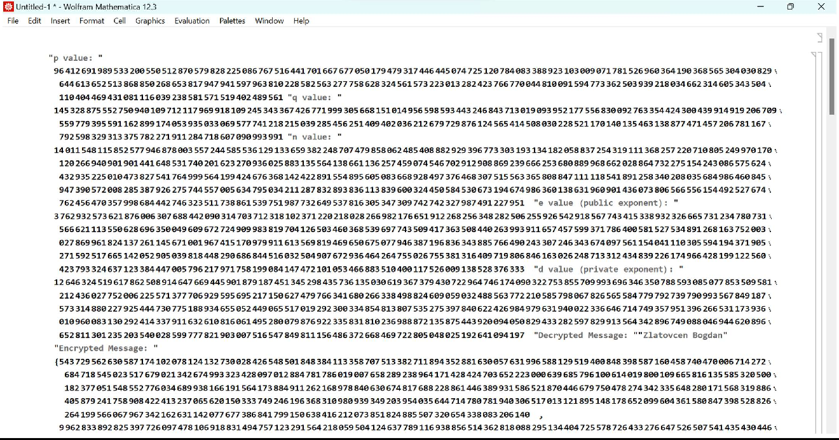

Figure 1 *– Program output for RSA Algorithm*

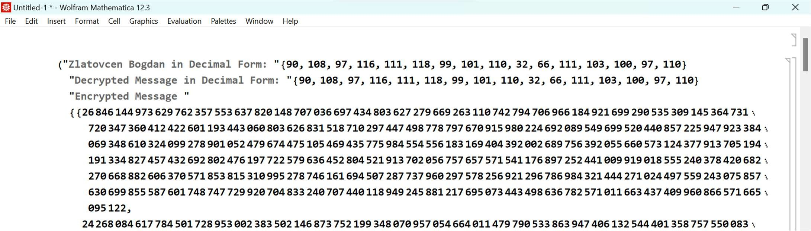

Figure 2 *– Program output for ElGamal Algorithm*

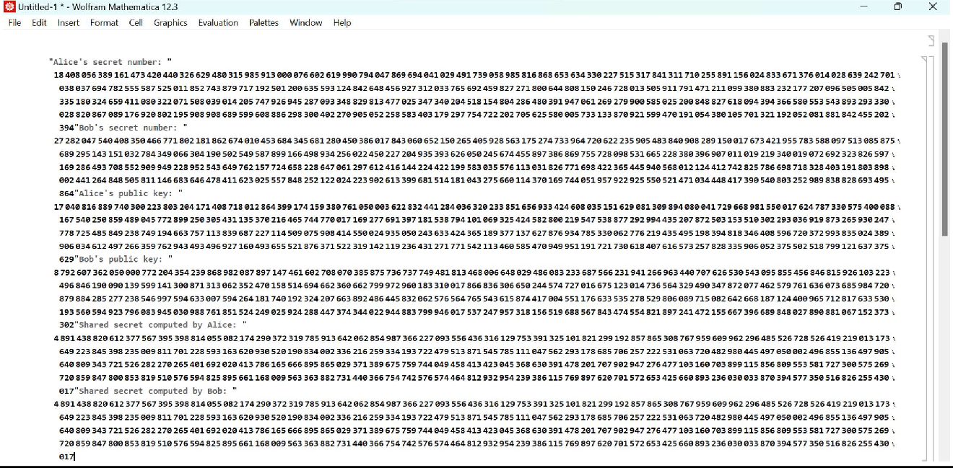

Figure 3 *– Program output for AES Algorithm*

## Conclusions

In this laboratory work, we successfully implemented three fundamental cryptographic algorithms in Wolfram Mathematica: RSA, ElGamal, and the Diffie-Hellman key exchange. Each algorithm showcased distinct aspects of modern cryptography, from the RSA's reliance on the difficulty of factoring large numbers to ElGamal's use of discrete logarithms and Diffie-Hellman's secure key exchange over public channels. The practical application of these algorithms in Mathematica provided valuable insights into their operational mechanisms and the underlying mathematical principles.

Code link: https://github.com/CristianBrinza/UTM/tree/main/year3/cs/lab5