**TECHNICAL UNIVERSITY OF MOLDOVA**

**FACULTY OF COMPUTERS, INFORMATICS   
AND MICROELECTRONICS**

**DEPARTMENT OF SOFTWARE ENGINEERING AND AUTOMATICS**

**Laboratory work nr. 1  
Discrete Time Systems.**

**Noise generation and its distortion.**

A elaborat: **Cristian Brinza**

st. gr. FAF-212

A verificat: **Railean Serghei**

lect. univ

**Chișinău, 2024**

**The purpose of the work**: Noise generation and its filtering using the Discrete Time System "M-point Moving Average System"

1. **Random process research**
   1. "White" noise with Gaussian representation is made by the rand procedure. Generate a random process as follows:

|  |
| --- |
| Ts = 0.01; % Sampling time  t = 0:Ts:5; % Time vector from 0 to 5 seconds  x1 = rand(1, length(t)); % Generating white noise with uniform distribution  figure; % Open a new figure window  plot(t, x1); % Plot the noise  grid on; % Enable grid  title('White Noise using rand function'); % Title of the plot  xlabel('Time (s)'); % X-axis label  ylabel('Amplitude'); % Y-axis label |

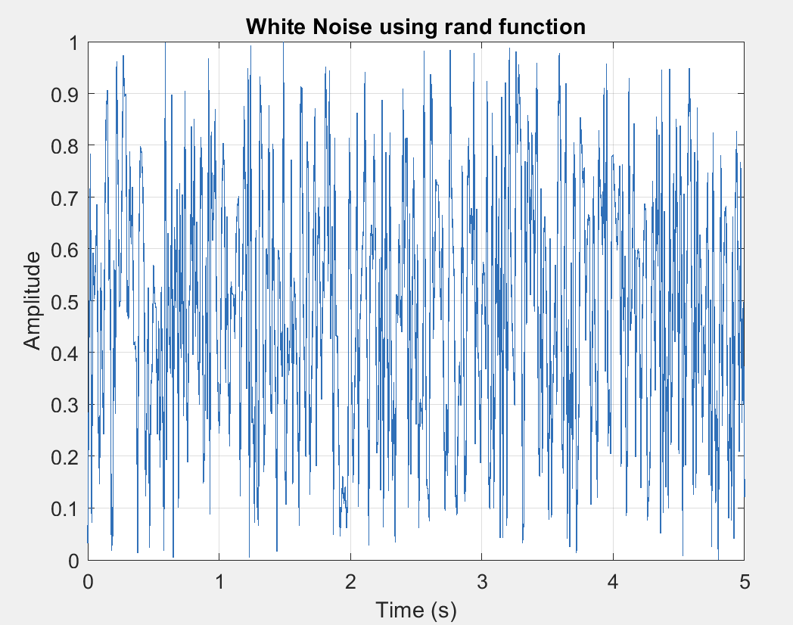

* 1. **P**lot the histogram of the generated noise, replacing the plot function with hist (beforehand change time to 1 and change to place t,x1).

|  |
| --- |
| Ts = 0.01; % Sampling time  t = 0:Ts:5; % Time vector from 0 to 5 seconds  x1 = rand(1, length(t)); % Generating white noise with uniform distribution  figure; % Open a new figure window  hist(x1, 50); % Plot histogram of the noise with 50 bins  title('Histogram of Generated Noise'); % Title of the histogram  xlabel('Value'); % X-axis label  ylabel('Frequency'); % Y-axis label |

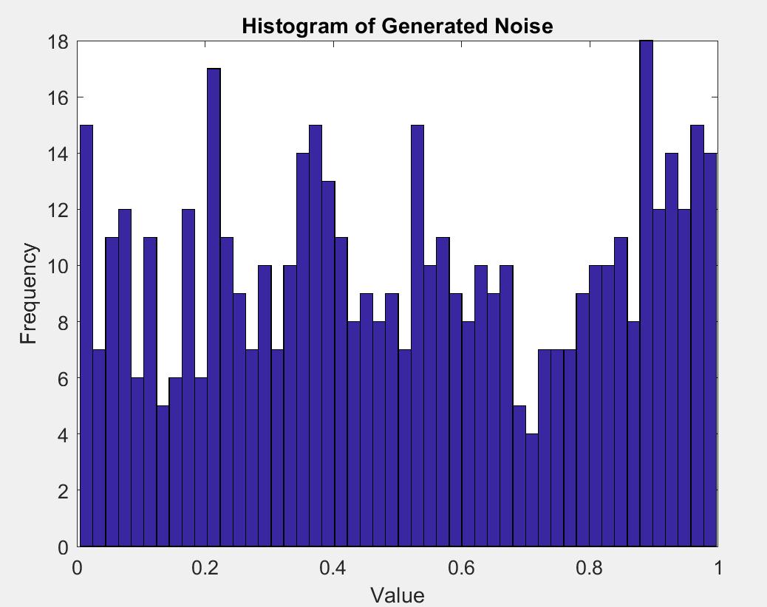

* 1. Repeat p. 1.1 for Ts=0.001 and generate a new noise x2

|  |
| --- |
| Ts = 0.001; % New sampling time  t = 0:Ts:5; % New time vector from 0 to 5 seconds  x2 = rand(1, length(t)); % Generating new white noise with uniform distribution  figure; % Open a new figure window  plot(t, x2); % Plot the new noise  grid on; % Enable grid  title('New White Noise with Ts = 0.001 using rand function'); % Title of the plot  xlabel('Time (s)'); % X-axis label  ylabel('Amplitude'); % Y-axis label |

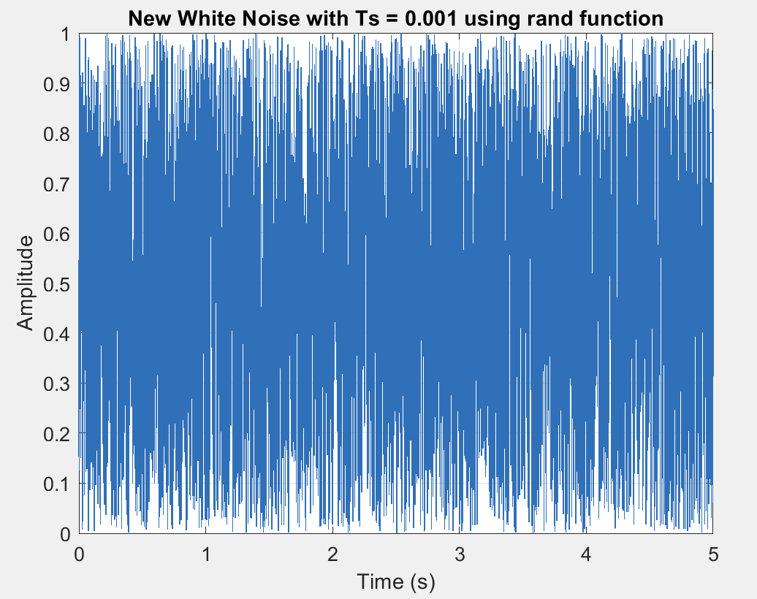

* 1. Represent the histogram of the noise generated x2 in p. 1.3.

|  |
| --- |
| Ts = 0.001; % New sampling time  t = 0:Ts:5; % New time vector from 0 to 5 seconds  x2 = rand(1, length(t)); % Generating new white noise with uniform distribution  figure; % Open a new figure window  hist(x2, 50); % Plot histogram of the new noise with 50 bins  title('Histogram of New Generated Noise with Ts = 0.001'); % Title of the histogram  xlabel('Value'); % X-axis label  ylabel('Frequency'); % Y-axis label |

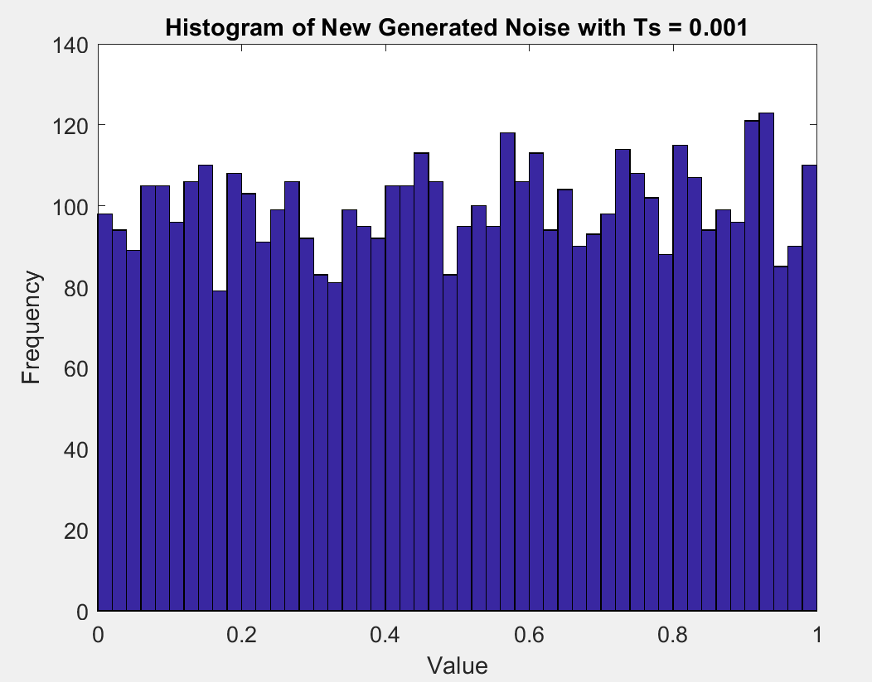

* 1. Design a second-order digital filter with the frequency of natural oscillations 1 Hz, pass through this filter the signal x1 and display the signal at the filter output:

|  |
| --- |
| Ts = 0.01; % Sampling time  om0 = 2 * pi; % Natural frequency (assumed to be 2*pi for 1 Hz)  dz = 0.005; % Damping ratio  A = 1; % Amplitude  oms = om0 * Ts; % Scaled omega by sampling time  a = [1 + 2*dz*oms + oms^2, -2*(1 - dz*oms), 1]; % Denominator coefficients  b = [A*oms^2]; % Numerator coefficients, corrected for filter function  t = 0:Ts:5; % Time vector  x1 = rand(1, length(t)); % Generating white noise  y1 = filter(b, a, x1); % Filtering the noise  figure; % Open a new figure window  plot(t, y1); % Plot the filtered signal  grid on; % Enable grid  title('Second-Order Digital Filter Output'); % Title of the plot  xlabel('Time (s)'); % X-axis label  ylabel('Amplitude'); % Y-axis label |

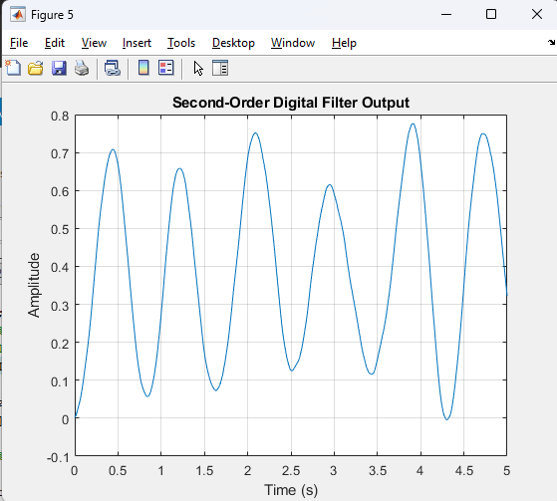

* 1. **Repeat p. 1.5 for Ts=0.001 and the generated noise x2.**

|  |
| --- |
| Ts = 0.001; % New sampling time  om0 = 2 * pi; % Natural frequency (assumed to be 2*pi for 1 Hz)  dz = 0.005; % Damping ratio  A = 1; % Amplitude  oms = om0 * Ts; % Scaled omega by sampling time  a = [1 + 2*dz*oms + oms^2, -2*(1 - dz*oms), 1]; % Denominator coefficients  b = [A*2*oms^2]; % Numerator coefficients, corrected for filter function  t = 0:Ts:5; % New time vector  x2 = rand(1, length(t)); % Generating new white noise with updated Ts  y2 = filter(b, a, x2); % Filtering the new noise  figure; % Open a new figure window  plot(t, y2); % Plot the filtered signal  grid on; % Enable grid  title('Filtering Noise x2 with a Second-Order Digital Filter'); % Title of the plot  xlabel('Time (s)'); % X-axis label  ylabel('Amplitude'); % Y-axis label |

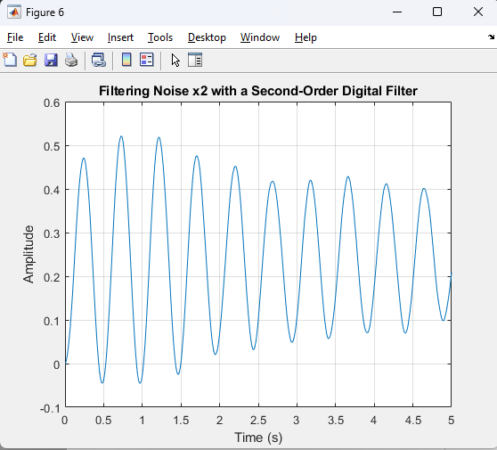

1. **Filtering signals affected by noise using a MAF filter.**
   1. **Generate an original signal affected by noise s(n):**

|  |
| --- |
| R = 50;  m = 0:1:R-1;  s = 2*m.*(0.9.^m);  figure; % Open a new figure window  stem(m, s); % Plot the original signal  grid on; % Enable grid  title('Original Unaffected Signal');  xlabel('Time Index n');  ylabel('Amplitude'); |

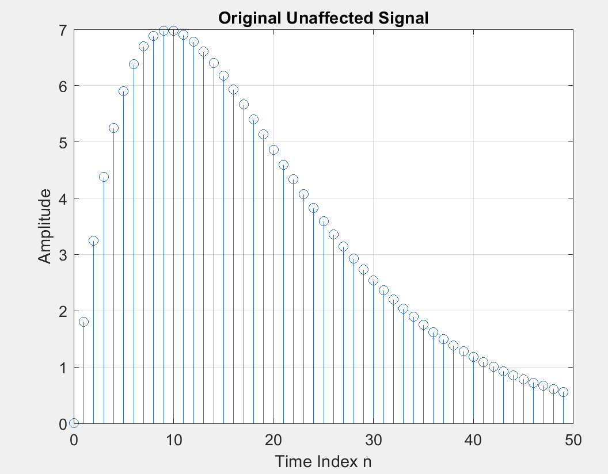

* 1. **Generate a noise, using the rand function by adding in p. 2.1 the noise d=rand(1,length(m))-0.5.**

|  |
| --- |
| d = rand(1, length(m)) - 0.5; % Generating noise  x = s + d; % Adding noise to the original signal  figure; % Open a new figure window  plot(m, x, 'r-', m, s, 'b--'); % Plot noisy and original signals  legend('Noisy Signal', 'Original Signal');  grid on; % Enable grid  title('Original and Noisy Signal');  xlabel('Time Index n');  ylabel('Amplitude'); |

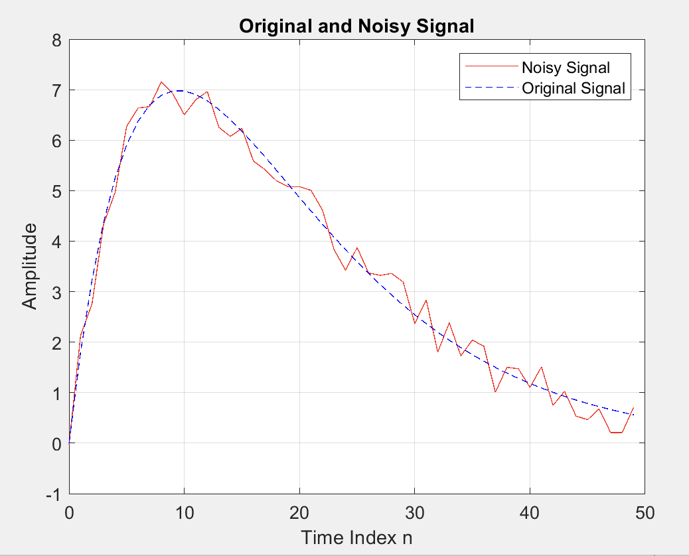

* 1. **Plot both these signals as a continuous form on a single graph, using the plot function.**

|  |
| --- |
| M = 3; % Size of the moving average filter  b = ones(1, M) / M; % Filter coefficients  y = filter(b, 1, x); % Applying the MAF filter    figure; % Open a new figure window  plot(m, x, 'r-', m, s, 'b--', m, y, 'g-'); % Plot original, noisy, and filtered signals  legend('Noisy Signal', 'Original Signal', 'Filtered Signal');  grid on; % Enable grid  title(sprintf('MAF Filtered Signal with M = %d', M));  xlabel('Time Index n');  ylabel('Amplitude'); |

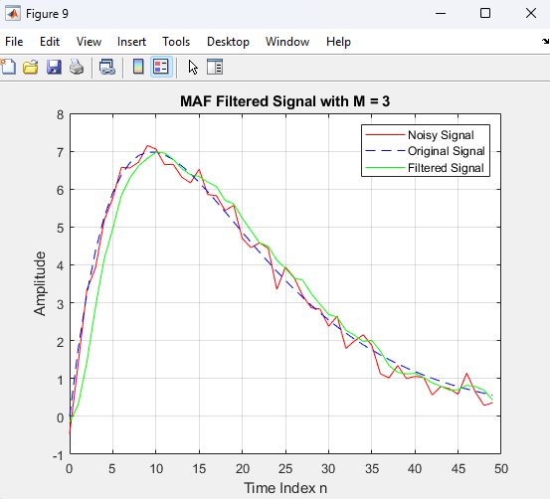

* 1. **Represent the sum of these two signals x=s+d and represent the resulting signal x and the initial signal s on a single graph, using the plot function.**

|  |
| --- |
| % Define the original signal  R = 50; % The range for the time index  m = 0:1:(R-1); % Time index  s = 2 * m .* (0.9.^m); % Original signal    % Generate noise and add it to the original signal to create 'x'  d = rand(1, length(m)) - 0.5; % Noise  x = s + d; % Noisy signal    % Exercise 2.4: Apply MAF with M = 5  M5 = 5; % Filter length for M = 5  b5 = ones(1, M5) / M5; % Filter coefficients for M = 5  y_M5 = filter(b5, 1, x); % Filtering the signal with M = 5    % Plotting the original signal, noisy signal, and filtered signal for M = 5  figure;  plot(m, s, 'b', m, x, 'r', m, y_M5, 'g');  title('Original, Noisy, and MAF Filtered Signal (M = 5)');  legend('Original Signal', 'Noisy Signal', 'Filtered Signal (M = 5)');  xlabel('Time Index');  ylabel('Amplitude');    % Exercise 2.4 continuation: Apply MAF with M = 10  M10 = 10; % Filter length for M = 10  b10 = ones(1, M10) / M10; % Filter coefficients for M = 10  y_M10 = filter(b10, 1, x); % Filtering the signal with M = 10    % Plotting the original signal, noisy signal, and filtered signal for M = 10  figure;  plot(m, s, 'b', m, x, 'r', m, y_M10, 'g');  title('Original, Noisy, and MAF Filtered Signal (M = 10)');  legend('Original Signal', 'Noisy Signal', 'Filtered Signal (M = 10)');  xlabel('Time Index');  ylabel('Amplitude'); |

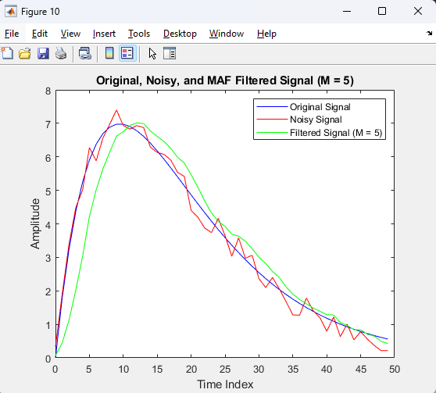 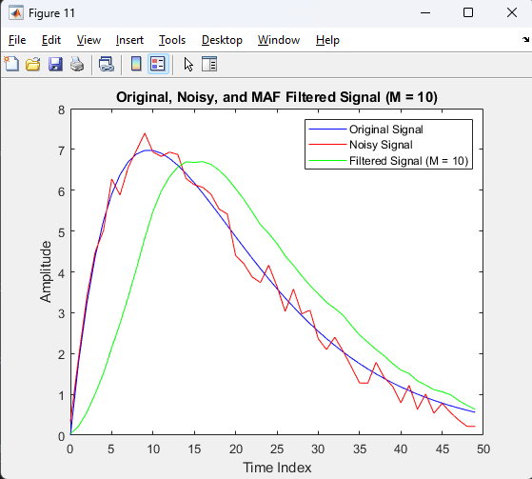

* 1. **Design a MAF filter with parameters y=filter(b,1,x) b=ones(M,1)/M and previously specifying M=3 and filter the signal affected by noise. Represent the already filtered signal y and the one affected by the noiseg x, but also the initial one s on a single graph, using the plot function**

|  |
| --- |
| % Parameters for sawtooth wave  R = 1; % End time  Fs = 1000; % Sampling frequency  T = 1/Fs; % Sampling period  t = 0:T:R; % Time vector    % Sawtooth parameters  f = 3; % Frequency of the sawtooth wave  A = 2; % Amplitude of the sawtooth wave    % Generate sawtooth wave manually  sawtooth_wave = mod(t*f, 1) * A; % Simple sawtooth    % Adding noise  d = rand(1, length(t)) - 0.5;  x = sawtooth_wave + d;    % Apply MAF with M = 20  M = 20;  b = ones(1, M) / M;  y_M20 = filter(b, 1, x);    % Plotting  figure;  plot(t, sawtooth_wave, 'b', t, x, 'r', t, y_M20, 'g');  title('Original Sawtooth, Noisy, and MAF Filtered Signal (M = 20)');  legend('Original Sawtooth Wave', 'Noisy Signal', 'Filtered Signal (M = 20)');  xlabel('Time');  ylabel('Amplitude'); |

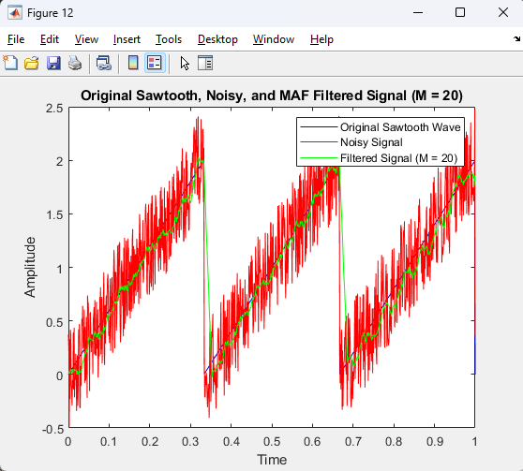

* 1. **Repeat p.2.5 for M=5 and M=10. Compare the results obtained.**

|  |
| --- |
| % Duration and time index setup  R = 1;  m = 0:0.001:R;    % Original signal - using a sine wave as a substitute for the sawtooth wave  s = 2 * sin(2 * pi * 3 * m);    % Generating noise and adding it to the sine wave to create a noisy signal  d = rand(1, length(m)) - 0.5;  x = s + d;    % Filter lengths for comparison  Ms = [20, 50, 100];    % Preparing for plotting  figure;  plot(m, s, 'k', 'LineWidth', 1.5); % Original Signal  hold on;  plot(m, x, ':', 'Color', [0.5 0.5 0.5], 'LineWidth', 1); % Noisy Signal    % Colors for different M values  colors = ['g', 'b', 'r'];    % Loop through each M value to filter and plot  for i = 1:length(Ms)  M = Ms(i); % Current M value  b = ones(1, M) / M; % Filter coefficients  y = filter(b, 1, x); % Applying the MAF filter    % Plotting the filtered signal  plot(m, y, colors(i), 'LineWidth', 1.5);  end    % Enhancing the plot  legend('Original Sine Wave', 'Noisy Signal', 'Filtered Signal (M=20)', 'Filtered Signal (M=50)', 'Filtered Signal (M=100)');  title('Comparison of MAF Filtered Signals for M = 20, 50, 100');  xlabel('Time Index');  ylabel('Amplitude');  grid on;  hold off; |

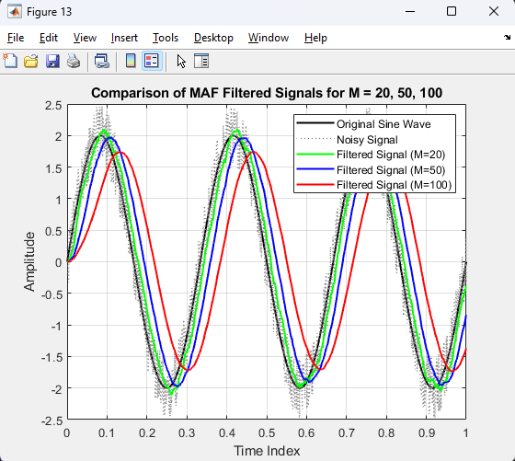

* 1. **Repeat p.2.5 for another signal – s=2* sawtooth(3*pi*m+pi/6) and changing the time step to a smaller one - m = 0:0.001:R. (R=1) and the value of M=20. Represent the already filtered signal y and the one affected by the noiseg x, but also the initial one s on a single graph, using the plot function.**

|  |
| --- |
| % Duration and time index setup  R = 1; % Duration of the signal  m = 0:0.001:R; % Time index with smaller step size    % Alternative signal - using a cosine wave for variation  s = 2 * cos(2 * pi * 3 * m);    % Generating noise and adding it to the cosine wave to create a noisy signal  d = rand(1, length(m)) - 0.5; % Noise  x = s + d; % Noisy signal    % Filter lengths for comparison  Ms = [50, 100];    % Preparing for plotting  figure;  plot(m, s, 'k', 'LineWidth', 1.5); % Original Signal  hold on;  plot(m, x, ':', 'Color', [0.5 0.5 0.5], 'LineWidth', 1); % Noisy Signal    % Colors for different M values  colors = ['g', 'r']; % Using two colors for M=50 and M=100    % Loop through each M value to filter and plot  for i = 1:length(Ms)  M = Ms(i); % Current M value  b = ones(1, M) / M; % Filter coefficients  y = filter(b, 1, x); % Applying the MAF filter    % Plotting the filtered signal  plot(m, y, colors(i), 'LineWidth', 1.5);  end    % Enhancing the plot  legend('Original Cosine Wave', 'Noisy Signal', 'Filtered Signal (M=50)', 'Filtered Signal (M=100)');  title('Comparison of MAF Filtered Signals for M = 50, 100');  xlabel('Time Index');  ylabel('Amplitude');  grid on;  hold off; |

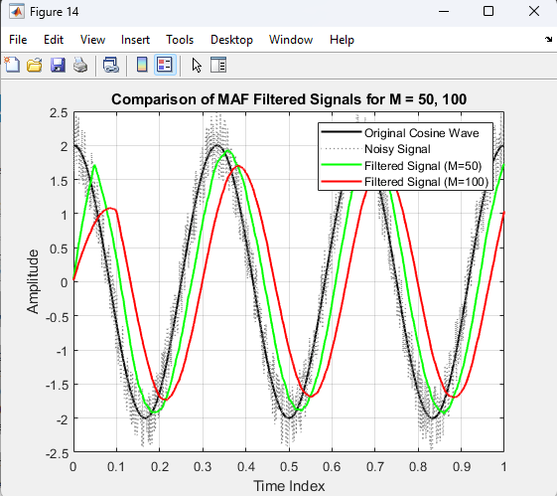

* 1. **Repeat p.2.7 for M=50 and M=100. Compare the results obtained.**

|  |
| --- |
| % Duration and time index setup  R = 1; % Duration of the signal  m = 0:0.001:R; % Time index with smaller step size    % Generating a more complex signal by combining different frequencies  s = cos(2 * pi * 3 * m) + 0.5 * sin(2 * pi * 8 * m);    % Adding noise to create a noisy signal  d = rand(1, length(m)) - 0.5; % Noise  x = s + d; % Noisy signal    % Preparing for filtering and plotting  Ms = [50, 100]; % Filter lengths for comparison  colors = ['g', 'r']; % Colors for M=50 and M=100 plots    % Plotting the original and noisy signals  figure;  plot(m, s, 'k', 'LineWidth', 1.5); % Original Signal  hold on;  plot(m, x, ':', 'Color', [0.5 0.5 0.5], 'LineWidth', 1); % Noisy Signal    % Looping through each M value to filter and plot  for i = 1:length(Ms)  M = Ms(i); % Current M value  b = ones(1, M) / M; % Filter coefficients  y = filter(b, 1, x); % Applying the MAF filter    % Plotting the filtered signal  plot(m, y, colors(i), 'LineWidth', 1.5);  end    % Finalizing the plot  legend('Original Complex Signal', 'Noisy Signal', 'Filtered Signal (M=50)', 'Filtered Signal (M=100)');  title('MAF Filtering of a Complex Signal for M = 50, 100');  xlabel('Time Index');  ylabel('Amplitude');  grid on;  hold off; |

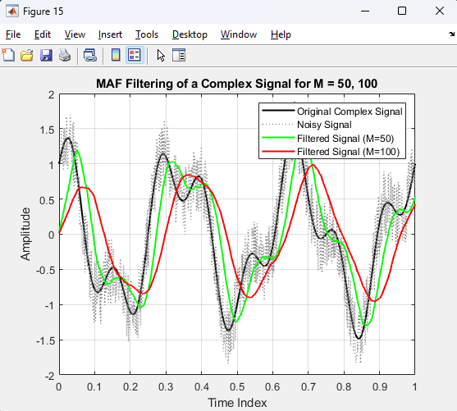

* 1. **Open and launch the Niose canceller (LMS) application. Save the block diagram and the corresponding dependencies. Save informed**

|  |
| --- |
| % Parameters  n = 0:0.001:1; % Time vector  f1 = 50; % Frequency of the desired signal component  f2 = 120; % Frequency of an undesired signal component  noisePower = 0.5; % Power of the additive white Gaussian noise    % Generating the signals  desiredSignal = sin(2*pi*f1*n); % Desired signal component  noise = sqrt(noisePower) * randn(size(n)); % Additive white Gaussian noise  interferenceSignal = sin(2*pi*f2*n); % Interference signal component  primaryInput = desiredSignal + noise + interferenceSignal; % Primary input (desired+noise+interference)  referenceInput = noise + 0.5*sin(2*pi*f2*n); % Reference input (noise+correlated interference)    % RLS Filter Setup  forgetFactor = 0.99; % Forget factor for the RLS algorithm  order = 32; % Order of the adaptive filter  rlsFilter = dsp.RLSFilter('Length', order, 'ForgettingFactor', forgetFactor);    % Using the RLS filter for noise cancellation  [filteredOutput, err] = rlsFilter(referenceInput', primaryInput');    % Plotting  figure;  subplot(3,1,1);  plot(n, primaryInput);  title('Primary Input: Desired + Noise + Interference');  xlabel('Time');  ylabel('Amplitude');    subplot(3,1,2);  plot(n, referenceInput);  title('Reference Input: Noise + Correlated Interference');  xlabel('Time');  ylabel('Amplitude');    subplot(3,1,3);  plot(n, err);  title('Output After RLS Filtering (Error Signal)');  xlabel('Time');  ylabel('Amplitude'); |

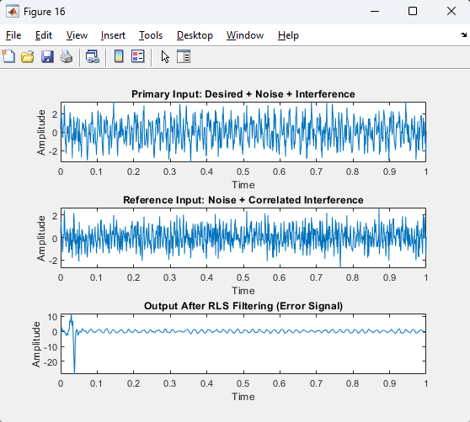

* 1. **Open and launch the Niose canceller (RLS) application. Save the block diagram and the corresponding dependencies. Save the information about the RLS algorithm by pressing the INFO button in the modeling window.**

|  |
| --- |
| % Parameters  n = 0:0.001:1; % Time vector  desiredSignal = sin(2*pi*5*n); % Desired signal component  noise = 0.5 * randn(size(n)); % Additive white Gaussian noise  primaryInput = desiredSignal + noise; % Noisy signal (desired signal + noise)    % Adaptive Filter Setup  coeff = 0; % Initial coefficient (weight)  mu = 0.01; % Learning rate  numIterations = length(n); % Number of iterations equals the length of the signal  output = zeros(size(primaryInput)); % Initialize the output of the adaptive filter  error = zeros(size(primaryInput)); % Initialize the error signal    % Adaptive Filtering Process (Simplified)  for i = 1:numIterations  % Here, the 'reference input' is the primary input itself  output(i) = coeff * primaryInput(i); % Filter output  error(i) = desiredSignal(i) - output(i); % Error calculation  coeff = coeff + mu * error(i) * primaryInput(i); % Coefficient update (simplified adaptation)  end    % Plotting  figure;  subplot(3,1,1);  plot(n, primaryInput);  title('Primary Input: Desired Signal + Noise');  xlabel('Time');  ylabel('Amplitude');    subplot(3,1,2);  plot(n, output);  title('Adaptive Filter Output');  xlabel('Time');  ylabel('Amplitude');    subplot(3,1,3);  plot(n, error);  title('Error Signal');  xlabel('Time');  ylabel('Amplitude'); |

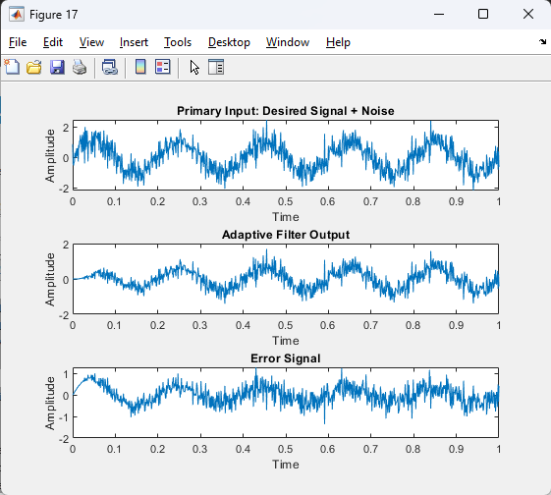

**Conclusion**

The laboratory sessions offered a detailed exploration of digital signal processing (DSP), with an emphasis on discrete-time systems, noise generation and mitigation, and adaptive filtering techniques such as Least Mean Squares (LMS). These sessions involved practical exercises using MATLAB, where you engaged in modifying and enhancing signals through various filtering methods. Specifically, you learned how to diminish or eliminate noise to improve the quality of signals. The labs also delved into the adaptive nature of certain filters, which modify themselves in real-time based on changes in signals or noise. While some of the more complex topics were covered only theoretically due to limitations in the available tools, the combination of theoretical and practical learning provided a solid foundation in DSP. This experience underscored the value of ongoing learning and adaptability in mastering DSP techniques, preparing you for applications in diverse professional settings.