Mapeo de los recursos y herramientas disponibles:

Cost and benefits:
https://sunrise-bookcase-985.notion.site/Cost-and-benefits-27aaa3a48b0d80cb8444f79faad703e7
Inventory of resources:
https://sunrise-bookcase-985.notion.site/Inventory-of-resources-27aaa3a48b0d80b6aeadeeddeb5409bb
Matriz de Stakeholders:
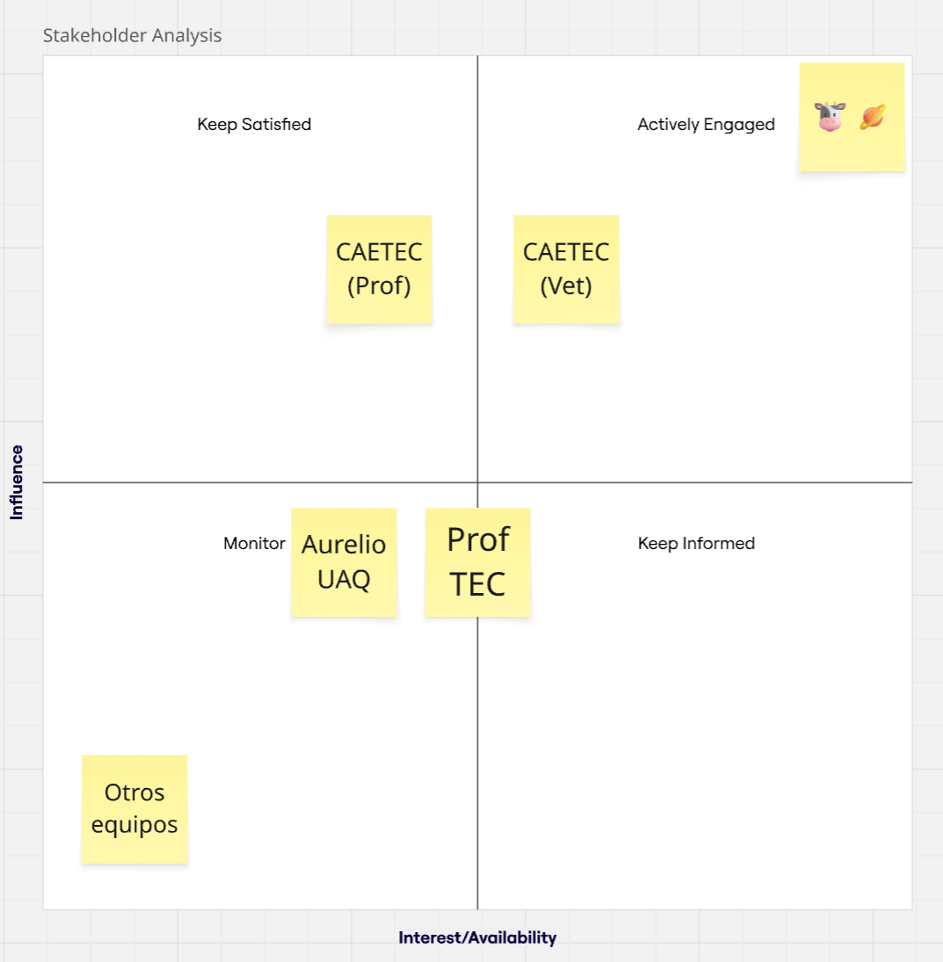

Generen un plan inicial basado en la metodología
PVG:
https://docs.google.com/spreadsheets/d/1YzFk8QZiyHJ-n4SVHrqdMWF-mLoZMC5zWgD1-EeDnxg/edit?usp=sharing
WBS:
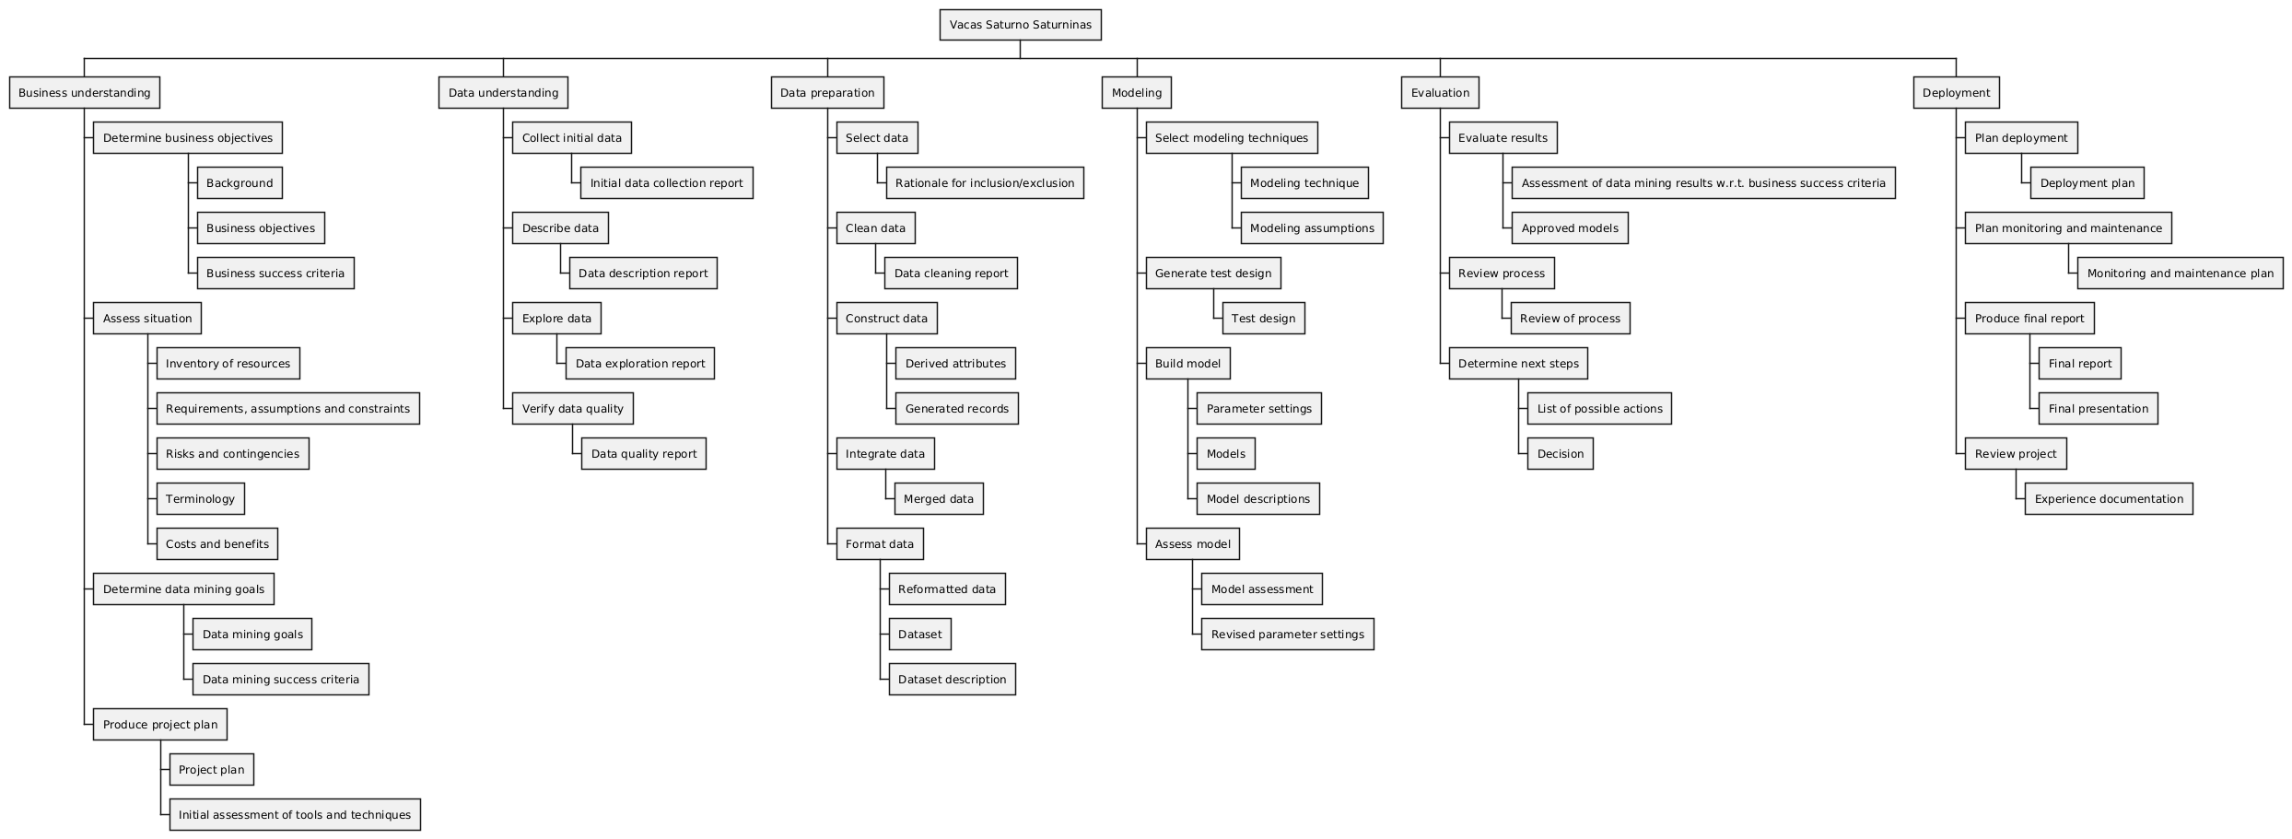
Gestión de riesgos:
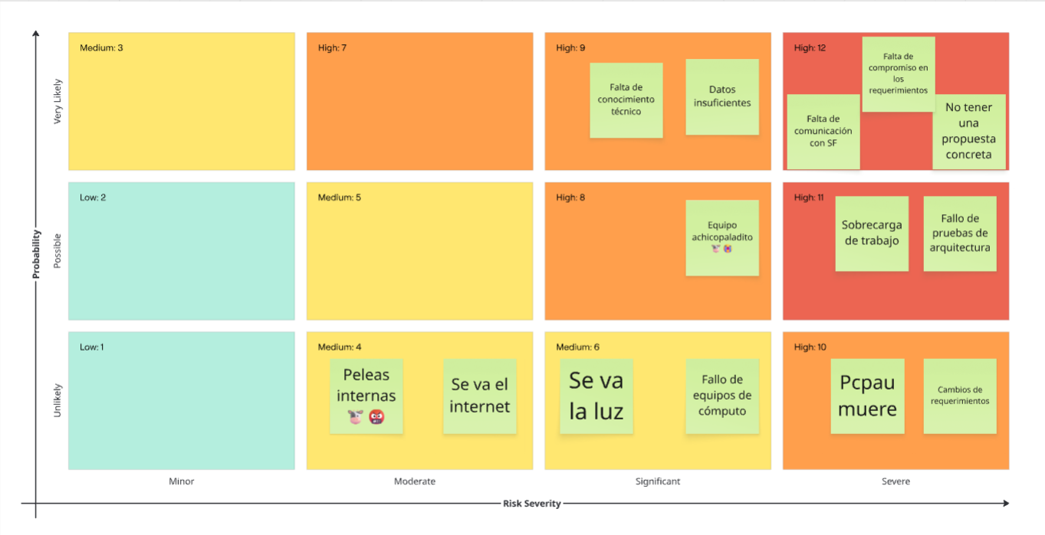
https://sunrise-bookcase-985.notion.site/Gesti-n-de-riesgos-281aa3a48b0d806d9606f9940190ba7b
Plan de comunicación:
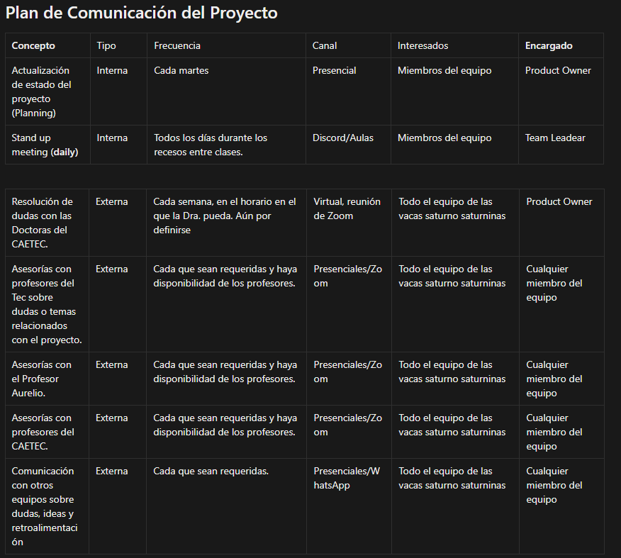
https://sunrise-bookcase-985.notion.site/Plan-de-comunicaci-n-285aa3a48b0d80f098bfd365bc5bf772

Memorandum of Understanding:
