Experience Prototyping Report

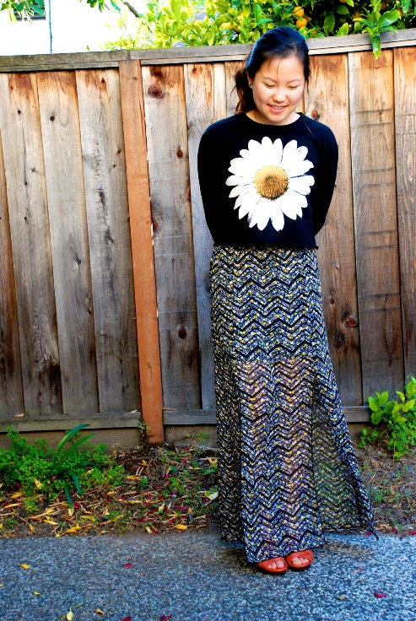Our group’s members are Cristian L, Dartis W, and Neven WT. Our studio theme is crowd power, and our particular problem domain is events. More specifically, we are interested in the crowds at events, and how they affect the entire event experience. We initially met both event organizers and attendees at two distinct events, and we were amazed to find the existence of a “sweet spot” crowd size. It would be game changing if we could make users knowledgeable about the crowds at events. Since then we went to one more event and interviewed one more person to solidify certain common trends, and to possibly find something new. We went to wine and cheese night at Kairos, because we had yet to go to an event that was representative of common events on campus (i.e. parties thrown by houses). While there we interviewed a sophomore named Jenny Lu. She reaffirmed many of the things other interviewees mentioned and gave us some new food for thought. One particularly interesting thing was her thought process when it came to making decisions regarding the event. It was her first time attending wine and cheese night, so she was fairly unsure of how crowded it was going to be, what time was appropriate to show up, and what time the party was going to be at its best. This unsureness resulted in a sense of uneasiness when she arrived, which was easily preventable with information. She also noted that the tone and size of the crowd was very important to her, and that she in particular strives for a nice balance between it “not being so empty that it’s awkward, but not so big that it’s super hot and you can’t breathe.” She elaborated that at most parties, the sweet spot is a crowd of approximately 75% “fullness”. This interview in combination with our previous ones allowed us to refine some of our discoveries. We realized that while sweet spots vary a lot based 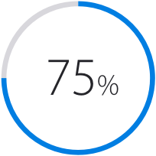on the event and the person, there are some commonalities that exist. Sweet spots often exist at a three-fourths position on the crowd spectrum. This means that, depending on the event, sweet spots usually exist when a venue is either three-fourths full or three-fourths empty. This lean to one side allows event-goers to reap the greatest benefits from whatever the event provides, without having the crowd (or lack thereof) interfere. This sweet spot specificity helped us understand just how vital group experiences are. At most if not all events, there exists an underlying connection between everyone present. A sort of unified set of desires, concerns, and excitements. This unification provides many things that humans inherently want, namely validation that their concerns and desires are valid, and comradery through similar paths. Considering how important these group experiences are to an event, it was doubly surprising the degree to which people relied on poor information to make decisions about events; a reliance that comes from a lack of resources rather than a lack of desire.

As a result of these realizations, we were able to generate two central points of view that sufficiently capture what we learned. First, we met event-goers at two different events, a career fair and a party. We were surprised to realize how much people rely on inferred guesses and shoddy information when it comes to making large decisions about events. It would be game changing if we could regularly and reliably provide information regarding events and their crowds, saving them from disappointing experiences. Secondly, we met event organizers at one event, and through the contribution of our other interviews, we were surprised to find that the group experience largely defines how much people enjoy an event. These underlying and satisfying group connections often contribute more to individual enjoyment than actual tangible parts of an event. It would be game changing if we could extend and enhance these group experiences before, during, and after an event.

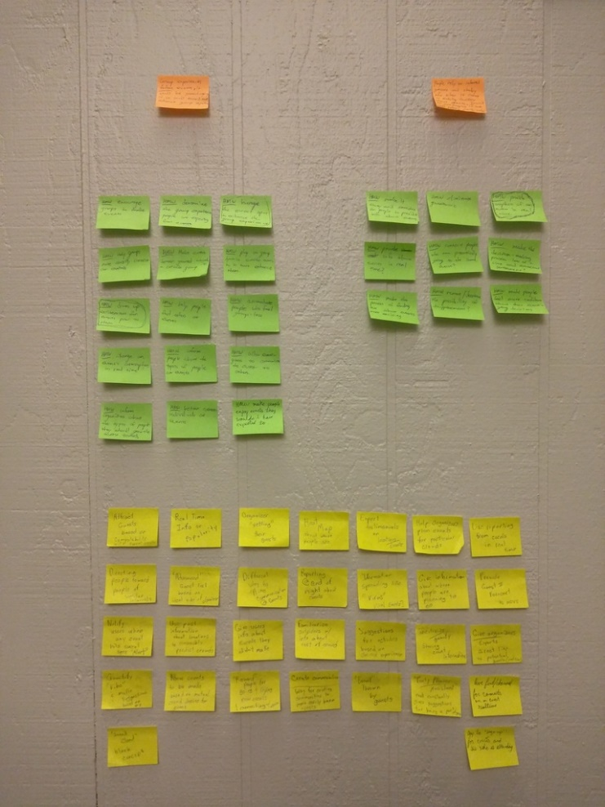 From these points of view, we generated many “How Might We” questions. For our first point of view, we produced questions such as “how might we make the process of finding out about events more fun and exciting? How might we eliminate guesswork?" For our second point of view, we generated questions such as “how might we play on group dynamics outside of events to enhance them? How might we determine the group experience people are expecting out of their events? How might we alter a crowd’s tone in real time?” Eventually, we settled on three primary questions. From the first point of view regarding poor information, we asked how might we provide snapshots of events in real time? We felt that this captured the point of view well because we want to find a way to communicate the tone and feel of events as they happen, reliably providing this information would solve the issues that our first point of view presents. From the second point of view regarding the importance of the group experience, we wondered how might we play on how individuals remember groups to extend these experiences beyond the duration of the event. Considering how powerful groups can be, it would be amazing if we could provide the resources for people to build on that power. Our final question, which captured pieces of both points of view, is how might we drum up excitement for events prior to them? This would allow us to improve the group experience while at an event, by giving it a starting foundation before the event.

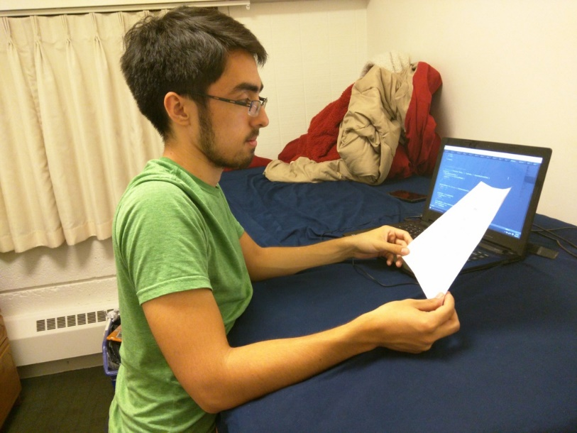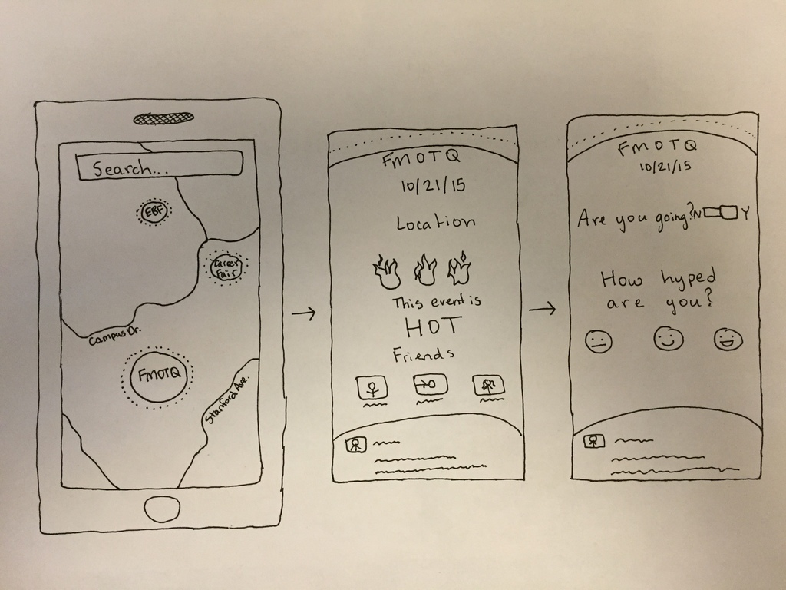 To put these questions into a solution and test them, we developed three experience prototypes, one to test each question. The first prototype we made focused on upcoming events by displaying them as bubbles on a map. The bigger the bubble, the more hype exists for the event. If a user clicks on a bubble, they can view information about the event, such as current popularity, friends attending, and comments. It would also allow users to fill out whether or not they are going, and how hyped they are for the event. This prototype functioned under the assumption that people would want to visualize events on a local map, and that people would be willing/want to fill out personal information about the event. The prototype was made on simple paper, displaying a natural progression of clicks. We tested the prototype by giving it to a friend and walking them through a scenario in which they would use the application. At each point we asked him about his intuitions and his input, then at the end we asked more overarching questions about pieces of the prototype, such as the map implementation or questions. The feedback we received lead us to believe that the “hotness” meter and the map representation both worked, what didn’t was the strong possibility of inaccurate information regarding time (when events start, and end, regardless of their official times). Also the survey-esque questions did not work, they are too uninteresting. The assumption about the map was valid, however the assumption about users providing information was not.

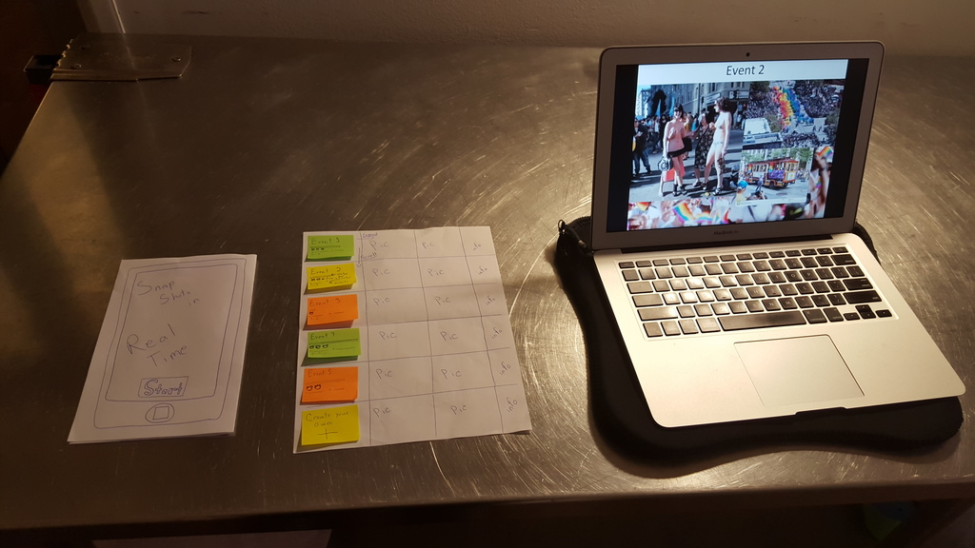 The second prototype we made focused on events that are currently happening. We worked under the assumption that if users were willing to supply pictures and information, other users would use this information as a snap shot of an event. This led us to prototype our 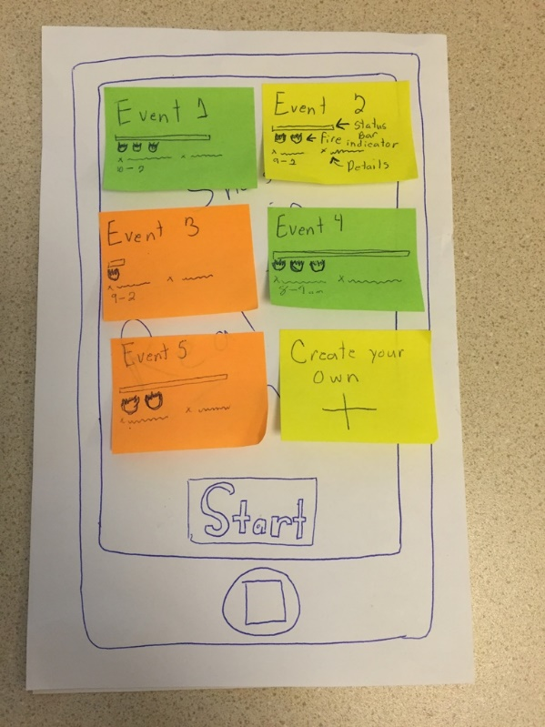“snapshot” concept by creating a collection of events on a sheet of paper with attached sticky notes featuring information about each individual event. We tested this prototype by asking the subjects to treat the paper with sticky notes as an interface, then asking them to act as though they were choosing an event to attend based on the information given. This lead the users to navigate the prototype by pressing on events to see the snapshot information and party pictures we used as substitutes. Based on the information they were able to gather we asked them to make a decision about which of the events on the 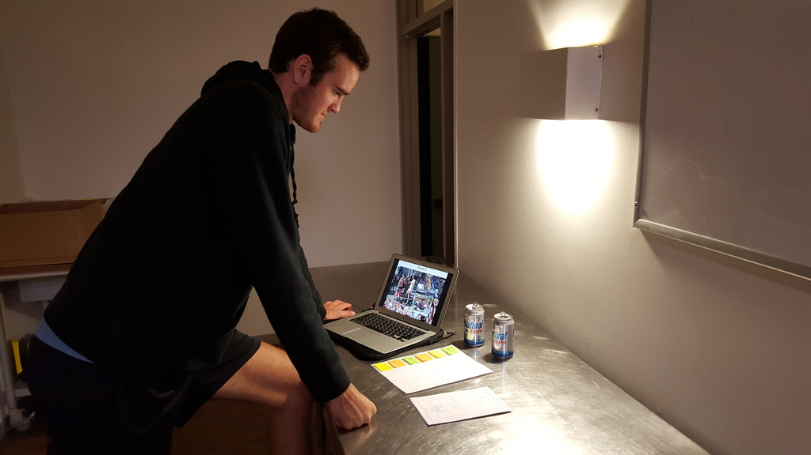prototype they wanted to attend. After giving them a predetermined result about how much they would have enjoyed the event they chose we asked them questions about their experience with the snapshot prototype. The subjects enjoyed the concept and consistently stated that they saw a practical use for such a product. However, they expressed concern about posting images of themselves, inability to include friends in their activities on the application, and security of unofficial event locations. Our assumption that people would be willing to share and use the information of others proved to be valid. However, there is a new assumption that people will want to include their friends in their plans to utilize information about events.

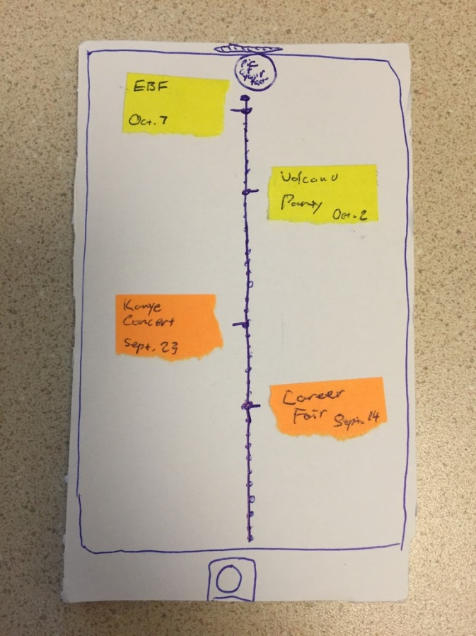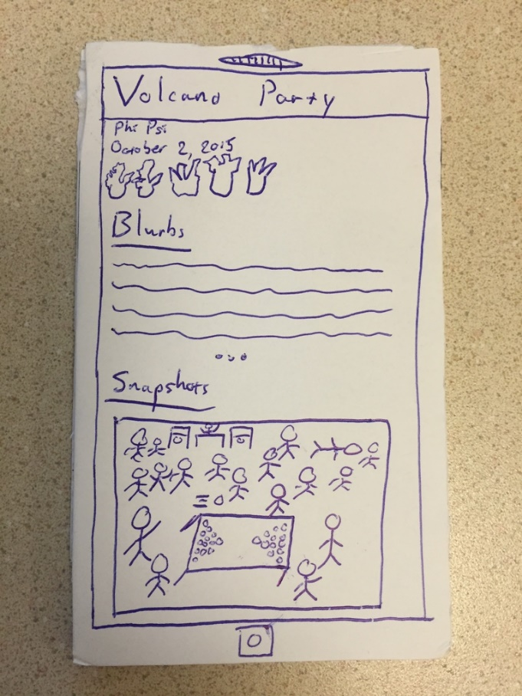Our final prototype revolved around a timeline feature in which users could view events that they had attended in the past. Along with the events, users could view blurbs and pictures that were posted while the event was going on, essentially a snapshot in time. This entire prototype is itself an assumption that people are interested in going back and remembering the past. We made the prototype by drawing a simple interface on a cardboard cutout, then tested it by giving it to a user, setting him in a scene, and guiding him through active decisions regarding past events he attended. Based on our tester’s feedback, we realized that the timeline format and blurb documentation worked as effective means of communicating events. What didn’t work was the separation of blurbs and snapshots. Our user expressed that displaying the event page chronologically as things were posted through the night would be more conducive to nostalgia than simply a list. Additionally, we were surprised as to how much the tester wanted photos to be a part of the experience, he explained 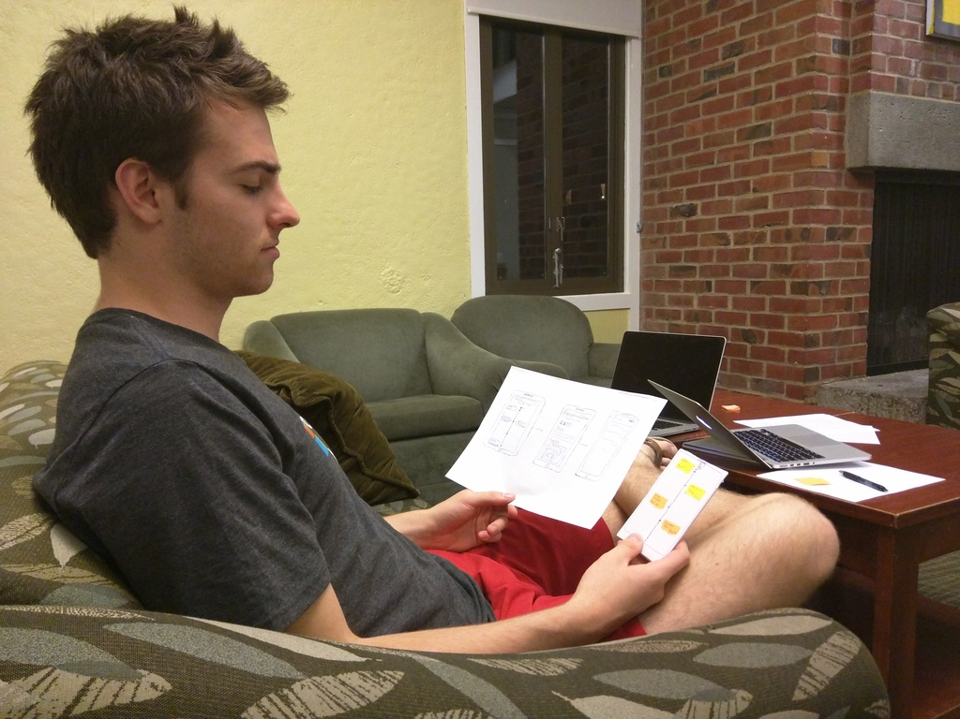that photos are far better for remembering something than simple text. That being said, our initial assumption about this being a feature that people want and would use was valid.

While all three prototypes resonated well, the second prototype that focused on current events was best received and showed the most promise in terms of solving the problems we are facing. Users seemed most enthused about the possibilities with this prototype, and overall were more impressed with what it had to offer. In the coming weeks we are going to work on fleshing out a more refined model of the prototype and possibly incorporating elements of the other two.