Master Thesis Project
Thesis verification

Author: Cristian Leoni
Supervisor: Rafael M. Martins
Examiner: Narges Khakpour
Semester: VT/HT 21
Course Code: 4DV50E
Subject: Computer Science

Contents

1 Problem Statement 2
2 Tool assisted analysis 2

- Problem Statement.
I want to see if my tool works as intended, in particular I want to see if I’m able to explain why a set of points resulted in a cluster after having applied a dimensionality reduction algorithm to them

Tool assisted analysis.
The Iris flower data set or Fisher's Iris data set is a multivariate data set introduced by the British statistician, eugenicist, and biologist Ronald Fisher in his 1936 paper The use of multiple measurements in taxonomic problems as an example of linear discriminant analysis.[1] It is sometimes called Anderson's Iris data set because Edgar Anderson collected the data to quantify the morphologic variation of Iris flowers of three related species.[2] Two of the three species were collected in the Gaspé Peninsula "all from the same pasture, and picked on the same day and measured at the same time by the same person with the same apparatus".[3]

The data set consists of 50 samples from each of three species of Iris (Iris setosa, Iris virginica and Iris versicolor). Four features were measured from each sample: the length and the width of the sepals and petals, in centimeters. Based on the combination of these four features, Fisher developed a linear discriminant model to distinguish the species from each other. Based on Fisher's linear discriminant model, this data set became a typical test case for many statistical classification techniques in machine learning such as support vector machines.[5]

The use of this data set in cluster analysis however is not common, since the data set only contains two clusters with rather obvious separation. One of the clusters contains Iris setosa, while the other cluster contains both Iris virginica and Iris versicolor and is not separable without the species information Fisher used. This makes the data set a good example to explain the difference between supervised and unsupervised techniques in data mining: Fisher's linear discriminant model can only be obtained when the object species are known: class labels and clusters are not necessarily the same. -Wikipedia

Let’s see if we can replicate this results:

- Select iris dataset
- Select PCA
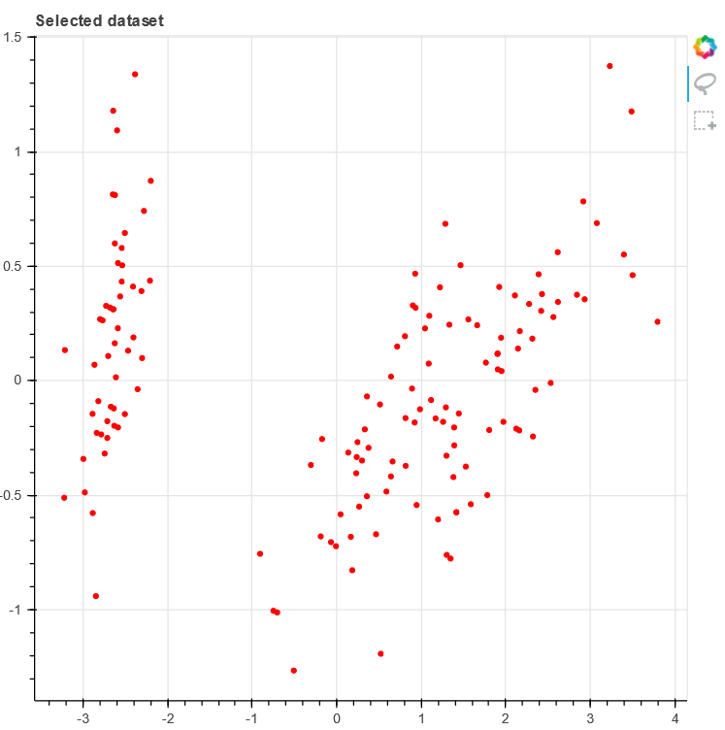
As we can see from the PCA results we can see two different clusters, it is rather obvious that the cluster on the left contains the Setosa elements, we will select those points and continue our analysis.

The Overview tab in the selection classifier shows that all classifiers achieve perfect separation of the classes, let us analyze all of them with default parameters:
- Tree: the tree classifier shows a strong preference for one feature, either petal length or petal width.
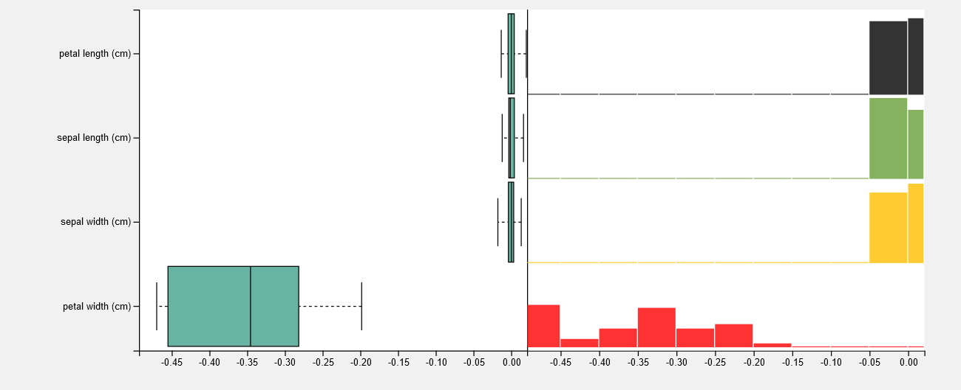
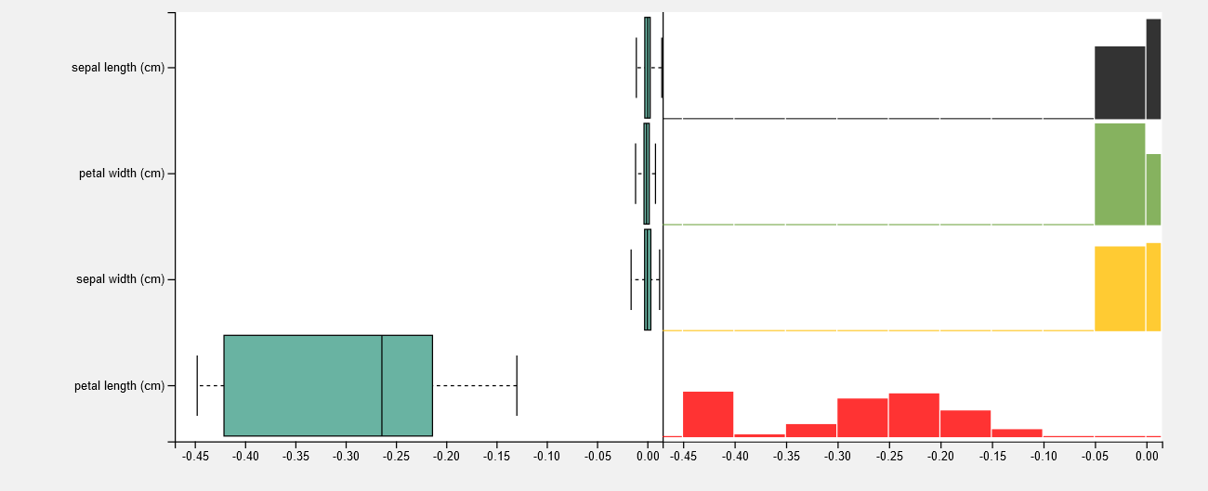

- Knn: the knn classifiers strongly prioritizes petal length, this classifier behaves in a deterministic way
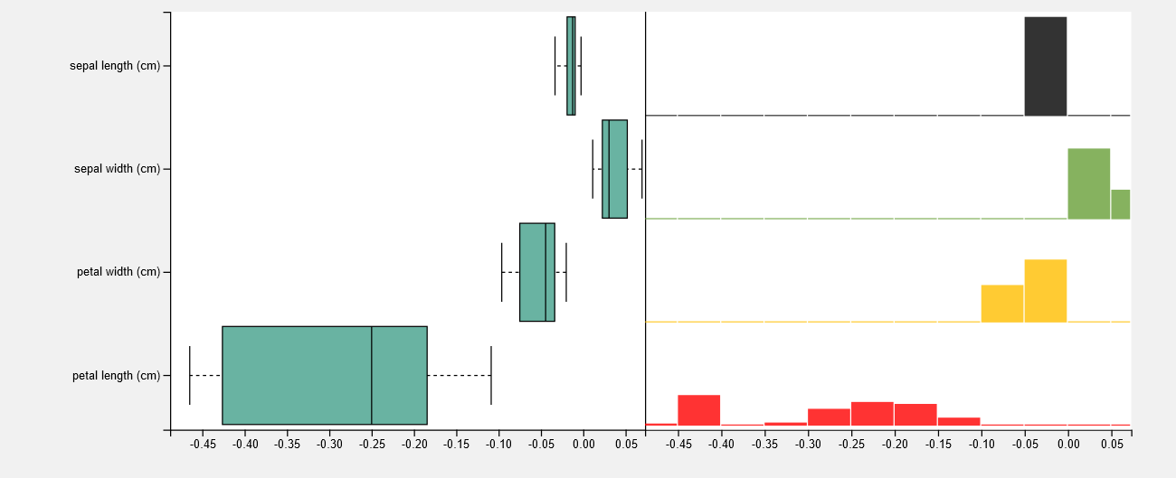
- SVC: this classifier prefers petal length and width closely followed by sepal width
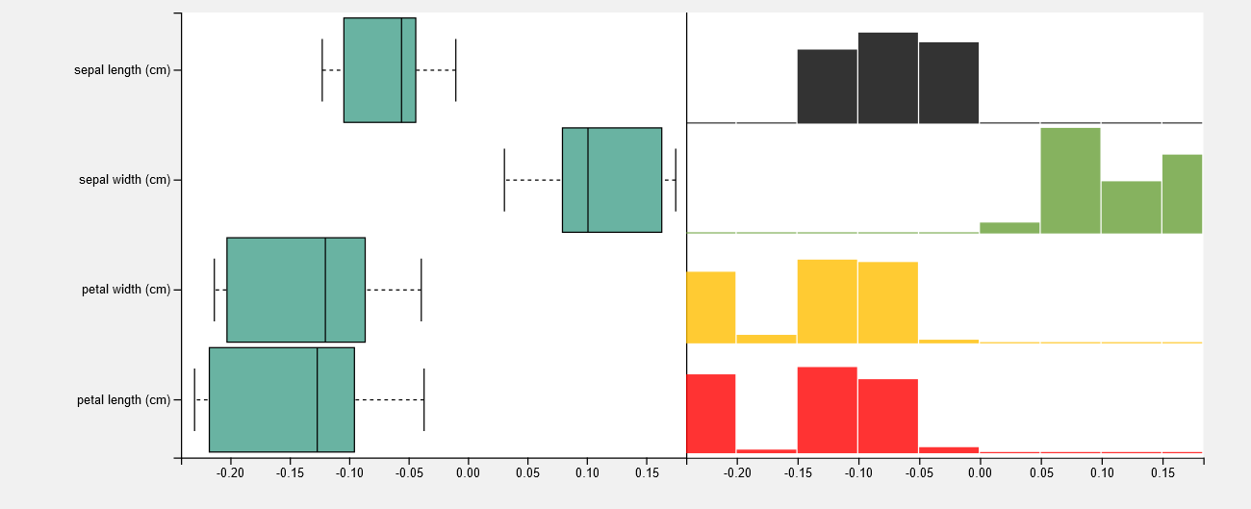
- Decision tree: behaves in a similar way to the tree
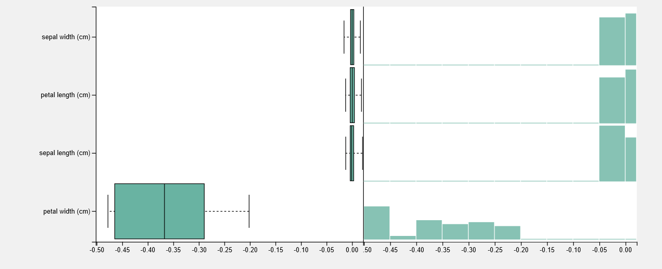
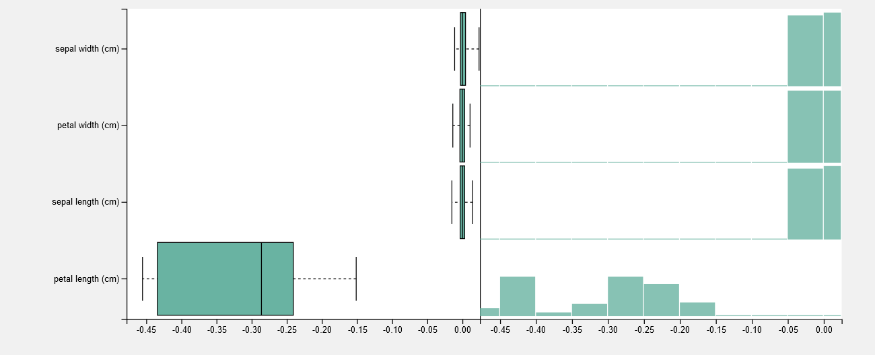
- Naïve Bayes: petal length and petal width are the preferred features, but the overall scores are much lower compared to the other classifiers
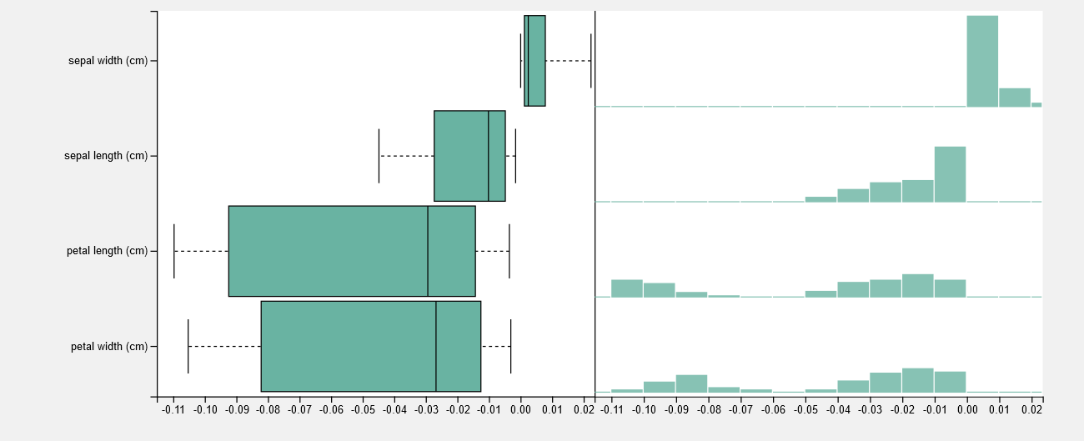

Since all the features are present in the explanation, we can analyze them by clicking on each feature in the explanation plot:
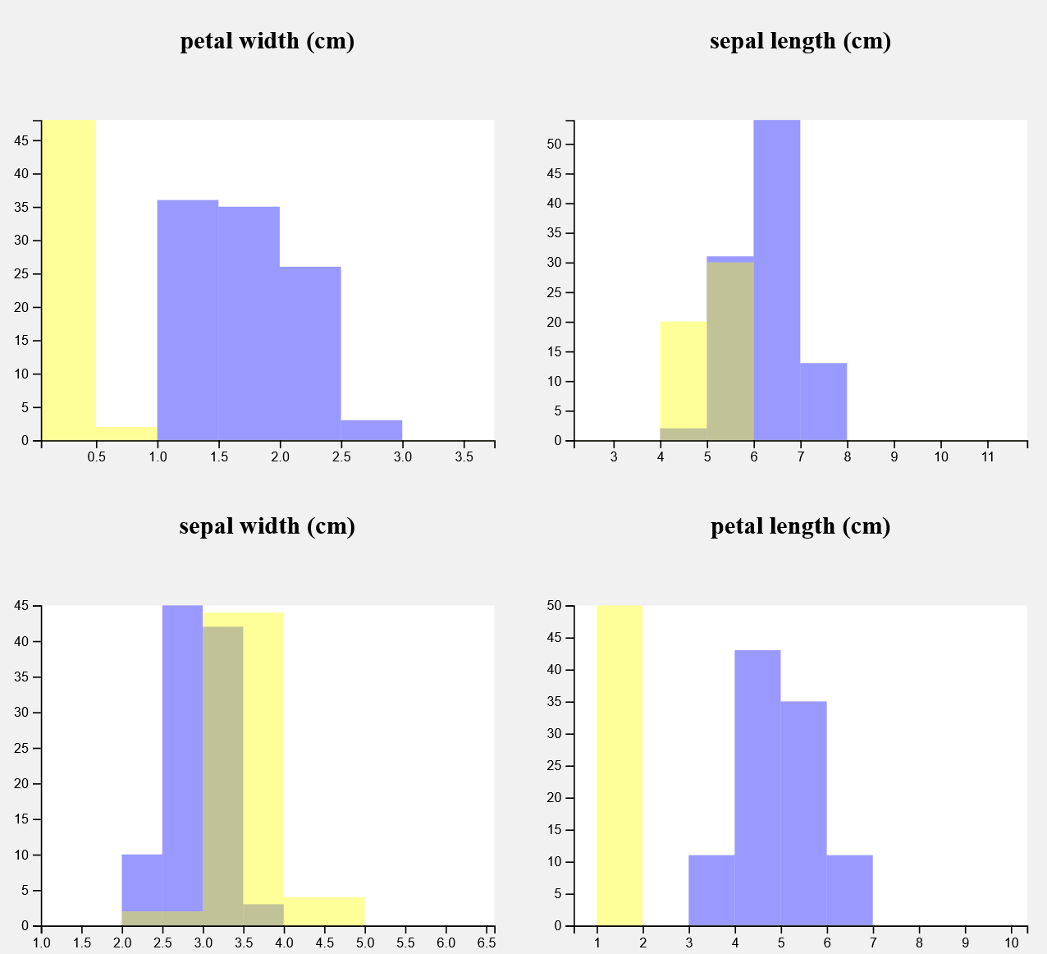

As we expected both petal width and petal length form a perfect split of the dataset, as such a classification accuracy of 100% can be achieved only based on either feature.
Sepal length has a good split for petal length for the value of 6, this split in unbalanced in favor of class 0, this means that based on sepal length is a good predictor for class 0 for values greater than 6.
Sepal width has the worst separation overall but contains a clear separation in favor of class one for values greater than 4.

Overall, this manual analysis and the classifiers explanation mostly agree over the results, however some interesting results can be observed:
- Some of the classifiers, such as the tree, may ignore perfectly good features in favor of a strong reliance on a single feature.
- The classifiers that do not rely on a single feature for the explanation better reflect the hierarchy of feature importance, however the importance of perfect split features are much lower and possibly underestimated.
- With the exception of the Naïve Bayes classifier, most importance distributions lie either on the positive or negative side of the axis.

The process was repeated, this time trying to select the versicolor class, since there is no clear separation this time we plotted the pca beforehand (picture on the left). The picture on the right shows the manual selection in the tool, in red the selected points.

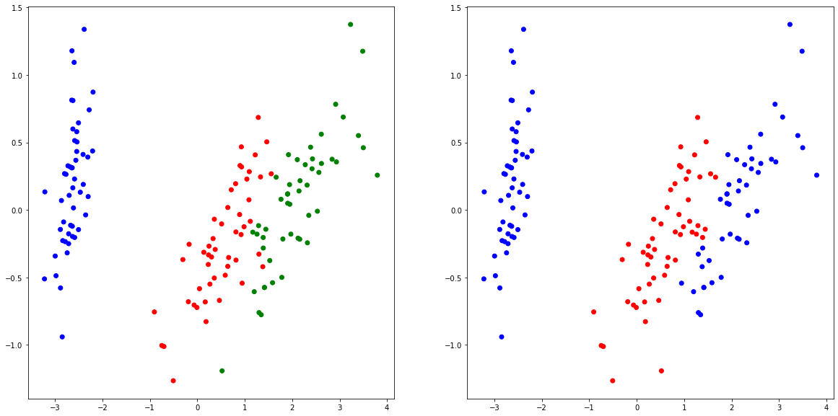

The Overview tab in the selection classifier shows that all classifiers achieve perfect separation of the classes, let’s analyze all of them with default parameters:

- Tree: petal width and petal length are the two top predictors, with little variance across multiple runs
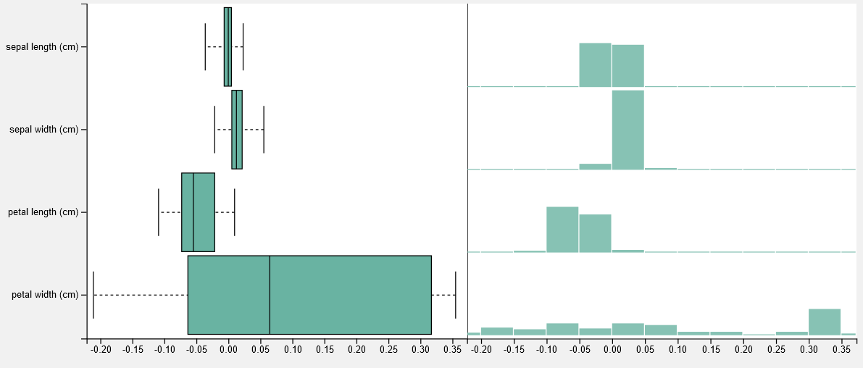
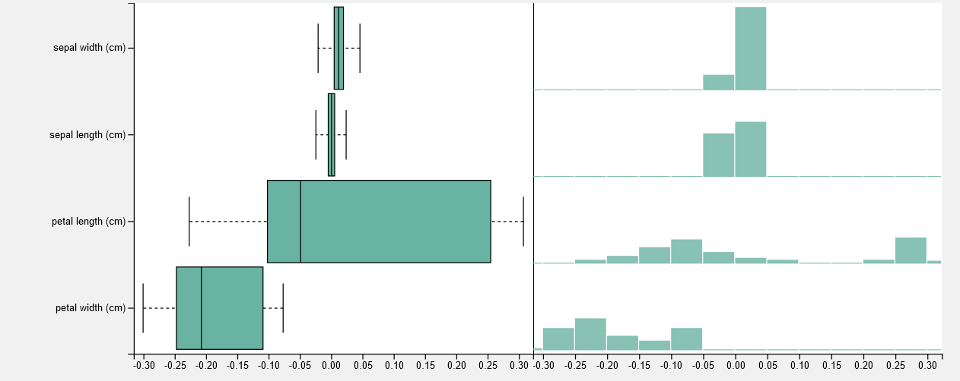
- Knn: petal length shows the widest importance distribution, while sepal and petal width have a denser distribution
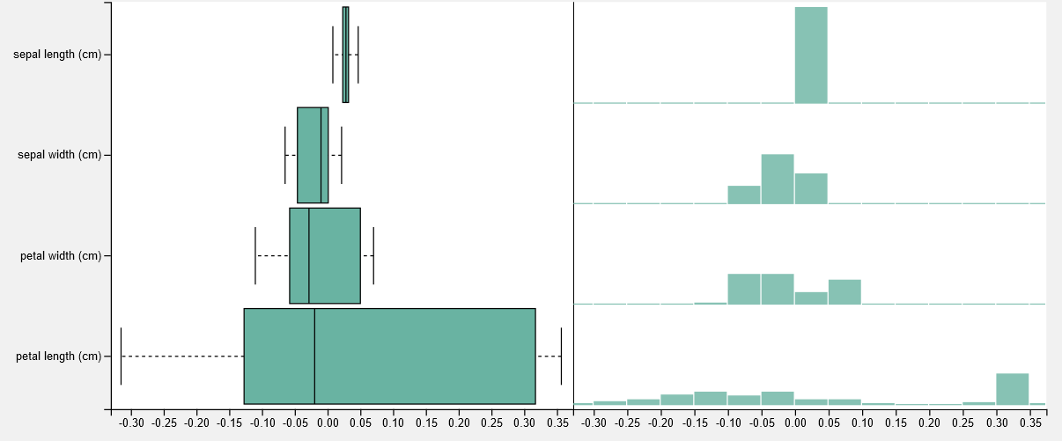
- Svc: wider importance distribution than previous classifiers, interestingly, sepal width has less importance than sepal length
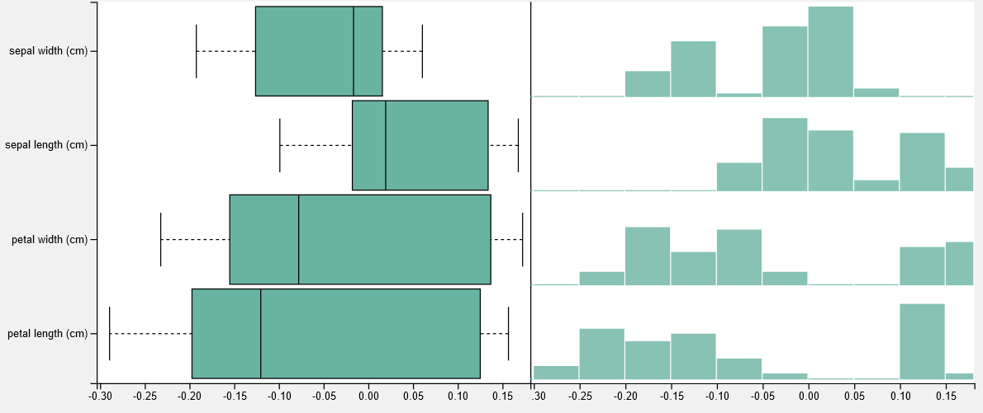
- Decision tree: petal length and petal are the two most important features across multiple runs, sepal width is slightly more important than sepal length
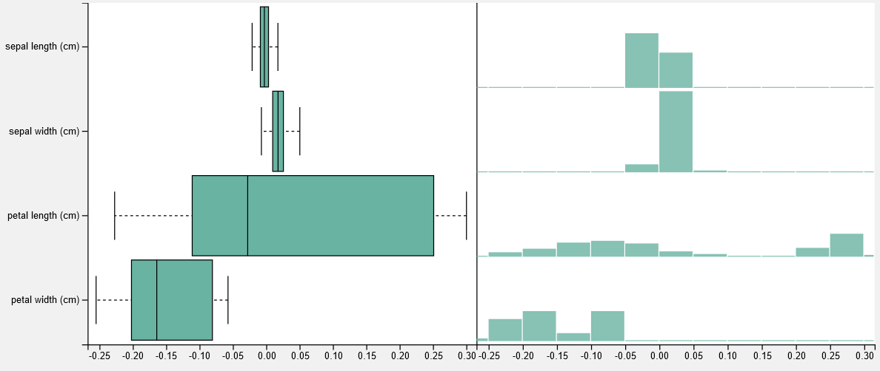
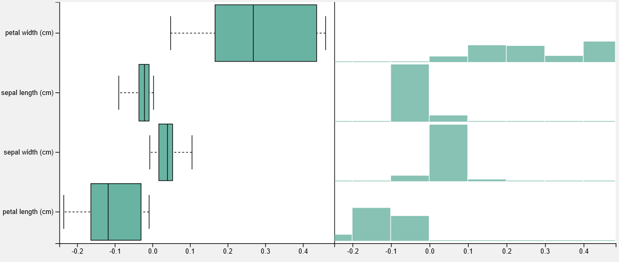
- Naïve Bayes: Interestingly this classifier shows similar importance distributions for petal length, sepal length and petal width, with sepal width being the less important one
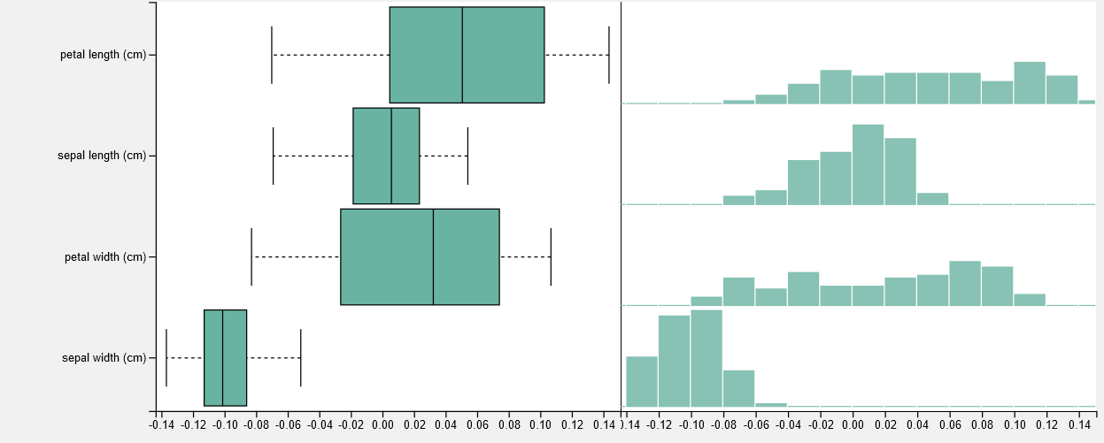

Analyzing the dataset we find no perfect split, with petal length and width still look to be the clearest predictors:

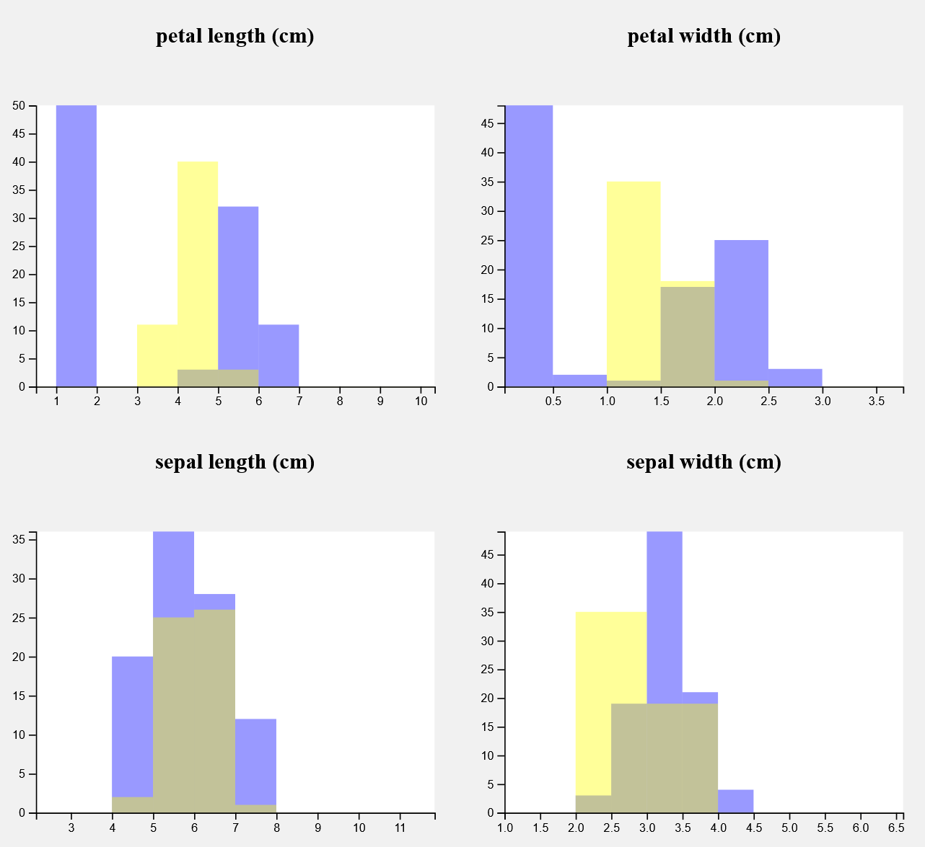

Based on this analysis the following consideration can be made:
- Despite all achieving perfect score these classifiers seem to disagree on the importance of the features, with some preferring sepal width over sepal length and other the opposite.
- All classifiers seem to agree that petal length and petal width are still the two best features for identifying the cluster
- The lower scores of this more difficult case reflect a less clear distinction between classes in the data, reflected also by the histograms plots.
- In the explanations the importance histogram display a less clear prevalence for any single class (selected vs non selected), with some peaks on both sides. This behavior might be due to an asymmetric importance for some values for the classes.

