**Universidad de las Fuerzas Armadas ESPE**

**Members:** Gallardo Juan, Hidrobo Nicolás, Lara Nicole, Maranje Cristian.

**NRC:** 3248

**Object-Oriented Programming**

**Specification of Requirements according to the standard from IEEE830**

**Proyect: University Restaurant Capacity Control System**

**1 Introduction**

This document is a Software Requirement Specification (ERS) for the People Control System in a university bar. This specification has been structured based on the guidelines given by the IEEE 830, 1998 standard.

**1.1 Purpose**

The purpose of this document is to define functional and non-functional specifications for the development of a people control and management system for edible products in a university bar.  
Which will be used by students, teachers and those in charge of the bar.

**1.2 System scope**

University Capacity Control is a system aimed at the user of the system; it will help solve the current problem of covid 19 by distancing people in a place that is very frequented by all kinds of people at the university. This project aims to manage people, orders and products in a university bar.

**1.3 Involved personnel**

|  |  |
| --- | --- |
| **Name** | Juan Gallardo |
| **Role** | Analyst, designer and programmer |
| **Professional Category** | Software engineering student |
| **Responsibility** | Information analysis, design and programming of the System |
| **Contact Information** | jegallardo@espe.edu.ec |

|  |  |
| --- | --- |
| **Name** | Nicolás Hidrobo |
| **Role** | Analyst, designer and programmer |
| **Professional Category** | Software engineering student |
| **Responsibility** | Information analysis, design and programming of the System |
| **Contact Information** | anhidrobo@espe.edu.ec |

|  |  |
| --- | --- |
| **Name** | Nicole Lara |
| **Role** | Analyst, designer and programmer |
| **Professional Category** | Software engineering student |
| **Responsibility** | Information analysis, design and programming of the System |
| **Contact Information** | nalara1@espe.edu.ec |

|  |  |
| --- | --- |
| **Name** | Cristian Maranje |
| **Role** | Analyst, designer and programmer |
| **Professional Category** | Software engineering student |
| **Responsibility** | Information analysis, design and programming of the System |
| **Contact Information** | ccmaranje@espe.edu.ec |

**1.4.Definitions, acronyms and abbreviations.**

|  |  |
| --- | --- |
| **Name** | **Description** |
| **Usuario** | **Person who will use the system to manage processes.** |
| **SIS-I** | **Web Information System for the Management of Administrative and Academic Processes.** |
| **ERS** | **Software Requirements Specification.** |
| **FR** | **Functional Requirement.** |
| **RNF** | **Non-functional requirement.** |
| **FTP** | **File Transfer Protocol.** |
| **Moodle** | **Virtual classroom.** |

**1.5 Referencias**

|  |  |
| --- | --- |
| **Document Title** | **Reference** |
| **Standard IEEE 830 - 1998** | **IEEE** |

**1.6.Reference**

IEEE(03 January 2021) Specification of Requirements by IEEE 830 obtained from:https://www.fdi.ucm.es/profesor/gmendez/docs/is0809/ieee830.pdf

**1.7 Summary.**

This document consists of three sections. The first section introduces it and provides an overview of the system resource specification.

In the second section of the document, a general description of the system is made, in order to know the main functions that it must perform, the associated data and the factors, restrictions, assumptions and dependencies that affect development, without going into excessive detail.

**2.General Description.**

**2.1 Product Perspective**

The purpose of this software system offers a capacity and inventory control that can be adapted to different contexts of a changing commercial world, unlike most existing programs that are only focused on the current reality but not in the future in the conditions are determined by external factors such as a global health emergency.

The versatility of functions that the future software will have will allow it to adapt to cash control programs, billing, data registration, among others, such as those that commonly affect a large part of businesses today, since this software does not influence these characteristics if not rather complements them by adding extra information and additional functionalities.

Although this system is focused on improving the customer experience of a restaurant, it is not thinking of its present version to interact directly with customers, but rather through an intermediary, which in this case is the restaurant's employees and administrators. It is not oriented or adapted to a friendly interface for a general user or to be coupled to devices that facilitate its reach to a more general public. Its main objective is to serve small or large companies to have a better control of their commercial activities.

**2.2 Product Functions.**

The University Restaurant Capacity Control System will regulate and warn about violation of the capacity conditions allowed in the specifications of its configuration, the system will notify and anticipate both the restaurant employees and the customers about the availability of people who can enter.

For clients:.

The system will generate a random location between the tables that meet the minimum distance specifications defined in their previous configuration, thus guaranteeing the correct positioning between clients.

In order to guarantee a correct flow of people within the facilities, which will be indispensable for the availability of tables to be a test, this program will have a timer function that will notify both the client and the collaborator of the time limit that has been set. intended for a table in use.

For the restaurant:

This system will allow an independent inventory program to be carried out from information supplied to a not very extensive database that will allow the program to provide better control of:

* Inputs and acquisition of products as raw material
* Departure and sale of products present in a menu.
* Availability or exhaustion of products
* Maximum inventory capacity according to the conditions defined by an administrator according to the agreement for the business conditions

This information defined by the program can be reviewed and exported by a specific administrator in order to reproduce the data generated in a more formal report.

**2.1.1 Function Relationship**

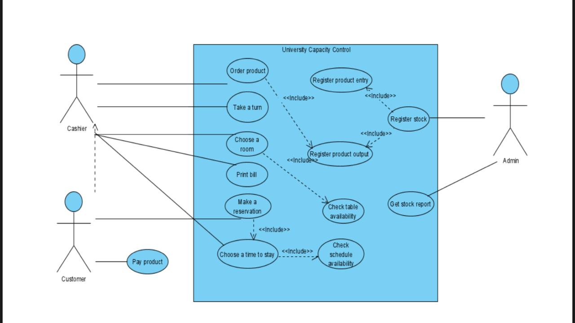

**2.3 Users Characteristics.**

|  |  |
| --- | --- |
| Type of User | System administrator |
| Professional training | Business manager |
| Activities | -Authorizes the change or new entry of data on a product  -Manages and defines the default configurations of the system |

|  |  |
| --- | --- |
| Type of User | Business collaborator |
| Professional training | Restaurant assistant |
| Activities | -Manipulates the system to provide information to the client or administrator  -Gives shifts and assigns positions to the client  -Registers entries and exits of products to inventory |

|  |  |
| --- | --- |
| Type of User | Customer |
| Professional training | Undefined |
| Activities | -Choose a room to which a positionit should be assigned  -Request through a restaurant employee a table or an assignment shift |

**2.4 Restrictions**

The restrictions for the software developers are the following:

* Hardware limitations: the software must run in a low-end machine so it must be easy to run.
* Ability requirements: the developing team needs to have a minimum to medium knowledge to be able to create the software.
* Programming language: the software has to be made in java language and in the NetBeans IDE software.

**2.5 Dependencies and suppositions**

The software is going to be developed for the restaurant at the “ESPE” University, for the control of the tables and seats that are inside and outside of the restaurant, it will have a record of the menu of the restaurant, it complies with the most recent biosecurity protocols in Ecuador.

**3 Specific requirements**

Functional requirement 1

The cashier registers the order of the customer in the system.

|  |  |
| --- | --- |
| Requirement identification | FR01 |
| Requirement Name | Order |
| Characteristics | The order is registered in the system. |
| Requirement description | The cashier is the person in charge of registering the order. |
| Non-functional requirement |  |
| Requirement priority | High |

Functional requirement 2

The system will allow to create, delete and edit an order.

|  |  |
| --- | --- |
| Requirement identification | FR02 |
| Requirement Name | Order editor |
| Characteristics | The order can be created, changed or deleted. |
| Requirement description | Manipulate the orders. |
| Non-functional requirement |  |
| Requirement priority | High |

Functional requirement 3

The system will increase and decrease the amount of product in stock.

|  |  |
| --- | --- |
| Requirement identification | FR03 |
| Requirement Name | Stock actualization |
| Characteristics | Edits the totals in the stocks. |
| Requirement description | The amount of certain product in the stock can be increased or decreased. |
| Non-functional requirement |  |
| Requirement priority | High |

Functional requirement 4

The system will keep track of the expiration date of the products.

|  |  |
| --- | --- |
| 05Requirement identification | FR04 |
| Requirement Name | Expiration dates |
| Characteristics | Checks the date of the products |
| Requirement description | Gives an alert if there is a product close to expiration date. |
| Non-functional requirement |  |
| Requirement priority | Medium |

Functional requirement 5

The system keeps track of the viable seats

|  |  |
| --- | --- |
| Requirement identification | FR05 |
| Requirement Name | Availability |
| Characteristics | Checks if the seats are empty. |
| Requirement description | If the seats are available the costumer can seat |
| Non-functional requirement |  |
| Requirement priority | High |

Non-functional requirement 1

The system will have an interface that is easy to use for the cashier

|  |  |
| --- | --- |
| Requirement identification | NFR01 |
| Requirement Name | Interface |
| Characteristics | Easy to use |
| Requirement description | The interface will have a low amount of clutter. |
| Requirement priority | Medium |

Non-functional requirement 2

The system is going to realize all of the process in the minimum time possible

|  |  |
| --- | --- |
| Requirement identification | NFR02 |
| Requirement Name | Response time |
| Characteristics | The system loads and realizes orations quickly. |
| Requirement description | Fast System |
| Requirement priority | Medium |