**B.E. CSE IV R BATCH**

**CS6107 COMPUTER ARCHITECTURE INTEGRATED LAB**

**LAB NO. : 1 DATE : 03.03.2021**

**REG NO. : 2019103066 NAME : SRIVATSAV R**

1. **HELLO.S :**

**Code :**

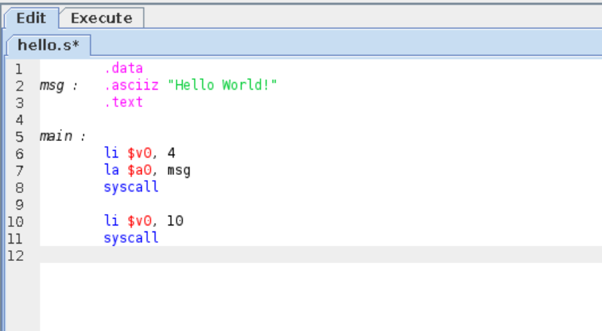

**Assembling :**

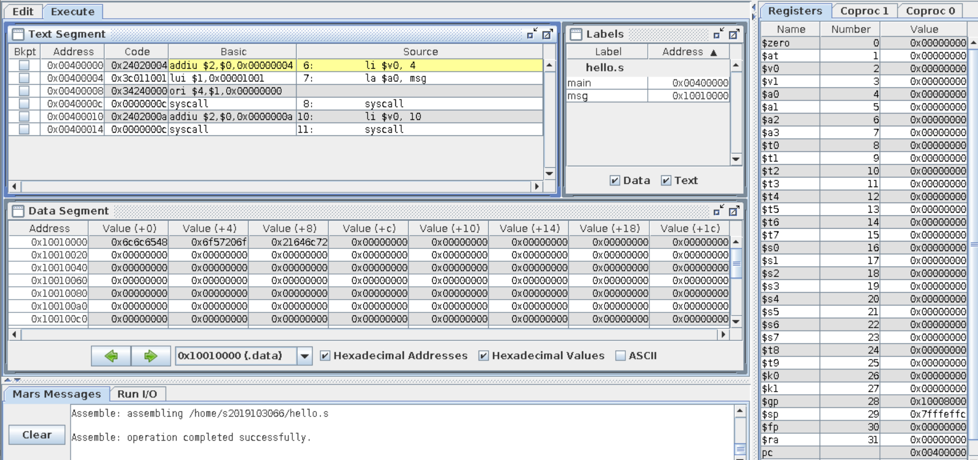

**Run :**

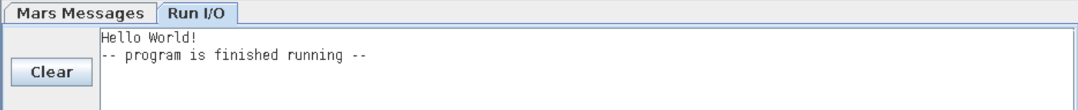

|  |  |
| --- | --- |
| Laboratory exercises identified (15) |  |
| On the Spot exercise (5) |  |
| Observation document (5) |  |
| Total (25) |  |
| Signature |  |