**OS ONSPOT LAB – 4**

**DATE : 08.03.2021**

1. **Write a program to copy the contents of one file to another files and the names of the two files should be read as an input from the command line :**

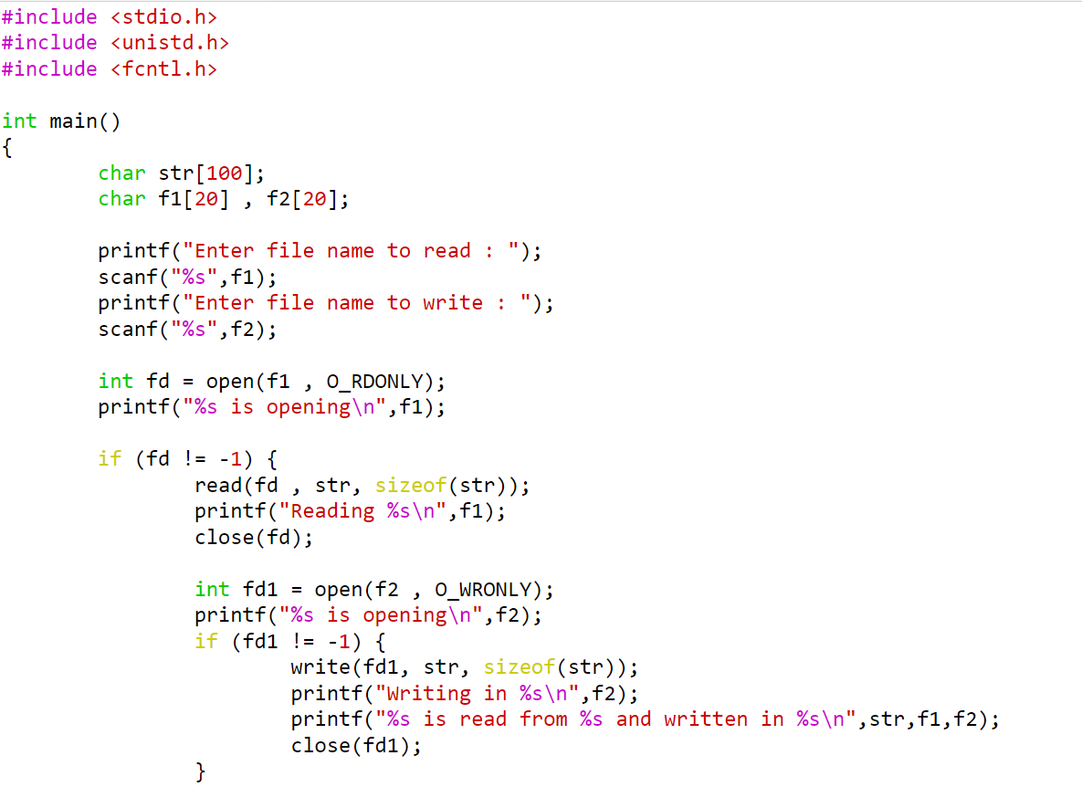

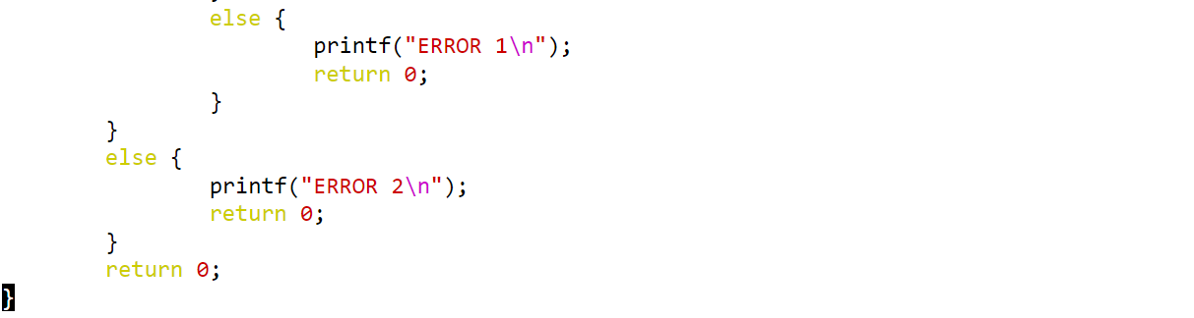

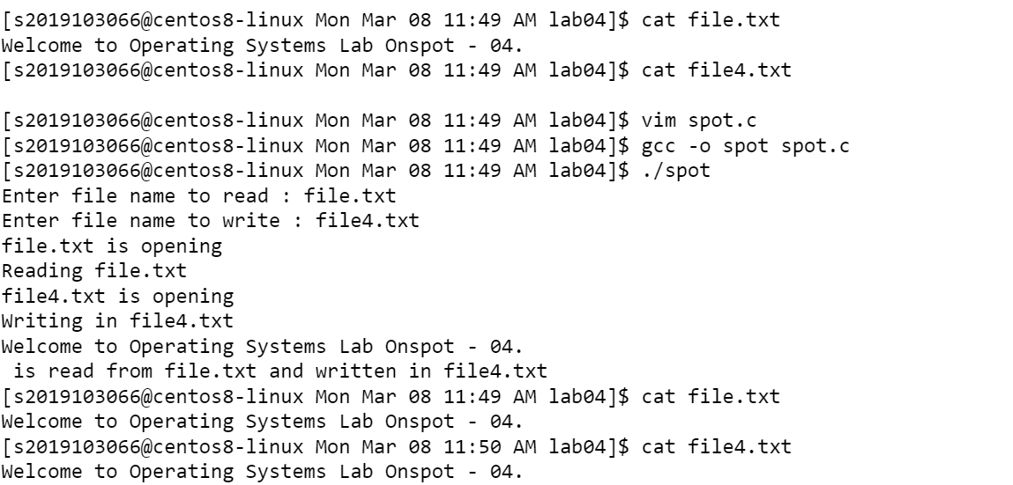

**BY.**

**SRIVATSAV R**

**2019103066.**