**OS LAB ASSIGNMENT – 4**

**SYSTEM CALLS**

**DATE : 08.03.2021**

1. **Creating a file and writing a string in it :**

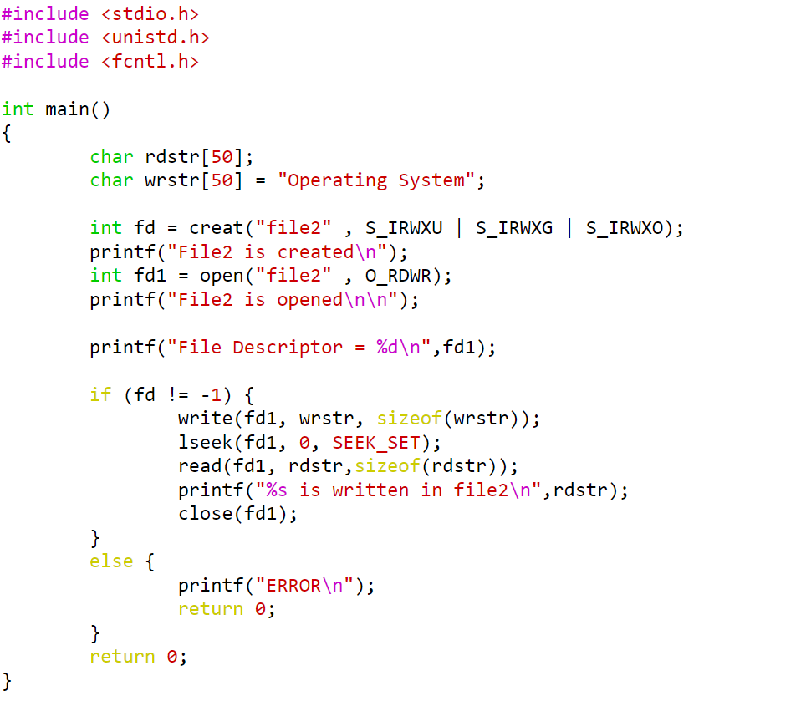

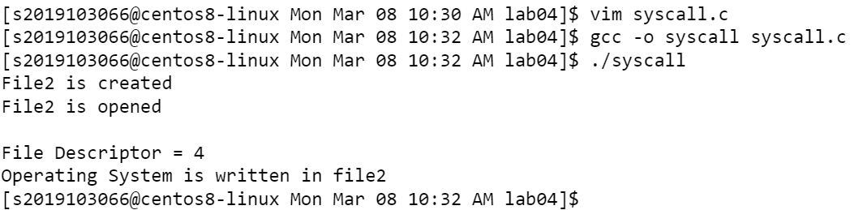

1. **Reading from an existing file ,creating a new file and writing in it :**

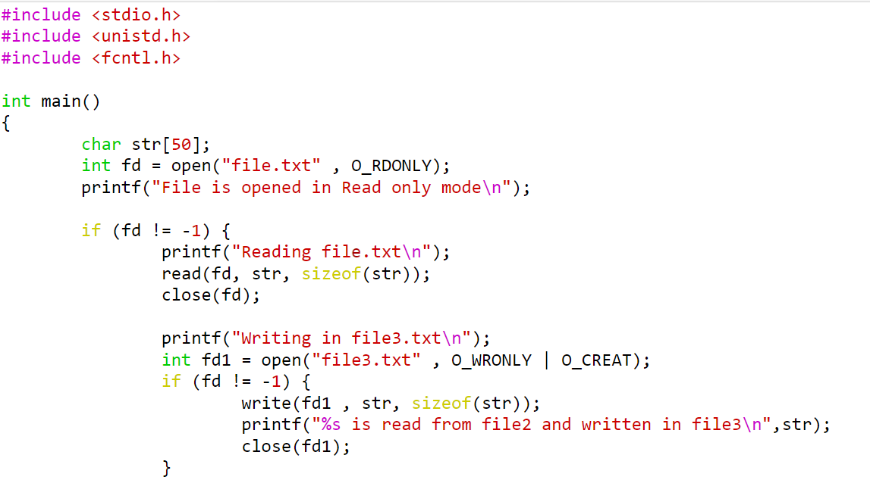

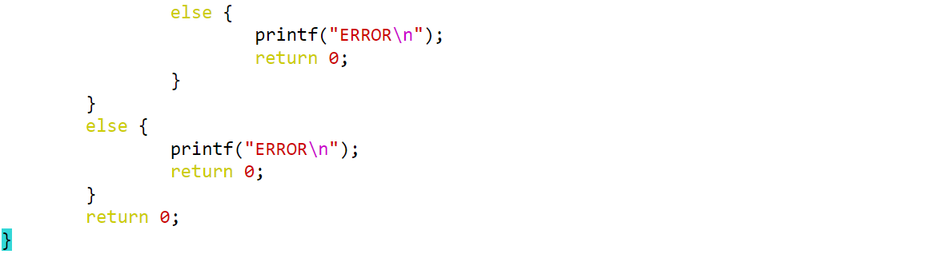

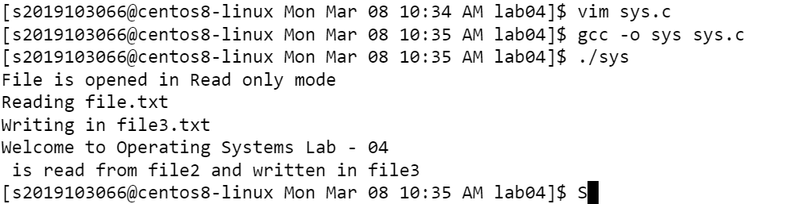

1. **Stat() :**

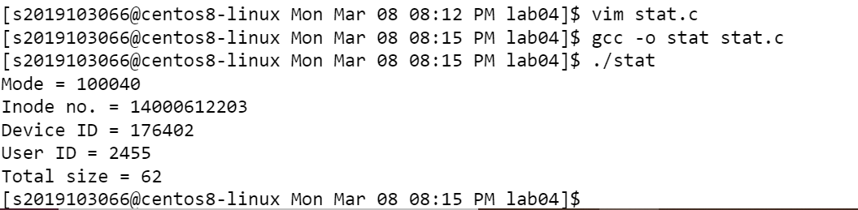

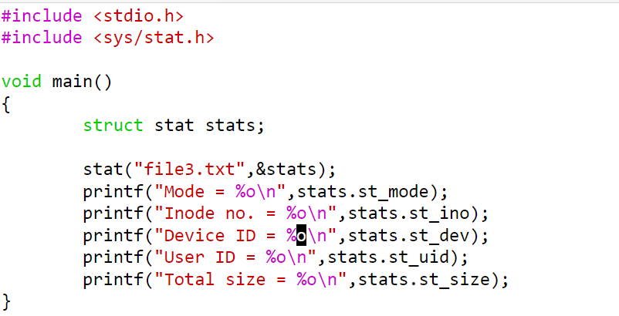

1. **Fstat() :**

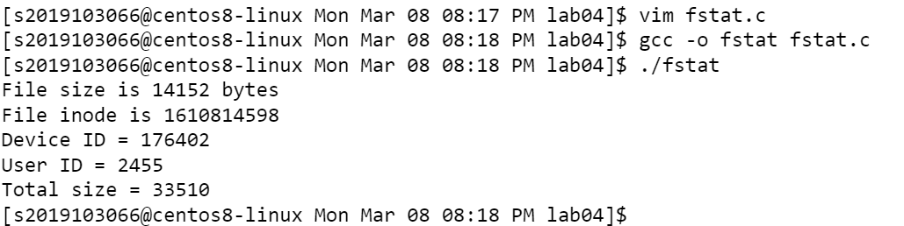

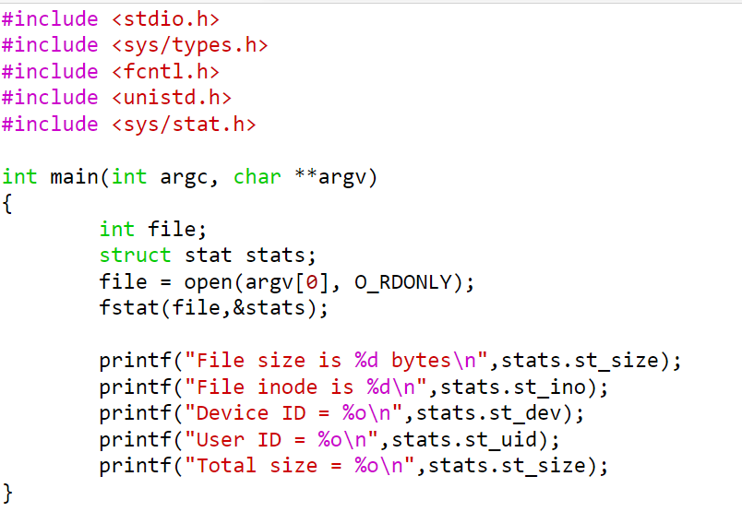

**BY.**

**SRIVATSAV R**

**2019103066.**