<https://youtube.com/playlist?list=PLG8SxFEDF7HAMntDi-BAgiMKNQKsSzzhr&si=Wk-chE52STuFgQjx>

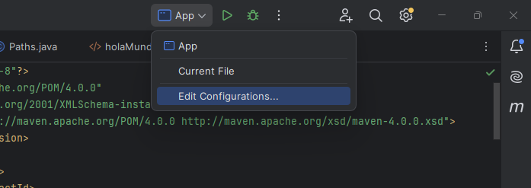

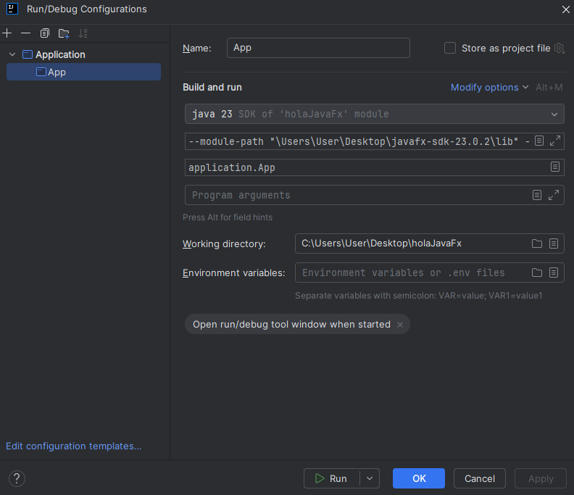

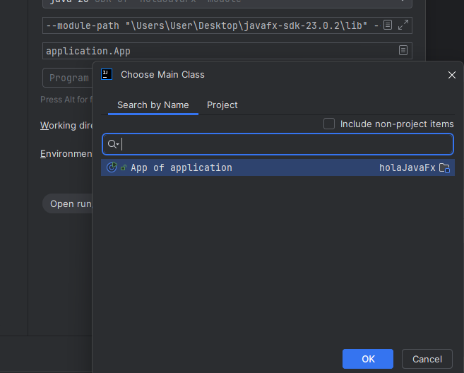

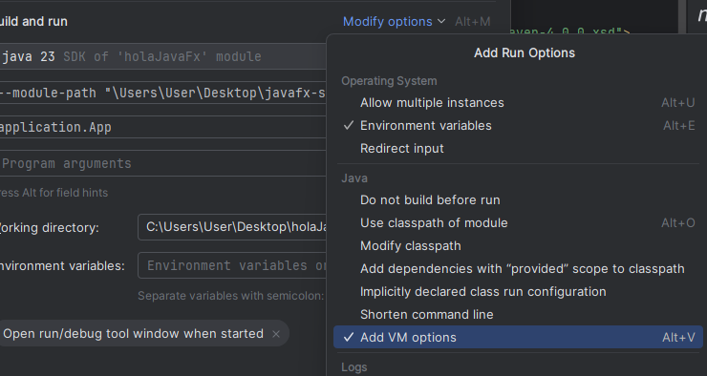

--module-path "\Users\User\Desktop\javafx-sdk-23.0.2\lib" --add-modules javafx.controls,javafx.fxml

<https://gluonhq.com/products/javafx/>

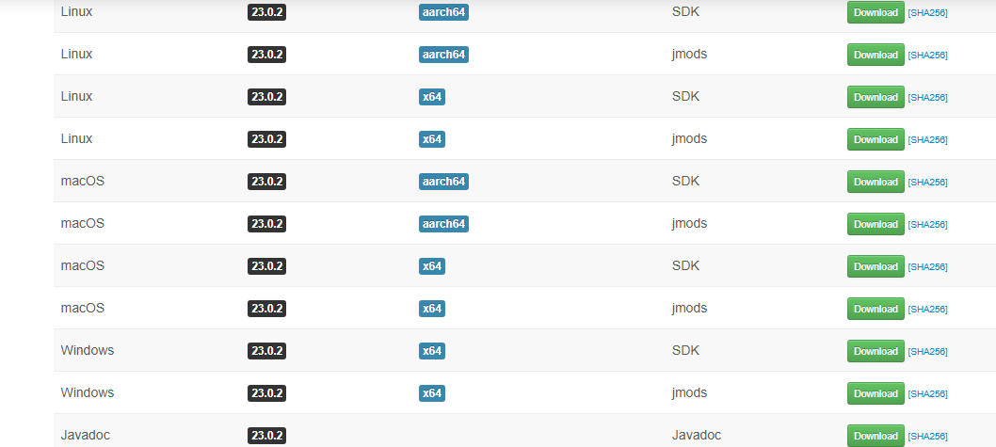

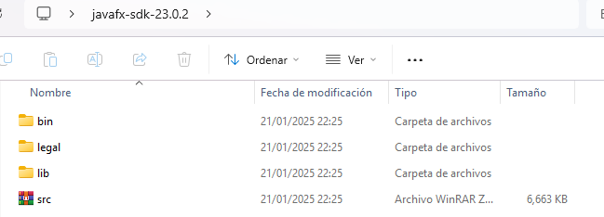

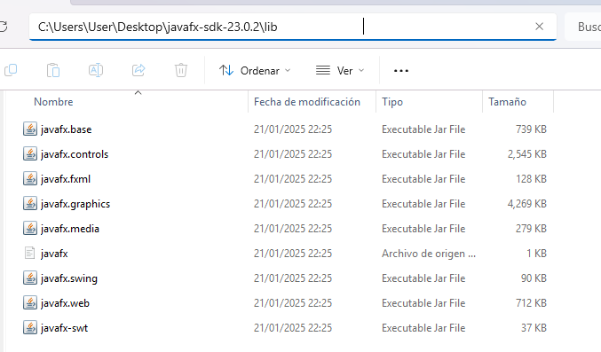

--------------------------------------------------------------------------------------------------------------------------

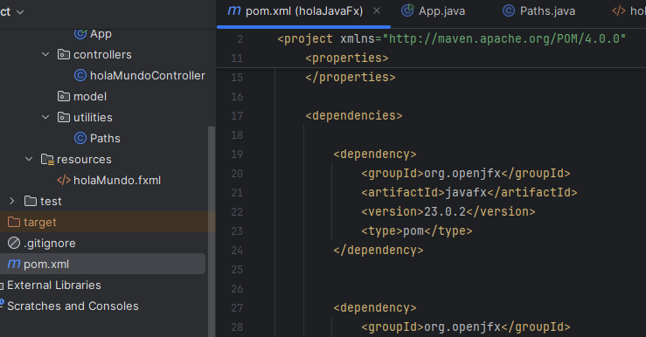

<?xml version="1.0" encoding="UTF-8"?>  
<project xmlns="http://maven.apache.org/POM/4.0.0"  
 xmlns:xsi="http://www.w3.org/2001/XMLSchema-instance"  
 xsi:schemaLocation="http://maven.apache.org/POM/4.0.0 http://maven.apache.org/xsd/maven-4.0.0.xsd">  
 <modelVersion>4.0.0</modelVersion>  
  
 <groupId>org.example</groupId>  
 <artifactId>holaJavaFx</artifactId>  
 <version>1.0-SNAPSHOT</version>  
  
 <properties>  
 <maven.compiler.source>23</maven.compiler.source>  
 <maven.compiler.target>23</maven.compiler.target>  
 <project.build.sourceEncoding>UTF-8</project.build.sourceEncoding>  
 </properties>  
  
 <dependencies>  
  
 <dependency>  
 <groupId>org.openjfx</groupId>  
 <artifactId>javafx</artifactId>  
 <version>23.0.2</version>  
 <type>pom</type>  
 </dependency>  
  
  
 <dependency>  
 <groupId>org.openjfx</groupId>  
 <artifactId>javafx-media</artifactId>  
 <version>23.0.2</version>  
 </dependency>  
  
  
 <dependency>  
 <groupId>org.openjfx</groupId>  
 <artifactId>javafx-fxml</artifactId>  
 <version>23.0.2</version>  
 </dependency>  
  
  
  
  
 <dependency>  
 <groupId>org.openjfx</groupId>  
 <artifactId>javafx-graphics</artifactId>  
 <version>23.0.2</version>  
 </dependency>  
  
  
 <dependency>  
 <groupId>org.openjfx</groupId>  
 <artifactId>javafx-base</artifactId>  
 <version>23.0.2</version>  
 </dependency>  
  
  
 <dependency>  
 <groupId>org.openjfx</groupId>  
 <artifactId>javafx-controls</artifactId>  
 <version>23.0.2</version>  
 </dependency>  
  
  
  
  
  
  
 </dependencies>  
  
  
</project>

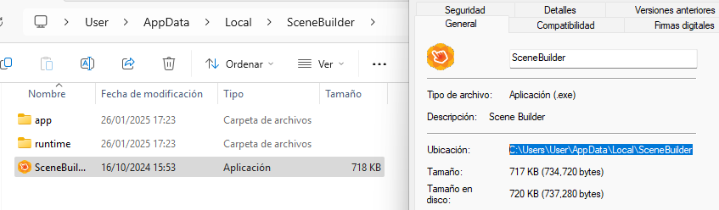

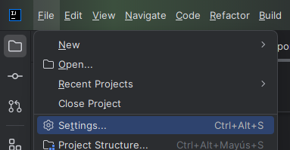

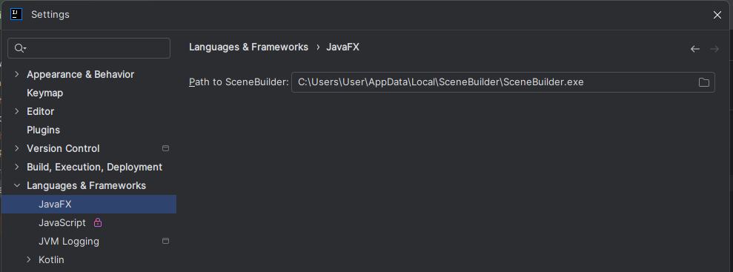

<https://gluonhq.com/products/scene-builder/#download>