1 – The first step, showing a hash. Using python2

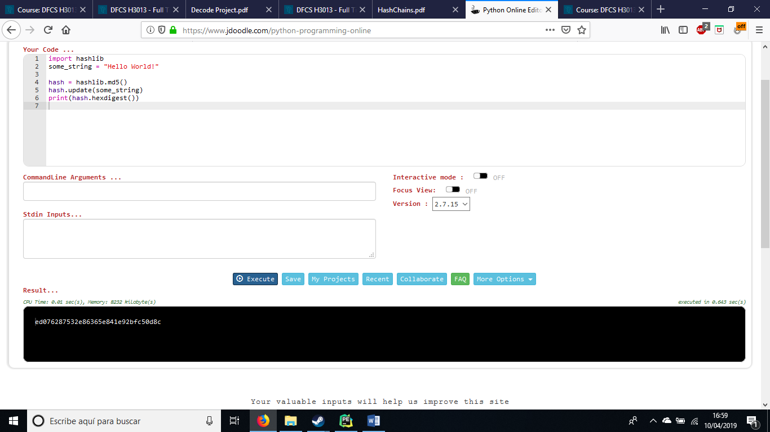

2- If you google the seed for nOOB (654e1c2ac6312d8c6441282f155c8ce9) you will see is encoded using md5 and its reverse is Noob, which is the original word but changing the upper for lower cases and viceversa.

