CS 255 System Design Document Template

This template lays out all the different sections that you need to complete for Project Two. Each section has guidance to prompt your thinking. You will need to continually reference the interview transcript as you work to make sure that you are addressing your client’s needs. There is no required length for the final document. Instead the goal is to complete each section based on what your client’s needs are. Remove this note when you are finished, and replace all bracketed text with the relevant information.

UML Diagrams

UML Use Case Diagram
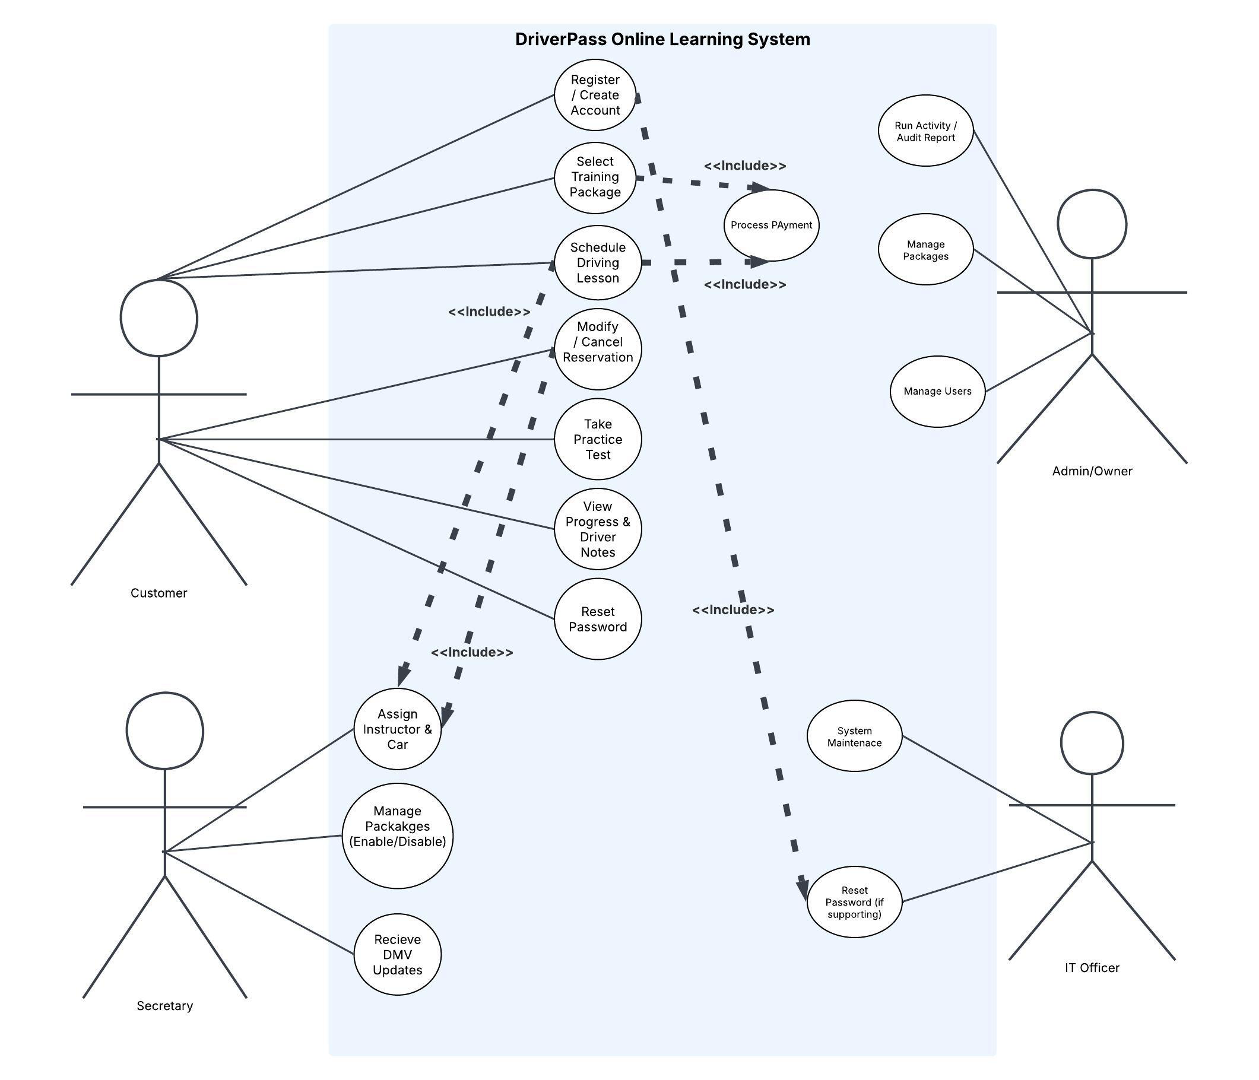

UML Activity Diagrams
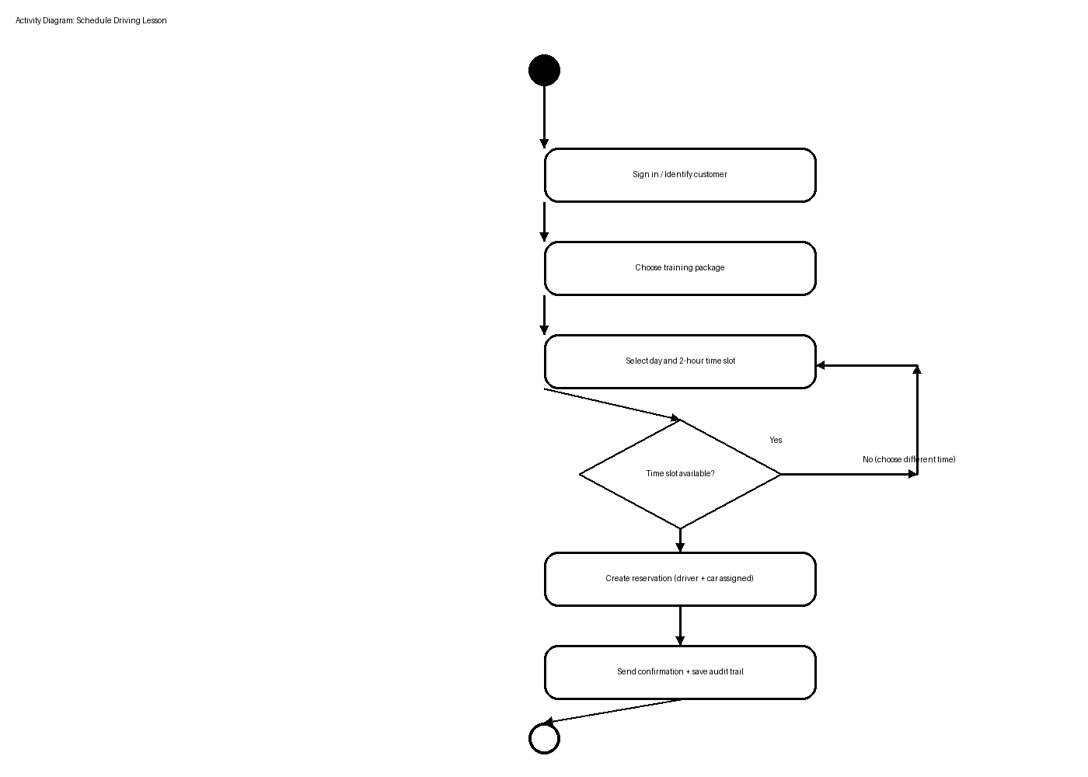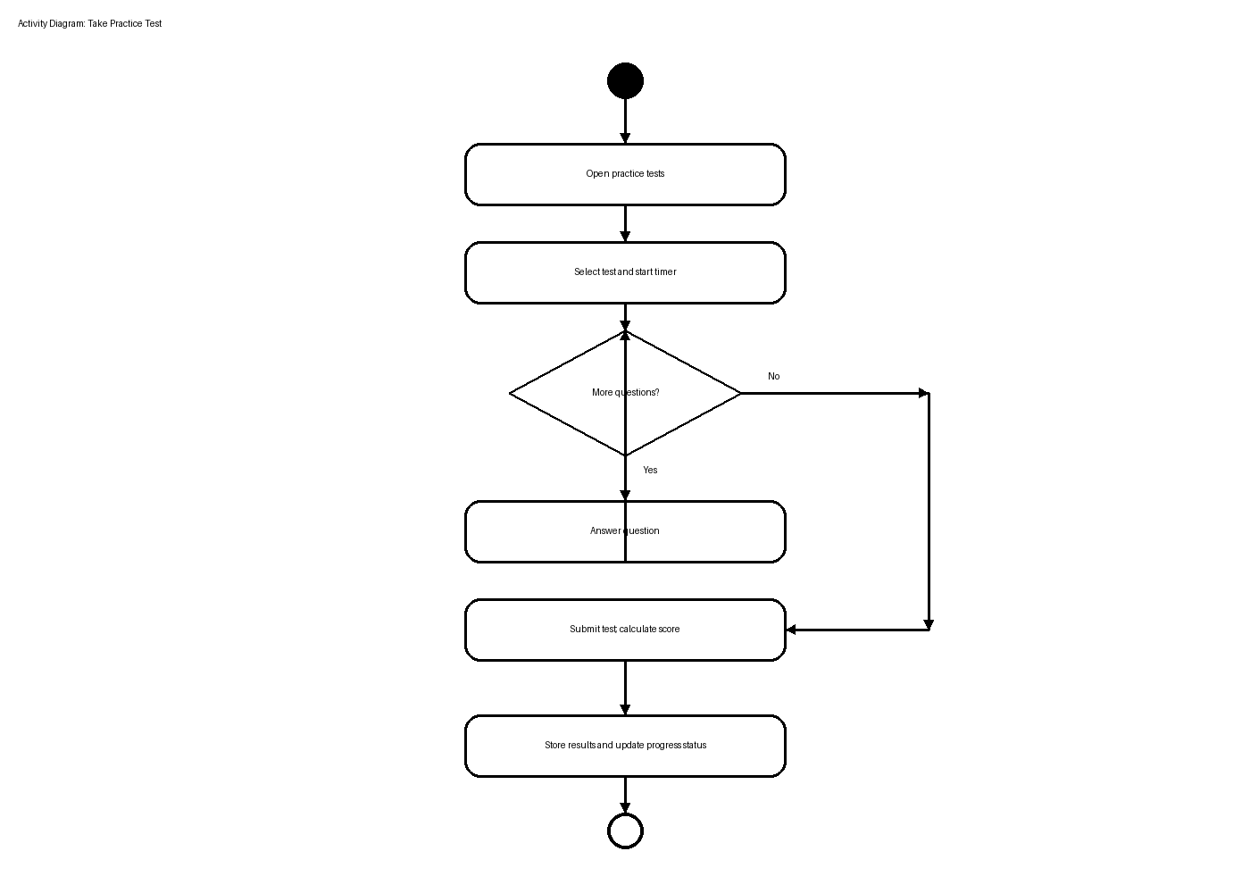

UML Sequence Diagram
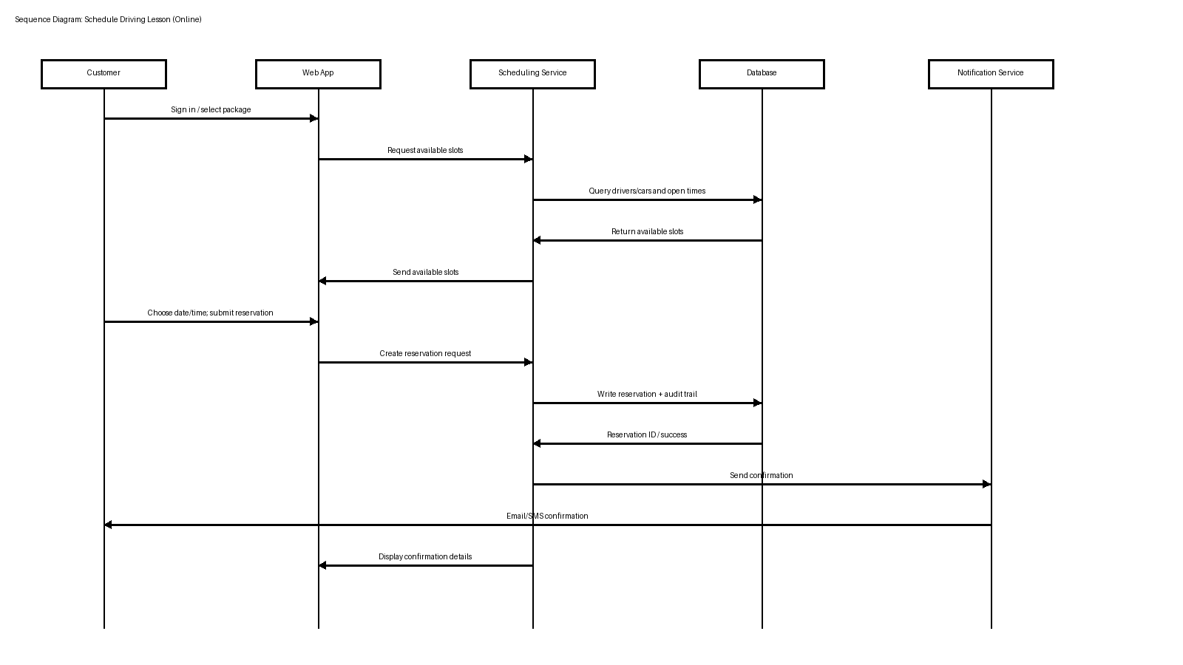

UML Class Diagram
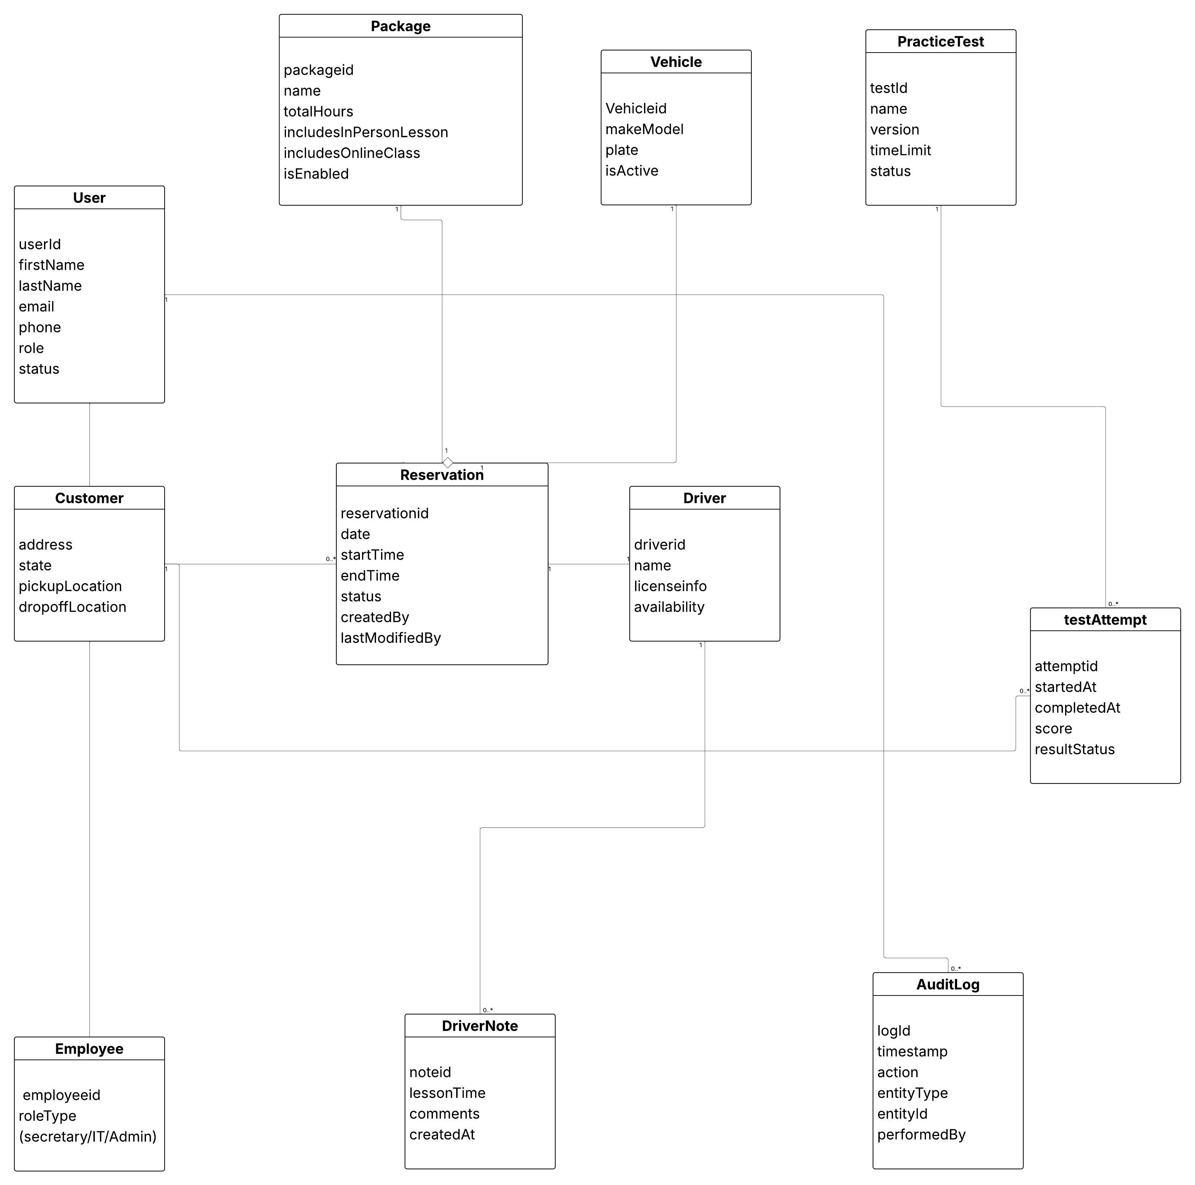

Technical Requirements

The DriverPass system is designed as a cloud-hosted web application that supports both desktop and mobile browsers. Users can view information from anywhere online, and authorized staff can export reports for offline work (for example, in Excel).

Hardware
• Cloud hosting environment (managed virtual servers or container platform) sized to support peak student traffic.
• Company workstations for staff (secretary, admin, IT officer) with a modern web browser and office productivity tools.
• Optional tablets/phones for drivers to view schedules and add lesson notes (mobile browser support).

Software
• Web application (responsive UI) for customers and employees to register, schedule lessons, and view progress.
• Relational database to store user accounts, packages, reservations, vehicles/drivers, practice tests, and audit logs.
• Email/SMS notification service for confirmations, reminders, and password resets.
• Reporting/export capability (CSV/Excel-friendly exports) for reservations, progress, and activity/audit reports.

Tools and Integrations
• Role-based access control supporting customer, secretary, admin/owner, and IT officer permissions.
• Audit logging to track who created, modified, or canceled reservations and when.
• DMV content update integration point to import rule changes and sample questions and trigger notifications.
• Automated backups and monitoring handled by the cloud provider to reduce DriverPass maintenance overhead.

Infrastructure and Networking
• HTTPS/TLS enforced for all traffic; web application firewall and rate limiting for public endpoints.
• Separate environments for development, testing, and production to reduce deployment risk.
• Centralized logging and alerts for errors, security events, and integration failures.
• Data retention policies for reservations, practice tests, and audit logs to support troubleshooting and accountability.

