|  |
| --- |
| 646-21 Visual Acuity Screening Test  User Guide |
| December 2022 |

Photo by [David Travis](https://unsplash.com/@dtravisphd) on [Unsplash](https://unsplash.com/photos/aVvZJC0ynBQ)

Authors: Gustin Gwenaëlle, Hagenbuch Matthieu, Tapparel Océane, Flament Quentin

Professors:Gard Sébastien, Cotting Alexandre

External Client: Steinfeld Katia

Table of contents

1. Description: 2

A. Project 2

B. Developer Team 2

C. Versioning: 2

2. Installation: 2

3. Use: 3

View Results 3

Start game 4

Patient from school roster 4

Patient from Excel file 5

Add manually patient 7

Lets’s Play 8

Visual Acuity Test 8

Limitation 11

# Description:

## Project

Visual Acuity Screening Tool is an application designed to perform vison test digitally.

There is a main screen where a stimulus (a Landolt C) appears in a defined angle and position, and a second screen used as a controller to select the desired answer with four buttons.

The results must be stored in a database and the application must have the possibility to run offline.

## Developer Team

The team behind this project is composed of 4 students from the HES-SO:

|  |  |  |
| --- | --- | --- |
| Profil mâle avec un remplissage uni |  | Adresse de courrier contour |
| Gwenaëlle Gustin | [gwenaelle.gustin](https://gitlab.com/gwenaelle.gustin) | [gwenaelle.gustin@students.hevs.ch](mailto:gwenaelle.gustin@students.hevs.ch) |
| Océane Tapparel | [oceane.tapparel](https://gitlab.com/oceane.tapparel) | [oceane.tapparel@students.hevs.ch](mailto:oceane.tapparel@students.hevs.ch) |
| Matthieu Hagenbuch | [matthieu.hagenbuch](https://gitlab.com/matthieu.hagenbuch) | [matthieu.hagenbuch@students.hevs.ch](mailto:matthieu.hagenbuch@students.hevs.ch) |
| Quentin Flament | [Qflament](https://gitlab.com/Qflament) | [quentin.flament@students.hevs.ch](mailto:quentin.flament@students.hevs.ch) |

## Versioning:

|  |  |  |  |
| --- | --- | --- | --- |
| Version | Who | When | What |
| 1.00 | Flament Quentin | 15.10.2022 | Creating the template |
| 2.00 | Flament Quentin | 08.12.2022 | Explanation of using |
| 3.00 | Flament Quentin | 10.12.2022 | Finalization |
| 4.00 | Hagenbuch Matthieu | 15.12.2022 | Refactor |

# Installation:

The application is a web application available offline, but we must load it online the first time.

The data are saved in the local storage, and when we have an available connection again, we can synchronize the local storage and the database with a button.

# Use:

First you can go to the following link <https://magical-klepon-7470b6.netlify.app/> to enter to our website:

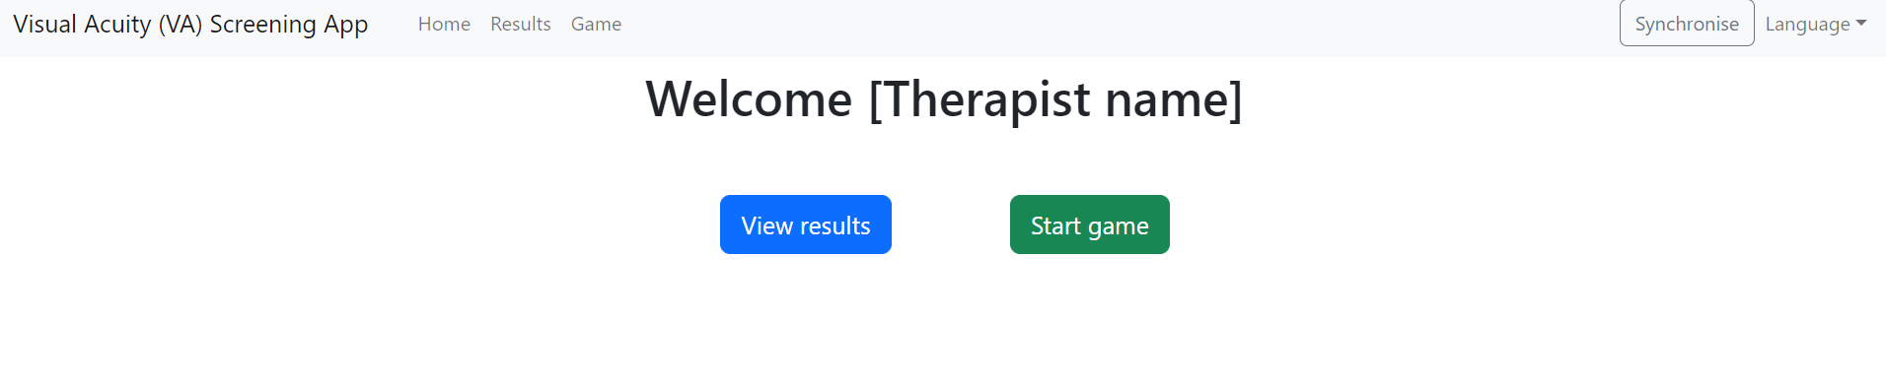

If there is a problem for the first connection in download and store in local storage you have to reload the page with a good connection otherwise an error page appears.



You have two main buttons:

* + [View Result] you can see all the results in database and/or not synchronized in database
  + [Start game] you can start the game and do the visual acuity test

The synchronize button is used to synchronize all the finished test into the database when there is an internet connection

The Language button is not yet available but it’s for change the language of the site

### View Results

In the View Result there is all the results in the database and the results from your local storage

You can:

* Filter each Class, School, Name
* Export all filtered data in a CSV file
* Synchronize your results if you have an internet connection
  + If there is internet you have a success pop-up
  + If there is not internet you have a failure pop-up

All filtered results:

Exported filtered results:



### Start game

In Start game you can select a patient from different methods:

* One of the imported database patients from school roster
* You can import a school list with an Excel file
* You can add a patient manually

### Patient from school roster

You can filter for searching a patient and click on it, and it import the selection

Before filtered school roster:

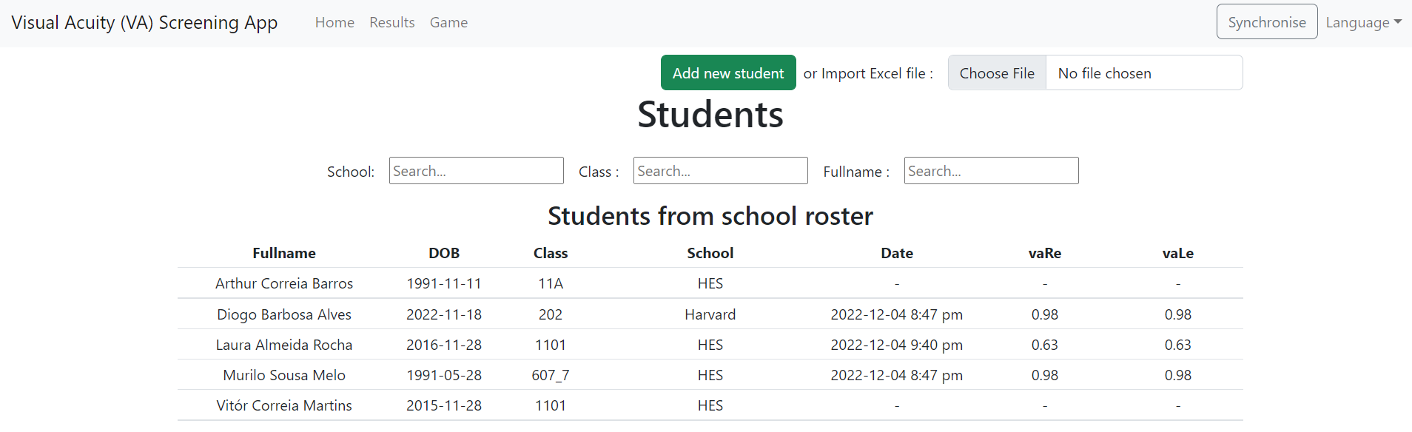

After filter applied:

And select your choice

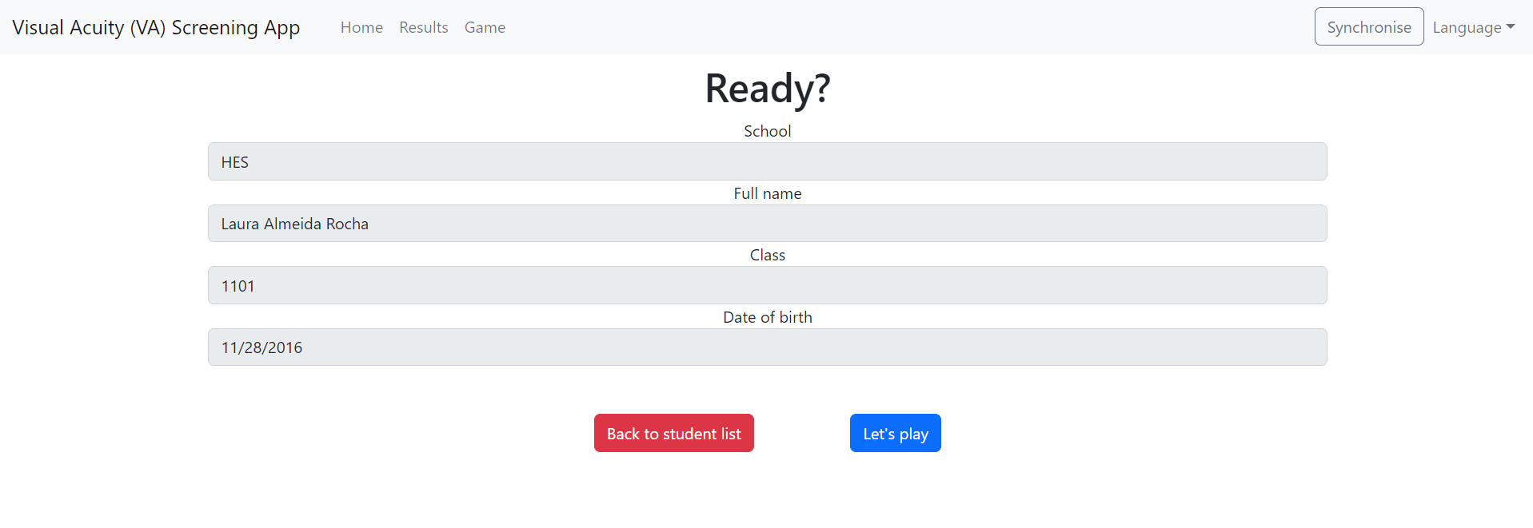

### Patient from Excel file

You must use only this model and only the red identifications can be modified

If you use another one or modify something else all the importation could be false

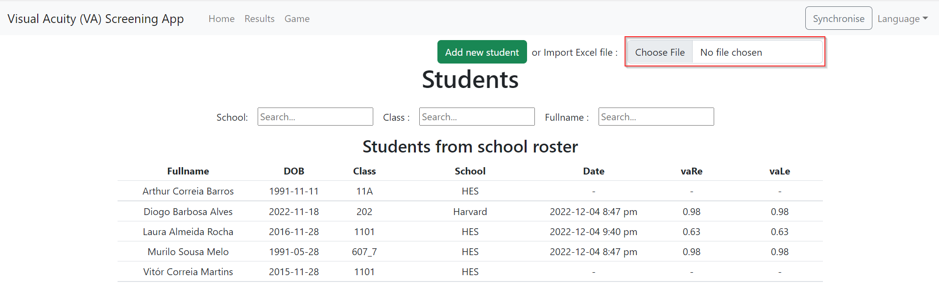

And you can download your class list from the Excel file.

The imported list is in the second part of the page. It can be filtered to find a patient if needed.

### Add manually patient

If you have no class list and no patient in the school roster you can add a new patient for a test.

All parameters are mandatory. If you forgot one of them, you can’t go further.

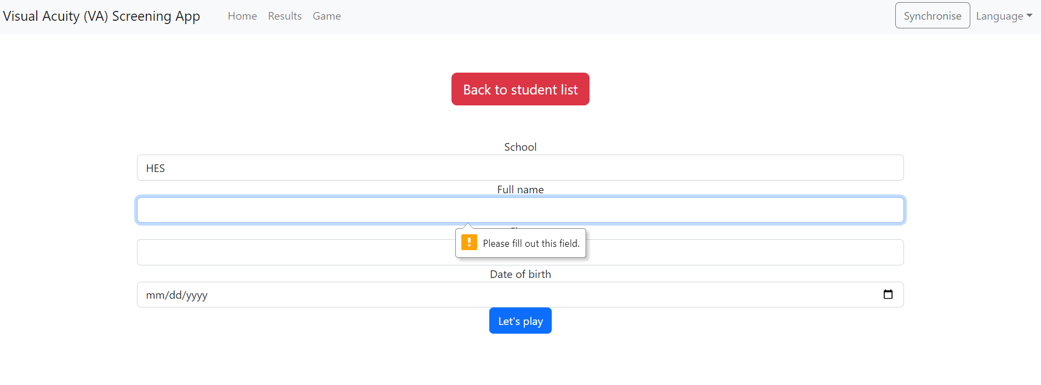

When all the field are completed, you can start the test.

### Lets’s Play

When the patient has been selected or added you can start the test by pressing Let's play.

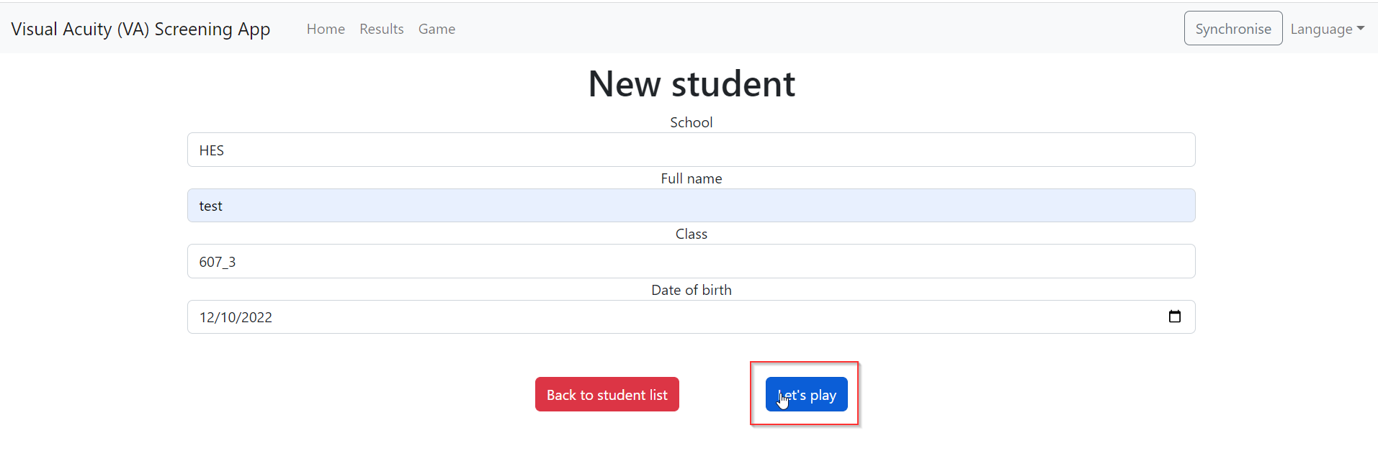

A Pop-up appears and ask you if the patient is wearing glasses for the test.

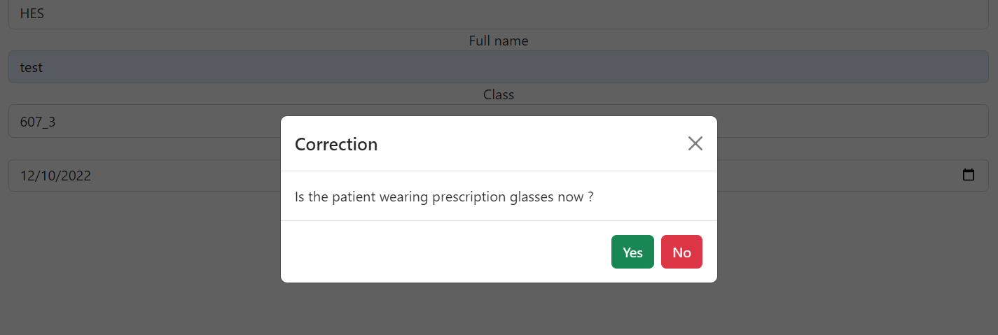

When the response is saved the Visual Acuity Test start.

### Visual Acuity Test

The test is implemented in two screens:

* Controller Screen
* Visual Test Screen

You can use the visual test screen in the computer and the controller screen with an external screen (tactile or not) connected by cable (HDMI, USB-C) with the patient standing 1.5m away from the Visual Test Screen.

#### Controller Screen



The screen is inactivated at the beginning of the test for 1 second.

For a valid test you must click twice in 200 ms for validate the response.

The selected C is activated and colored in green and inactivated 200ms when the response is validated.



The response is not valid if:

* You click for the second click after 200 ms
* If you click for the second click outside of the first C selection

Information about all click on the screen are printed in the console. You can have access easily by following procedure:

* Right click on the page and go in “inspect”

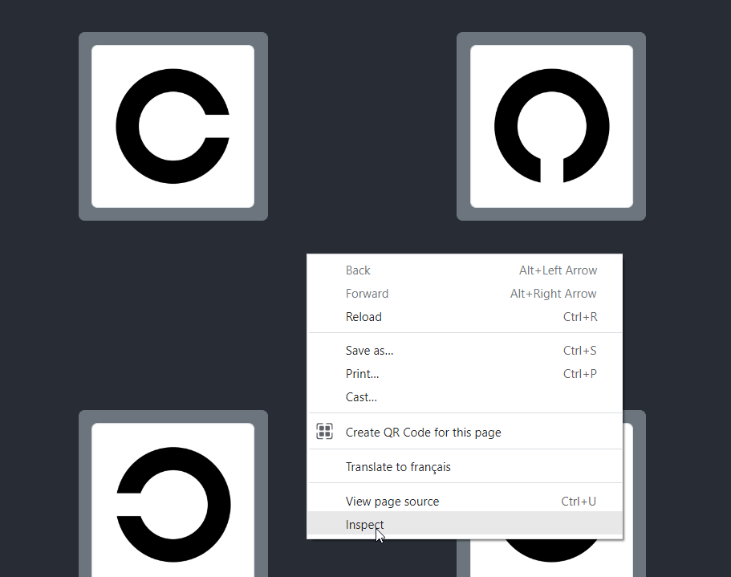

* Go into console and you can see all information about click and at which tour it’s for statistic or other.

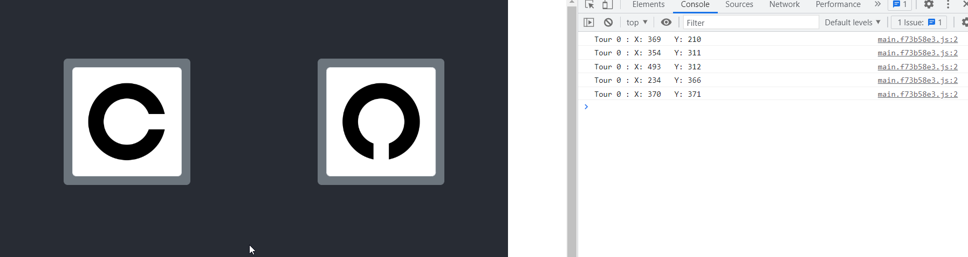

#### Visual Test Screen

In the Visual Test Screen there are the patient information, temporarily all the data of results to test the algorithm (removable with the toggle switch button) and the C with size generated by the algorithm depending of the previous answer

At the end of the test, you can return to the home page, view results or start a new game and choose a new patient.

Temporarily there are all the result displayed to test the JSQuest+ algorithm

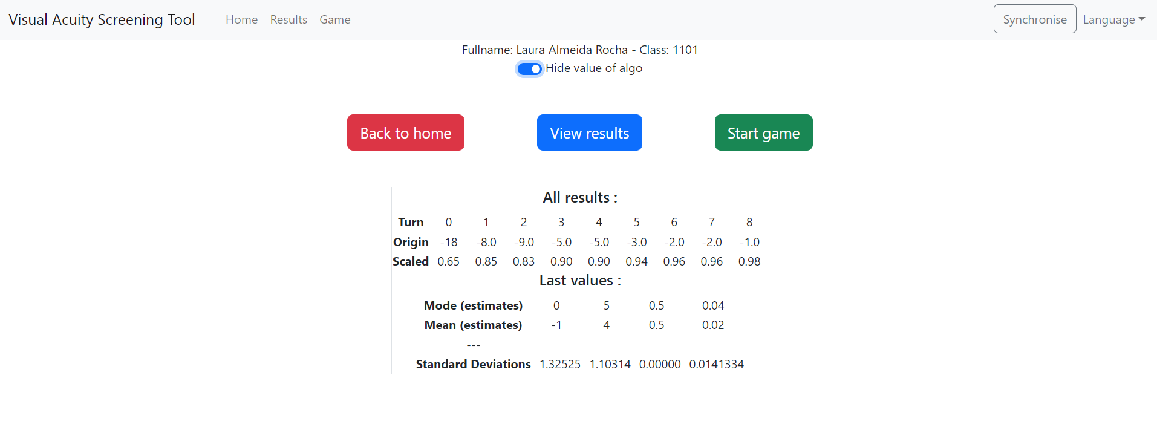

# Limitation

* All the tests are assigned to Katia Therapist because therapists can't connect yet.
* It is not possible to add a student to an unsynchronized school.
* It is not possible to change the language yet.
* It is not possible to edit a student, a school or a test except in the database.
* There is no duplicate check when importing and adding students.