Installation of Bro
In this document I will be explaining how to install and start working with the BRO command line. This document shows how I installed and configured BRO, I have used many different sources and combined them together in one document to help you get started. This document is made in series of steps to help those who are new to the Ubuntu operating system.
Step 1) The first thing we need to do is update the host machine. Before we start, I must mention that if you run any of the commands and it does not allow you to execute the command then its most likely because you need to have root access. You can do this with simply adding SUDO at the beginning of the command. You can update your system with the following command:
sudo apt-get update

Step 2) Installing dependencies. The bro has pre-required dependencies which you must download before downloading bro else it will not run. You can install the dependencies with the following command:
sudo apt-get install cmake make gcc g++ flex bison libpcap-dev libgeoip-dev libssl-dev python-dev zlib1g-dev libmagic-dev swig2.0

Step 3) You also need to install the followings and then unzip the files. The // lines are to give you further information on what each command is doing.
//installing GeoLiteCity
sudo wget http://geolite.maxmind.com/download/geoip/database/GeoLiteCity.dat.gz
//installing GeoLiteCityv6
sudo wget http://geolite.maxmind.com/download/geoip/database/GeoLiteCityv6-beta/GeoLiteCityv6.dat.gz
//unzipping the file GeoLiteCity
gunzip GeoLiteCity.dat.gz
//unzipping the file GeoLiteCityv6
gunzip GeoLiteCityv6.dat.gz

Then we will Link the above files with:
ln -s /usr/share/GeoIP/GeoLiteCity.dat
/usr/share/GeoIP/GeoIPCity.dat
ln -s /usr/share/GeoIP/GeoLiteCityv6.dat
/usr/share/GeoIP/GeoIPCityv6.dat

Step 4) Downloading BRO. Although the bro documentation recommends cloning BRO from Github repository, there are a lot of problem with this especially for those who are new to BRO. So, instead we will download the latest version of bro from the bro website. I done that with this command:
//wget allows you to download straight from the internet.
Sudo wget http://www.bro.org/downloads/release/bro-2.4.1.tar.gz

//converting the files into archives

tar -xvzf bro-2.2.tar.gz

//enter the directory of bro
cd bro-2.4.1

//configure the bro path, I recommend using /nsm/bro although by
//default bro would be in /usr/share/bro file
./configure --prefix=/nsm/bro

//then simply make and install the file
make
make install

If there are no errors then simply add bro to your path. You can do it with this command
export PATH=/nsm/bro/bin:$PATH

Step 5) Configuring the BRO_IDS. You can use any editor you want to configure these files. I recommend Nano, personally think it’s a bit easy compared to other editors. The first file we are going to configure is node.cfg file.

//$prefix being the bro path set in the above step.
$PREFIX/etc/node.cfg -> Configure the network interface to monitor
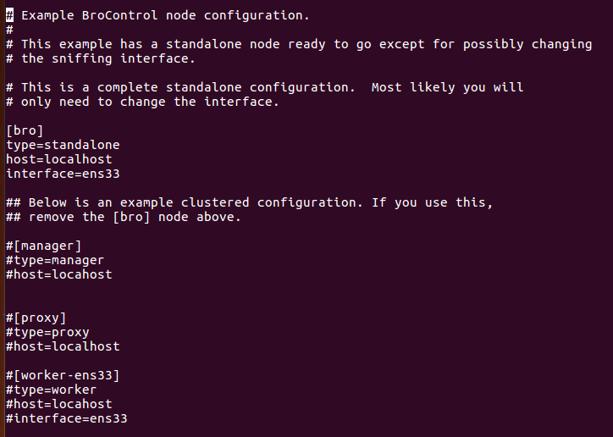
(use ifconfig on the terminal to look at what your interface is, although by default it may be eth0.)

Then, we are going to configure the network.cfg file.

$PREFIX/etc/networks.cfg -> Configure the local networks (i.e. 10.0.0.0/8 Private IP space)

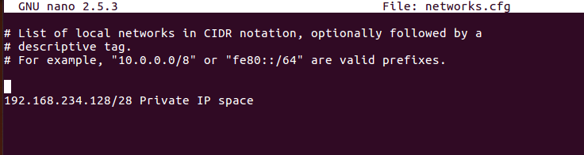

Finally, we are going to configure broctl.cfg file.

$PREFIX/etc/broctl.cfg -> Change the MailTo address and the log rotation
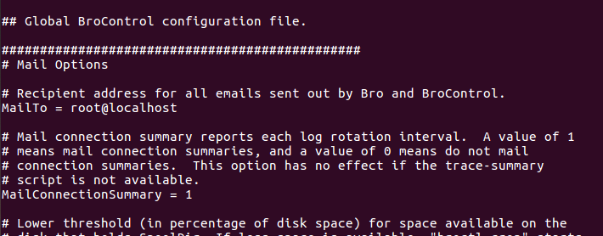

Step 6) Starting Bro Control

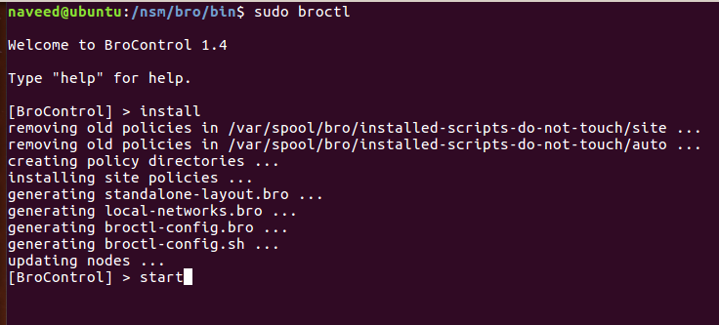

Step 7) Remember, you only need to get bro control working if you are monitoring your own interface. For capturing or generating logs from PCAP files, you can do that with the command utility.
Bro -r ens33 local
This will use the local scripts in the /base directory to generate logs.

You can further play with the default scripts and make your own addition to them to make the scripts more suitable for your use.
For further information you can go to the BRO website.

https://www.bro.org/

I hope this has been helpful. If you need further assistance Stack overflow is your best friend.

