Forecasting Premier League match results from public data: six models against the bookmaker
IAPD course project, final report. November 2026
Abstract. We study how well the result of an English Premier League match (home win, draw or away win) can be forecast before kickoff from freely available data, and how such forecasts compare with bookmaker odds. We collected twelve seasons (2014/15 to 2025/26, 4,560 matches) of results, match statistics and Bet365 odds from Football-Data.co.uk and derived 21 pre-match features, among them an Elo rating and recent form. Six models were compared: class frequencies, a logistic regression on the Elo difference, a Poisson goal model, a multinomial logistic regression on all features, a random forest and gradient boosted trees. All were evaluated walk-forward on the last three seasons (1,140 matches). The best model, the logistic regression, reached 53.9% accuracy and a Brier score of 0.584, against 0.650 for class frequencies and 0.570 for the bookmaker; the gap to the bookmaker is statistically clear for every model, and more flexible models did not help. The error analysis shows that draws are never predicted, that the models are well calibrated, that disagreements with the bookmaker are mostly model errors, and that promoted clubs account for the largest errors.
Keywords: football, match outcome prediction, Poisson model, Elo rating, probabilistic forecasting

1 Introduction
Football is a low-scoring game, so chance has a large share in every result and the stronger side fails to win surprisingly often. At the same time, few events are forecast as intensively: for every league match bookmakers publish odds, which are probability forecasts in disguise and are built with far more information than any public statistic. This combination makes match prediction a demanding test for predictive modelling. The task is well defined, the data are public, and a strong reference forecast exists for every match.
This project asks two questions about the English Premier League. First, how accurately can the result of a match be forecast before kickoff from public data alone, that is, from past results and basic match statistics? Second, how far are such forecasts from those of a bookmaker? We treat the problem as probabilistic three-class classification: for every match a model outputs the probabilities of a home win, a draw and an away win, and is judged on those probabilities rather than on a single guess.
The work has three parts. We built a reproducible pipeline that downloads twelve seasons of data, cleans them and derives pre-match features that never use information from the match being predicted. We compared six models, from a trivial baseline through a classical Poisson goal model and an Elo rating to standard machine-learning classifiers, under a walk-forward protocol on three held-out seasons. Finally, we analysed the errors of the best model and set them against the errors of the bookmaker, which shows not only how large the remaining gap is but where it comes from. Section 2 reviews related work, Section 3 describes the data, the models and the evaluation, Section 4 reports the results, and Sections 5 and 6 discuss them and conclude.

2 Related work
Goal models. The classical statistical approach models the number of goals each side scores. Maher (1982) treated the two scores as independent Poisson variables whose means depend on the attacking strength of one side and the defensive strength of the other. Dixon and Coles (1997) adjusted the probabilities of low-scoring results, which the independence assumption misjudges, gave recent matches more weight, and used the forecasts to look for inefficiencies in the betting market. Karlis and Ntzoufras (2003) proposed bivariate Poisson models that allow the two scores to be correlated and can inflate the probability of draws. The Poisson model in this report is the simplest member of this family.
Ratings. A second line of work summarises each team by a single rating that is updated after every match. The best known is the Elo system (Elo, 1978), designed for chess. Hvattum and Arntzen (2010) used Elo ratings as covariates in ordered logit regressions for football and found them better than several statistical benchmarks but worse than forecasts derived from bookmaker odds.
Machine learning. More recent studies feed engineered features to general classifiers. Baboota and Kaur (2019) did so for the Premier League; their best model, gradient boosting, did not outperform the bookmakers. In the 2017 Soccer Prediction Challenge the leading approaches combined rating features with gradient boosted trees or nearest-neighbour models (Hubáček et al., 2019; Berrar et al., 2019), and Berrar et al. conclude that the key factor is how domain knowledge is built into the features.
Odds as forecasts. Forrest et al. (2005) compared the forecasts implied by bookmaker odds with a detailed statistical model for English football and found that the odds became more effective over the period studied and were the better forecast by its end. Štrumbelj (2014) examined how odds should be converted into probabilities and found Shin's method more accurate than the simple normalisation used in many studies, including this one.
Evaluation and home advantage. Probabilistic forecasts are judged with scoring rules such as the Brier score (Brier, 1950). Constantinou and Fenton (2012) argued that football forecasts should be scored with the ranked probability score, which respects the order of the three results; Wheatcroft (2021) argued against it and in favour of the logarithmic score. We report the Brier score and the log loss. Home advantage, the best documented regularity in football results (Pollard, 1986), was studied anew when matches were played without crowds during the Covid-19 pandemic: McCarrick et al. (2021) found it significantly reduced in goals and points across 15 European leagues, and Bryson et al. (2021) found that referees gave fewer yellow cards to away teams.

3 Method

3.1 Data acquisition
The data come from Football-Data.co.uk, which publishes one CSV file per league and season with one row per match: date, teams, full-time and half-time score, referee, match statistics (shots, shots on target, corners, fouls, cards) and the pre-match odds of several bookmakers. A small crawler (extraction/download.py) builds the address of each Premier League season file from the season code, requests it once, checks that the reply is a match file and stores it unchanged. It identifies itself in the request, waits one second between requests and skips files that already exist, so it can be re-run safely. We collected the twelve complete seasons from 2014/15 to 2025/26: twelve files of 380 rows each, with 62 to 132 columns depending on the season.

3.2 Preprocessing and features
Cleaning (extraction/preprocess.py) merges the files into one table. The two date formats used by the site are parsed into one, blank rows are dropped, 31 columns are kept under readable names, counts are stored as integers and the result is derived from the score. Columns that a season lacks are left empty rather than filled in: the odds at kickoff and the over/under odds are published only from 2019/20. Table 1 summarises the resulting dataset.
Table 1. The dataset after cleaning.
Property | Value
Matches | 4,560, in 12 seasons (16 August 2014 to 24 May 2026)
Clubs | 35
Columns | 31: identity (6), result (5), match statistics (12), Bet365 odds (8)
Results | home win 44.4%, draw 23.8%, away win 31.8%
Goals per match | 2.80 (home side 1.54, away side 1.26)
Missing values | odds at kickoff and over/under odds for the 1,900 matches before 2019/20; none elsewhere
Engineered features | 21 per match, complete for 4,313 matches

The modelling table (extraction/features.py) describes both sides as they stood before kickoff. Every feature of a match is computed only from matches played earlier, and a unit test verifies this by checking that changing one result alters the features of later matches only. The main feature is an Elo rating. Before a match between home side h and away side a with ratings R_{h} and R_{a}, the expected score of the home side is
$E_{h} = \frac{1}{1 + {10}^{−(R_{h} + H − R_{a})/400}}$ (1)
where H = 60 rating points represent home advantage. After the match both ratings move by K(S − E_{h}) in opposite directions, with K = 20 and S equal to 1, 0.5 or 0 for a home win, a draw or a home defeat. Ratings start at 1500 and carry over between seasons; a club new to the data starts at the average rating of the clubs relegated that season. The other features are, for each side: points, goals scored and conceded, and shots on target for and against per game over the last five matches; goals scored and conceded per game over the last 38 matches (one season); points per game over the last five matches at the same venue; and days since the previous league match, capped at 14. With the two ratings and their difference this gives 21 features. Features are empty for a club's first matches in the data (247 rows).

3.3 Models
We compare six forecasters. Class frequencies are the shares of home wins, draws and away wins in the training matches, the same for every match: the floor any useful model must beat. Elo is a multinomial logistic regression with a single feature, the rating difference. The Poisson goal model follows Maher (1982): the goals of the home and away side, X and Y, are independent Poisson variables with means λ and μ,
$λ = a_{h}d_{a}g_{H}, μ = a_{a}d_{h}g_{A}, P(X = i, Y = j) = \frac{λ^{i}e^{−λ}}{i!} · \frac{μ^{j}e^{−μ}}{j!}$ (2)
where g_{H} and g_{A} are the league's average goals per match at home and away, a is a club's attack strength (its goals scored per match divided by the league average) and d its defence weakness (goals conceded divided by the league average), each computed separately for home and away matches. Every strength is shrunk towards 1 as if the club had played five extra matches at the league average. Summing the score probabilities over a grid of 0 to 6 goals per side gives the probabilities of the three results. The model is refitted before every match day on the two previous seasons and the current season so far.
The remaining three models are classifiers from scikit-learn (Pedregosa et al., 2011) trained on all 21 features: a multinomial logistic regression with L2 regularisation on standardised features, a random forest (Breiman, 2001) of 400 trees, and gradient boosted trees (Friedman, 2001). Missing features are replaced by the training median for the first two; the boosted trees handle them natively.

3.4 Evaluation
Seasons are used in time order. Season 2014/15 only warms up the ratings and the form features. Each classifier has a small grid of settings, and the setting with the lowest log loss on two validation seasons (2021/22 and 2022/23) is kept: regularisation strength C = 0.003 for the logistic regression, at least 60 matches per leaf for the random forest, and 100 trees of depth 2 with learning rate 0.03 for gradient boosting. The test set is the last three seasons, 2023/24 to 2025/26 (1,140 matches). Before each test season a classifier is refitted on all earlier seasons from 2015/16 on, between 3,040 and 3,800 matches, while its features keep updating match by match. No forecast uses information from its own day or later.
Forecasts are scored by accuracy (how often the result rated most likely occurred), the Brier score B and the log loss L,
$B = \frac{1}{N}\sum_{n=1}^{N}{\sum_{c=1}^{3}{{(p_{nc} − o_{nc})}^{2}}}, L = − \frac{1}{N}\sum_{n=1}^{N}{ln p_{ny}}$ (3)
where p_{nc} is the probability given to result c in match n, o_{nc} is 1 if that result occurred and 0 otherwise, and p_{ny} is the probability given to the result that did occur. Lower is better for both; the Brier score ranges from 0 to 2. The reference is Bet365's odds at kickoff, converted to probabilities by taking reciprocals and scaling them to sum to one. To judge whether a model differs from the bookmaker we bootstrap the difference of their Brier scores over the same matches (2,000 resamples) and report a 95% interval.

4 Results

4.1 Exploratory analysis
The home side wins 44.4% of matches, 23.8% are drawn and 31.8% are won by the away side (Figure 1). The shares are stable across seasons with one exception: in 2020/21, played mostly without crowds, home wins fell to 37.9% and away wins rose to 40.3%, in line with the studies cited in Section 2. Matches have 2.80 goals on average. The distribution of goals per side is close to Poisson: the variances (1.70 for the home side, 1.42 for the away side) are only slightly above the means (1.54 and 1.26), and every observed share of 0, 1, 2 or more home goals is within 1.9 percentage points of the Poisson value. The most frequent score is 1-1, in 10.8% of matches.
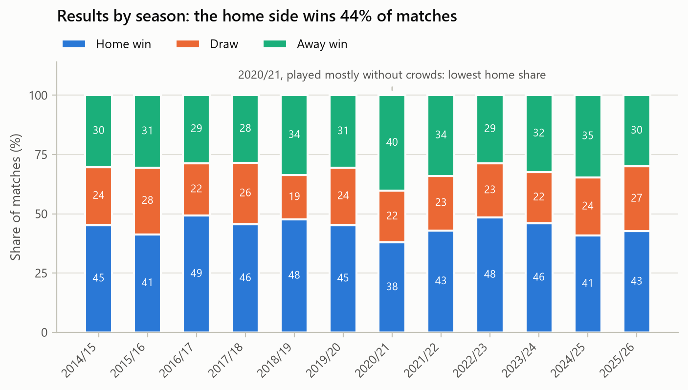
Figure 1. Share of home wins, draws and away wins by season.
Figure 2 relates the result to the Elo difference before kickoff. When the home side is rated more than 200 points below its opponent it wins 13% of matches; more than 200 points above, 78%. Draws behave differently: their share stays between 14% and 28% in every group and never comes close to being the most frequent result. Among the features, the home side's advantage in Elo rating has the highest rank correlation with the goal difference of the match (0.44), followed by goals scored and conceded over the last 38 matches (0.41 and 0.37). The five-match form features correlate less (0.23 to 0.32), and rest days not at all (−0.07).
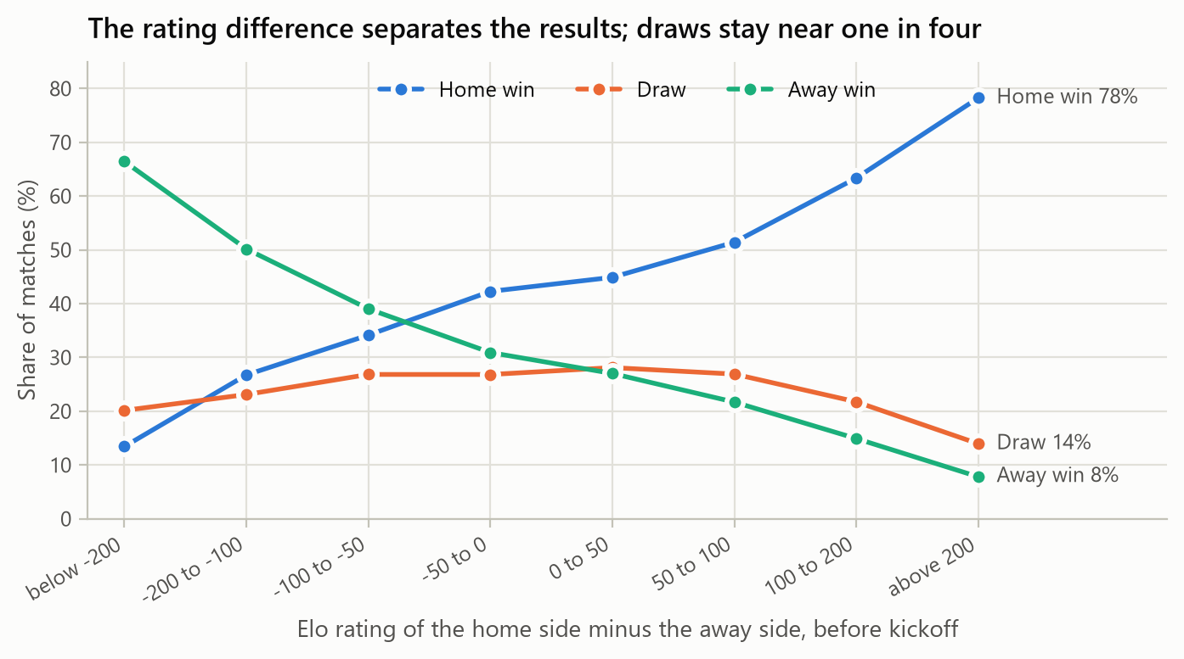
Figure 2. Result shares by Elo rating difference before kickoff (seasons 2015/16 to 2025/26).

4.2 Model comparison
Table 2 gives the scores on the 1,140 test matches. Every model is far better than the class frequencies, and no model reaches the bookmaker. The best one, the logistic regression on all features, has a Brier score of 0.584 against 0.570 for the bookmaker; the difference of 0.014 has a 95% interval of 0.007 to 0.021, and the interval excludes zero for every model (Figure 3). The ranking by log loss is the same.
Table 2. Scores on the test seasons 2023/24 to 2025/26 (1,140 matches). The gap is the model's Brier score minus the bookmaker's, with its 95% bootstrap interval. The last three columns give the Brier score per season.
Model | Accuracy | Brier | Log loss | Gap to bookmaker | 2023/24 | 2024/25 | 2025/26
Logistic regression | 53.9% | 0.584 | 0.980 | +0.014 (+0.007 to +0.021) | 0.544 | 0.589 | 0.620
Elo | 53.4% | 0.585 | 0.981 | +0.015 (+0.008 to +0.022) | 0.545 | 0.590 | 0.620
Random forest | 53.6% | 0.587 | 0.986 | +0.017 (+0.010 to +0.023) | 0.549 | 0.591 | 0.621
Gradient boosting | 52.5% | 0.589 | 0.990 | +0.019 (+0.011 to +0.026) | 0.548 | 0.595 | 0.624
Poisson goal model | 52.0% | 0.592 | 0.994 | +0.022 (+0.013 to +0.031) | 0.560 | 0.597 | 0.620
Class frequencies | 43.2% | 0.650 | 1.073 | +0.080 (+0.063 to +0.095) | 0.637 | 0.656 | 0.656
Bookmaker | 55.0% | 0.570 | 0.960 | reference | 0.526 | 0.576 | 0.608

Two results stand out. First, the Elo difference alone does as well as all 21 features (0.585 against 0.584), and it had the lowest log loss on the validation seasons (0.968 against 0.970 for the logistic regression). A permutation test on the logistic regression agrees: shuffling the home rating, the rating difference or the home side's season-long goals raises the test log loss by 0.011 to 0.014 each, and no other feature by more than 0.004. Second, the more flexible models are slightly worse than the linear one, and for all three classifiers the validation seasons selected the most regularised setting of the grid. The Poisson goal model, which uses only goals, is the weakest of the informed models (0.592), although it is the only one that also gives a probability for every score.
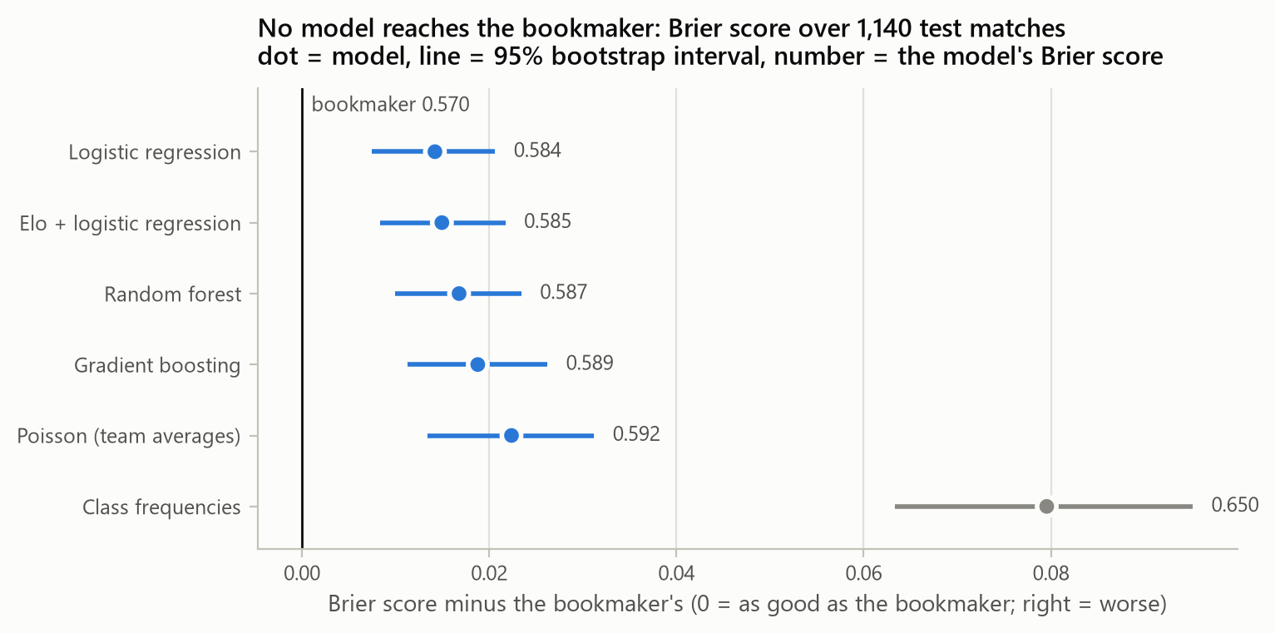
Figure 3. Brier score of each model relative to the bookmaker, with 95% bootstrap intervals.
The seasons differ in difficulty: the Brier score of every forecaster, the bookmaker included, rises from 2023/24 to 2025/26. The order of the models barely changes, and in 2025/26 all informed models are within 0.005 of each other.

4.3 Error analysis
Draws. Of the 1,140 test matches 279 (24.5%) were draws, and the logistic regression never rated a draw as the most likely result; neither did the bookmaker (Figure 4). The highest draw probability the model ever gives is 30%. It therefore calls 66% of matches for the home side, although only 43% are home wins, and every draw counts as an error, which alone removes 24.5 points of accuracy for any forecaster that never predicts one. This is why the bookmaker's accuracy (55.0%) is only about one point above the model's.
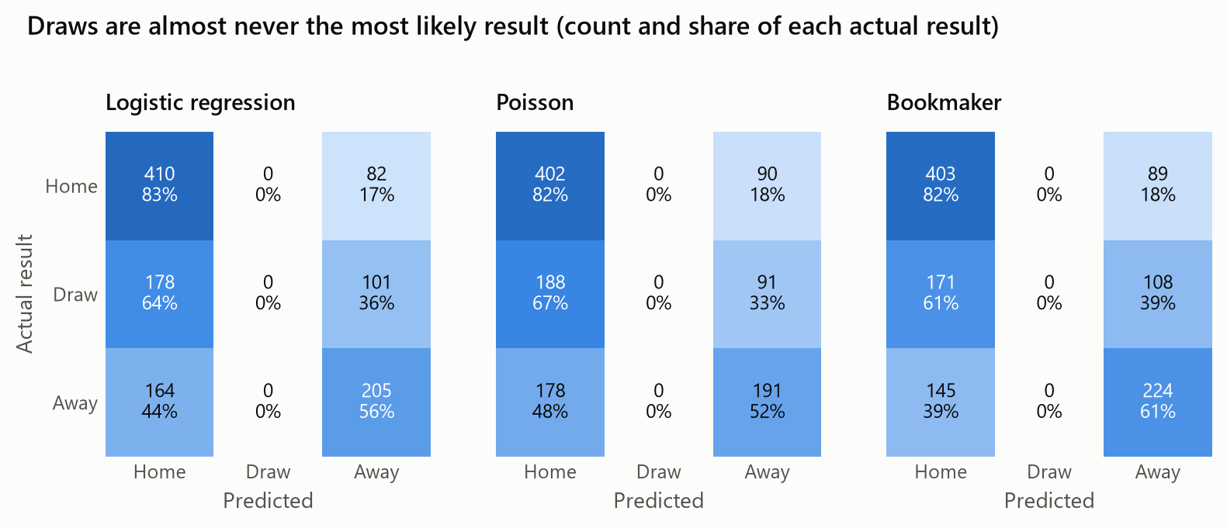
Figure 4. Confusion matrices on the test seasons: actual result against the result rated most likely.
Calibration. The errors are not a calibration problem. Grouping all forecast probabilities into bins a tenth wide, predicted probability and observed frequency differ by at most 2.5 percentage points for the logistic regression. The bookmaker's probabilities are too high for the least likely results (7.6% predicted, 4.5% observed) and too low for the most likely ones (77% against 81%), the favourite-longshot bias that simple normalisation of odds does not remove (Štrumbelj, 2014).
Kind of match and agreement with the bookmaker. Table 3 splits the test matches in two ways. Matches without a clear favourite are the hard ones for both forecasters, and the model trails the bookmaker in every group. The second split is more informative. In almost half of the matches the model's probabilities are within 5 percentage points of the bookmaker's, and there the two score the same. In the 182 matches where they differ by more than 10 points the bookmaker is far ahead (0.610 against 0.672). A simple betting rule gives the same message in money: staking one unit whenever a model sees an expected value above 5% at the kickoff odds loses for every model, from 7.0% of the stakes (Elo, 724 bets) to 18.5% (Poisson, 872 bets).
Table 3. Logistic regression and bookmaker by kind of match and by the distance between their forecasts (largest difference between the two over the three probabilities).
Group | Matches | Accuracy, model | Accuracy, bookmaker | Brier, model | Brier, bookmaker
By the probability of the bookmaker's favourite
Below 45% (even match) | 347 | 39.2% | 43.2% | 0.671 | 0.652
45% to 65% | 552 | 54.0% | 53.6% | 0.608 | 0.596
Above 65% | 241 | 75.1% | 75.1% | 0.404 | 0.392
By the distance between model and bookmaker
Within 5 points | 557 | 59.1% | 58.7% | 0.548 | 0.547
5 to 10 points | 401 | 51.9% | 53.4% | 0.595 | 0.584
More than 10 points | 182 | 42.9% | 47.3% | 0.672 | 0.610

Clubs. For each club we compared the points per game it won with the points the model expected (Figure 5). The eight largest errors all belong to clubs promoted during the test seasons. Sunderland and Leeds did better than expected (by 0.40 and 0.20 points per game); Southampton, Leicester, Luton, Sheffield United, Burnley and Ipswich did worse (by 0.25 to 0.37). A promoted club enters either with no history, in which case it receives the average rating of the relegated clubs, or with the rating it had when it last left the league. Among the clubs present in all three seasons the largest errors are much smaller (Aston Villa +0.17, Tottenham −0.16).
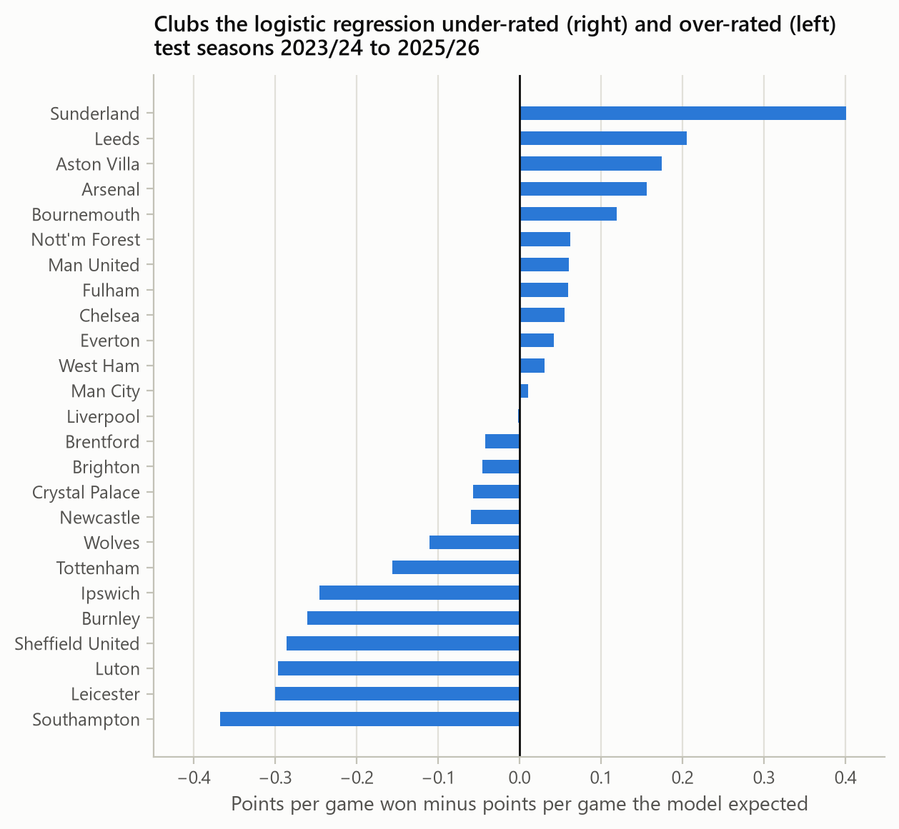
Figure 5. Points per game won minus points per game expected by the logistic regression, by club.
Upsets and exact scores. The results the model considered least likely were unlikely for the bookmaker too: Liverpool 0-1 Crystal Palace in April 2024 had a probability of 6% for the model and 9% for the bookmaker. This part of the error is chance. Chance also dominates the exact score: the most likely score of the Poisson model was right in 11.1% of matches, while always predicting 1-1 would have been right in 11.4%.

5 Discussion
The gap between a model built on public results and the bookmaker is small, 0.014 in Brier score and about one percentage point in accuracy, but it is consistent across seasons and statistically clear. This agrees with earlier work: rating-based and feature-based models have repeatedly come close to the odds without matching them (Hvattum and Arntzen, 2010; Baboota and Kaur, 2019). The error analysis suggests what the gap consists of. It is concentrated in the matches where the two forecasts differ and in promoted clubs, whose strength cannot be read from league history. Both point to information that results do not contain and the market has: transfers, injuries, expected line-ups, and the judgement of many bettors.
That the simplest informed model is also the best is less surprising than it looks. A football result is a very noisy signal of the strength of two teams, only a few thousand matches are available for training, and strength is close to one-dimensional, so a single well-maintained rating captures most of what past results can tell. Flexible models then mostly fit noise, which is why the validation seasons always preferred the strongest regularisation. Short-term form, a popular feature, added almost nothing beyond the long-run measures.
The treatment of draws is a structural limit rather than a defect of one model. Draws are common but never the single most likely result, so accuracy rewards a forecaster for ignoring them; proper scoring rules do not, and the calibration results show that the draw probabilities themselves are sound. Models with draw-specific terms (Dixon and Coles, 1997; Karlis and Ntzoufras, 2003) could sharpen those probabilities but would not change the picture for accuracy.
The study has limits. It covers one league and one bookmaker, and three test seasons leave intervals of ±0.007 to ±0.009 around each gap. The odds were converted with simple normalisation, which is less accurate than Shin's method (Štrumbelj, 2014), so the bookmaker's forecast is, if anything, understated. We did not report the ranked probability score. The grids of settings were small and the best setting always lay at their most regularised edge, so slightly better values may exist. Finally, the features use only results and shots; richer public data such as expected goals or line-ups were out of scope.

6 Conclusions
We built a complete pipeline, from crawling to error analysis, for forecasting Premier League results and compared six models with a bookmaker on three seasons never seen in training. A regularised logistic regression on 21 pre-match features reached 53.9% accuracy and a Brier score of 0.584, far better than the class frequencies (0.650) and close to, but clearly behind, the bookmaker (0.570). A single Elo rating difference performed as well as the full feature set, and tree ensembles did not help. The models are well calibrated; their errors come from draws, which no forecaster predicts, from matches in which they disagree with the bookmaker, and from promoted clubs.
Three extensions follow from the error analysis: adding squad and line-up information, which is the most likely content of the remaining gap; modelling draws explicitly with a Dixon-Coles or bivariate Poisson model; and giving promoted clubs a better starting rating, for example from their results in the division below.

Bibliography
Baboota, R., & Kaur, H. (2019). Predictive analysis and modelling football results using machine learning approach for English Premier League. International Journal of Forecasting, 35(2), 741–755.
Berrar, D., Lopes, P., & Dubitzky, W. (2019). Incorporating domain knowledge in machine learning for soccer outcome prediction. Machine Learning, 108(1), 97–126.
Breiman, L. (2001). Random forests. Machine Learning, 45(1), 5–32.
Brier, G. W. (1950). Verification of forecasts expressed in terms of probability. Monthly Weather Review, 78(1), 1–3.
Bryson, A., Dolton, P., Reade, J. J., Schreyer, D., & Singleton, C. (2021). Causal effects of an absent crowd on performances and refereeing decisions during Covid-19. Economics Letters, 198, 109664.
Constantinou, A. C., & Fenton, N. E. (2012). Solving the problem of inadequate scoring rules for assessing probabilistic football forecast models. Journal of Quantitative Analysis in Sports, 8(1).
Dixon, M. J., & Coles, S. G. (1997). Modelling association football scores and inefficiencies in the football betting market. Journal of the Royal Statistical Society: Series C (Applied Statistics), 46(2), 265–280.
Elo, A. E. (1978). The Rating of Chessplayers, Past and Present. New York: Arco.
Football-Data.co.uk. Historical football results and betting odds data. https://www.football-data.co.uk (accessed November 2026).
Forrest, D., Goddard, J., & Simmons, R. (2005). Odds-setters as forecasters: The case of English football. International Journal of Forecasting, 21(3), 551–564.
Friedman, J. H. (2001). Greedy function approximation: A gradient boosting machine. The Annals of Statistics, 29(5), 1189–1232.
Hubáček, O., Šourek, G., & Železný, F. (2019). Learning to predict soccer results from relational data with gradient boosted trees. Machine Learning, 108(1), 29–47.
Hvattum, L. M., & Arntzen, H. (2010). Using ELO ratings for match result prediction in association football. International Journal of Forecasting, 26(3), 460–470.
Karlis, D., & Ntzoufras, I. (2003). Analysis of sports data by using bivariate Poisson models. Journal of the Royal Statistical Society: Series D (The Statistician), 52(3), 381–393.
Maher, M. J. (1982). Modelling association football scores. Statistica Neerlandica, 36(3), 109–118.
McCarrick, D., Bilalic, M., Neave, N., & Wolfson, S. (2021). Home advantage during the COVID-19 pandemic: Analyses of European football leagues. Psychology of Sport and Exercise, 56, 102013.
Pedregosa, F., Varoquaux, G., Gramfort, A., et al. (2011). Scikit-learn: Machine learning in Python. Journal of Machine Learning Research, 12, 2825–2830.
Pollard, R. (1986). Home advantage in soccer: A retrospective analysis. Journal of Sports Sciences, 4(3), 237–248.
Štrumbelj, E. (2014). On determining probability forecasts from betting odds. International Journal of Forecasting, 30(4), 934–943.
Wheatcroft, E. (2021). Evaluating probabilistic forecasts of football matches: The case against the ranked probability score. Journal of Quantitative Analysis in Sports, 17(4), 273–287.

