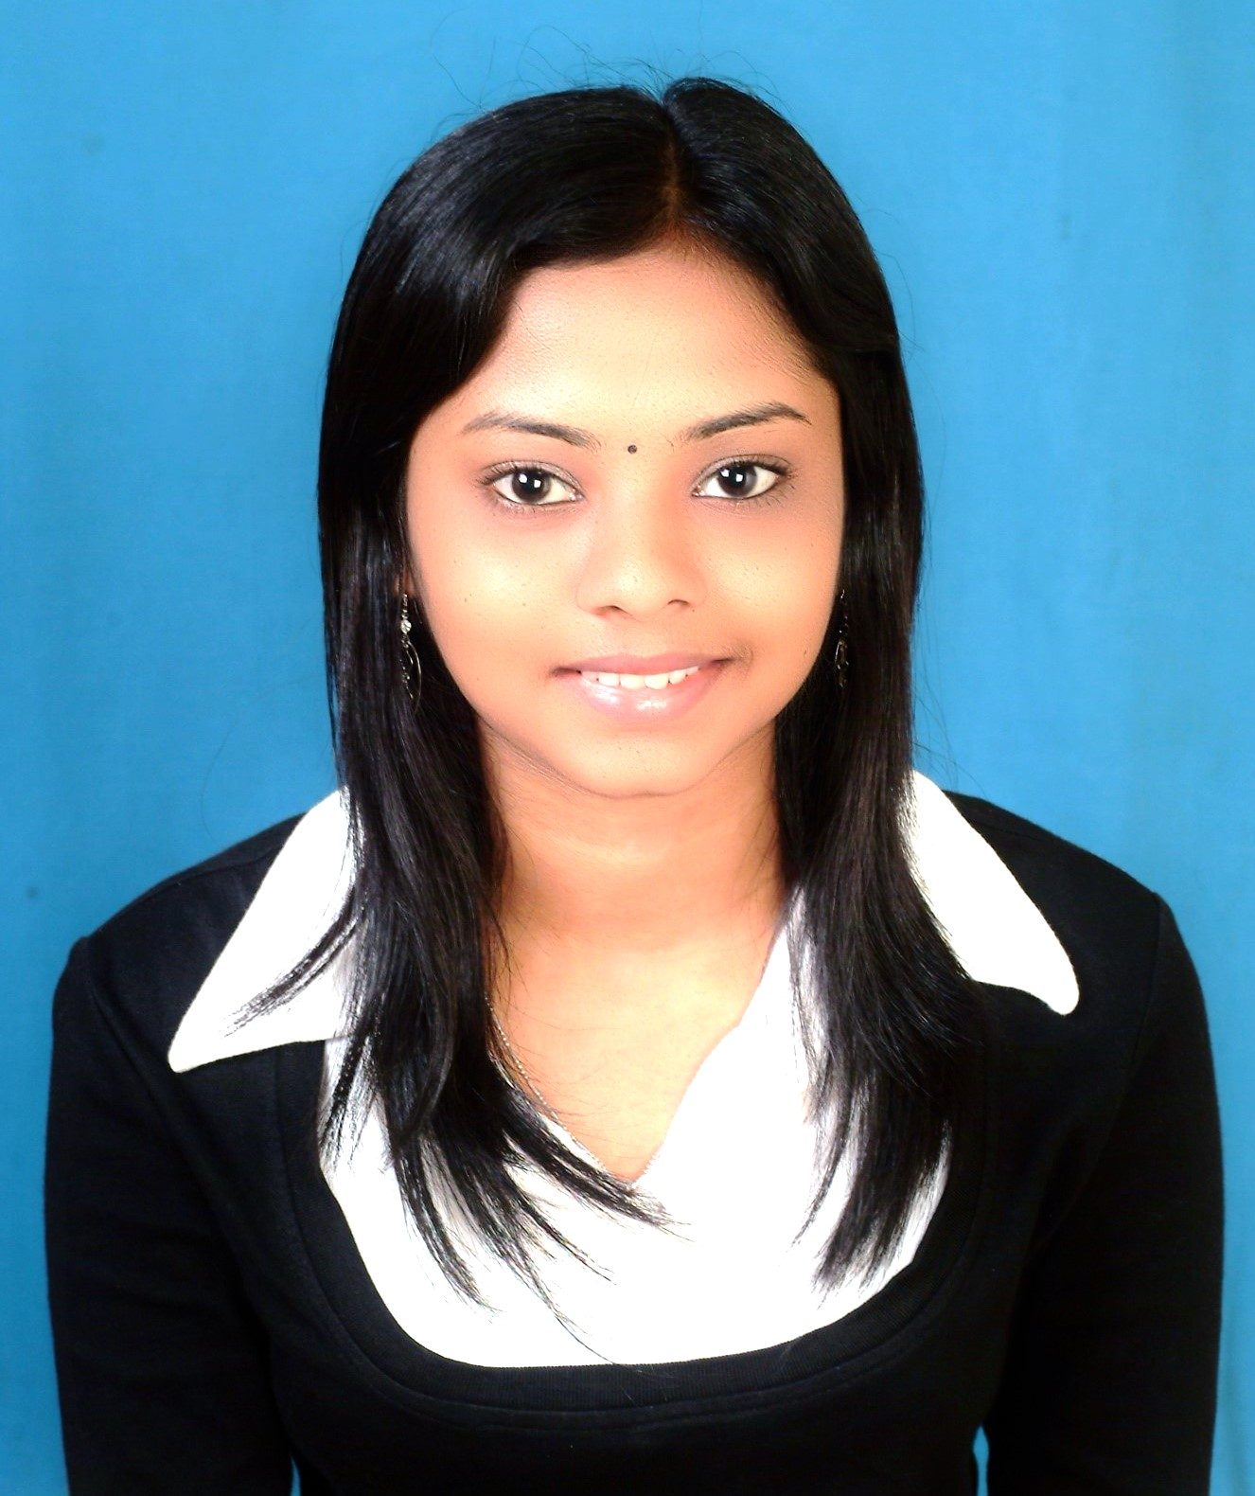
ELAWARASI D/O ARUMUGAM

An experienced graduate with strong communication and organizational skills with a practical approach to problem solving and a driven to see things through to completion.
MOBILE :+6014-9442812 / +6019-3382312

EMAIL :elawarasi23@gmail.com

CAREER OBJECTIVE

Looking for job that offers me an opportunity for advancement in my pharmacy career endeavors, where I can utilize my current technical skills and knowledge under a boss who can take best out of me & gives me a chance for my innovative work as well.

ACADEMIC QUALIFICATION

UNIKL ROYAL COLLEGE OF MEDICINE PERAK, MALAYSIA
(Graduation Date: OCTOBER 2012)

Qualification : Diploma in Pharmacy
Field of Study : Pharmacy
CGPA : 3.49
SCHOLARSHIP BY COLUMBIA ASIA HEALTHCARE

SMK CONVENT TELUK INTAN
(Graduation Date: DECEMBER 2008)

Qualification : Secondary School
Field of Study : Science Stream
Result : 4 1A, 2 2A, 4 3B, and 1 4B

WORKING EXPERIENCE

CURRENT JOB

COLUMBIA ASIA CHERAS HOSPITAL

- Currently working in this facility since May 2012.
- Screen incoming prescriptions and ensure the medications are entered into dispensing program accurately and software utilized correctly
- Responsible for preparing ,dispensing and delivering the accurate medications to the patients.
- Maintain minimum stock levels of medicines, checking expiry dates and storage conditions.

- Adhere to practice policies and procedures for dispensing medicines ,in particular those relating to expensive and controlled drugs.
- Communicate effectively and regularly with other members of the dispensing team to ensure the accurate exchange of information relating to patients and their medication.
- Compound preparations as required by nursing units.
- Negotiated with local pharmacy owners to purchase drugs during drug shortages
- Developed the minutes of meetings and reports
- Increased awareness of healthcare to customers through counseling.
- Assisted customers in medical equipment usage.
- Assisted customers regarding any queries.
- Provide training for new Pharmacy staff
- Comply with standard operating procedures for storage,recording and requisitions of drugs.
- Perform any other duties assigned.

PAST EXPERIENCES

HOSPITAL TAIPING (GH) & KLINIK KESIHATAN TAIPING

- Did practical for semester 5 and 6 .
- Led the practical group of pharmacy assistants & technicians ordering and preparing prescriptions.
- Toured all specialized departments from preparation, reconstitution to dispensing

KEY ACHIEVEMENT AND APPRECIATIONS

i)UNIKL ROYAL COLLEGE OF MEDICINE PERAK

Year | Position /Level/Award | Activities
2009 | Dean list | Semester 1 & 4
2011 | Committee member | 3rd Deans cup Debate Competition

ii) COLUMBIA ASIA CHERAS

- Has completed "Advocating Success at Work” workshop on 11 September 2014.
- Awarded Certificate of Appreciation in Recognition of Perfect Attendance 2014.
- Awarded Certificate of Appreciation in Recognition of Perfect Attendance 2016.
- Has completed the training BASIC LIFE SUPPORT (BLS) on 26th January 2017.

SKILLS

- Knowledge of Microsoft word, Microsoft excel, Microsoft window, Microsoft power point.
- Familiar with Internet Operations.
- Ability to dispense and compound pharmaceuticals
- Excellent customer service and interpersonal skills
- Capable to work independently and as a part of a dynamic team

LANGUAGES

Languages Spoken Written
English Excellent Excellent
Bahasa Melayu Excellent Excellent
Tamil Excellent Excellent

PERSONAL QUALIFICATION

- Highly motivated, pleasant personality, cheerful and hardworking
- Work well under pressure, flexible and quick learner
- Team oriented; Organized and manage time well.
- Willing to learn new things
- Cooperative and easily get adapted with working environment.
- Good assessment and problem solving skills.
- Positive attitude towards patients in critical situations.
- Possess own vehicle and have driving license.
- Ability to manage the team with a good relationship.

WORK PEFERENCE

- Willing to work shift : Yes
- Expected Monthly Salary : Negotiable

PERSONAL DETAILS

Name: ELAWARASI D/O ARUMUGAM
Age: 26
Date of Birth: 23 December 1991
Address: No 319, Lorong 9 Taman Kerentina Jalan Maharajalela 36000 Teluk Intan Perak
Nationality : Malaysian
Marital Status : Single
Employment Status : Full time

REFERENCE

Ms. Yap Poh Leng
Head of Pharmacy Department of Columbia Asia Hospital Cheras
Contact no:
Mobile No: 0123359611
Office No : 0390869999 (ext 9739)

