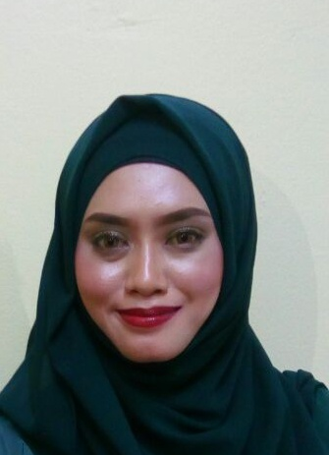
Nurul Ashikin Binti Abd Rashid
013-7438525
ashikinnurul25@yahoo.com / nurulashikinabdrashid@gmail.com

PERSONAL INFORMATION
Current Address :75 Jln Sg 9/2,
Seri Gombak,
68100 Batu Caves,Selangor.
Mailing Adress :No 37E,Parit Amal,
Jalan Datok Hj Kosai,84000 Muar Johor
Age : 31 Years
Date Of Birth : 20th April 1986
Race : Malay
Religion : Islam
Nationality : Malaysian
Gender : Female

EDUCATION BACKGROUND

Education : Diploma In Islamic Banking
Year : 2007 – 2012
Institution : Cybernetics International College Of
Technology
Grade : 3.5
Major : Islamic Banking

Education : Sijil Tinggi Pelajaran Malaysia ( Stpm )
Year : 2004 - 2005
Institution : S.M.K Tengku Mahkota Johor
Grade : Pass
Major : Graphic Design

Education : Sijil Pelajaran Malaysia
Year : 2002 - 2003
Institution : S.M.K Tengku Mahkota Johor
Grade : Pass
Major : Economy & Geography

WORKING EXPERIENCE

Company : Prism Berhad
(Performers Right & Interest Society of Malaysia)
Date Joined : 02 February 2014 - Present
Position : Hr Prism Berhad And Membership Executive For Singers And Musicians Malaysia

Company : Cybernetics International College
Date Joined : March 2012-March 2013 (1 Year)
Position : Marketing Executive, Register intake student, Admin work.

Company : Pasaraya Maju Jaya
Date Joined : April 2011 – February 2012
Position : Sales Assistant / Cashier (Part Time)

Company : Yang Wood Sdn Bhd
Date Joined : November 2005 – February 2006
Position : Clerk
Reason For Leaving : Further Study

MISCELLANEOUS
STRENGHTS
- Able to work under pressure and meet tight deadlines within minimum supervision.
- Quick learner and very active person.
- Willing to study new rules and regulation to improve personal skills and knowledge.
- Able to work independently (shift )
- Comfortable working alone or as part of a team
- Sense of responsibility
- High punctuality
- Good communication skills and collaboration
- Creative and resourceful
- Self – motivated and determined
- Team player
- Success oriented and natural leader

SKILLS
Computer literate especially in:
- Microsoft Office Word
- Microsoft Office Excel

Fairly spoken and written in:
- English
- Malay language

WORK STYLE
- Prefer to work in fairly organized environment
- Highly motivated person
- Hardworking person in order to complete the task given.

CAREER OBJECTIVE
- Having a stable mentality which enables me to enhance my skills and knowledge to improve and achieve company goals.

- To work in a company with good working environment in order to contribute my ideas and be part of it. And also willing to face new challenge in fulfilling the company vision and expanding my career.
Willing To Travel : Yes
Willing To Be Relocated : Yes
Possess Own Transport : No
Driving License : Class D
Availability : 1 Month
Expected Salary : RM 2500
REFERENCES
Name : Nivash Dhespal Singh
Company : Prism Berhad
(Performers Right & Interest Society of Malaysia)
Position : Chief Operating Officer
Phone : 011-28946532

Name : Tey Tong Seng
Company : Prism Berhad
(Performers Right & Interest Society of Malaysia)
Position : Head of Department Licencing
Phone : 018-2504600

Name : Syarifah Aswatul Hasanah
Company : Cybernetics International College
Position : Lecturer
Phone : 012-5839542

