Pentru:

-cnp cred –pacient id

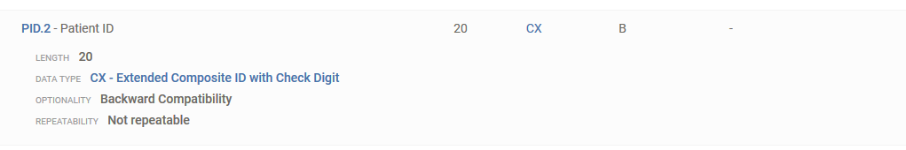

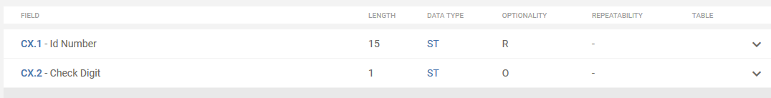

- patient name

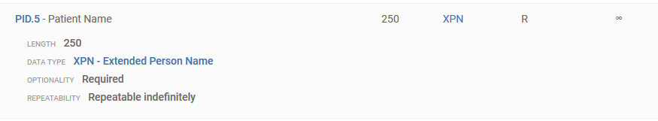

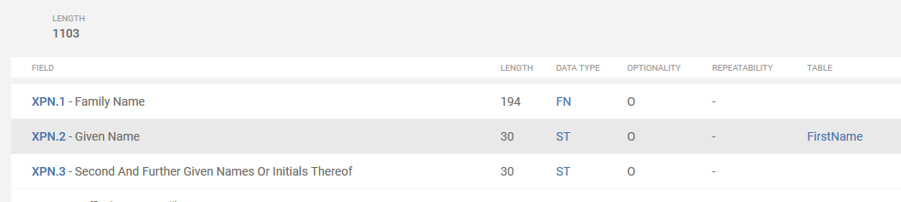

-race

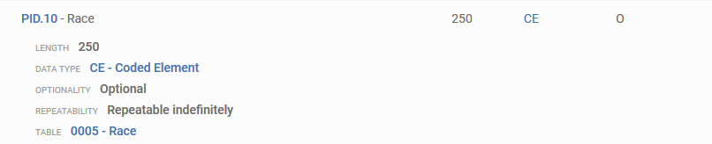

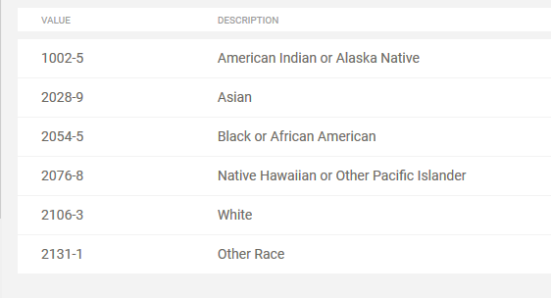

-sex

**HL7 v2.5 - 0001 - Administrative Sex**

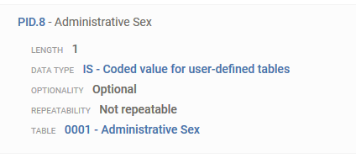

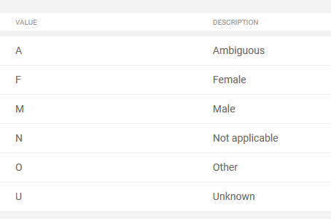

-data nasterii

https://hl7-definition.caristix.com/v2/HL7v2.5/DataTypes/TS

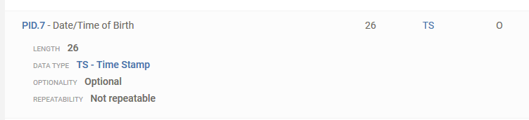

Telefon + email adress

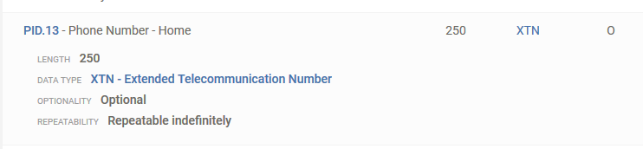

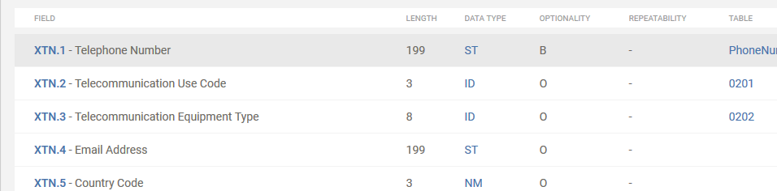

Diagnostic

<https://hl7-definition.caristix.com/v2/HL7v2.5/Segments/DG1>

alergii

<https://hl7-definition.caristix.com/v2/HL7v2.5/Segments/IAM>

locatia consultatiei?

<https://hl7-definition.caristix.com/v2/HL7v2.5/Segments/AIL>

asta a doua cred ca e mai buna

https://hl7-definition.caristix.com/v2/HL7v2.5/Segments/PV1

donator de organe:

<https://hl7-definition.caristix.com/v2/HL7v2.5/Segments/CON>



+ multe alte interventii

tratamente

https://hl7-definition.caristix.com/v2/HL7v2.5/Segments/RXG