# Quotes Data : https://quotes.toscrape.com/

|  |  |  |
| --- | --- | --- |
| Author | Quote | Tags |
| Albert Einstein | “The world as we have created it is a process of our thinking. It cannot be changed without changing our thinking.” | ['change', 'deep-thoughts', 'thinking', 'world'] |
| J.K. Rowling | “It is our choices, Harry, that show what we truly are, far more than our abilities.” | ['abilities', 'choices'] |
| Albert Einstein | “There are only two ways to live your life. One is as though nothing is a miracle. The other is as though everything is a miracle.” | ['inspirational', 'life', 'live', 'miracle', 'miracles'] |
| Jane Austen | “The person, be it gentleman or lady, who has not pleasure in a good novel, must be intolerably stupid.” | ['aliteracy', 'books', 'classic', 'humor'] |
| Marilyn Monroe | “Imperfection is beauty, madness is genius and it's better to be absolutely ridiculous than absolutely boring.” | ['be-yourself', 'inspirational'] |
| Albert Einstein | “Try not to become a man of success. Rather become a man of value.” | ['adulthood', 'success', 'value'] |
| André Gide | “It is better to be hated for what you are than to be loved for what you are not.” | ['life', 'love'] |
| Thomas A. Edison | “I have not failed. I've just found 10,000 ways that won't work.” | ['edison', 'failure', 'inspirational', 'paraphrased'] |
| Eleanor Roosevelt | “A woman is like a tea bag; you never know how strong it is until it's in hot water.” | ['misattributed-eleanor-roosevelt'] |
| Steve Martin | “A day without sunshine is like, you know, night.” | ['humor', 'obvious', 'simile'] |

**Temas principales *Top Ten tags*:** love, inspirational, life, humor, books, reading, friendship, Friends, truth, simile (simile tiene un error -> debería ser “smile”)

**Cada autor** tiene una citación, menos **Albert Einstein**, del que aparecen **tres**.

La tabla principal del actual documento se ha creado mediante el siguiente código, donde le dije como crearlo y guardarlo en la carpeta en curso. 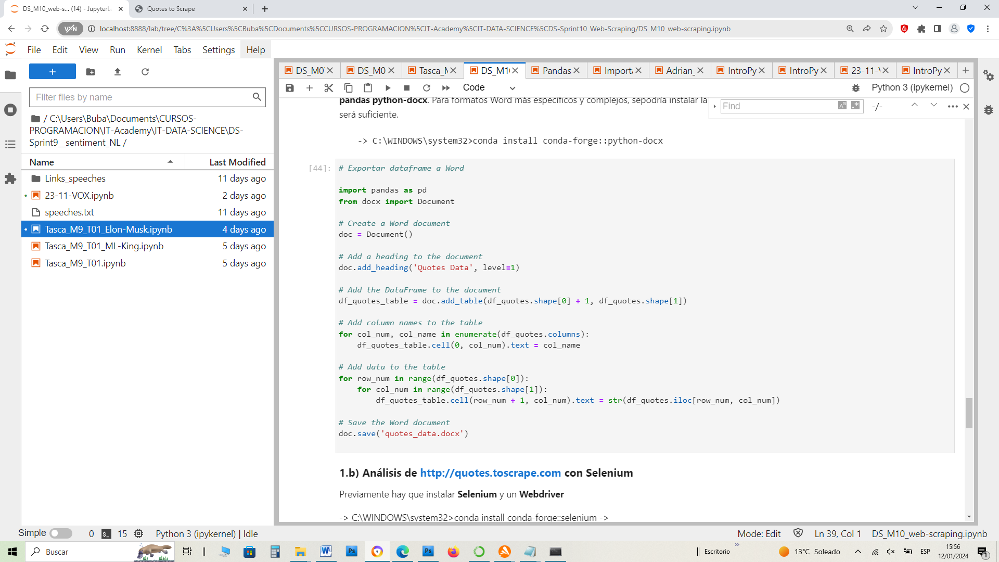

Las temáticas principales (*Top Ten tags*) en orden de importancia son : love, inspirational, life, humor, books, reading, friendship, Friends, truth, simile, se ha creado mediante el siguiente código :

