Aaaaa sdjfasdjfoa123
a | a | A
A | **** | tgdg
a | A | a
c

C
c
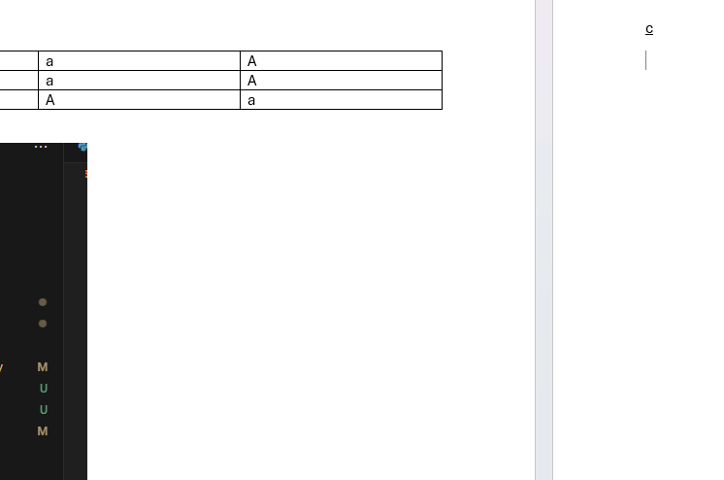

d


