Print Presentation Element

##### Author: Siri Chongasamethaworn

##### Publisher: No Magic

##### Date: Feb 9, 2021 12:52:10 PM

Presentation element is the visual elements which is display on the diagrams. A single element may have multiple presentation element.

This sample template show the important attributes of presentation and how to print an image of element.

Code learning:

Find all presentation elements of actual element

|  |
| --- |
| $element.presentationElement |

Find all presentation element of specific diagram

|  |
| --- |
| $report.getPresentationDiagramElements(diagram) |

Presentation element always contains in array. Loop will be used for printing the attributes of presentation element.

Looping

|  |
| --- |
| #foreach ($p in $element.presentationElement)  $p.name  $p.image  #end |

# Classes on diagrams

This sample uses 'presentationElement' to print class symbols and, where symbols are appeared at coordinate x,y.

# Symbols on diagrams

This sample uses 'getPresentationDiagramElements' to print all symbols which is appear on the diagram.

## TankControl-LocalCloud_Design

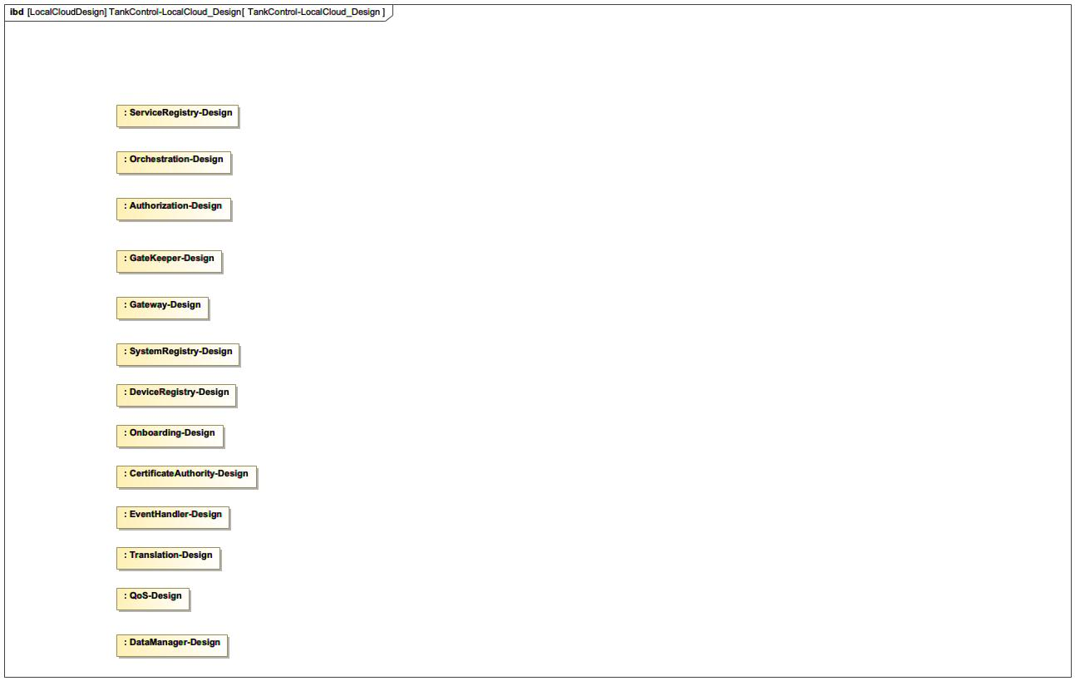

1. TankControl-LocalCloud_Design

TankControl-LocalCloud_Design contains the following elements

## Tank control Local cloud

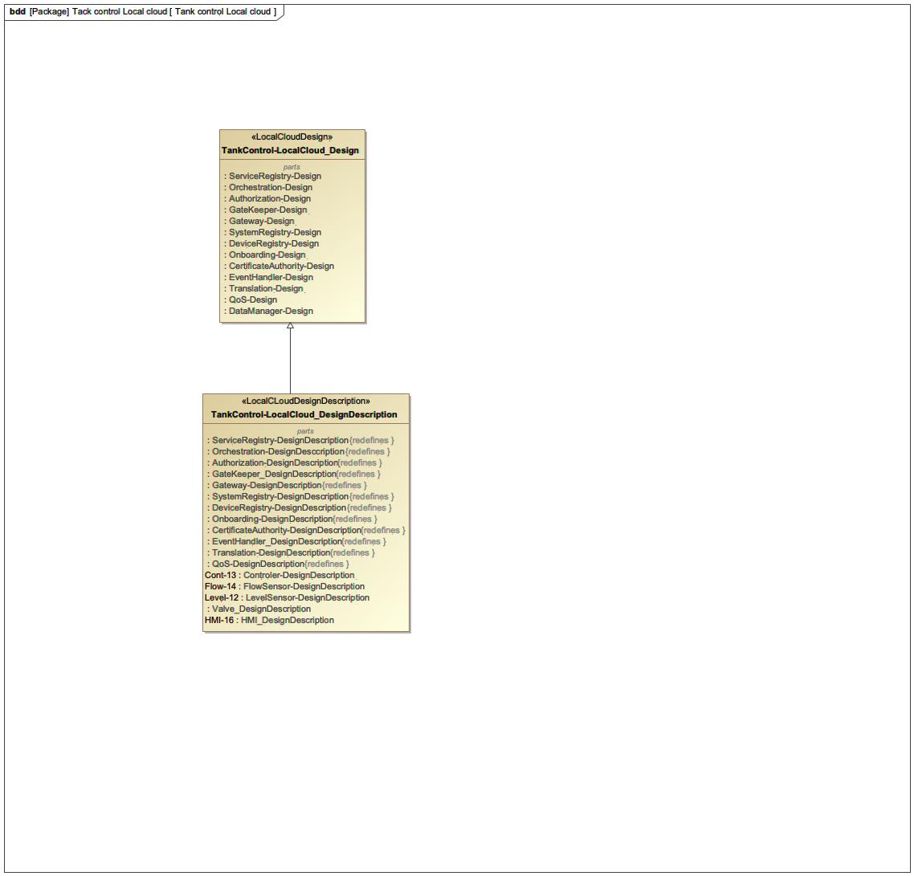

1. Tank control Local cloud

Tank control Local cloud contains the following elements

## Tank control

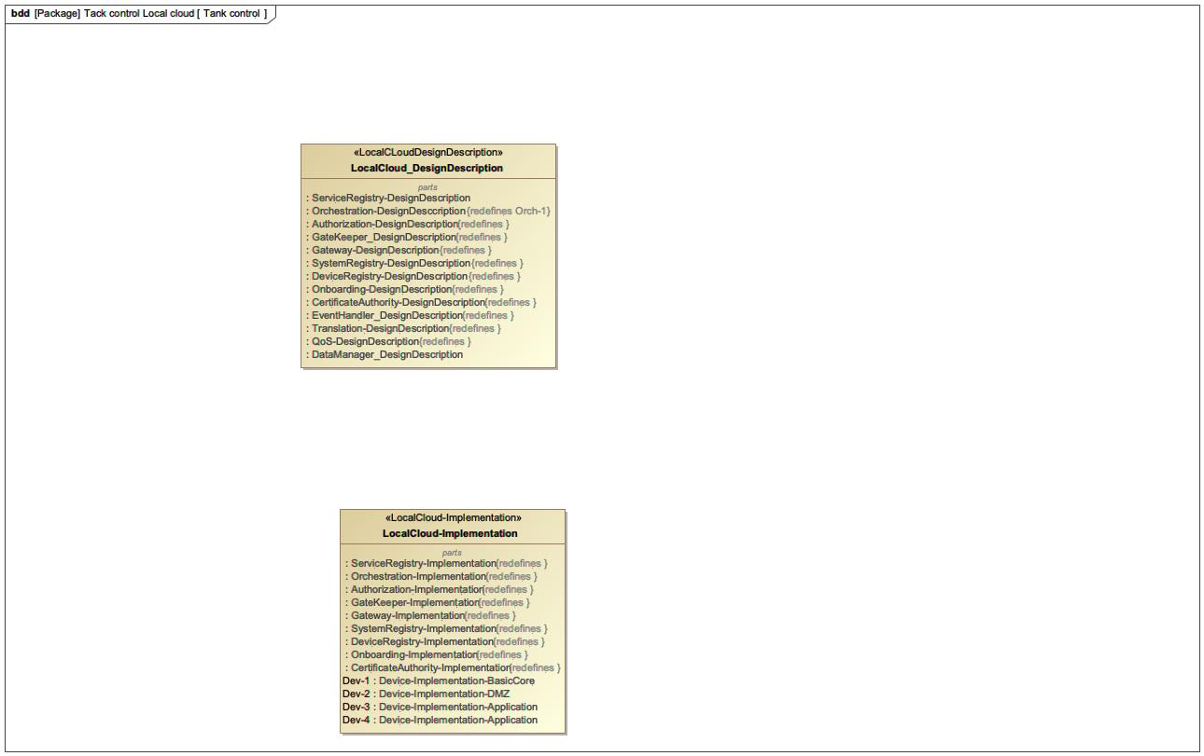

1. Tank control

Tank control contains the following elements

## TankControl-LocalCloud_DesignDescription

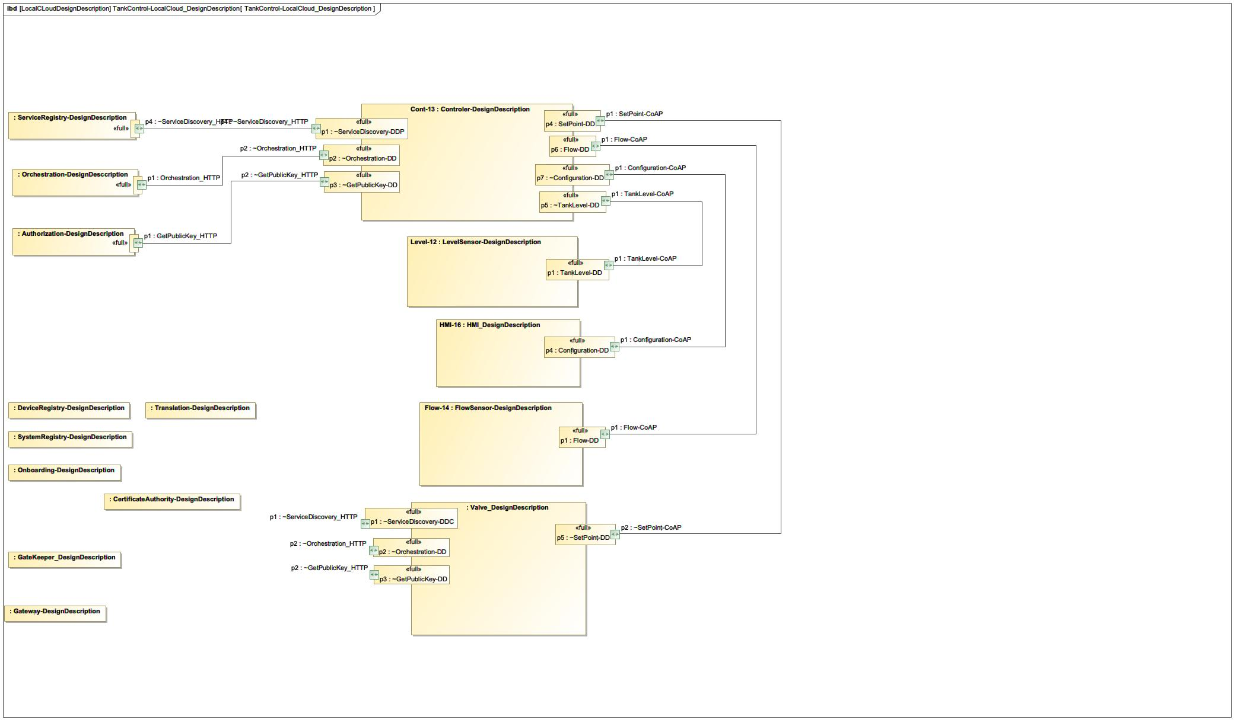

1. TankControl-LocalCloud_DesignDescription

TankControl-LocalCloud_DesignDescription contains the following elements