Query Tool

##### Author: Uraiwan Insoontorn

##### Publisher: No Magic

##### Date: Feb 9, 2021 12:58:18 PM

Query tool provides extra functions to retrieve MagicDraw elements using query language. Like any other Custom Tools, Query Tool (querytool.jar) must be installed in the 'extensions' folder of the Report Wizard plugin.and uses import directive to import a tool

#import("query", "com.nomagic.reportwizard.tools.QueryTool")

You can find more information about Query Tool on MagicDraw ReportWizard UserGuide.pdf section Query Tool

Code learning:

1. **Retrieve an array of element by query pattern**

$query.get(query)

1. **Getting single result from query functions**

Since MagicDraw model element does not have unique identified attribute so all methods will be return in Collection. Thus we will need convenient methods to get a single result from Collection.  Additional methods for getting single result from query methods are:

* 1. **Get the first element from collection**

$query.get(query).first()

* 1. **Get the last element from collection**

$query.get(query).last()

* 1. **Get the nth element from collection**

$query.get(query).get(index)

* 1. **Get the unique element from collection (equivalent to first)**

$query.get(query).unique()

1. **Retrieve an array of elements by name**

$query.getElementsByName(name)

1. **Retrieve the element by ID**

$query.getElementById(id)

**Example**

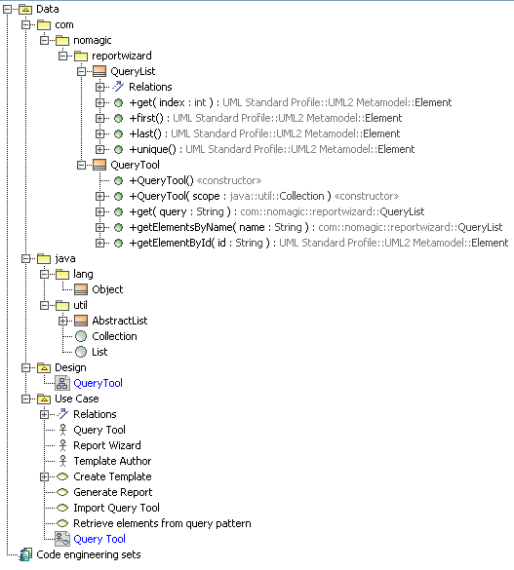

Figure 1 Query Tool Containment Tree

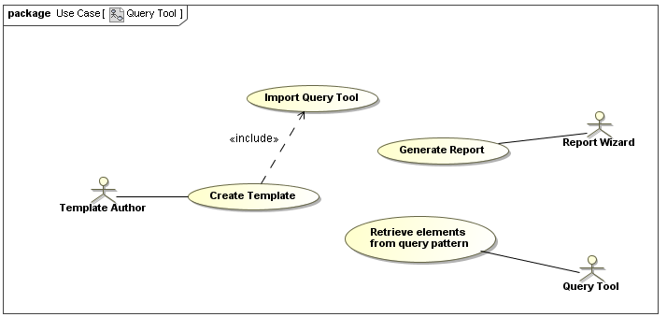

Figure 2 Query Tool Use Case Diagram

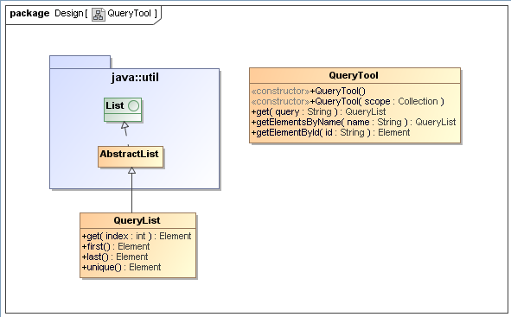

Figure 3 Query Tool Class Diagram

Try to create project elements according to above Query Tool use case and class diagram, then using following code:

**Retrieve array of element by Query Pattern**

**Example 1:**

Print all packages containing in this project

Without QueryTool:

|  |  |
| --- | --- |
| **Name** | **Qualified Name** |

|  |  |
| --- | --- |
| Tack control Local cloud | Tank control::Tack control Local cloud |

With QueryTool:

|  |  |
| --- | --- |
| **Name** | **Qualified Name** |

|  |  |
| --- | --- |
| Tack control Local cloud | Tank control::Tack control Local cloud |

**Example 2:**

Print any classes whose containing in package reportwizard and name attribute start with Query

Without QueryTool:

|  |  |
| --- | --- |
| **Name** | **Qualified Name** |

With QueryTool:

|  |  |
| --- | --- |
| **Name** | **Qualified Name** |

Or

|  |  |
| --- | --- |
| **Name** | **Qualified Name** |

**Example 3:**

Print any classes that has no child

Without QueryTool:

|  |  |
| --- | --- |
| **Name** | **Qualified Name** |

With QueryTool:

|  |  |
| --- | --- |
| **Name** | **Qualified Name** |

**Example 4:**

Print any elements which owner is class QueryTool

Without QueryTool:

|  |  |
| --- | --- |
| **Name** | **Qualified Name** |

With QueryTool:

|  |  |
| --- | --- |
| **Name** | **Qualified Name** |

**Example 5:**

Print any elements whose containing in model Use Case and name ends with Tool

Without QueryTool:

|  |  |
| --- | --- |
| **Name** | **Qualified Name** |

With QueryTool:

|  |  |
| --- | --- |
| **Name** | **Qualified Name** |

**Getting single result from query functions**

Print any classes in selected package

|  |  |
| --- | --- |
| **Name** | **Qualified Name** |

Print the first class in selected package

|  |  |
| --- | --- |
| **Name** | **Qualified Name** |
|  |  |

Print the last class in selected package

|  |  |
| --- | --- |
| **Name** | **Qualified Name** |
|  |  |

Print the nth class in selected package

|  |  |
| --- | --- |
| **Name** | **Qualified Name** |
|  |  |

Print the unique class in selected package

|  |  |
| --- | --- |
| **Name** | **Qualified Name** |
|  |  |

**Retrieve an array of elements by name**

Print any classes whose name is QueryTool

|  |  |
| --- | --- |
| **Name** | **Qualified Name** |

**Retrieve the element by ID**

Print element whose ID equivalent to the first class in selected package

|  |  |
| --- | --- |
| **Name** | **Qualified Name** |
|  |  |

|  |  |
| --- | --- |
| **Name** | **Qualified Name** |
|  |  |