Print Element

##### Author: Siri Chongasamethaworn

##### Publisher: No Magic

##### Date: Feb 9, 2021 2:56:50 PM

This sample template will list all classes from selected package. The content of each class consists of class name, visibility, and its operations.

This sample gives a practical demonstration of the Velocity Template Language (VTL) usage of variable properties.

Code learning:

Print element

|  |
| --- |
| $Class  $cls.name |

Looping

|  |
| --- |
| #foreach ($cls in $Class)  $cls.name  #end |

# List of Class

## More Information

You can find additional printable attributes of each element within the “Specification Dialog”

For example:

You have a class diagram with class name Customer

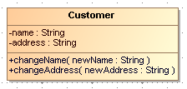

Figure 1: A Class Diagram

If you want to print attribute of Customer in a report, right click and open specification dialog of this class.

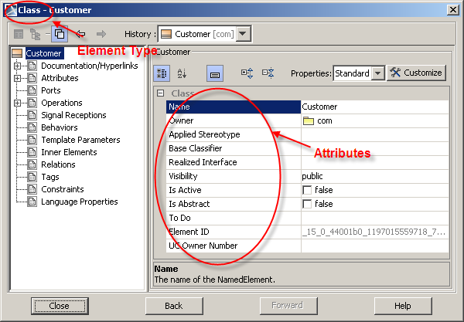

Figure 2: Display specification dialog of Customer

The element type displays on dialog title and attribute name displays on the right-hand side.

You can print other attributes of Class element by using the following statement.

|  |
| --- |
|  |

The output will be

|  |
| --- |
| Name: Customer  Owner: com  Visibility: public  Is Abstract: false |

Learn additional technical function of MagicDraw, the OMG meta-model, and get technical Java documentation from <MagicDraw install directory>\openapi\docs\

The printable element such as “Class”, “Interface”, “Use Case”, “Actor”, and “Extension Point” are contained in package “com.nomagic.uml2.ext.magicdraw” and sub-packages.