Use Case Specification Report

**Use Case Specification**

CasosUsoAngelM

Revision: 0.2

marzo 25, 2019

Approval

|  |
| --- |
| The original of this document is approved and signed by:  Name: Angel Manuel  Surname: Joaquin Yébenes  Title: Casos de Uso Página web Rocket Motors  Date: 25 mar 2019  Signature: Introducción a la Ingeniería del Software |

Revision History

|  |  |  |  |
| --- | --- | --- | --- |
| **Revision** | **Date** | **Description** | **Author** |
| 0.1 | <date 1> | <draft> | <Author name> |
| 0.2 | <date 2> | <release> | <Author name> |

Table of Contents

Microsoft Word users please click here and press F9 to create Table of Contents.

OpenOffice.org users please remove this text and select Insert Table of Content from menu.

Index of Use-Cases

|  |  |
| --- | --- |
| **UseCase** | **Page** |
| Añadir coche | Error! Bookmark not defined. |
| Editar coche | Error! Bookmark not defined. |
| Eliminar coche | Error! Bookmark not defined. |
| Escribir comentario | Error! Bookmark not defined. |
| Puntuar coche | Error! Bookmark not defined. |
| Ver coche | Error! Bookmark not defined. |

# Introduction

## Purpose

Describir las capacidades de edición del administrador y usuario en la web

## Scope

En este documento quedan reflejadas las acciones que se pueden realizar en la pagina web.

## Overview

Describe brevemente las interacciones de los usuarios y administradores en la pagina web y su

contenido.

# Actor Summary

|  |  |
| --- | --- |
| **Primary Actor** | **Use Cases** |
| Admin | * Añadir coche      * Editar coche      * Eliminar coche      * Escribir comentario      * Ver coche |
| User | * Escribir comentario      * Puntuar coche      * Ver coche |

# Use Case: Añadir coche Diagram

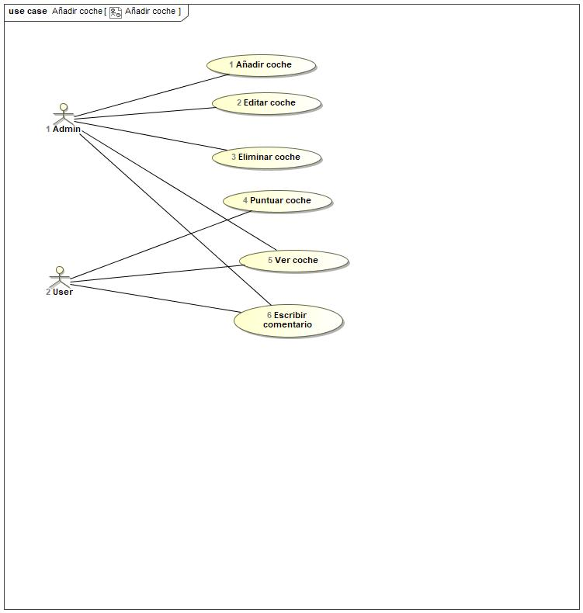

## Añadir coche Use Case

|  |  |  |  |
| --- | --- | --- | --- |
| **Use Case Name** | Añadir coche | ID | 1 |
| **Complexity** | Average Complexity | | |
| **Description** |  | | |
| **Actors** | * Admin | | |
| **Goal** |  | | |
| **Assumption** |  | | |
| **Non Functional Requirements** |  | | |
| **Pre Condition** | El administrador necesita añadir un coche. | | |
| **Post Condition** |  | | |
| **Constraints** |  | | |

|  |  |
| --- | --- |
| **Relations** | |
| **Association** | * Admin Actor |
| **Include** |  |
| **Extend** |  |
| **Generalization** |  |

|  |  |
| --- | --- |
| **Scenarios** | |
| **Basic Flow of Events** |  |
| **Basic Flow of Events Diagrams** |  |
| **Alternative Flow of Events** |  |
| **Alternative Flow of Events Diagrams** |  |
| **Exceptional Flow of Events** |  |
| **Exceptional Flow of Events Diagrams** |  |

## Editar coche Use Case

|  |  |  |  |
| --- | --- | --- | --- |
| **Use Case Name** | Editar coche | ID | 2 |
| **Complexity** | Average Complexity | | |
| **Description** |  | | |
| **Actors** | * Admin | | |
| **Goal** |  | | |
| **Assumption** |  | | |
| **Non Functional Requirements** |  | | |
| **Pre Condition** | Ante cualquier novedad o corrección el administrador puede editar cualquier número de coches. | | |
| **Post Condition** |  | | |
| **Constraints** |  | | |

|  |  |
| --- | --- |
| **Relations** | |
| **Association** | * Admin Actor |
| **Include** |  |
| **Extend** |  |
| **Generalization** |  |

|  |  |
| --- | --- |
| **Scenarios** | |
| **Basic Flow of Events** |  |
| **Basic Flow of Events Diagrams** |  |
| **Alternative Flow of Events** |  |
| **Alternative Flow of Events Diagrams** |  |
| **Exceptional Flow of Events** |  |
| **Exceptional Flow of Events Diagrams** |  |

## Eliminar coche Use Case

|  |  |  |  |
| --- | --- | --- | --- |
| **Use Case Name** | Eliminar coche | ID | 3 |
| **Complexity** | Average Complexity | | |
| **Description** |  | | |
| **Actors** | * Admin | | |
| **Goal** |  | | |
| **Assumption** |  | | |
| **Non Functional Requirements** |  | | |
| **Pre Condition** |  | | |
| **Post Condition** |  | | |
| **Constraints** |  | | |

|  |  |
| --- | --- |
| **Relations** | |
| **Association** | * Admin Actor |
| **Include** |  |
| **Extend** |  |
| **Generalization** |  |

|  |  |
| --- | --- |
| **Scenarios** | |
| **Basic Flow of Events** |  |
| **Basic Flow of Events Diagrams** |  |
| **Alternative Flow of Events** |  |
| **Alternative Flow of Events Diagrams** |  |
| **Exceptional Flow of Events** |  |
| **Exceptional Flow of Events Diagrams** |  |

## Escribir comentario Use Case

|  |  |  |  |
| --- | --- | --- | --- |
| **Use Case Name** | Escribir comentario | ID | 6 |
| **Complexity** | Average Complexity | | |
| **Description** |  | | |
| **Actors** | * Admin * User | | |
| **Goal** |  | | |
| **Assumption** |  | | |
| **Non Functional Requirements** |  | | |
| **Pre Condition** |  | | |
| **Post Condition** |  | | |
| **Constraints** |  | | |

|  |  |
| --- | --- |
| **Relations** | |
| **Association** | * Admin Actor * User Actor |
| **Include** |  |
| **Extend** |  |
| **Generalization** |  |

|  |  |
| --- | --- |
| **Scenarios** | |
| **Basic Flow of Events** |  |
| **Basic Flow of Events Diagrams** |  |
| **Alternative Flow of Events** |  |
| **Alternative Flow of Events Diagrams** |  |
| **Exceptional Flow of Events** |  |
| **Exceptional Flow of Events Diagrams** |  |

## Puntuar coche Use Case

|  |  |  |  |
| --- | --- | --- | --- |
| **Use Case Name** | Puntuar coche | ID | 4 |
| **Complexity** | Average Complexity | | |
| **Description** |  | | |
| **Actors** | * User | | |
| **Goal** |  | | |
| **Assumption** |  | | |
| **Non Functional Requirements** |  | | |
| **Pre Condition** |  | | |
| **Post Condition** |  | | |
| **Constraints** |  | | |

|  |  |
| --- | --- |
| **Relations** | |
| **Association** | * User Actor |
| **Include** |  |
| **Extend** |  |
| **Generalization** |  |

|  |  |
| --- | --- |
| **Scenarios** | |
| **Basic Flow of Events** |  |
| **Basic Flow of Events Diagrams** |  |
| **Alternative Flow of Events** |  |
| **Alternative Flow of Events Diagrams** |  |
| **Exceptional Flow of Events** |  |
| **Exceptional Flow of Events Diagrams** |  |

## Ver coche Use Case

|  |  |  |  |
| --- | --- | --- | --- |
| **Use Case Name** | Ver coche | ID | 5 |
| **Complexity** | Average Complexity | | |
| **Description** |  | | |
| **Actors** | * Admin * User | | |
| **Goal** |  | | |
| **Assumption** |  | | |
| **Non Functional Requirements** |  | | |
| **Pre Condition** |  | | |
| **Post Condition** |  | | |
| **Constraints** |  | | |

|  |  |
| --- | --- |
| **Relations** | |
| **Association** | * Admin Actor * User Actor |
| **Include** |  |
| **Extend** |  |
| **Generalization** |  |

|  |  |
| --- | --- |
| **Scenarios** | |
| **Basic Flow of Events** |  |
| **Basic Flow of Events Diagrams** |  |
| **Alternative Flow of Events** |  |
| **Alternative Flow of Events Diagrams** |  |
| **Exceptional Flow of Events** |  |
| **Exceptional Flow of Events Diagrams** |  |