Use Case Specification Report

**Use Case Specification**

Untitled2

Revision: 0.2

marzo 25, 2019

Approval

|  |
| --- |
| The original of this document is approved and signed by:  Name:  Surname:  Title:  Date:  Signature: |

Revision History

|  |  |  |  |
| --- | --- | --- | --- |
| **Revision** | **Date** | **Description** | **Author** |
| 0.1 | <date 1> | <draft> | <Author name> |
| 0.2 | <date 2> | <release> | <Author name> |

Table of Contents

Microsoft Word users please click here and press F9 to create Table of Contents.

OpenOffice.org users please remove this text and select Insert Table of Content from menu.

Index of Use-Cases

|  |  |
| --- | --- |
| **UseCase** | **Page** |
| Añadir a marcadores/ favoritos | Error! Bookmark not defined. |
| Buscar Fallos | Error! Bookmark not defined. |
| Cerrar Sesion | Error! Bookmark not defined. |
| Elegir Fallo de Favoritos | Error! Bookmark not defined. |
| Iniciar Sesion | Error! Bookmark not defined. |
| Previo Registro | Error! Bookmark not defined. |

# Introduction

## Purpose

<This Document describes Use Case Specification Report.>

## Scope

<This Document intends to describe use case specification for the system.>

## Overview

<Describe what the document contains and explain how the document is organized.>

# Actor Summary

|  |  |
| --- | --- |
| **Primary Actor** | **Use Cases** |
| Cliente | * Buscar Fallos      * Elegir Fallo de Favoritos      * Iniciar Sesion |

# Use Case: crear algo Diagram

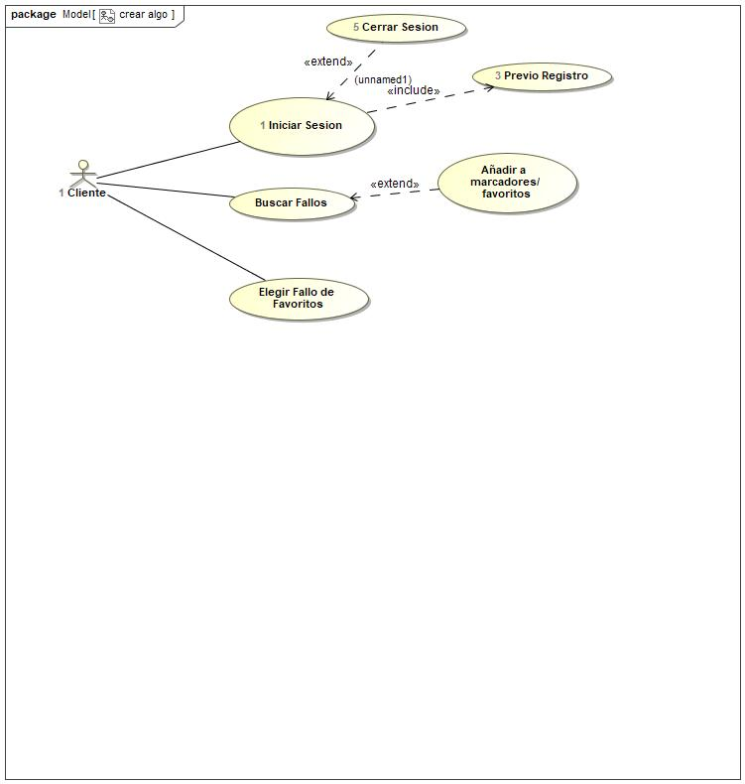

## Añadir a marcadores/ favoritos Use Case

|  |  |  |  |
| --- | --- | --- | --- |
| **Use Case Name** | Añadir a marcadores/ favoritos | ID |  |
| **Complexity** | Average Complexity | | |
| **Description** |  | | |
| **Actors** |  | | |
| **Goal** |  | | |
| **Assumption** |  | | |
| **Non Functional Requirements** |  | | |
| **Pre Condition** |  | | |
| **Post Condition** |  | | |
| **Constraints** |  | | |

|  |  |
| --- | --- |
| **Relations** | |
| **Association** |  |
| **Include** |  |
| **Extend** | * Buscar Fallos UseCase |
| **Generalization** |  |

|  |  |
| --- | --- |
| **Scenarios** | |
| **Basic Flow of Events** |  |
| **Basic Flow of Events Diagrams** |  |
| **Alternative Flow of Events** |  |
| **Alternative Flow of Events Diagrams** |  |
| **Exceptional Flow of Events** |  |
| **Exceptional Flow of Events Diagrams** |  |

## Buscar Fallos Use Case

|  |  |  |  |
| --- | --- | --- | --- |
| **Use Case Name** | Buscar Fallos | ID |  |
| **Complexity** | Average Complexity | | |
| **Description** |  | | |
| **Actors** | * Cliente | | |
| **Goal** |  | | |
| **Assumption** |  | | |
| **Non Functional Requirements** |  | | |
| **Pre Condition** |  | | |
| **Post Condition** |  | | |
| **Constraints** |  | | |

|  |  |
| --- | --- |
| **Relations** | |
| **Association** | * Cliente Actor |
| **Include** |  |
| **Extend** |  |
| **Generalization** |  |

|  |  |
| --- | --- |
| **Scenarios** | |
| **Basic Flow of Events** |  |
| **Basic Flow of Events Diagrams** |  |
| **Alternative Flow of Events** |  |
| **Alternative Flow of Events Diagrams** |  |
| **Exceptional Flow of Events** |  |
| **Exceptional Flow of Events Diagrams** |  |

## Cerrar Sesion Use Case

|  |  |  |  |
| --- | --- | --- | --- |
| **Use Case Name** | Cerrar Sesion | ID | 5 |
| **Complexity** | Average Complexity | | |
| **Description** |  | | |
| **Actors** |  | | |
| **Goal** |  | | |
| **Assumption** |  | | |
| **Non Functional Requirements** |  | | |
| **Pre Condition** |  | | |
| **Post Condition** |  | | |
| **Constraints** |  | | |

|  |  |
| --- | --- |
| **Relations** | |
| **Association** |  |
| **Include** |  |
| **Extend** | * Iniciar Sesion UseCase |
| **Generalization** |  |

|  |  |
| --- | --- |
| **Scenarios** | |
| **Basic Flow of Events** |  |
| **Basic Flow of Events Diagrams** |  |
| **Alternative Flow of Events** |  |
| **Alternative Flow of Events Diagrams** |  |
| **Exceptional Flow of Events** |  |
| **Exceptional Flow of Events Diagrams** |  |

## Elegir Fallo de Favoritos Use Case

|  |  |  |  |
| --- | --- | --- | --- |
| **Use Case Name** | Elegir Fallo de Favoritos | ID |  |
| **Complexity** | Average Complexity | | |
| **Description** |  | | |
| **Actors** | * Cliente | | |
| **Goal** |  | | |
| **Assumption** |  | | |
| **Non Functional Requirements** |  | | |
| **Pre Condition** |  | | |
| **Post Condition** |  | | |
| **Constraints** |  | | |

|  |  |
| --- | --- |
| **Relations** | |
| **Association** | * Cliente Actor |
| **Include** |  |
| **Extend** |  |
| **Generalization** |  |

|  |  |
| --- | --- |
| **Scenarios** | |
| **Basic Flow of Events** |  |
| **Basic Flow of Events Diagrams** |  |
| **Alternative Flow of Events** |  |
| **Alternative Flow of Events Diagrams** |  |
| **Exceptional Flow of Events** |  |
| **Exceptional Flow of Events Diagrams** |  |

## Iniciar Sesion Use Case

|  |  |  |  |
| --- | --- | --- | --- |
| **Use Case Name** | Iniciar Sesion | ID | 1 |
| **Complexity** | Average Complexity | | |
| **Description** |  | | |
| **Actors** | * Cliente | | |
| **Goal** | Iniciar sesión | | |
| **Assumption** |  | | |
| **Non Functional Requirements** |  | | |
| **Pre Condition** | Anteriormente debía haberse registrado | | |
| **Post Condition** | El cliente inicia sesión tiene acceso a su perfil | | |
| **Constraints** |  | | |

|  |  |
| --- | --- |
| **Relations** | |
| **Association** | * Cliente Actor |
| **Include** | * Previo Registro UseCase |
| **Extend** |  |
| **Generalization** |  |

|  |  |
| --- | --- |
| **Scenarios** | |
| **Basic Flow of Events** |  |
| **Basic Flow of Events Diagrams** |  |
| **Alternative Flow of Events** |  |
| **Alternative Flow of Events Diagrams** |  |
| **Exceptional Flow of Events** |  |
| **Exceptional Flow of Events Diagrams** |  |

## Previo Registro Use Case

|  |  |  |  |
| --- | --- | --- | --- |
| **Use Case Name** | Previo Registro | ID | 3 |
| **Complexity** | Average Complexity | | |
| **Description** |  | | |
| **Actors** |  | | |
| **Goal** | Ser capaz de iniciar sesion | | |
| **Assumption** |  | | |
| **Non Functional Requirements** |  | | |
| **Pre Condition** | No estar registrado anteriormente | | |
| **Post Condition** | Poder registrarse con sus datos | | |
| **Constraints** |  | | |

|  |  |
| --- | --- |
| **Relations** | |
| **Association** |  |
| **Include** |  |
| **Extend** |  |
| **Generalization** |  |

|  |  |
| --- | --- |
| **Scenarios** | |
| **Basic Flow of Events** |  |
| **Basic Flow of Events Diagrams** |  |
| **Alternative Flow of Events** |  |
| **Alternative Flow of Events Diagrams** |  |
| **Exceptional Flow of Events** |  |
| **Exceptional Flow of Events Diagrams** |  |