Use Case Specification Report

**Use Case Specification**

casosdeuso

Revision: 0.2

marzo 25, 2019

Approval

|  |
| --- |
| The original of this document is approved and signed by:  Name: Marta  Surname:Romero Sanchez  Title:Casos de Uso  Date:25/03/19  Signature:Marta |

Revision History

|  |  |  |  |
| --- | --- | --- | --- |
| **Revision** | **Date** | **Description** | **Author** |
| 0.1 | <date 1> | <draft> | <Author name> |
| 0.2 | <date 2> | <release> | <Author name> |

Table of Contents

Microsoft Word users please click here and press F9 to create Table of Contents.

OpenOffice.org users please remove this text and select Insert Table of Content from menu.

Index of Use-Cases

|  |  |
| --- | --- |
| **UseCase** | **Page** |
| Buscar información sobre el coche | Error! Bookmark not defined. |
| Buscarle una solución al problema | Error! Bookmark not defined. |
| Entregar al cliente | Error! Bookmark not defined. |
| Mete la información en el sistema | Error! Bookmark not defined. |
| Mete los datos de su coche en el sistema | Error! Bookmark not defined. |
| Observa sus características | Error! Bookmark not defined. |
| Reparar el daño producido | Error! Bookmark not defined. |
| Visualiza los posibles fallos técnicos | Error! Bookmark not defined. |

# Introduction

## Purpose

<This Document describes Use Case Specification Report.>

## Scope

<This Document intends to describe use case specification for the system.>

## Overview

<Describe what the document contains and explain how the document is organized.>

# Actor Summary

|  |  |
| --- | --- |
| **Primary Actor** | **Use Cases** |
| Cliente | * Mete los datos de su coche en el sistema |
| Mecánico | * Entregar al cliente      * Reparar el daño producido |
| Sistema | * Buscarle una solución al problema      * Mete la información en el sistema      * Observa sus características      * Visualiza los posibles fallos técnicos |

# Use Case: Actors Diagram

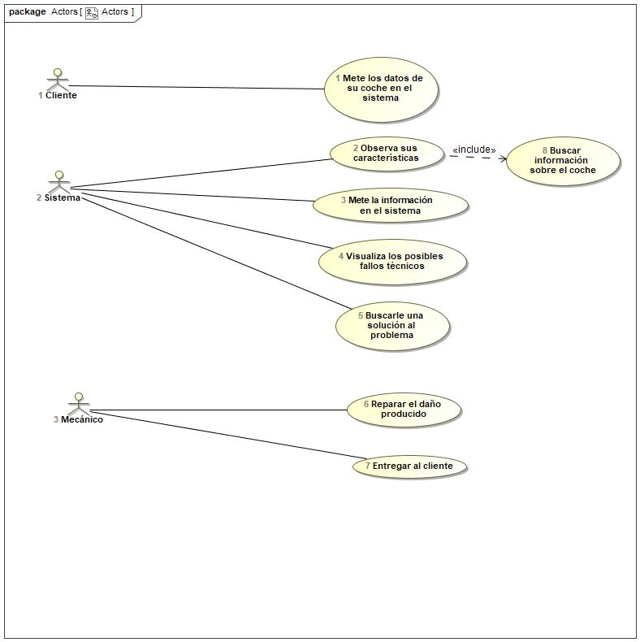

## Buscar información sobre el coche Use Case

|  |  |  |  |
| --- | --- | --- | --- |
| **Use Case Name** | Buscar información sobre el coche | ID | 8 |
| **Complexity** | Low Complexity | | |
| **Description** |  | | |
| **Actors** |  | | |
| **Goal** | Conocer a la perfeccion el coche | | |
| **Assumption** |  | | |
| **Non Functional Requirements** |  | | |
| **Pre Condition** | Conocer todas sus características | | |
| **Post Condition** | Saber todos los materiales del que está constituido el coche | | |
| **Constraints** |  | | |

|  |  |
| --- | --- |
| **Relations** | |
| **Association** |  |
| **Include** |  |
| **Extend** |  |
| **Generalization** |  |

|  |  |
| --- | --- |
| **Scenarios** | |
| **Basic Flow of Events** |  |
| **Basic Flow of Events Diagrams** |  |
| **Alternative Flow of Events** |  |
| **Alternative Flow of Events Diagrams** |  |
| **Exceptional Flow of Events** |  |
| **Exceptional Flow of Events Diagrams** |  |

## Buscarle una solución al problema Use Case

|  |  |  |  |
| --- | --- | --- | --- |
| **Use Case Name** | Buscarle una solución al problema | ID | 5 |
| **Complexity** | High Complexity | | |
| **Description** |  | | |
| **Actors** | * Sistema | | |
| **Goal** | Arreglar el coche | | |
| **Assumption** |  | | |
| **Non Functional Requirements** |  | | |
| **Pre Condition** | Estar informado de los fallos que pueda tener un coche. | | |
| **Post Condition** | Poder arreglar el coche. | | |
| **Constraints** |  | | |

|  |  |
| --- | --- |
| **Relations** | |
| **Association** | * Sistema Actor |
| **Include** |  |
| **Extend** |  |
| **Generalization** |  |

|  |  |
| --- | --- |
| **Scenarios** | |
| **Basic Flow of Events** |  |
| **Basic Flow of Events Diagrams** |  |
| **Alternative Flow of Events** |  |
| **Alternative Flow of Events Diagrams** |  |
| **Exceptional Flow of Events** |  |
| **Exceptional Flow of Events Diagrams** |  |

## Entregar al cliente Use Case

|  |  |  |  |
| --- | --- | --- | --- |
| **Use Case Name** | Entregar al cliente | ID | 7 |
| **Complexity** | Average Complexity | | |
| **Description** |  | | |
| **Actors** | * Mecánico | | |
| **Goal** | Que el cliente quede satisfecho | | |
| **Assumption** |  | | |
| **Non Functional Requirements** |  | | |
| **Pre Condition** | Saber que lo va a entregar correctamente | | |
| **Post Condition** | Revisarlo antes de entregarlo | | |
| **Constraints** |  | | |

|  |  |
| --- | --- |
| **Relations** | |
| **Association** | * Mecánico Actor |
| **Include** |  |
| **Extend** |  |
| **Generalization** |  |

|  |  |
| --- | --- |
| **Scenarios** | |
| **Basic Flow of Events** |  |
| **Basic Flow of Events Diagrams** |  |
| **Alternative Flow of Events** |  |
| **Alternative Flow of Events Diagrams** |  |
| **Exceptional Flow of Events** |  |
| **Exceptional Flow of Events Diagrams** |  |

## Mete la información en el sistema Use Case

|  |  |  |  |
| --- | --- | --- | --- |
| **Use Case Name** | Mete la información en el sistema | ID | 3 |
| **Complexity** | High Complexity | | |
| **Description** |  | | |
| **Actors** | * Sistema | | |
| **Goal** | Tener la información metida en el sistema | | |
| **Assumption** |  | | |
| **Non Functional Requirements** |  | | |
| **Pre Condition** | Tener un sistema generado | | |
| **Post Condition** | Tener la información completa para trabajar con el coche | | |
| **Constraints** |  | | |

|  |  |
| --- | --- |
| **Relations** | |
| **Association** | * Sistema Actor |
| **Include** |  |
| **Extend** |  |
| **Generalization** |  |

|  |  |
| --- | --- |
| **Scenarios** | |
| **Basic Flow of Events** |  |
| **Basic Flow of Events Diagrams** |  |
| **Alternative Flow of Events** |  |
| **Alternative Flow of Events Diagrams** |  |
| **Exceptional Flow of Events** |  |
| **Exceptional Flow of Events Diagrams** |  |

## Mete los datos de su coche en el sistema Use Case

|  |  |  |  |
| --- | --- | --- | --- |
| **Use Case Name** | Mete los datos de su coche en el sistema | ID | 1 |
| **Complexity** | Average Complexity | | |
| **Description** |  | | |
| **Actors** | * Cliente | | |
| **Goal** | Meter al vehículo en el sistema. | | |
| **Assumption** |  | | |
| **Non Functional Requirements** |  | | |
| **Pre Condition** | El administrador está conectado en el sistema y en el formulario de coches. | | |
| **Post Condition** | El coche ya está dentro del sistema. | | |
| **Constraints** |  | | |

|  |  |
| --- | --- |
| **Relations** | |
| **Association** | * Cliente Actor |
| **Include** | * Entregar al cliente UseCase |
| **Extend** |  |
| **Generalization** |  |

|  |  |
| --- | --- |
| **Scenarios** | |
| **Basic Flow of Events** |  |
| **Basic Flow of Events Diagrams** |  |
| **Alternative Flow of Events** |  |
| **Alternative Flow of Events Diagrams** |  |
| **Exceptional Flow of Events** |  |
| **Exceptional Flow of Events Diagrams** |  |

## Observa sus características Use Case

|  |  |  |  |
| --- | --- | --- | --- |
| **Use Case Name** | Observa sus características | ID | 2 |
| **Complexity** | Average Complexity | | |
| **Description** |  | | |
| **Actors** | * Sistema | | |
| **Goal** | Observar las características detalladamente. | | |
| **Assumption** |  | | |
| **Non Functional Requirements** |  | | |
| **Pre Condition** | El sistema esté informado correctamente. | | |
| **Post Condition** | Tener todas las características del vehículoc dado. | | |
| **Constraints** |  | | |

|  |  |
| --- | --- |
| **Relations** | |
| **Association** | * Sistema Actor |
| **Include** | * Buscar información sobre el coche UseCase |
| **Extend** |  |
| **Generalization** |  |

|  |  |
| --- | --- |
| **Scenarios** | |
| **Basic Flow of Events** |  |
| **Basic Flow of Events Diagrams** |  |
| **Alternative Flow of Events** |  |
| **Alternative Flow of Events Diagrams** |  |
| **Exceptional Flow of Events** |  |
| **Exceptional Flow of Events Diagrams** |  |

## Reparar el daño producido Use Case

|  |  |  |  |
| --- | --- | --- | --- |
| **Use Case Name** | Reparar el daño producido | ID | 6 |
| **Complexity** | High Complexity | | |
| **Description** |  | | |
| **Actors** | * Mecánico | | |
| **Goal** | Reparar el coche | | |
| **Assumption** |  | | |
| **Non Functional Requirements** |  | | |
| **Pre Condition** | Tener el material necesario | | |
| **Post Condition** | Entregar su trabajo correctamente sin fallos | | |
| **Constraints** |  | | |

|  |  |
| --- | --- |
| **Relations** | |
| **Association** | * Mecánico Actor |
| **Include** |  |
| **Extend** |  |
| **Generalization** |  |

|  |  |
| --- | --- |
| **Scenarios** | |
| **Basic Flow of Events** |  |
| **Basic Flow of Events Diagrams** |  |
| **Alternative Flow of Events** |  |
| **Alternative Flow of Events Diagrams** |  |
| **Exceptional Flow of Events** |  |
| **Exceptional Flow of Events Diagrams** |  |

## Visualiza los posibles fallos técnicos Use Case

|  |  |  |  |
| --- | --- | --- | --- |
| **Use Case Name** | Visualiza los posibles fallos técnicos | ID | 4 |
| **Complexity** | Average Complexity | | |
| **Description** |  | | |
| **Actors** | * Sistema | | |
| **Goal** | Tener lo necesario para arreglar el fallo técnico. | | |
| **Assumption** |  | | |
| **Non Functional Requirements** |  | | |
| **Pre Condition** | Estar informado de cada parte del coche. | | |
| **Post Condition** | Saber lo que le ha ocurrido al coche. | | |
| **Constraints** |  | | |

|  |  |
| --- | --- |
| **Relations** | |
| **Association** | * Sistema Actor |
| **Include** |  |
| **Extend** |  |
| **Generalization** |  |

|  |  |
| --- | --- |
| **Scenarios** | |
| **Basic Flow of Events** |  |
| **Basic Flow of Events Diagrams** |  |
| **Alternative Flow of Events** |  |
| **Alternative Flow of Events Diagrams** |  |
| **Exceptional Flow of Events** |  |
| **Exceptional Flow of Events Diagrams** |  |