Project 1
Cristobal Guerrero
CIS -17A
Instructor: Mark Lehr

Table of Contents
Introduction 3
Statistics 3
Summary 3
Extra 4
Description 4
Sample Inputs/outputs 4
Flow Chart 6
Variables 6
Concepts 6
References 6
Program 6

Introduction
Have you ever wondered how a vending machine works, well I created a program that simulates a vending machine. This vending machine is used for soda dispensation. Ultimately the goal for this project was to produce a simulated vending machine that could be tested by either having a full vending machine or an empty one in which the user would fill it in with specific soda’s as well as price management. The user will be prompted in the beginning if they want to either test the machine with it already being filled or to fill it themselves.
I wanted to make this program to simulate a person being a vendor and being able to electronically manipulate the vending machine and to make sure it takes correct currency correctly and is able to give the correct change. Then the user will be able to make the choice again to either fill, test or quit the program all together.

Statistics
Summary
This program should be approximately 250 lines of coding, more or less. There can be ways to extend this as doing individual functions that can change the current populated vending machine, which I have been thinking of adding. There will be roughly 5 variables. These variables will consist of “doubles” and “string” arrays. These will be implemented in the structure and will be constantly accessed and changed as well as random variables for counters.
struct Vending{
int sarray;
string response;
string *machine;
double *cost;
};
The program was easy enough to do. It was an expansion based on other students assignments from CIS-5. Their assignment was to create a vending machine for deep-fried Twinkies, yes deep-fried Twinkies. Their assignment was to just keep track of the total amount the user put in the machine as well as checking the increments. My job was to expand it and manipulate it into my own vending machine that could literally take in anything. If the user was to put in anything it is checked by a string so that there are no errors with people putting chars, integers or doubles for the input incorrectly. The only exception is when the user inputs doubles for the price values there may be an error that may occur.
Extra
The structure could have been implemented into a “.h” file to use classes. This would have had the variables that were in the structure private and the prototypes and the functions in the program to be in the classes file. Other then that an editor for the already populated array for the vending machine could have had an editor so that one specific entity in the array could be changed at any time. For example if there was a sprite in the 2nd index of the array it could be changed to a Dr. Pepper along side with the price for the drink.
Description
Sample Inputs/outputs
In the beginning of the program the user will be asked if they would like to test or fill the vending machine
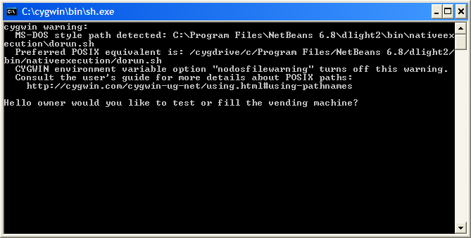
*Please excuse the beginning warning
now the user can either put in: test, Test, t, T to test the vending machine with a filled array if the user does not put in this input they will be asked if they would like to try again or quit the program. To quit the program the user types in “quit”, otherwise they will be prompted again to do a test or a fill.
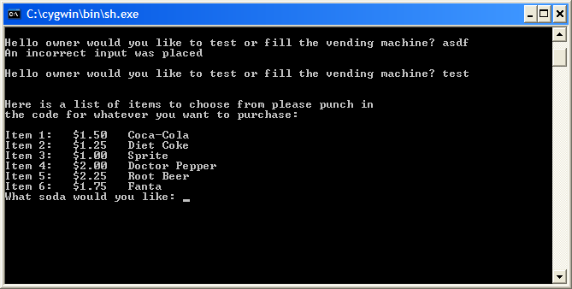
The user then is prompted to enter in the integer for the item that they would like. This then calls the search function to search the array for the correct cost of the item. The user is then asked to place either a 5 dollar bill, 1 dollar bill, quarters, dimes or nickels into the machine and then there is a deduction along with the display of the soda chosen with its price as seen below.
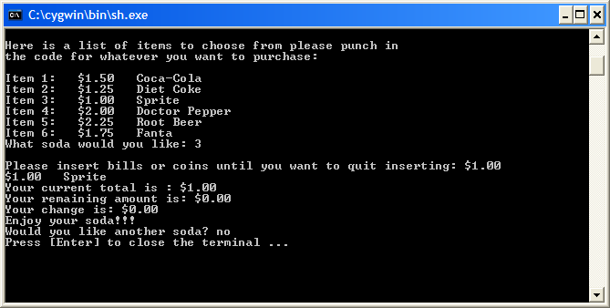
The user then types in the amount of money they would like to place in the machine. This is passed in as a string so that if the user puts in something invalid they are given a warning and prompted again. The valid input for the prompt if they would like another soda they would have to type in yes and then the user is then prompted to see if they want test or fill the vending machine.
Flow Chart
Start Program
User Decision
for Testing

User Prompt
for direction
Populate the array
for the names
and the cost

Prompt user for the
soda they want

Ask the user to
enter the currency
Call the function that
keeps track
of the user total

Checks the total

Prompt user if they
want to do it again

exit

Variables
The main variables that are used throughout the program are the ones that are from the structures. Most of the items are passed through as strings and with the user input as well for minimal errors as possible.
Concepts
The main concepts that are covered are arrays and structures. The structures come from chapter 12 from the book and the rest come from before in previous chapters. The concepts cover everything that has been in the class by far.
References
My references are my tutee's that I have tutored and the book the problem came from. The idea came from the currently used book for the CIS-5 class. All the coding is original
Program
/*
* File: Project 2
* Author: Cristobal Guerrero
*
* Created on April 22, 2010, 12:11 PM
*/

#include <cstdlib>
#include <stdlib.h>
#include <iostream>
#include <string>
#include <iomanip>
using namespace std;

/*
* This program is meant to simulate a vending machine being filled or already filled
* The user will be able to put in products into the vending machine and have a setinel
* value that will be implemented so that when the user puts in a negative amount
* or a product with a negative interger taken in as a string the vending machine will then
* be filled and then be able to be tested to see if the machine is in full working order
*/

struct Vending{
int sarray;
string response;
string *machine;
double *cost;
};

void fvending(); //This will fill the vending machine
void testvending(); //This will test if the vending machine was filled correctly
double validateentry(string,double); //This will validate the users input for currency as a boolean
string *autovendfill(int); //This is an auto fill for the vending machine if the user picks to test
void vendprint(string *,double *,int); //This will print the array with the size and the contents
string *manualfill(int); //This is for the manual fill for the users
double *autofillmoney(int); //This is for auto fill for the cost
double arraysearch(double*,int); //This is to search and return the cost of the soda
void vendprintcost(string *,double *,int); //This prints out cost and the item as well that is currently being purchased
double *manualcostfill(string *,int); //This is for the manual fill of the vending machine

int main(int argc, char** argv) {

Vending vend;
string currency="s";
double total=0,total2=0,csoda;
int soda;
vend.sarray=6;
vend.response="yes";

cout.setf(ios::fixed);
cout.precision(2);

while(vend.response!="no")
{
cout << "\nHello owner would you like to test or fill the vending machine? ";
cin >> vend.response;
if(vend.response=="Test"||vend.response=="test"||vend.response=="t"||vend.response=="T")
{

cout << "\n\nHere is a list of items to choose from "
"please punch in \nthe code for whatever you "
"want to purchase: \n"<<endl;

vend.machine=autovendfill(vend.sarray);
vend.cost=autofillmoney(vend.sarray);
vendprint(vend.machine,vend.cost,vend.sarray);
cout<<"What soda would you like: ";
cin>>soda;
soda--;
csoda=arraysearch(vend.cost,soda);

while(total<csoda)
{
cout << "\nPlease insert bills or coins until you want to quit inserting: $";
cin >> currency;
total+=validateentry(currency,total2);
total2=0;
vendprintcost(vend.machine,vend.cost,soda);
cout <<"Your current total is : $"<<total<<endl
<<"Your remaining amount is: $"<<(csoda-total)<<endl;
}
cout<<"Your change is: $"<<(total-csoda)<<endl
<<"Enjoy your soda!!!"<<endl<<"Would you like another soda? ";
cin>>vend.response;
if(vend.response!="quit"||vend.response!="no")
{
delete []vend.cost;
delete []vend.machine;
}
}

else if(vend.response=="Fill"||vend.response=="fill"||vend.response=="F"||vend.response=="f")
{
cout<<"In this section you can fill the vending machine with drinks\n"
<<"Please enter how many soda's will be in the machine: ";
cin>>vend.sarray;

vend.machine=manualfill(vend.sarray);
vend.cost=manualcostfill(vend.machine,vend.sarray);

cout<<endl<<"Now to test your vending machine"<<endl;
cout<<"What soda would you like: ";
cin>>soda;
soda--;
csoda=arraysearch(vend.cost,soda);

while(total<csoda)
{
cout << "\nPlease insert bills or coins until you want to quit inserting: $";
cin >> currency;
total+=validateentry(currency,total2);
total2=0;
vendprintcost(vend.machine,vend.cost,soda);
cout <<"Your current total is : $"<<total<<endl
<<"Your remaining amount is: $"<<(csoda-total)<<endl;
}
cout<<"Your change is: $"<<(total-csoda)<<endl
<<"Enjoy your soda!!!"<<endl<<"Would you like another soda? ";
cin>>vend.response;
if(vend.response!="quit"||vend.response!="no")
{
delete []vend.cost;
delete []vend.machine;
}

}

else if(vend.response!="no")
{
cout<<"An incorrect input was placed "<<endl;
}
}

return (EXIT_SUCCESS);
}

double validateentry(string currency,double total)
{

if(currency=="5.00"||currency=="5"||currency=="5.0"||currency=="five"){
total+=5;
}
else if(currency=="1.00"||currency=="1"||currency=="1.0"||currency=="dollar"){
total+=1;
}
else if(currency==".25"||currency==".250"||currency=="0.25"||currency=="quarter"){
total+=.25;
}
else if(currency==".1"||currency==".10"||currency=="0.1"||currency=="dime"){
total+=.1;
}
else if(currency==".05"||currency==".050"||currency=="0.05"||currency=="nickel"){
total+=.05;
}
else{
cout << "You put in an invalid coin or bill please try again"<<endl;
}
return total;

}

string *autovendfill(int size)
{
string *vend=new string[size];
vend[0]="Coca-Cola";
vend[1]="Diet Coke";
vend[2]="Sprite";
vend[3]="Doctor Pepper";
vend[4]="Root Beer";
vend[5]="Fanta";
return vend;
}

double *autofillmoney(int size)
{
double *cost=new double[size];
cost[0]=1.50;
cost[1]=1.25;
cost[2]=1.00;
cost[3]=2.00;
cost[4]=2.25;
cost[5]=1.75;
return cost;
}

string *manualfill(int size)
{

string *vend=new string[size];
for(int i=0;i<size;i++){
cout<<"Enter in a name of a soda: ";
cin>>vend[i];
for(int j=0;j<=i;j++){
cout<<"Item "<<(j+1)<<": "<<vend[j]<<endl;
}
}
return vend;
}

double *manualcostfill(string *a,int sarray)
{
double *cost=new double[sarray];
for(int i=0;i<sarray;i++){
cout<<"Enter in price for "<<a[i]<<": $";
cin>>cost[i];
for(int j=0;j<=i;j++){
cout<<a[j]<<": "<<cost[j]<<endl;
}
}
return cost;

}

double arraysearch(double *cost,int soda)
{
double csoda=cost[soda];
return csoda;
}

void vendprint(string *a,double *b,int sarray)
{
for(int i=0;i<sarray;i++){
cout << "Item "<<(i+1)<<": $"<<b[i]<<" "<<a[i]<<endl;
}
}

void vendprintcost(string *a,double *b,int sarray)
{
cout <<"$"<<b[sarray]<<" "<<a[sarray]<<endl;
}

