SPMP Document for Slidewinder

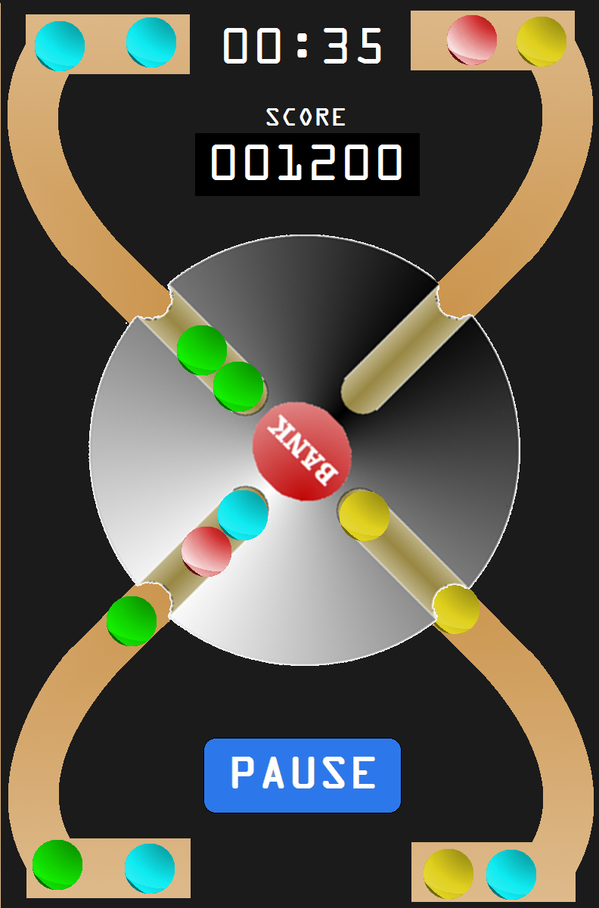

Cristobal Guerrero
February 8th, 2012

- Overview
1.1 Project summary
1.1.1 Purpose, scope, and objectives
The purpose of this document, the system requirements specification (SRS), is to have an outline of the requirements for the mobile application for its first check. This documentation is intended for the Winter 2012 Computer Science and Engineering course for software engineering (Dr. Concepcion’s CSE 445) in which multiple teams develop software for a variety of uses. The product that is to be created is called “Slidewinder”. This game will contain the elements listed below by the half way mark

      - Start Menu
      - Actual game interface
      - Scoring
      - Timer

The Slidewinder game screen size will be adjusted depending on the type of phone that it will be opened on.
    - Assumptions and constraints
The project is assumed to be at least to a 50%+ completion due to the time frame that we are given for the class.
    - Project deliverable
The project by the end of the term will be able to be a playable demo that will show the basic controls as well as game play for the slidewinder game.
    - Schedule and budget summary
The project will be implemented within a 10 week schedule. By the 6th-7th week the first iteration of the project will be completed. This includes a working demo on a given device. By week 10 there will be a working demo with more add-on for the slidewinder game
  - Evolution of the plan
If the game is not fully developed which is estimated not to be by the end of the term it will more than likely carry on to the next time the class is open. If the same group sticks together they will work together to complete the project even when the term is over. The final plan is to have a working game that can be distributed through either the Apple market or the Android market.
- References
IEEE Std 1058-1988 for software project management plan
Gaming documentation from original Slidewinder concept
- Definitions
SlideWinder - The Game
FIFO - First In, First Out
Points - Game Score
Scoreboard - Game score display
IEEE - Institute of Electrical and Electronics Eng.
SRS - Software Requirement Specification
Wheel - Function of the game
Facebook - Social Networking Service and Website
Mode - A manner of acting or doing or methods
Classic - Highest or High Rank
Garbage - Players can block others progress
Epic - Special Properties in this game
CSCI - Computer Software Configuration Items
4. Project organization
4.1 External interfaces
The way anyone would be able to contact us from outside the group would to either approach us at our meeting times or by email.
4.2 Internal structure
Communication between each other will be either through meetings, our personal Google group, the classes Google group or through our email.
  - Roles and responsibilities
Cristobal – Slidewinder lead/assistant project manager
Rimmi – Software Engineer/Compiler
Matt – Software Engineer/Designer
Ryan – Software Engineer/Sound FX technician
Jack – Slidewinder’s creator/Software Engineer/Client
5. Managerial process plans
5.1 Start-up plan
5.1.1 Estimation plan
The estimation for the project will be over 10 weeks which it will carry over to the next term when the class is offered. The estimation for a working demo that is playable will be that of the 10th week of the term
5.1.2 Staffing plan
Staff will be hired and moved upon permission by Dr. Concepion. Any type of replacements are to adhere to his approval as well changing any implementation plans.
5.1.3 Project staff training plan
If at any given time if there are question or something new to be implemented in the game that is not understood there will be staff training which will cover the materials i.e. programming languages that are to be used. Currently due to jumping from platform to platform there were mini tutorials being given at each meeting by other staff members of the group that had knowledge in that vicinity.
5.2 Work plan
5.2.1 Schedule allocation
The schedule will be as follows:
Week 6: working demo along with quality assurance testing
Week 7: begin to implement any changes that is needed after testing
Week 10: Bug fixes as well as more features will be implemented
5.3 Control plan
    - Requirements control plan
If there are any issues with the implementation of the project it will be brought up to Dr. Concepcion and will be discussed with the group as well. As for a resolution for the issue that would be at hand it will be discussed and have the SRS reviewed to see what can be cut down to have a sufficient demo to be presented on the date that it is to be presented. The SRS will then be updated and any changes made will be documented as well for future implementations of the project
    - Schedule control plan
If the schedule that is planned falls behind its original schedule it will be changed so that a proper implementation of the project would be at a presentable phase.
    - Quality control plan
Quality control will be dependent on the quality assurance team that will be testing an early implementation of the slidewinder project.
    - Reporting plan
Any problems with the program as well as errors will be documented in the code so that the same errors to not occur again.

    - Metrics collection plan
None
  - Risk management plan
risk: If someone were to not show up for any given reason
resolution: The person who is absent from any of the meetings will be emailed instructions as to what they must do and what was missed from that meeting.
Risk: If there is an error in the implementation of the product
resolution: If there is an error in the implementation of the product when attempting to present the demo an alternative PC version demo will be shown instead.
Risk: Lack of knowledge in the specific language
resolution: There will be training that will be scheduled to fix this. If the employee of the company cannot make it to that training meeting then they will have to learn on their own. If possible there will be something that can be referenced to given material.
  - Closeout plan
All methods and procedures to implement the Slidewinder game will be part of the documentation of the
6. Technical process plans
6.1 Process model
6.2 Methods, tools, and techniques
6.3 Product acceptance plan
7. Supporting process plans
  - Configuration management plan
Any configuration towards the overall system will be presented to the CEO. If there are any changes that are approved they will be reflected within the SRS.
7.2 Verification and validation plan
  - Documentation plan
Any type of documentation for the project will be clearly visible when looking at the source code. Any portions that do not seem to work or are suggested by the software team will be commented as such in the code.
  - Quality assurance plan
The quality assurance plan will follow testing and then fixing bugs along with pointing out points that were not implemented within the SRS iteration.
7.5 Reviews and audits
7.6 Problem resolution plan
7.7 Process improvement plan
8. Additional plans
Annexes
Index

