SRS Document for Slidewinder

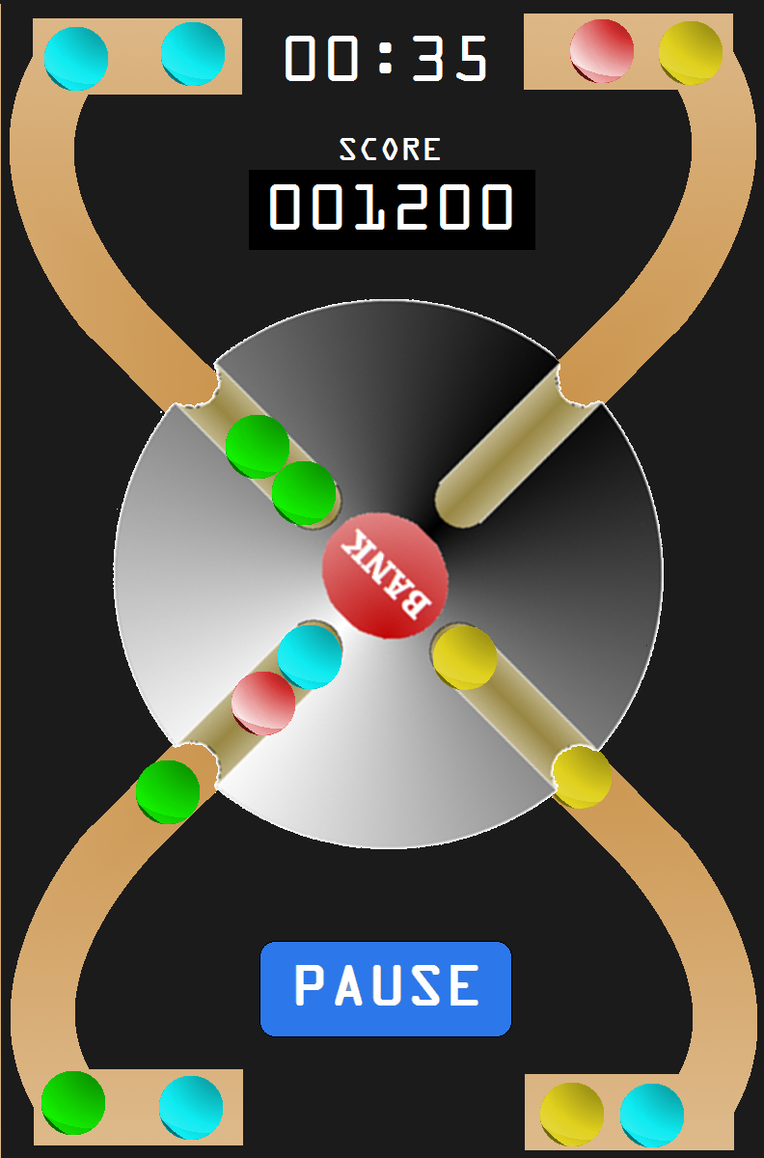

Cristobal Guerrero & Ryan Davis
January 27th, 2011

Table Of Contents

1. Introduction 3

1.1) Purpose 3
1.2) Scope 3
1.3) Definitions 4
1.4) Overview 4
1.5) References 4

2) Overall Description
2.1) Product Perspective 5
2.1.1) System Interface 5
2.1.2) User Interface 5
2.1.3) Hardware Interface 5
2.1.4) Software Interface 5
2.1.5) Communication Interface 6
2.1.6) Memory Contsraints 6
2.2) Product Functions 7
2.3) User Characteristics 8
2.4) Constraints, Assumptions, Dependencies 8

3) Specific Requirements 9
3.1) External Interfaces 9
3.2) Function 9
3.3) Performance Requirements 9
3.5) Design Constraints 9
3.6) Key Features 9
3.7) Addendum 9

1. Introduction:
The Slidewinder game project aims to create a mobile game application that will be created for cross platforms (Smartphones, and possibly PC). The game will feature an easy to use User Interface (UI) that will be versatile for a broad range of users, ranging from children to adults. It will have a basic implementation of having a score keeping method and a timer for the user, and the game’s difficulty will increase gradually as time goes by.

1.1 - Purpose:
The purpose of this document, the system requirements specification (SRS), is to have an outline of the requirements for the mobile application for its first check. This documentation is intended for the Winter 2012 Computer Science and Engineering course for software engineering (Dr. Concepcion’s CSE 445) in which multiple teams develop software for a variety of uses.

1.2 - Scope:
The product that is to be created is called “Slidewinder”. This game will contain the elements listed below by the half way mark

    - Start Menu
    - Actual game interface
    - Scoring
    - Timer

The Slidewinder game screen size will be adjusted depending on the type of phone that it will be opened on.

1.3 - Definitions/Abbreviations:
    - CSE: Computer Science and Engineering
    - CSUSB: California State University, San Bernardino
    - End User: any person that uses a executable form of a computer program
    - IDE: Integrated development environment. A software application that provides interfaces for computer programmers that makes software development more accessible
    - Mobile Application: reference to any type of software and/or program that runs on a current cell phone or smart-phone technology
    - SRS: Software Requirements Specification.

1.4 - References
    - Software Requirements Specification IEEE 830-1998
    - iCoyote Mobile application SRS version 1.0

1.5 - Overview:
This SRS contains an overview for the End User as well as for the administrative side. This overview will give descriptions of how the product will be implemented as well as how it will be used as a mobile application. Please refer to the table of contents for the descriptions for certain areas.

2. Overall Description

This iteration of the Slidewinder game will have a generic start menu as well as a simple playable demo of the game. It is planned to be implemented on the Google Android as well as the iPhone. The game will have two screens, one for the start menu and another for the actual game. The game demo will have a timer and a possible score board if it is able to be implemented. It will be touched screen based with a wheel in the center so the player can move it as opposed to tilting the device.
2.1.1– System Interfaces
The Slidewinder game will be developed with Game Maker IDE and will be deployed through the Android and Apple marketplace. The mobile device will load the game and run without any internet access

2.1.2– User interface
- All user interaction will be as a GUI and will have a simplistic rotation wheel which the user will have to rotate the wheel on the screen
- There will be a start menu screen that will lead to sub-menus to change the sound and possibly the difficulty of the game

The Bank wheel will be able to rotate by touch. The bank button will be able to reset the bank slots that are in brown so that a score is obtained. Depending in which way the balls are collected they will add points accordingly.

2.1.3 – Hardware Interfaces
The operating systems of the Android-based devices and Apple devices will need to be tested so that proper operation can be implemented

2.1.4 – Software Interfaces
The software if not limited to will consist of:
- Game Maker Lite v 8.1
- Eclipse
- Android SDK
- Java Development Kit (JDK)
2.1.5 – Memory Constraints
Slidewinder must abide to the memory constraints of supported iPhone and Android-based devices.
2.2 – Product Functions (Use Case Diagram)
a) Slidewinder will randomly feed a series of multicolored balls through 4 tubes.
b) Slidewinder will show the player’s score on top of the graphic interface.
c) Slidewinder will feature a timer for the player.
d) Slidewinder’s difficulty (speed, etc) will increase as the timer increments.
e) The player will hit the “Bank” button to store the same colored balls within each tube.
f) The player will tilt the centerpiece in order to store the specific-colored balls they wish to put in certain slots.
g) Any ball that hits the surface of the centerpiece (and doesn’t enter a slot) will be deleted/erased.
h) The difficulty (speed of ball entrance, etc) will increase as the timer increases.
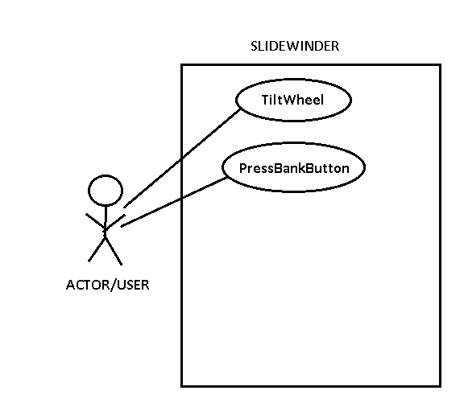

2.3 - User Characteristics
Each user in Slidewinder will be using a Smart-phone to play the game. They will need to download the game from the Android Marketplace or Apple’s App Store. The educational level for the user should be at least preschool or kindergarten level, as the counting of the balls piling up and basic color coordination will need to be analyzed by the user. Qualifying users with little to no experience with these types of games will be able to understand this game in seconds, with little technical expertise.
2.4 – Constraints
Thus far there are few constraints in developing our software for Slidewinder. Considering the game will be developed for a Smart-phone, we assume the biggest constraint will be hardware and screen size related. For some users with eyesight issues, the score, timer, the color of the balls may be difficult to see and hence, the user experience may be affected. Also, younger users who do not have the password to either the Android Marketplace or Apple App Store will not be allowed to download and install the game, as any application requires the master account user’s password.
The game Slidewinder has to be reliable and avoid crashing, as that is the number one cause of users deleting a game and passing it off as poorly developed software. Safety and regulatory policies aren’t to be worried about, as the game is very safe to play and shouldn’t induce any sort of stress or physical harm to the player.

2.5 – Assumptions and Dependencies
We must assume that each user has a Smart-phone and Internet to access the Android Marketplace or Apple App Store, in to download the application and its updates. Similarly, users must depend on the operating systems of either Windows, Apple OSX, or Linux in order to download the application and get the game onto their Smart-phone We also assume the user is in a physical condition that will allow them to properly assess the progress of the game and react to how the game is going. Physical conditions such as color blindness and other issues will be considered and perhaps a special mode to accommodate them will be featured.

3 Specific Requirements
3.3 Performance Requirements
All instances of playing the game should be in relation for the game time from when the player begins a round for the game. This is also susceptible by pausing the game and then returning to it later on.

3.5 – Design Constraints
The game will be limited to it not all by the size of the window that the game is being implemented on.

3.7 – Addendum
Approval for this documentation must be given by the following:
- Dr. Arturo Concepcion

