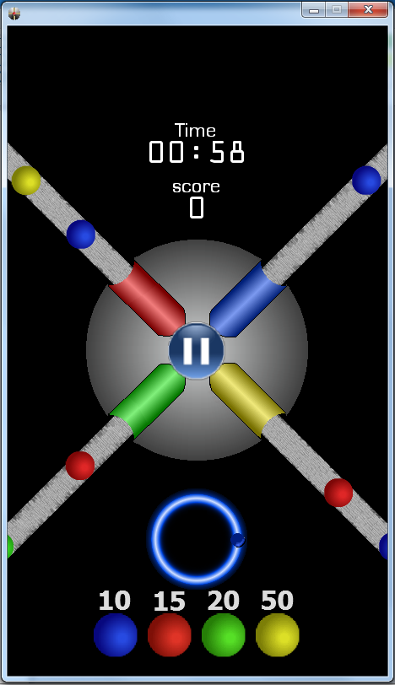
Software Requirements Specification
Version 2.0 - February 26, 2012

SLIDEWINDER
Team Members: Cristobal Guerrero
Ryan Davis
Table of Contents

1. Introduction
1.1 Purpose
1.2 Scope
1.3 Definitions, Acronyms, and Abbreviations
1.4 References
1.5 Overview

2. Overall Description
2.1 Product Perspectives
2.1.1 System interfaces (deployment diagram)
2.2 Product Functions (use case diagram)
2.3 User Characteristics
2.4 Constraints
2.5 Assumptions and Dependencies

3. Specific Requirements
3.1 External interface requirements
3.1.1 User interfaces
3.1.2 Hardware interfaces
3.1.3 Software interfaces
3.1.4 Communication interfaces
3.2 Functional requirements
3.3 Performance requirements
3.4 Design constraints
3.5 Software system attributes
3.6 Other requirements

1.0. Purpose

1.1. Introduction
The SlideWinder Game is an interactive mobile game, in which the user explores a screen with a center wheel, a pause button and much more features. Slidewinder will take in two types of input. User touches on the game screen and user presses on the Pause Button. Both of these inputs affect the properties of the Center Wheel

1.2. Scope
This specification establishes the functional, performance, and development requirements for Release 1 of the SlideWinder Game.

1.3. Glossary
Term | Definition
SlideWinder | The Game
FIFO | First In, First Out
IEEE | Institute of Electrical and Electronics Eng.
SRS | Software Requirement Specification
Wheel | Function of the game
Facebook | Social Networking Service and Website
Mode | A manner of acting or doing or methods
Classic | Highest or High Rank
Garbage | Players can block others progress
Epic | Special Properties in this game
CSCI | Computer Software Configuration Items

1.4. References
[IEEE] The applicable IEEE standards are published in “IEEE Standards Collection,”

Reference from previous SRS version 1.2

Reference Document from Jack Price (See attached)

1.5. Document overview
Section 1 identifies the scope of this document, the purpose of the software, and lists the definitions, acronyms and reference documents. Section 2 lists the documents referred to elsewhere in this document. Section 3 identifies the four main Computer Software Configuration Items (CSCIs) that comprise the system, and gives the functional requirements and constraints for each CSCI. Section 3 also describes the quality requirements for the software.
2.0. Overall Description
Slidewinder is a 2-D video game that will be portable on the I-Phone. This system’s purpose and focus is to create a simple smart phone game for users to play at anytime and anywhere .

2.1. System Perspective
Use Case Diagram
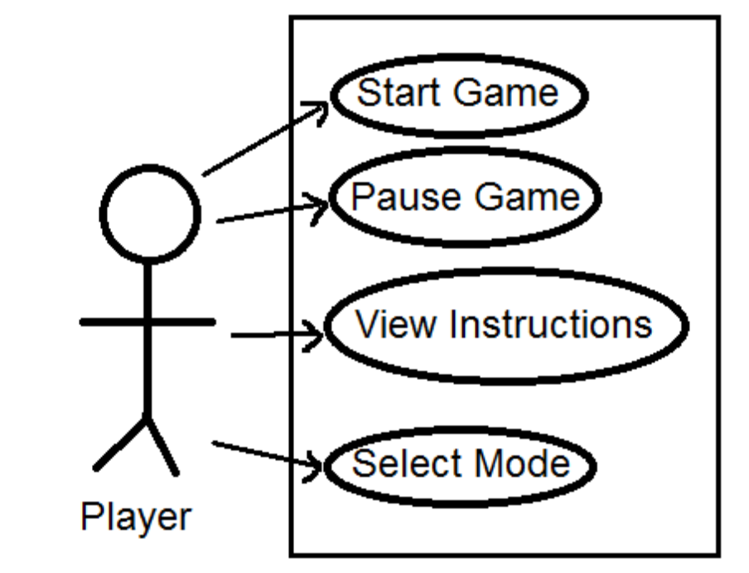
Deployment Diagram
User
Market

After download user will activate app from device
User
Device

Download from market to device

2.2 Product Functions

2.3 User Characteristics
The game should be useable by any users, via a command line interface. No special knowledge or skills should be assumed on the part of the users. Users are should not be expected to learn a set of commands in order to start using the game.

2.4 Constraints
No special constraints have been identified.

2.5 Assumptions and Dependencies
No special assumptions or dependencies have been identified.

3.0. Specific Requirements

3.1. External Interface Requirements

3.1.1 User interfaces
The player collects points by connecting colored balls which slide down a ramp, with bumpers of the same color on a rotating wheel controlled by the player. There will be a start button at the top that will start a count down timer and will also start the game as well. There will be a select menu for the type of difficulty that will be implemented. There will also be a pause button that will be able to temporary halt the game and resume it from where it was left off

3.1.2 Hardware interfaces
Any compatible IOS device which will need to have further testing for specific generation compatibility.

3.1.3 Software interfaces
The system shall be capable of running on any version of the IPhone. The system shall make use of the operating system calls to the file management system to store and retrieve game states.

3.1.4 Communication interfaces
None

3.2. Functional Requirements
See attached Original SlideWinder Game Design

SCREEN LAYOUTS

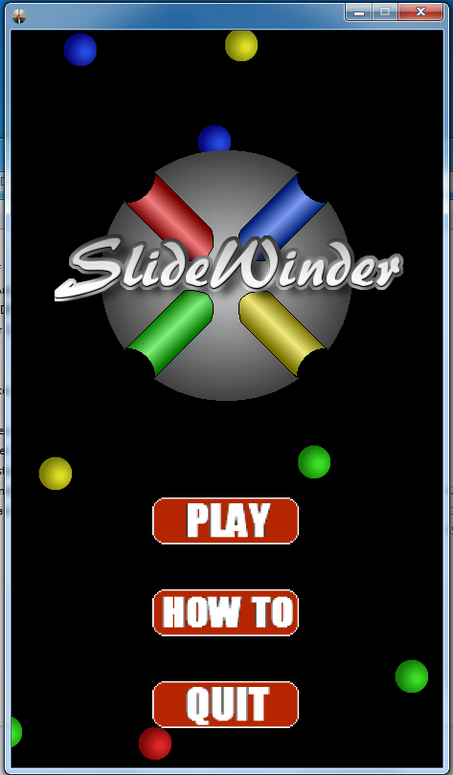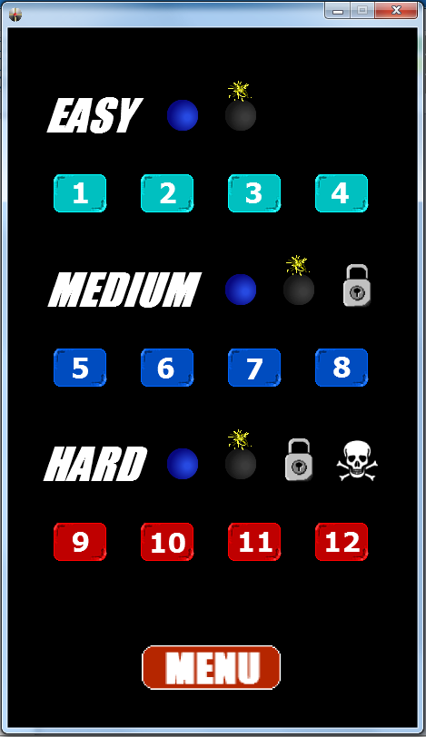
3.2.1. Single Player Mode (New Game)
Use Case Name: | Single Player Mode(New Game)
Priority | Essential
Trigger | user Selection
Precondition | users will have reached the Single Player Mode screen
Basic Path | 1. user selects Single Player Mode(New Game).  2. SlideWinder presents the user with the Single Player mode options for a new game.
Alternate Path | The user may choose to load a previous game state.
Post-Condition | The new game has been initiated successfully.
Exception Path | If there is any type of failure, the user will be returned to t
Other
Reference | Game Design Documentation

3.3 Performance Requirements
The system should respond to each user input within 2 seconds. There are no other performance requirements.

3.4 Design Constraints
See attached original SlideWinder Game Design

3.5 Software System Attributes

3.5.1 Reliability
The system should never crash or hang, other than as the result of an operating system error.
3.5.2 Availability
There are no specific availability requirements

3.5.3 Security and Privacy
There are no specific security and privacy requirements.

3.5.4 Maintainability
All code shall be fully documented. Each function shall be commented with pre- and post-conditions. All program files shall include comments concerning authorship and date of last change.
The code should be modular, to permit future modifications. Anticipated updates include changes to the sets of objects and their descriptions used during the game. These should be stored in a separate data file, rather than embedded in the program code.

3.5.5 Portability
The system should be portable to any I-Phone. No other specific portability requirements have been identified.

3.5.6 Safety
No safety requirements have been identified.

3.5.7 Training-related Requirements
No specific training should be necessary for a user to begin playing the game. If the user needs assistance understanding the game for the first time then they will be able to read the instructional manual.

3.5.8 Packaging Requirements
The system should be packaged along with source code and all documentation, and be available for electronic transfer as a single compressed file to any purchaser. The uncompressed set of files should include a README file containing a minimal guidance for installing and running the game, including recompilation if needed. For recompilation, the system should include a make file.

3.6 Other Requirements
There are no other requirements.

SLIDEWINDER GAME DESCRIPTION (ORIGINAL)

Defining primary game play mode (Jack)
The Game play mode of SlideWinder takes place on a touch screen device (smart phone or tablet). The primary mode takes place on a single screen which is stationary (only the center wheel and the balls change position). It is based on a timer and the player has a set time to try to build up as many points as possible. The timer is in view at the top of the screen and counts down from a set time (probably 1 or 2 minutes but will depend on the difficulty level). However, the player can pause and restart the game at any time. Once the timer counts down to zero, the total points are displayed.
The player collects points by capturing 3 balls of the same color, which slide down a ramp and connect to the wheel, in the same tube within the center wheel (for further detail of the design, see Level Design) and then pressing the “bank” button in the center of the wheel. There are 4 different colors of balls (Red, Blue, Green, Yellow) and each collection of each color is worth different points (for example having all three green=100, red=200, blue=400, yellow=800). Balls worth more points are less frequent. Having a completed tube, with 3 balls of the same color will result in the specified amount of points. If there are 2 or more completed tubes, each tube will bank its specified points plus bonus points depending on how many tubes are complete (x2 or x3). Points increase and are shown at the top of the screen. If a tube is incomplete or has different colored balls, it is worth no points.
The player must control the wheel by touch and observe all activity on the screen in order to collect the correct ball in the correct tube. The game requires quick thinking and strategy in order to gain the most points.
Designing the core mechanics (Theo)
After starting a new game of Sidewinder, the user will be presented with a screen with a Center Wheel, a Bank Button, two labels: a decrementing time label, a background graphic with four ramps, and a variable amount of moving balls flowing down the ramps towards the center. Sidewinder will take in two types of input. User touches on the game screen and user presses on the Bank Button. Both of these inputs affect the properties of the Center Wheel.
The Center Wheel consists of a position, four sockets, and four collision points located at the end of each socket. User touches on the game screen will rotate the Center Wheel’s position around its center. The sockets and collision points will rotate as well with the
Center Wheel. The goal is for the user to understand that the sockets stay constant in an “X” formation, but that they can be moved when the Center Wheel is moved. When a ball collides with one of the collision points, the ball will be inserted in a FIFO manner to that point’s respective socket.
The Bank Button, positioned on the center of the Center Wheel, is used by the user to remove all balls from all sockets. Based on the game mode, the user will be rewarded based on the the combination of the balls in the sockets. These rewards will require the button to update
the player’s score and/or the player’s remaining time.
Aside from handling user inputs, the game also needs to be able to generate balls for the Center Wheel to collect in its sockets. In general, the balls should be generated with a random number generator. However, depending on the selected difficulty, balls should be generated more or less often. A ball class should be designed so that the application can dynamically create the balls. It should at the minimum include properties for the ball’s position, speed, image, and color. A container such as an array should be used to manage the balls so that they can be deleted from memory once they are no longer part of the user’s view. Depending on the ramp type of the game (straight, curved, zigzagged, etc), the balls will need to follow a programmed path that makes it appear that the ball is flowing down the ramp.
After these three mechanics are implemented, all that is needed is the programming of the specifications of the different game modes, a visual clock, and a persistent high score board.
Creating additional modes (Jared)
In addition to the primary single player mode in SlideWinder, there will be a competitive mode. Vs. mode involves connecting with a friend (via Facebook, for instance) and competing in different game settings. vs. mode plays out similar to the single player mode, but with a few adjustments to that affect the competing player. Here are the different modes for Vs. Play:
Classic Mode: Players simply compete for the high score. The only changes made to this mode are to display both of the player’s score on the display. screen.
Garbage Mode: Players can send balls that block the other player’s progress. If players bank more than 2 sets of 3 matched balls at one time, a “garbage” ball will be sent the other players screen. If collected, the garbage ball will prevent the player from matching that row. The garbage balls stay until they hit the center bank button. No
score is attributed to garbage balls.
Epic Mode: Balls with special properties come down the ramp. If three of these balls are matched, points will be added to that player’s score, and the competing player will experience a harmful effect on their screen. Garbage Mode rules may also apply if the settings are adjusted accordingly. Here are the temporary effects a player will experience if three special balls are matched by the other player: The outer edges are blocked from view so that the player can only see part of the ramps. The speed of the balls coming down the ramps increases. One or more of the tubes in the center wheel are blocked off. The controls for spinning the center wheel are reversed. Sliding a finger clockwise around the screen will result in a counterclockwise turn.
The settings of each of these modes can be altered in three ways:
Time Attack [default]: The game ends after a certain time (also determined by the players), whoever has the highest score wins. Survival: Players compete until one player is unable to bank at least one row of balls. For Classic mode, balls come down the ramps quicker as time goes on.
Set Score: Players play until a determined score is reached by either player.
The player will also have number options for single player game play. One option for single player mode is CPU Vs. This mode is the same as the Vs. Mode, but the second player is controlled by AI. Players can adjust the difficulty of the CPU. The primary game mode
can also be adjusted with the settings detailed in Vs. mode:
Time Attack [default]: The game ends after a certain time (also determined by the player), whoever has the highest score wins.
Survival: The player plays until one he/she is unable to bank at least one row of balls. Balls come down the ramps quicker as time goes on.
Set Score: The player plays until a determined score is reached. The goal is to reach the score in the quickest amount of time.
The player can also decide whether “garbage” balls come down the ramps randomly. Finally, a high score leader board will be available in-game. The player will be able submit high scores to compete with other players worldwide.
Level design (Jack)
In SlideWinder there is only one designed level that can be played in different modes. The level features a wheel in the center of the screen that has four tubes/sockets, one on each side. In the conceptual design of the wheel, it looked 3D and metallic with a red button in the center acting as the “bank” button to collect points. When creating the prototype and gif animation, the wheel was more plain, being only 2D and consisting of flat color.
Each corner of the screen has a small box where two balls can be shown to the player in order to develop a strategy. There are four different color balls that can appear in random order. The ball closest to the wheel will drop randomly and make its way down a ramp/ slide towards the center wheel. The balls will appear 3D in a perfected design of the game (more marble-like). The balls will slide down the ramp into the wheel tube where they will stay until the bank button is pressed and points are collected. If the wheel is positioned where the ball cannot enter the tube, the ball will hit a collision and disappear. The main screen will also feature a time counter at the top (which counts down), a score total near the top, a play/pause button at the bottom, and a menu button to return to a menu option in order to change difficulty levels. The design of the play/ pause button and menu button will be simple and easy to see, but far enough away from the center wheel as to not interfere with game play.
The background of the screen will be a plain color, either black or dark gray. However, a possible alteration to the game would be to allow the player to choose a custom background for their own machine/ smart phone. The slides will also be a plain color and their width
will be equivalent to the tubes found on the center wheel.

