Name: Mherlie Joy U. Chavez  
  
Section: BSCS 3-A AI

Date/Deadline: September 13, 2024

//

***Guidelines

Repository Link: <https://github.com/Pithovirus/AppDevProject2.git>

File Name should be FamilyName_App2 for this document, different file name for the repo, please refer to my filename in repo.

1. Create a simple App you can reference my work on the repository.
2. Upload it on the repository using the git bash command line.
3. Screenshot the following commands used to copy the repository and upload the app using git commands.
4. Paste the screenshot of the ff. Here:  
   *Command Line including the commands.

*Your uploaded file in the repository  
  
*****Deadline: Friday Midnight****  
//

**Screenshots:**

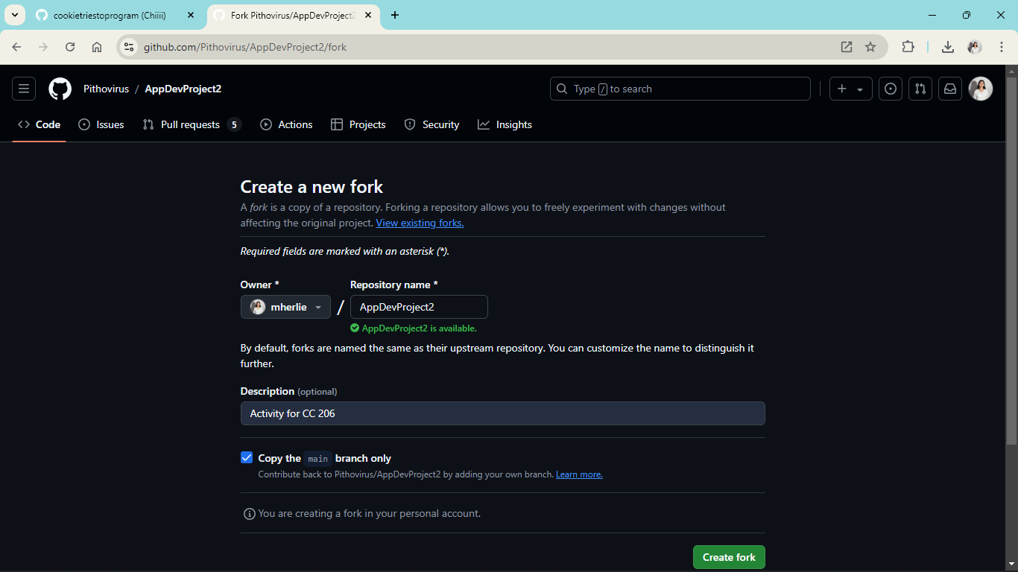

Fork the ‘AppDevProject2’ in my repository

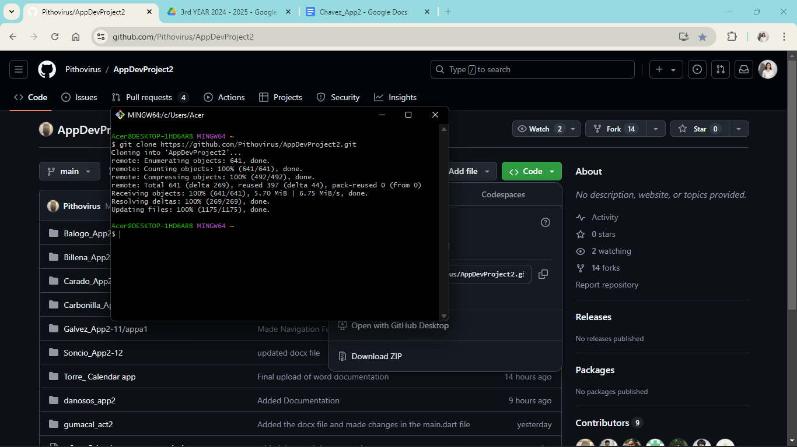

Clone the repository ‘AppDevProject2’ to local drive

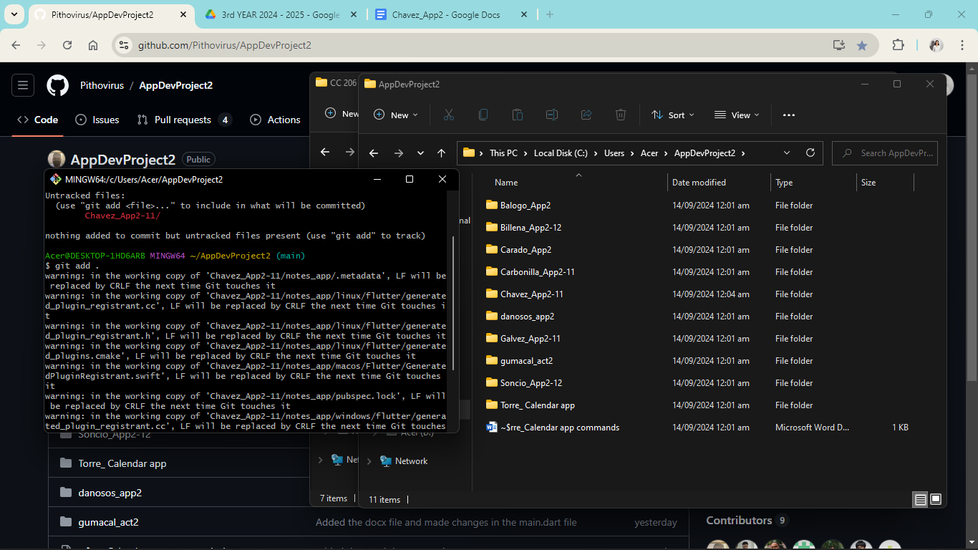

Adding my folder ‘Chavez_App2-11’ by ‘git add .’

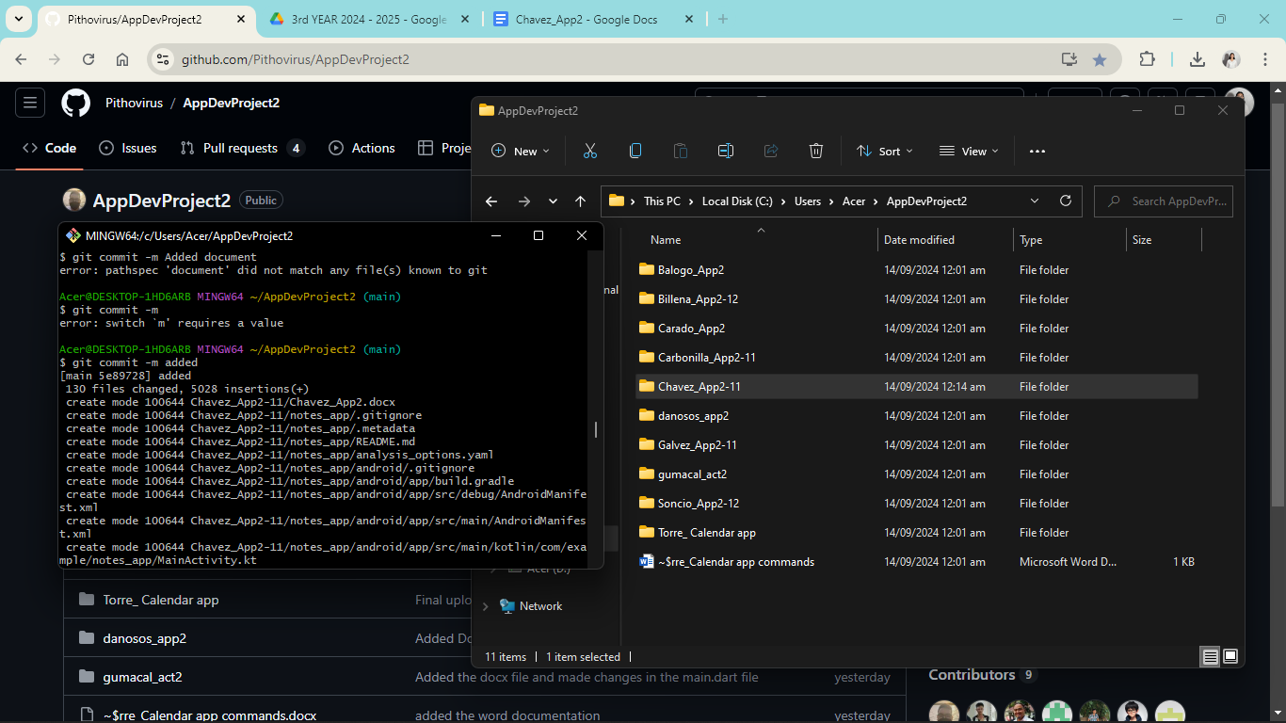

Using ‘git commit -m added’ to add the document and other changes.

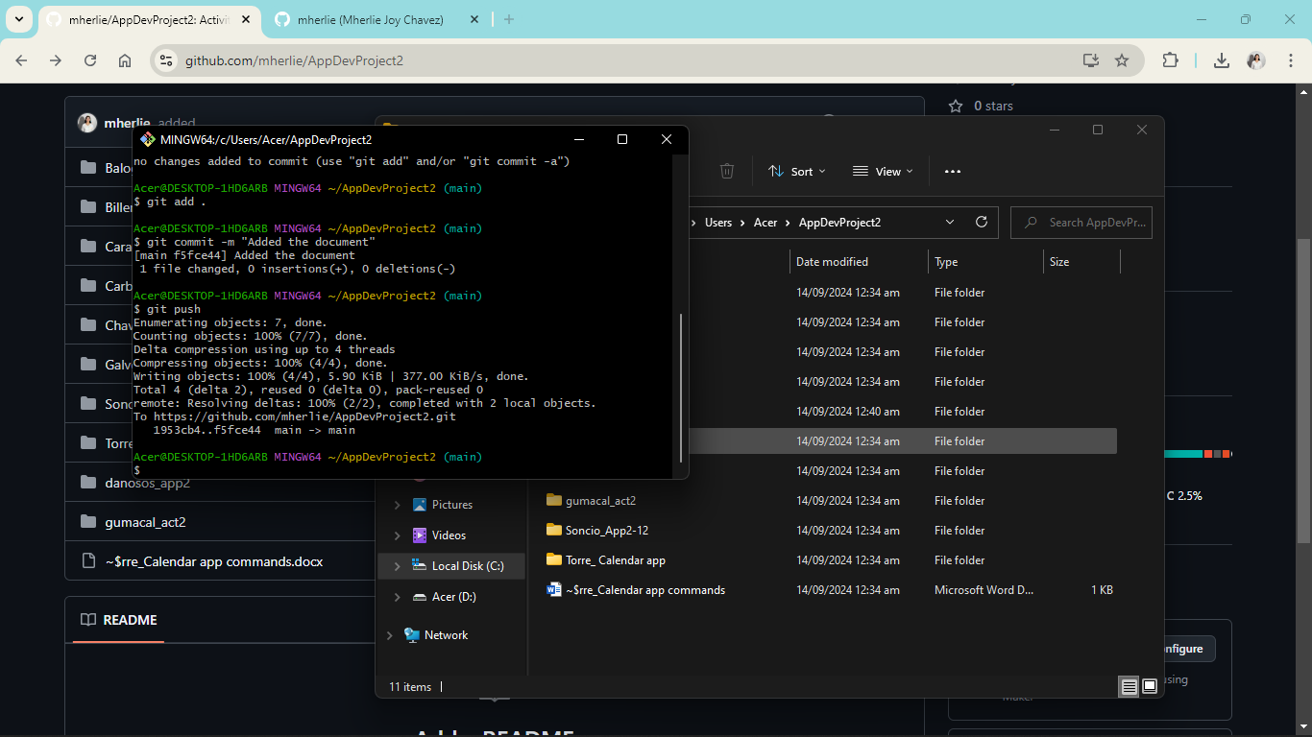

Using ‘git push’ to update in the repository

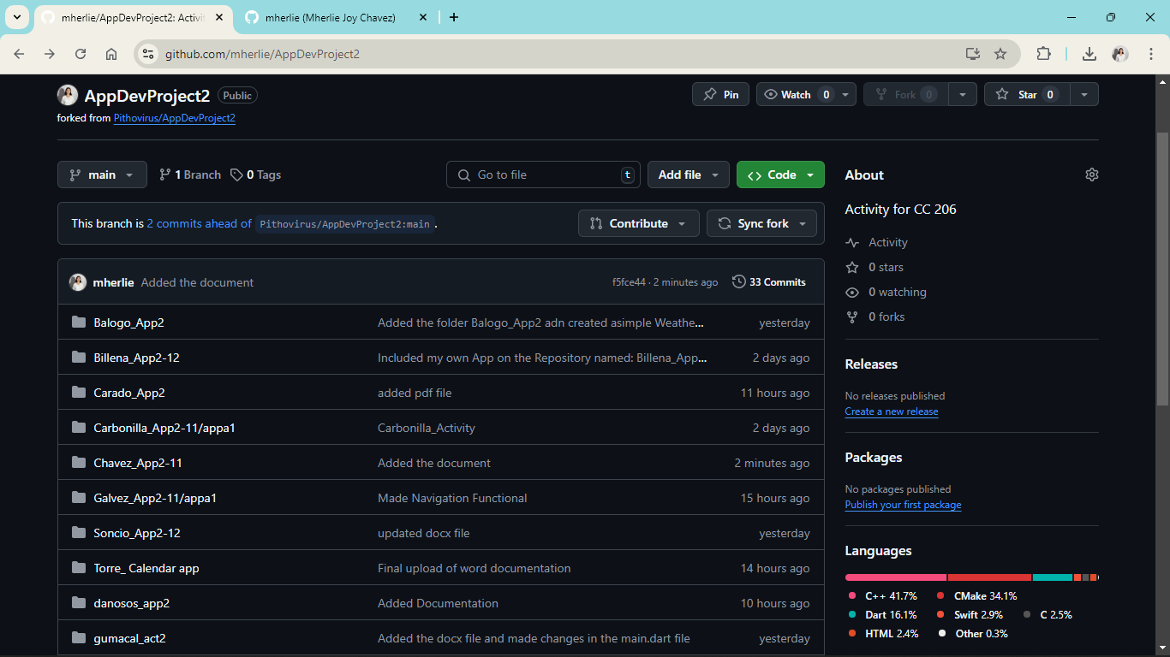

The file committed changes in the forked repository and will be creating pull request.